Overview
Despite urging House Republican leadership to not make large spending cuts to Medicaid, Bacon voted for the U.S. House budget framework that directed the House Energy and Commerce Committee to make $880 billion in cuts. It has been widely reported that House Republicans would have to cut Medicaid in order to achieve that goal. Bacon initially claimed concerns about the proposed Medicaid cuts were “hysteria” but later admitted that $880 billion in cuts would affect Medicaid. Then in April 2025, Bacon said he would accept $500 billion in cuts to Medicaid. An estimated 78,600 or nearly 14 percent of Nebraskans in Bacon’s district relied on Medicaid or CHIP for health insurance.

2025: Bacon Voted For $880 Billion In Cuts To Medicaid
2025: DESPITE URGING GOP LEADERSHIP NOT TO ENACT LARGE SPENDING CUTS TO MEDICAID, BACON VOTED FOR THE HOUSE BUDGET FRAMEWORK THAT SET UP $880 BILLION IN CUTS TO MEDICAID
January 2025: Bacon Implored GOP Leadership Not To Pursue Large Spending Cuts To The Affordable Care Act, Medicaid Or SNAP. According to Politico, "House Republicans in competitive districts warned GOP leaders Thursday: We could lose our seats if you gut Obamacare to pay for a massive border, energy and tax bill. A group of about a dozen centrist Republicans delivered the message in a meeting with GOP Whip Tom Emmer (R-Minn.) and other senior lawmakers, according to four Republicans familiar with the meeting who were granted anonymity to speak frankly. GOP members are already concerned that they’re poised to lose their trifecta and a swath of seats in the 2026 midterms — they worry GOP efforts to pare back the Affordable Care Act could pour fuel on the fire. Centrists conveyed to leaders in the meeting that they needed to ‘learn the lessons’ from the last GOP attempt to undercut the Affordable Care Act in 2017, according to one of the Republicans. The party went on to lose more than 40 House seats in the 2018 midterms. Instead, they argued, Republicans needed to embrace the GOP’s role as the working class party. Leaders would counter that message by slashing programs working Americans rely on, they said. GOP lawmakers in the room included Rep. Brian Fitzpatrick (Pa.), Young Kim (Calif.), David Valadao (Calif.), Andrew Garbarino (N.Y.), Tom Barrett (Mich.) and Don Bacon (Neb.)." [Politico, 1/23/25]
February 2025: Despite Previously Claiming The Republican Budget Proposal’s Cuts To Medicaid Were Too Significant, Bacon Said He Voted For It Because He Was “Assured That The Final Bill Will Not Affect The Quality Of Healthcare Covered By Medicaid.” According to Nebraska Public Media, News, "The resolution calls for the House Energy and Commerce committee to cut around $880 billion by 2034. Some fear a chunk of that would come out of Medicaid funding. While the resolution doesn’t directly mention cuts to Medicaid, the Energy and Commerce committee oversees the program. One initial holdout to the resolution was Nebraska’s second district Congressman Don Bacon. He told Nebraska Public Media News earlier this month he thought the size of the cut was too significant. ‘The experts that I have been talking to think you can only do that by significantly cutting Medicaid, and we have a lot of people depend on Medicaid,’ he said in an interview on Feb. 20. A total of 54% of Nebraskans voted for a ballot initiative to expand Medicaid in 2018. Nebraskans at or under 138% of the federal poverty line are eligible, amounting to at or below $21,600 a year for a single person, or $44,400 for a family of four. But Bacon did vote to approve the resolution and said in a written statement after the vote he was ‘assured that the final bill will not affect the quality of healthcare covered by Medicaid.’" [Nebraska Public Media, 2/26/25]
- HEADLINE: "House Republican Budget Takes Away Health Care, Food Aid To Pay For Expanded Tax Cuts For Wealthy" [Center on Budget and Policy Priorities, 2/21/25]
- New York Times Reported The $880 Billion In Cuts Required By The Republican Budget Proposal Would Have To Come From Medicaid, Medicare, Or CHIP. According to the New York Times, "The budget resolution itself is silent on whether Congress cuts Medicaid, which provides health coverage to 72 million poor and disabled Americans. But it instructs the House Energy and Commerce Committee, which has jurisdiction over the program, to cut spending by $880 billion over the next decade. If the committee can’t save at least that much, the entire effort could be imperiled because of the special process Congress is using to avoid a Senate filibuster. Ten other committees have their own instructions to follow, though none have been assigned with cutting nearly as much. It’s not so simple as finding the cuts elsewhere. The special process, known as budget reconciliation, means Republicans will have to find all $880 billion from within the Energy and Commerce Committee’s jurisdiction. That leaves them with fewer options than one might think. […] If Republicans want to avoid major cuts to Medicaid, the largest pot of available money is in the other big government health insurance program: Medicare. […] Even if the committee cuts everything that’s not health care to $0, it will still be more than $600 billion short. The committee could also save around $200 billion by eliminating the Children’s Health Insurance Program, but that option has not been raised by the budget committee or anyone in House leadership. […] Even if all of these cuts, revenues and rule cancellations from outside health care can pass muster, the committee will still be left with hundreds of billions of dollars to cut to hit its goal. Mathematically, the budget committee’s instructions mean the committee would need to make major cuts to either Medicare, Medicaid or both." [New York Times, 2/25/25]

February 2025: Bacon Claimed Concerns About Medicaid Cuts Were “Hysteria”
February 2025: Bacon Questioned If The U.S. House Republican Budget Proposal Mentioned Medicaid And Said “Don’t Get Caught Up In The Hysteria.” According to a post on Rep. Don Bacon’s Twitter, "Does the bill even mention Medicaid? We’ll have two more votes. Don’t get caught up in the hysteria."
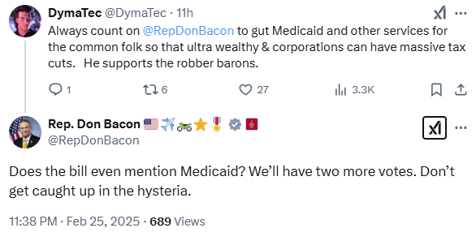
[Twitter, @RepDonBacon, 2/25/25]
February 2025: In Response To A Twitter User Claiming Bacon Cut Medicaid, Bacon Said “There’s Been Nothing Cut Yet. Breathe Into A Bag Slow Deeply And Exhale.” According to a reply on Don Bacon’s Twitter,
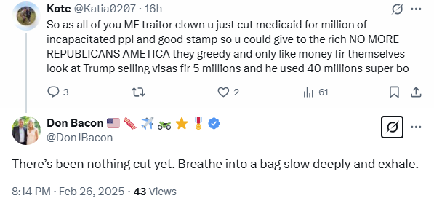
[Twitter, @DonJBacon, 2/26/25]

April 2025: Bacon Said The $880 Billion In Medicaid Cuts He Voted For Would Lower Quality Of Health Care
Bacon: “You're Right. If The Final Numbers Are $880 Billion Out Of ENC. I Think You're Right, It Would Affect Medicaid.” According to an interview Rep. Don Bacon gave on PBS NewsHour, “ANCHOR: And you did say, according to reports, there are no threats right now to the stability of Medicaid, which people asked about. Mathematically, sir, you know, there's no way to reach the target cuts that have been set in the budget by that committee. other than touching Medicaid, it has to be touched in some way. So how can you guarantee that the hundreds of thousands of people in Nebraska will not feel any impact to Medicaid? BACON: You're right. If the final numbers are $880 billion out of ENC. I think you're right, it would affect Medicaid.” [PBS NewsHour, 3/26/25] (video)
Bacon Said The $880 Billion In Medicaid Cuts Under The House Budget Proposal Would Force Cuts To Quality Of Health Care And Reimbursements To Hospitals. According to Punchbowl News, "Rep. Don Bacon (R-Neb.) told us he’d vote against a final bill if it includes massive spending cuts that harm Medicaid. ‘I reflect about 20 people. I think there’s a bunch of us that don’t want to see cuts to the quality of health care and reimbursements to hospitals. We think $880 [billion] would force that.’" [Punchbowl News, 4/9/25]
- HEADLINE: "Republicans Can't Meet Their Own Budget Target Without Cutting Medicare Or Medicaid, Budget Office Says" [NBC News, 3/5/25]
- HEADLINE: "Can House Republicans Cut $880 Billion Without Slashing Medicaid? It’s Likely Impossible." [KFF Health News, 3/13/25]

April 2025: Bacon said he would accept $500 billion in cuts to medicaid, which one of his colleagues called “a lot”
HEADLINE: "Don Bacon Sets $500B Red Line On Medicaid" [Politico, 4/29/25]
Bacon Reportedly Told The White House He Would Accept $500 Billion In Cuts To Medicaid. According to Politico, "Rep. Don Bacon, a key GOP moderate, is drawing a red line on Medicaid cuts. The Nebraska Republican has privately told the White House he won’t accept more than $500 billion in reductions to the program, according to two people with direct knowledge of the matter. That could complicate the GOP’s effort to pass a domestic policy bill that is set to include an extension of President Donald Trump’s 2017 tax cuts." [Politico, 4/29/25]
- Bacon: "I Don't Consider This A Cut To Medicaid, Frankly." According to KETV, "Bacon said he's not flip-flopping on his stance. ‘What I said was that I'm not supporting cuts to the quality of care of Medicaid or the hospitals,’ he said. ‘So I don't consider this a cut to Medicaid, frankly.’" [KETV, 4/29/25]

Another Republican Representative Said He Thought $500 Billion In Cuts To Medicaid Was “A Lot”
Republican Rep. Valadao Said He Would Not Have Associated Himself With Bacon’s Position Supporting $500 Billion In Medicaid Cuts And, “I Still Think $500 Billion Is A Lot.” According to Politico, "Valadao has previously said he supports the GOP’s push to implement federal work requirements for Medicaid and could be willing to go along with reducing the federal share of funding for beneficiaries in Medicaid expansion states. But he pointed to Bacon’s position as something he ‘wouldn’t have associated’ himself with, suggesting that number might be too high for him, too. ‘I still think $500 billion is a lot, depending on how they score things,’ Valadao said, but added the cost estimate ‘might be all foo-foo numbers just to make people happy.’" [Politico, 4/29/25]
2023: AN ESTIMATED 78,600 OR NEARLY 14 PERCENT OF NEBRASKANS IN THE SECOND CONGRESSIONAL DISTRICT RELIED ON MEDICAID OR CHIP FOR HEALTH INSURANCE
2023: 78,600 Nebraskans In The Second District Were Enrolled In Medicaid Or CHIP, Which Amounted To 13.9-Percent Of People In The District. According to Georgetown University’s Center for Children and Families,
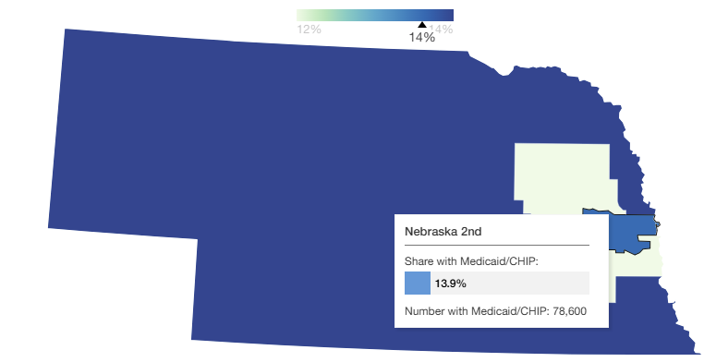
[Georgetown University, Center for Children and Families, Viewed 5/6/25]

