Overview
Van Orden attended the “Stop the Steal” rally headlined by Donald Trump on January 6th, 2021.
Despite claiming he did not engage in the riot or reach Capitol grounds, there was a photo of him posted on Facebook within a restricted area on the Capitol Grounds on January 6th.
Van Orden’s campaign finance report also included several charges for transportation and hotels in Washington, D.C. around January 6th, indicating that he used campaign money to fund his trip.

Van Orden Attended The “Stop The Steal” Rally On January 6th In The Capital

Van Orden Attended The January 6th “Stop The Steal” Rally Then Was Photographed Near Capitol Grounds Afterward
Van Orden Attended The “Stop The Steal” Rally Headlined By Donald Trump, Then Was Photographed On Or Near The Capitol Grounds Afterward. According to the Associated Press, “Derrick Van Orden was among the thousands of people who went to Washington for the ‘Stop the Steal’ rally headlined by then-President Donald Trump on Jan. 6, 2021. Afterward, Van Orden was photographed on or near the grounds of the U.S. Capitol, where rioters violently breached the building in one of American democracy’s darkest days. Now Van Orden, a Donald Trump-endorsed retired Navy SEAL who says he took no part in the riot and did not set foot on the Capitol grounds, appears poised to win the U.S. House seat held since 1997 by retiring Democratic Rep. Ron Kind.” [Associated Press, 10/16/22]
- Van Orden Said He Went To March On January 6th To “Stand Up For Electoral Integrity.” According to the Washington Post, “Van Orden was at President Donald Trump’s ‘Save America’ rally on Jan. 6, 2021, and then joined the crowd that marched down the Mall toward the Capitol, saying in a television interview that ‘I went there to stand with them, to stand up for electoral integrity.’ Van Orden said he never entered the Capitol, which was ransacked that day by a pro-Trump mob seeking to overturn the results of the 2020 election.” [Washington Post, 11/15/22]
The Daily Beast Confirmed The Photo Of Van Orden Shared On Facebook On January 6th Was Inside A Restricted Area On The Capitol Grounds. According to the Daily Beast, “A Facebook image from Jan. 6 shows Van Orden standing on a wall on the Capitol grounds that was inside a restricted area. (The Daily Beast recreated the photo on Friday and confirmed that Van Orden would have had to cross police barricades to reach that area.)”
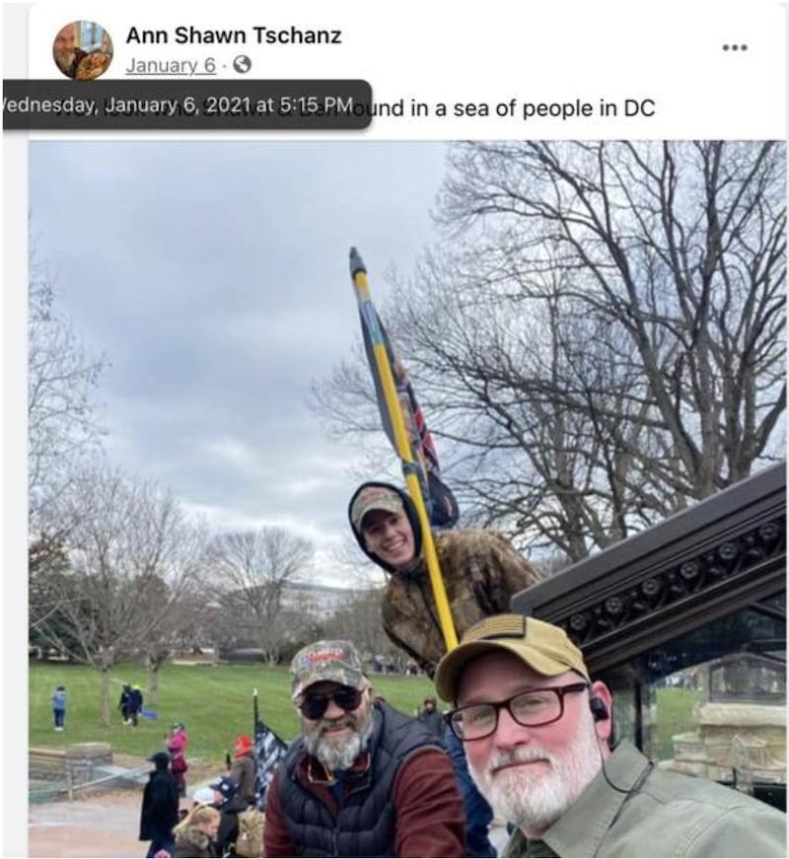
Screen_Shot_2021-06-25_at_10.26.45_PM_im0yzg
[Daily Beast, 6/26/21]

Van Orden Reportedly Used Campaign Money to Fund His Trip to D.C. on January Sixth
Van Orden’s Campaign Finance Reports Indicated He Wrote Off Roughly $4,000 In Transportation And Hotel Costs In Washington, D.C. Around January 6th. According to the Daily Beast, “As for Van Orden’s campaign expenses surrounding Jan. 6, it’s unclear how they relate to Van Orden’s attendance. Federal Election Commission regulations state that travel expenses must be ‘directly related to the campaign.’ Van Orden—who wrote off roughly $4,000 in transportation and D.C. hotel costs around Jan. 6 for him, his wife, and a campaign staffer—lost his race in November and didn’t declare his 2022 candidacy until April.” [Daily Beast, 6/26/21]

