Overview
Sullivan introduced a disapproval resolution that would rescind a Biden administration Integrated Activity Plan (IAP) that closed half of the National Petroleum Reserve-Alaska (NPR-A) to oil and gas leasing. Following the passage of the resolution, an Iñupiat-aligned group, alongside conservation groups, sued against the approval of an exploratory drilling program in the NPR-A. While Sullivan claimed the initial closure of the NPR-A was “cancelling native voices”, Native Alaskan communities
say oil and gas leasing would endanger their homelands, unity, and way of life.

Carter Sullivan Supported The Opening OF The National Petroleum Reserve-Alaska

Sullivan Supported The Repeal Of A 2024 National Petroleum Reserve-Alaska (NPR-A) Rule
Sullivan Thanked His Senate Colleagues For Passing His Resolution Resciding A Biden Administration Integrated Activity Plan (IAP) That Closed Off Much Of The NPR-A To Oil And Gas Leasing, Claiming It “Ignored” Alaska Native Voices. According to a press release by Senator Dan Sullivan, “The U.S. Senate, by a vote of 52 to 45, today passed Senators Dan Sullivan and Lisa Murkowski’s (both R-Alaska) joint resolution of disapproval under the Congressional Review Act (CRA) to overturn the Biden administration’s restrictive 2022 Integrated Activity Plan (IAP) Record of Decision (ROD) for the National Petroleum Rese+rve in Alaska (NPR-A).[...] ‘The Biden administration’s 2022 NPR-A Integrated Activity Plan was one of the most blatant examples of federal overreach we’ve seen in Alaska in decades,’ said Sen. Sullivan. ‘This plan effectively locked up about half of the National Petroleum Reserve—an area Congress explicitly set aside for energy production, ignored Alaska Native voices, violated clear congressional intent, and undermined our state’s ability to responsibly develop the resources that support our communities and strengthen our nation. As I said in my remarks on the Senate floor, responsible resource development builds infrastructure, supports communities, creates good-paying jobs, and literally leads to my constituents living longer. I wish more of my Senate Democratic colleagues recognized that truth and found the courage to stand up to the far-left Lower 48 eco-colonialists who are determined to lock up Alaska, kill good-paying jobs, and silence the people who live there. But I do want to thank the majority of my colleagues in the Senate who stood with me, Senator Murkowski, and Congressman Begich in passing this resolution—restoring balance, upholding the law, and ensuring Alaska’s resources are managed responsibly for the benefit of our people, our economy, and America’s national security.” [Press Release - Senator Dan Sullivan, 11/17/25]
Sullivan Claimed That The Rule And Similar Action By The Biden Administration Canceled Native Voices That Supported Development. According to Politico, “On the Senate floor Wednesday, Sullivan reiterated his contention that the Biden administration wrongly attacked his state with 70 executive actions targeting resource development, hurting jobs and life expectancy — all in the name of helping Alaska Native people. ‘That was a bald-faced lie,’ he said, arguing the Biden administration was in fact canceling Native voices that support development. Sullivan’s Congressional Review Act resolution, which only needs simple majorities in both chambers, comes as the Trump administration takes executive actions to boost energy and mining in the state.” [Politico, 10/29/25]
Sullivan Referred To The 2024 NPR-A Rule As A “Blatant [Example] Of Federal Overreach” And Applauded Secretary Burgum For The Rescission Of The Rule. According to a press release by Senator Dan Sullivan, “U.S. Senators Lisa Murkowski and Dan Sullivan and U.S. Congressman Nick Begich (all R-Alaska) today issued the following statements after the Department of the Interior (Interior) repealed a rule the Biden administration imposed in 2024 as it sought to halt future development in the National Petroleum Reserve-Alaska (NPR-A). [...] ‘The Biden administration’s NPR-A rule was one of the most blatant examples of federal overreach we’ve seen in Alaska in decades,’ said Senator Sullivan. ‘This rule locked up of about half of the National Petroleum Reserve—an area Congress explicitly set aside for energy production, ignored Alaska Native voices, violated clear congressional direction and undermined our state’s ability to responsibly develop the resources that support our communities, create good paying jobs, and strengthen our nation. But under the Trump administration, it is a new day filled with opportunity for Alaskans. I want to commend Secretary Burgum for taking action to rescind this rule on behalf of Alaskans, our jobs and economy, and for faithfully implementing President Trump’s comprehensive, Day One, Alaska-specific executive order.’” [Press Release - Senator Dan Sullivan, 11/17/25]
Sullivan Called Restrictions On NPR-A Development The “Most Egregious Effort Of The Biden Administration” And Claimed Removing Biden Administration Regulations On The NPR-A A “Huge Prioritiy.” According to the Alaska Beacon, “During a brief question-and-answer session with reporters on Sunday, U.S. Sen. Dan Sullivan, R-Alaska, sat alongside the three cabinet members and called the effort to restrict development in NPR-A the ‘most egregious effort of the Biden administration,’ adding that ‘one of the top priorities is to get the NPRA back to where it was supposed to be by the intention of Congress, to develop oil and to remove all the regulations that the Biden guys put on NPR-A, and that is a huge priority.’” [Alaska Beacon, 6/2/25]
Sullivan Called The Reopening Of 82% Of The NPR-A “Exciting News” And Claimed Alaska Was “On The Verge Of An Unprecedented Energy Crisis.” According to Must Read Alaska, “Sen. Dan Sullivan was encouraged by the news: ‘Secretary Burgum recently announced at a town hall we held in Utqiagvik that he will rescind the Biden administration’s illegal rule that locked up vast swaths of the NPR-A,’ Sullivan said. ‘The announcement was roundly met with cheers from Alaskans of the North Slope. Today, the Secretary took another important step, building upon the First Trump Administration’s leasing plan, by proposing to reopen up to 82 percent of the NPR-A—probably the hottest oil play in the world—for responsible resource development. This is exciting news not only for the people of the North Slope, but for the state of Alaska and for the country. Between Republicans in Congress on the cusp of passing the budget reconciliation bill with significant provisions for Alaska resource development, and a White House laser focused on unleashing our potential, our state is on the verge of an unprecedented energy renaissance.’” [Must Read Alaska, 6/17/25]
Sullivan Commended The Interior Department’s Rescission Of Biden Era Policies Protecting The National Petroleum Reserve-Alaska From Development. Senator Dan Sullivan tweeted, “For four years, the Biden administration fought to lock up NPR-A, one of the most prolific oil basins in the world specifically set aside by Congress for responsible resource development. But under the Trump administration, it is a new day filled with opportunity for Alaskans. I want to commend @SecretaryBurgum for rescinding these 3 key policy documents that were issued by the Biden administration to lock up NPR-A, shut down Alaska’s economy, and defy the voices of Alaska Native leaders of the North Slope.Between President Trump's Day One Alaska-specific executive order and the key resource provisions for Alaska in the One Big Beautiful Bill, we are on the cusp of a historic opportunity to bolster our resource development economy, dramatically increase revenues to the State of Alaska, and create thousands of good-paying jobs for our hard-working families.” [Twitter, @SenDanSullivan, 7/29/25]
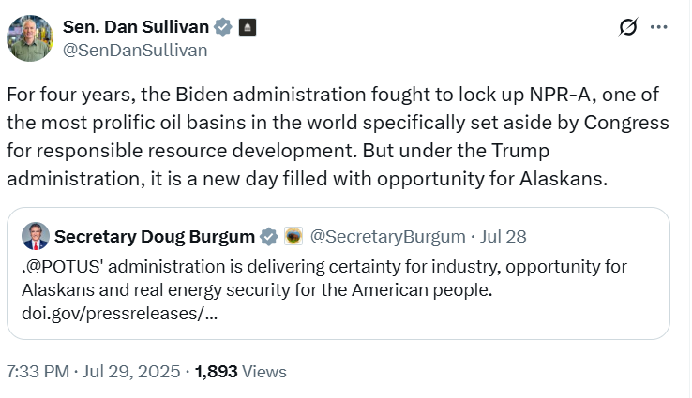
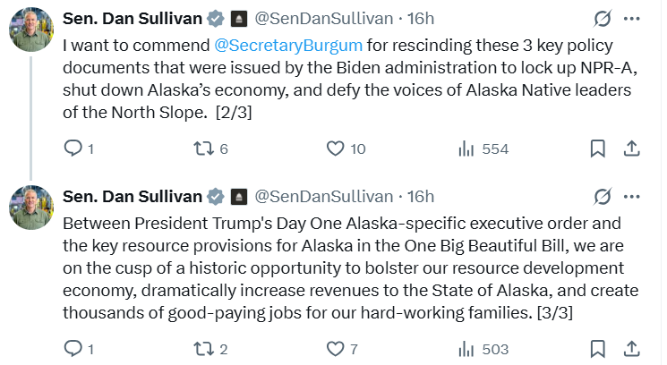
Sullivan Claimed “No State Fared Better” Than Alaska In The Reconciliation Bill And That Opening ANWR, The NPR-A, And Cook Inlet to Resource Development Would “[Generate] Billions Of Dollars In New Revenues” For Alaska. According to a press release by Senator Dan Sullivan, “‘This comprehensive legislation is the product of months of relentless, focused work on behalf of Alaskans—and it delivers significant wins for our state. I think it is safe to say, no state fared better from this bill,’ said Sen. Sullivan. ‘From Day One of these negotiations, which have been going on for months, I fought to ensure that Alaska wasn’t just included, but prioritized. An overriding focus of mine in shaping this legislation was ensuring it helps to unleash Alaska’s private sector economy for the benefit of our hard-working families and more job creation. The One Big Beautiful Bill works in concert with President Trump’s Day One, Alaska-specific executive order to unleash Alaska’s vast natural resource potential, restoring and establishing in law the first Trump administration’s mandate to unlock ANWR, NPR-A, and Cook Inlet for responsible resource development. These provisions are focused on creating good-paying jobs, generating billions of dollars in new revenues for the state, and putting Alaskans back in the driver’s seat of our economic future. Importantly, the historic resource development provisions cement regular lease sales into law for Alaska to guard against attempts by future Democratic administrations and Senate leaders to use regulatory powers to lock up our state and shut down our economy, as was done with President Biden’s 70 executive orders and actions targeting Alaska, what I called the ‘Last Frontier Lock-Up.’” [Press Release - Senator Dan Sullivan, 7/1/25]

Alaska Native Groups Opposed The Rescission Of The Rule
An Iñupiat-Aligned Group Said An Exploratory Drilling Program In The NPR-A Would Endanger Alaskan Natives’ Homelands, Unity, And Way Of Life. According to the Associated Press, “Nauri Simmonds, executive director of Sovereign Iñupiat for a Living Arctic, said the proposed exploration program is ‘not only an assault on caribou and tundra — it is another chapter in the enfoldment of our people into systems designed to fracture us from within.’ ‘Sovereign Iñupiat for a Living Arctic stands against this approval because our future depends on protecting our homelands, our unity, and our right to live free from the harms of industrial expansion,’ Simmonds said in a statement. The group describes itself online as ‘an organization of Iñupiat Peoples and community members that believe in a balanced Earth for future generations.’” [Associated Press, Accessed On 12/18/25]

