Overview
- Carter backed MAGA attacks on the judiciary.
  - Carter cosponsored Rep. Brandon Gill’s articles of impeachment against the Chief Judge of the D.C. District Court James Boasberg.
- Carter decried judicial authority and claimed that federal injunctions usurped Trump’s “mandate.”

Carter Supported Trump’s Attacks On American Democracy

Carter Backed MAGA Attacks On The Judiciary

Carter Cosponsored Rep. Brandon Gill’s Articles Of Impeachment Against The Chief Judge Of The D.C. District Court James Boasberg
[AUDIO] Carter Supported Congressman Gill’s Impeachment Effort And Wanted The Supreme Court To Decide Legal Questions Pertaining To The Executive Branch. “Now let's talk about those unelected activist judges. Yes, that's what Brandon Gill was here earlier, and we talked about it. He's got articles of impeachment against one of them. Uh, one of them up here in Washington, DC, and you're absolutely right, their whole intention is just to delay, delay, delay, stop Trump and just drag it out as long as they can. And that's why President Trump said, let's send it directly to the Supreme Court. Let them make the decision. Supreme Court is the ultimate decider, so just send it straight to them and cut out all these others who were unelected. That that is that that makes sense to me. And yes, we in Congress can do something about it. That's why Brandon Gill, who was here earlier, he is he has introduced these articles of impeachment. He went over some other things that we can do that hopefully we will do. But absolutely, that's what needs to be done.” [Carter Telephone Town Hall, 3/24/25]
Carter Alleged That Boasberg “Did Knowingly And Willfully Use His Judicial Position To Advance Political Gain” And Claimed That The Alien Enemies Act Gave The President “Sole And Unreviewable Discretion” To Determine Whether An “Invasion Has Taken Place.” According to Axios, “Rep. Brandon Gill (R-Texas) said Tuesday he is introducing articles of impeachment against Boasberg, arguing he ‘overstepped his authority, compromised the impartiality of the judiciary, and created a constitutional crisis.’ [...] Gill's four-page impeachment resolution charges Boasberg with abuse of power, arguing that he ‘did knowingly and willfully use his judicial position to advance political gain.’ It argues that the Alien Enemies Act gives the president ‘sole and unreviewable discretion’ to determine whether an ‘invasion has taken place’ — and thus whether its powerful emergency provisions can be exercised. Gill's measure is co-sponsored by Reps. Eli Crane (R-Ariz.), Buddy Carter (R-Ga.), Mike Collins (R-Ga.), Barry Moore (R-Ala.) and Andrew Clyde (R-Ga.).” [Axios, 3/18/25]
[AUDIO] Carter Claimed To Respect “The Separation Of Powers,” But In The Same Breath Claimed That “Judges Who Are Acting As Activists” Were Improperly “Legislating From The Bench,” And Finally Said Boasberg Was Biased Because He Was “Appointed By A Different Administration.” “Certainly, if you look at some of these some of these judges who are making these decisions, you see that they were appointed by a different administration. And you wonder if that is that has anything to do with it. I mean, you know, we're we're not that naive. I was born at night, but it wouldn't last night. So that that is a concern. And let me preface my remarks here by saying I couldn't agree with you more. I have a healthy respect for the separation of powers, and I do respect the judicial branch. And I think that they play an important role, just as I feel like the legislative and executive branch do. But, you know, some of these judges who are acting as is activists and. Yes. And just, you know, they're legislating from the bench. That's that's not the way that our system was intended to be. And that's what's happening here. A judge moved to halt the deportation of some Venezuelans that were that that we tried to get deported. And, you know, I actually I actually signed on to a to a resolution that that would articles of impeachment, as a matter of fact, against that judge.” [Martha Zoller Show, 3/18/25]
Carter Called Boasberg “Unconstitutional And Traitorous” And Declared That “Unelected District Court Judges Stopping A Duly Elected President From Protecting Our Homeland Is Wrong And I Won’t Tolerate It.” Congressman Buddy Carter tweeted, “Sign me up, @RepBrandonGill. Unelected District Court judges stopping a duly elected president from protecting our homeland is wrong and I won’t tolerate it. We must stop these unconstitutional and traitorous judges from imposing their will on people who never voted for them.” [Twitter, @RepBuddyCarter, 3/16/25]
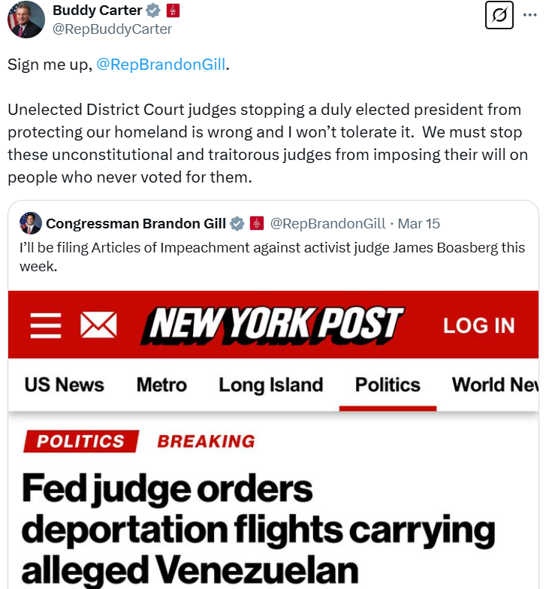
Carter Circulated A WinRed Fundraising “Petition” In Support Of Judge Boasberg’s Impeachment And Claimed That Boasberg Was “An Unelected District Court Judge” Who Was “Stopping A Duly Elected President From Protecting Our Homeland” Before Asking His Followers To Sign His WinRed “Petition.” Congressman Buddy Carter tweeted, “An unelected District Court judge is stopping a duly elected President from protecting our homeland. I won’t tolerate it. That’s why we’re filing IMMEDIATE articles of impeachment against this activist judge. Please join us ASAP by signing the petition: https://secure.winred.com/buddycarter/impeach-activist-judge” [Twitter, @Buddy_Carter, 3/18/25]
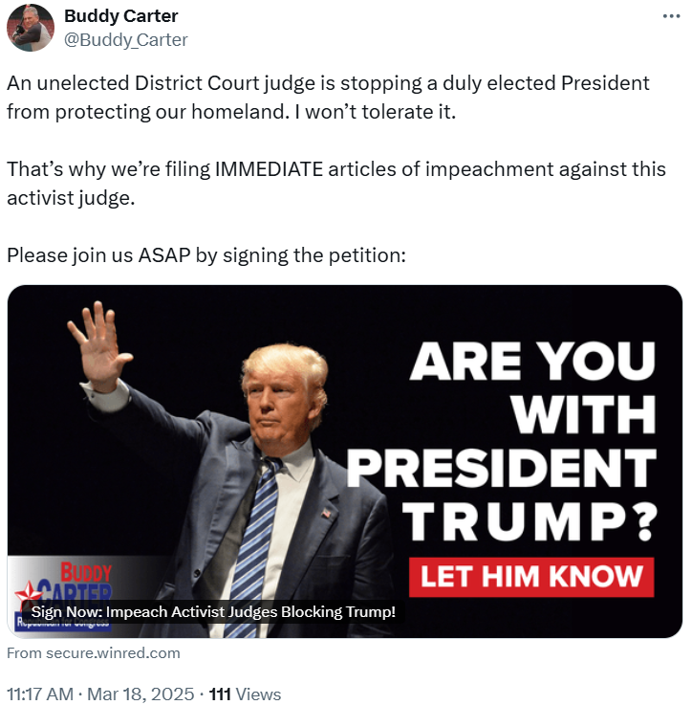

Carter Decried Judicial Authority And Claimed That Federal Injunctions Usurped Trump’s “Mandate”
[AUDIO] Carter Thought It Was “Ridiculous” For “A Circuit Court Judge Making These Kind Of Decisions And Blocking The President.” “It is ridiculous to have, with all due respect, to have a circuit court judge making these kind of decisions and blocking the president of the United States, who's under a clear mandate from the American people, overwhelmingly elected back in November and said what he was going to do. Now he's doing it. That's the difference between him and other presidents. He said what he was going to do, and he actually does it. If you look at everything that's happening, if you see that did that, he that the tariffs he’s enacting, if you see what the policies are, he said he was going to do this.” [Morning Xtra, 3/28/25]
[AUDIO] Carter Claimed The Judges Were “Legislating From The Bench” And Asked, “How Is President Trump Supposed To Enact His Agenda And Follow Through On The Promises He Made If We Got These Unelected, Unelected Activist Judges Allowed To Undo His Policy Decisions From The Bench.” “Well, thank you. I appreciate that. And let me ask you something. How is how is President Trump supposed to enact his agenda and follow through on the promises he made if we got these unelected, unelected activist judges allowed to undo his policy decisions from the bench, They're legislating from the bench, aren't they?” [Carter Telephone Town Hall, 3/24/25]
[AUDIO] Carter Bemoaned “Activist Juries And Justices And Judges That Are Trying To Block The Administration” And Wanted All Of Trump’s Legal Issues Decided By The Supreme Court. “And that is exactly what's happening with some of these activists’ drugs excuse me, some of these activist juries and justices and and judges that are trying to block the administration from doing that. That's why the president wants to bypass the lower courts and say, just let the Supreme Court tell me it's going to end up there anyway. And them tell me first and foremost, okay, this is right, or this is wrong. I can do this, or I can't do that. Instead of having an appeals court that overrules, the president says, no, you can't do that. And then it goes to the Supreme Court later on. This goes directly to the Supreme Court. That's what the problem is. And actually, there are some judges that there have been articles of impeachment filed against them by members of our conference, by members of Congress because of just that.” [Scott Ryfun Show, 3/20/25]

