Overview
Buddy Carter was an out-of-touch anti-abortion extremist who condemned the Supreme Court for upholding abortion pill access and attempted to block Planned Parenthood's federal funding. Carter previously led letters to the FDA, calling on the administration to restrict abortion pill access, and proposed legislation to codify pharmacists’ right to deny care to patients with abortion pill prescriptions.
Carter celebrated the overturning of Roe v. Wade, annually, and in Congress, Carter repeatedly backed “born-alive” legislation and supported a federal ban on abortions “20 weeks or more after conception.”
Carter supported fetal personhood, claimed abortion was “not health care,” and endorsed Georgia’s extreme ‘heartbeat bill.’ He supported opt-outs to allow medical professionals to refuse reproductive health care and voted to require parental abortion notifications regarding minors.
Carter claimed abortion was “murder,” that anti-abortion legislation “saved 2.5 million lives,” and voted to expand the definition of “feticide” to include any stage of pregnancy.

Carter Sought To Limit Abortion Pill Access

2023: Carter Decried The Supreme Court’s Decision To Uphold Mifepristone’s FDA Approval
Carter Was “Disappointed” With The Court’s Ruling And Claimed That The “Abortion-On-Demand Agenda Took Precedence Over Human Rights And The Integrity Of Our Health Care System.” Congressman Buddy Carter tweeted, “I am disappointed by today’s #SCOTUS ruling. We must continue to fight for the rights of the unborn and mothers, who are both endangered by the unsupervised use of Mifepristone for chemical abortions. Life at every stage is precious. Unfortunately, today the abortion-on-demand agenda took precedence over human rights and the integrity of our health care system, which is severely harming women and children by removing important guardrails on this drug.” [Twitter, @RepBuddyCarter, 4/21/23]
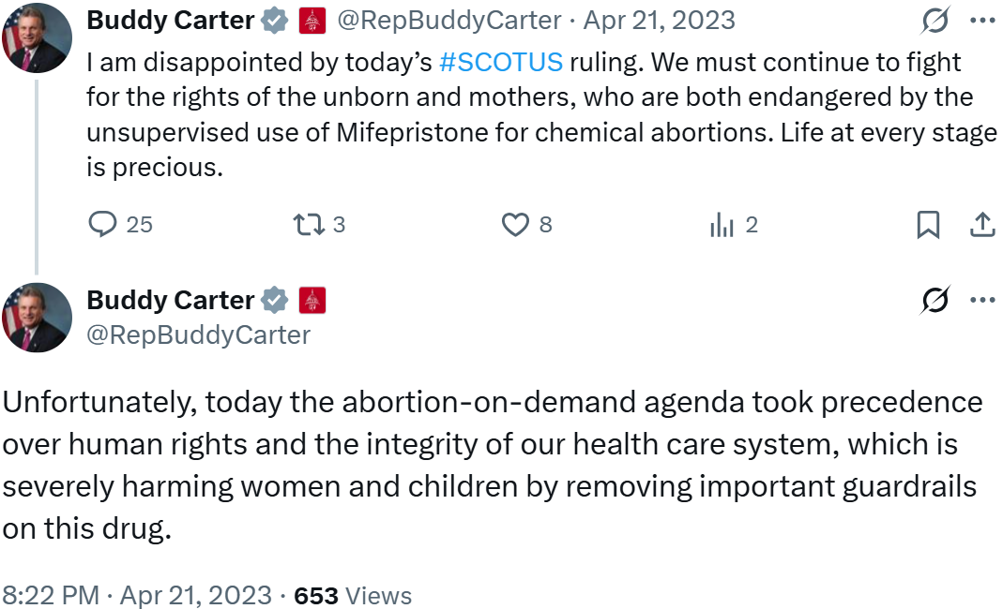
- April 2023: The Supreme Court Issued A Stay On The Texas Federal District Court’s Ruling Revoking Mifepristone’s FDA Approval Before They Dismissed The Case In June 2024. According to the Johns Hopkins, Bloomberg School of Public Health, “In November 2022, a group of anti-abortion medical professionals known as The Alliance for Hippocratic Medicine sued the FDA in a Texas federal district court over its approval in 2000 of the abortion drug mifepristone and actions to expand access to the drug. In early April 2023, the judge in that case ruled in agreement with the challengers and issued a preliminary injunction suspending the FDA’s approval of mifepristone and effectively halting its availability nationwide. Later that month, the U.S. Supreme Court issued a temporary order that allowed mifepristone to remain available for the duration of the appeals process. SCOTUS heard arguments in the case—FDA v. Alliance for Hippocratic Medicine—in March 2024 and issued their decision on June 13. In a unanimous opinion, SCOTUS dismissed the case on the basis that the plaintiffs who initiated the case did not have the necessary legal standing to bring this challenge in federal court in the first place.” [Johns Hopkins, Bloomberg School of Public Health, 7/3/24]

2023: Carter Led A Letter To The FDA Calling On The Administration To Restrict Abortion Pill Access
Carter Claimed That Greater Access To Mifepristone Posed “Significant Health Risks For Pregnant Women” And Declared That Expanded Access Would “Turn Many Post Offices And Pharmacies Into Abortion Clinics.” According to a press release from Representative Buddy Carter, “Earl L. ‘Buddy’ Carter (R-GA) today led a letter to the Food and Drug Administration (FDA), alongside 24 Republican members of Congress, calling on the administration to safeguard women and children’s health by rescinding its dangerous, problematic abortion pill regulations. The letter comes after FDA Commissioner Califf modified the Risk Evaluation and Mitigation Strategy (REMS) for mifepristone, allowing greater access to a drug used for elective chemical abortions. In the letter, the Members write: ‘In addition to killing her unborn baby, consuming mifepristone poses significant health risks for pregnant women…the FDA has sacrificed important safeguards against potential misuse and harm, jeopardizing the safety of patients.’ The Members continue: ‘Modifying the REMS to remove the in-person dispensing requirement will turn many post offices and pharmacies into abortion clinics. It is not in the best interest of patients, including the mother and unborn child. It shows a complete disregard for protecting mothers and unborn children that will result in more innocent lives lost.’” [Press Release – Representative Buddy Carter, 1/11/23]

2022: Carter Introduced Legislation Codifying Pharmacists’ Right To Deny Care To Patients With Abortion Pill Prescriptions
Carter Claimed That His Legislation Would “Protect Pharmacists' Conscience Rights When Choosing Whether To Fill Prescriptions For Elective Abortions.” According to a press release from Representative Buddy Carter, “Rep. Earl L. ‘Buddy’ Carter (R-GA), a pharmacist by trade, introduced a bill today alongside Reps. Diana Harshbarger (R-TN) and Blake Moore (R-UT) to protect pharmacists' conscience rights when choosing whether to fill prescriptions for elective abortions. The Pharmacist Conscience Protection Act, co-sponsored by 26 House Republicans, comes after the Department of Health and Human Services (HHS) issued guidance warning pharmacists that they may be in violation of federal civil rights laws if they do not fill such prescriptions. ‘Your first amendment rights don’t go away when you put on a white coat,’ said Rep. Carter. ‘This legislation will ensure that pharmacists are able to make the medical decisions that are best for the health of the mother, the life of the child, and the integrity of their practice without threats from non-medically trained bureaucrats. Medical decisions should be made between doctors, pharmacists, and patients - not the federal government.’” [Press Release – Representative Buddy Carter, 9/14/22]
- Carter: “There Is No Constitutional Right To An Abortion, And As Such, There Is No Constitutional Obligation For Pharmacists To Knowingly Dispense Drugs Intended For An Abortion.” According to a press release from Representative Buddy Carter, “Following the Department of Health and Human Services' memo warning pharmacists that failing to fill prescriptions for abortion pills will violate federal law, Rep. Earl L. ‘Buddy’ Carter (R-GA), a pharmacist by trade, sounded the alarm on this gross abuse of executive authority: ‘Bureaucrats should not infringe on a pharmacist’s ability to do their job. There is no constitutional right to an abortion, and as such, there is no constitutional obligation for pharmacists to knowingly dispense drugs intended for an abortion. This Administration has a habit of using health care professionals as political pawns, from vaccines to abortions, and that abuse must come to an end.’” [Press Release – Representative Buddy Carter, 7/14/22]

Carter Repeatedly Backed “Born-Alive” Legislation

Carter Supported The “Bring The Born-Alive Abortion Survivor Protection Act”
2021: Carter Called On Nancy Pelosi To “Bring The Born-Alive Abortion Survivor Protection Act To The House Floor To Help End Infanticide Once And For All.” Congressman Buddy Carter tweeted, “As a father and grandfather, I know there is no greater blessing than the birth of a child. Nancy Pelosi needs to bring the Born-Alive Abortion Survivor Protection Act to the House Floor to help end infanticide once and for all.” [Twitter, @RepBuddyCarter, 5/3/21]
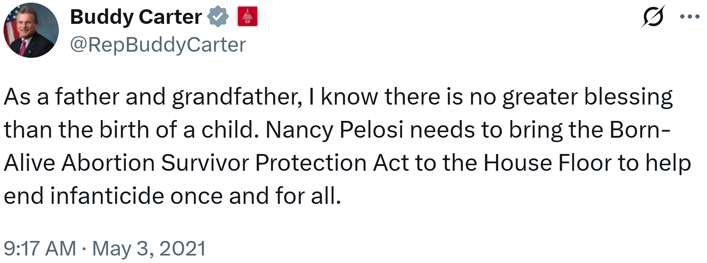
- Carter Joined Representative Kat Cammack’s Petition To Force A Vote On The Legislation “To Protect All Precious Newborn Babies.” Congressman Buddy Carter tweeted, “I'm proud to sign @RepKatCammack's petition to force a vote on the Born Alive Abortion Survivors Protection Act. Congress must stand together to protect all precious newborn babies.” [Twitter, @RepBuddyCarter, 4/14/21]
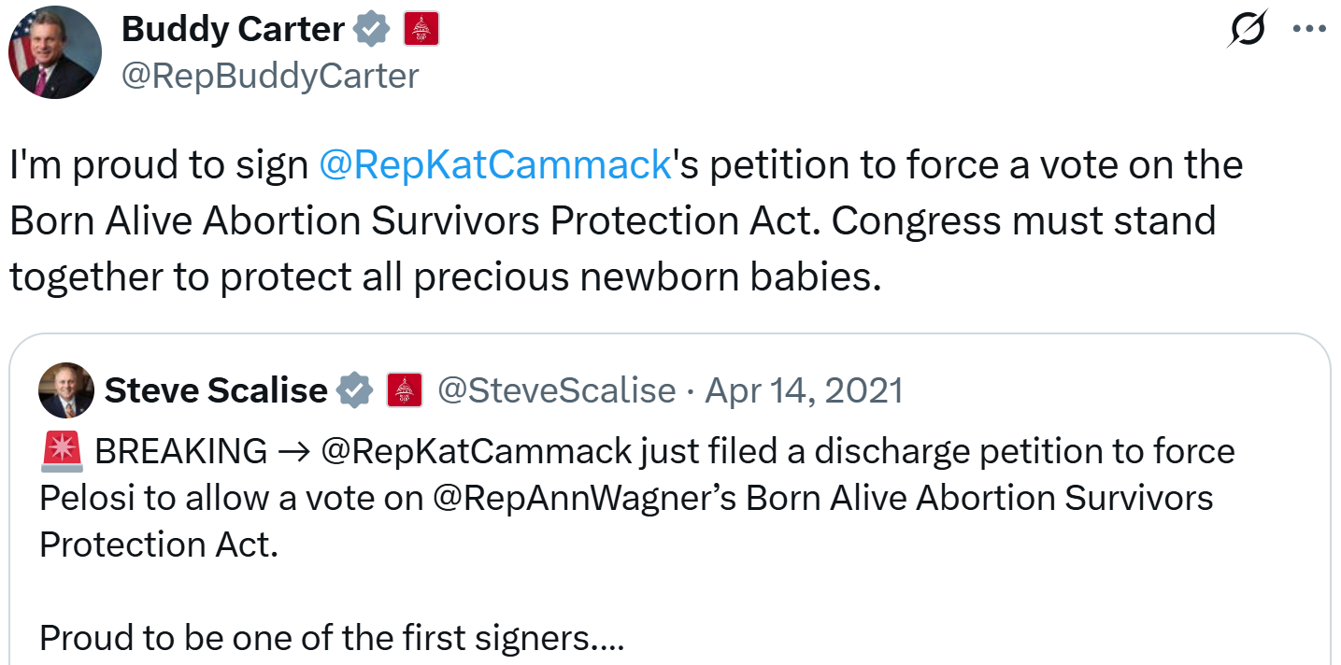
2019: Carter Claimed That The Born-Alive Abortion Survivors Protection Act “Ensures Protection Of Babies Born Alive During Attempted Abortions.” Congressman Buddy Carter tweeted, “The Born-Alive Abortion Survivors Protection Act ensures protection of babies born alive during attempted abortions. Unfortunately, House Democrats refuse to bring this legislation to the House Floor for a vote and even denied us a hearing room to discuss the bill today.” [Twitter, @RepBuddyCarter, 9/10/19]
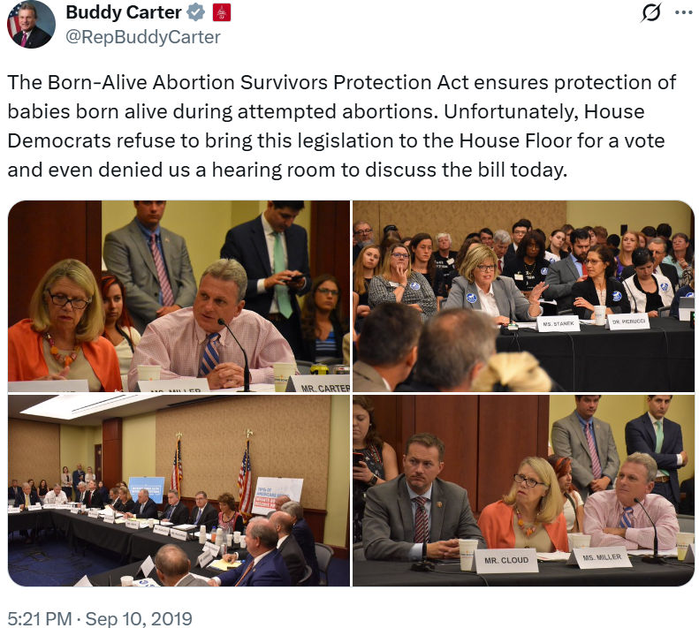

Carter Celebrated The Overturning Of Roe V. Wade

Carter Celebrated The Supreme Court’s Overturning Roe V. Wade
Carter: “The Heartbeats Heard In Ultrasound Appointments Have Now Been Heard By The Supreme Court, And We Finally Have A Nation That Honors The Humanity Of Unborn Children.” According to a press release from Representative Buddy Carter, “Rep. Earl L. “Buddy” Carter (R-GA) reacted to today’s landmark Supreme Court ruling in Dobbs vs. Jackson Women’s Health Organization, overturning the federal abortion protections in Roe v. Wade and Casey v. Planned Parenthood in favor of states’ rights: ‘Millions of children have been silent victims of a decades-long siege on their right to life. The heartbeats heard in ultrasound appointments have now been heard by the Supreme Court, and we finally have a nation that honors the humanity of unborn children,’ said Carter.” [Press Release – Representative Buddy Carter, 6/24/22]
Carter Claimed That “More Than 56 Million Innocent Babies Have Been Denied The Right To Life Since The Tragic And Injudicious Supreme Court Decision In Roe V. Wade.” According to Representative Buddy Carter’s website, “More than 56 million innocent babies have been denied the right to life since the tragic and injudicious Supreme Court decision in Roe v. Wade more than forty years ago.” [Representative Buddy Carter, Issues, Protecting Life, Accessed 6/2/25]

Carter Celebrated The Third Anniversary Of The Overturning Of Roe V. Wade
Carter Claimed That The Dobbs Decision Reaffirmed “Unborn Children’s Right To Life.” Congressman Buddy Carter tweeted, “Today marks the 3rd anniversary of the landmark Dobbs decision, overturning Roe v. Wade and reaffirming unborn children’s right to LIFE. 💜” [Twitter, @RepBuddyCarter, 6/24/25]
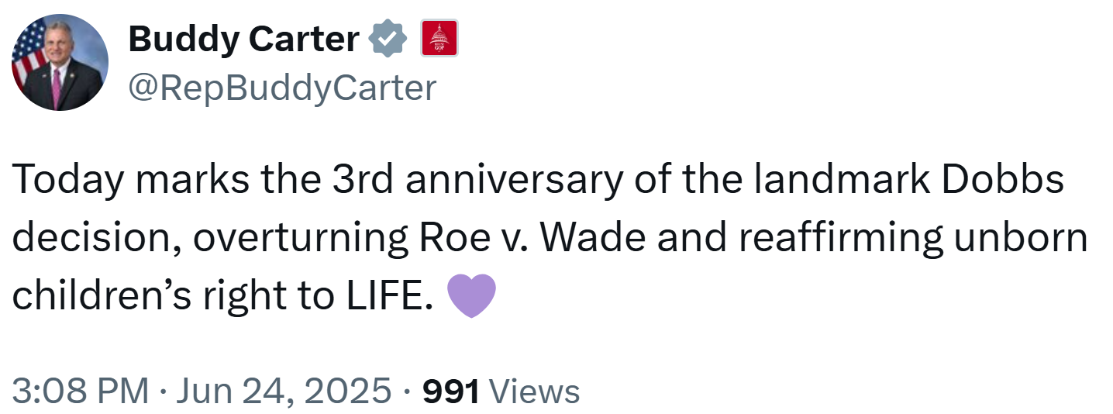

Carter Supported Fetal Personhood

Carter Believed That Life Began At Conception
Carter: “We Followed The Science, And It Led Us To Know, Beyond A Shadow Of A Doubt, That Life Begins At Conception.” According to a press release from Representative Buddy Carter, “Said Carter. ‘We followed the science, and it led us to know, beyond a shadow of a doubt, that life begins at conception. The same unborn children that can feel pain in the womb will one day feel immense joy knowing that their life was valued from day one.’” [Press Release – Representative Buddy Carter, 6/24/22]
[VIDEO] Carter Opposed Abortion “Because Every Human Life Is Precious And Deserves Protections At All Stages Of Development.” “I'm Congressman Buddy Carter. And I'm proud to say that I'm pro-life. I'm pro-life because every human life is precious and deserves protections at all stages of development. I'm pro-life because there's no greater joy in the world watching your children and grandchildren grow, learn and thrive. I'm pro-life so that mothers have the support, quality, health care, resources necessary to safely delivering care for their child.” [Buddy Carter Social Media Video, 1/24/25]

Carter Called For “Permanent Federal Legislation To Protect The Sanctity Of Human Life From Conception”
Carter Called For “Permanent Federal Legislation To Protect The Sanctity Of Human Life From Conception” And Declared That He Looked Forward To “The Day We Can Finally Protect Innocent Lives At Any Stage Of Gestation.” According to a press release from Representative Buddy Carter, “Congressman Earl L. ‘Buddy’ Carter (GA-01) voted today to extend protections for the unborn. [...] ‘This is a great win in the fight to stand up for those who cannot stand up for themselves, but it does not end here. It's past time to pass permanent federal legislation to protect the sanctity of human life from conception and I look forward to the day we can finally protect innocent lives at any stage of gestation.’” [Press Release – Representative Buddy Carter, 10/3/17]
Carter Was “A Proud Cosponsor Of The Sanctity Of Human Life Act, Which Protects Life From Conception With No Exceptions.” According to Representative Buddy Carter’s website, “As a healthcare professional, father, grandfather and Congressman, I strongly believe life starts at conception and support the sanctity of human life. [...] It’s time for the United States Congress to stand up for those who cannot stand up for themselves and pass permanent federal legislation that will protect the most innocent of lives. I am a proud cosponsor of the Sanctity of Human Life Act, which protects life from conception with no exceptions” [Representative Buddy Carter, Issues, Protecting Life, Accessed 6/2/25]

Carter Claimed That Abortion Was “Murder”
Carter Asked His Followers To Retweet His Post If They Agreed With Him That, “Abortion Is Murder.” Congressman Buddy Carter tweeted, “RT if you agree ➡️ abortion is murder” [Twitter, @RepBuddyCarter, 12/1/21]
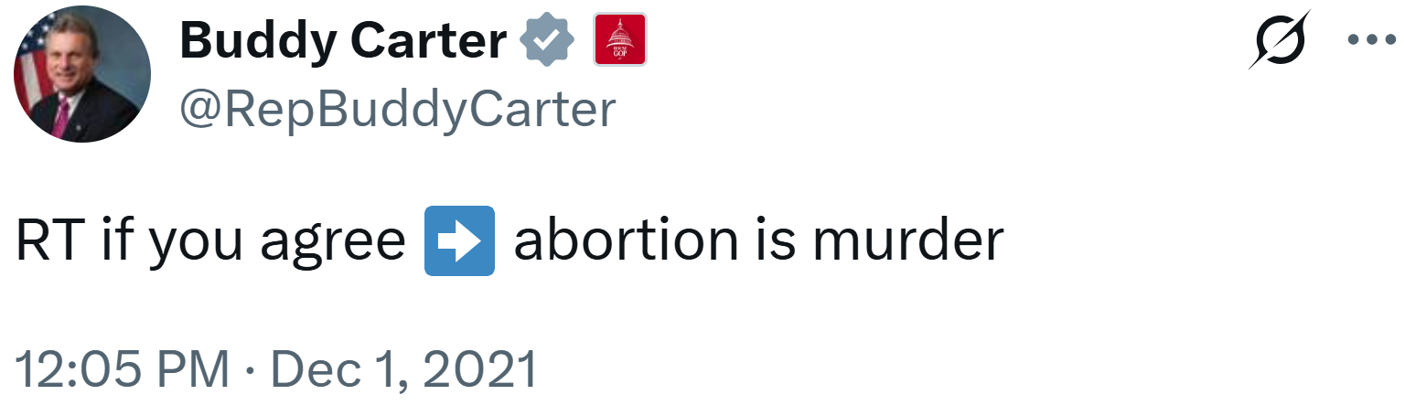
Carter Declared That, “Abortion = Murder,” And Claimed That The Hyde Amendment “Saved Nearly 2.5 Million Lives.” Congressman Buddy Carter tweeted, “Abortion = murder. Democrats want to get rid of the Hyde Amendment so they can force you to pay for the murders of our unborn. It’s disgusting, and I will fight their efforts to do this all the way. #HydeSavesLives” [Twitter, @Buddy_Carter, 7/15/21]
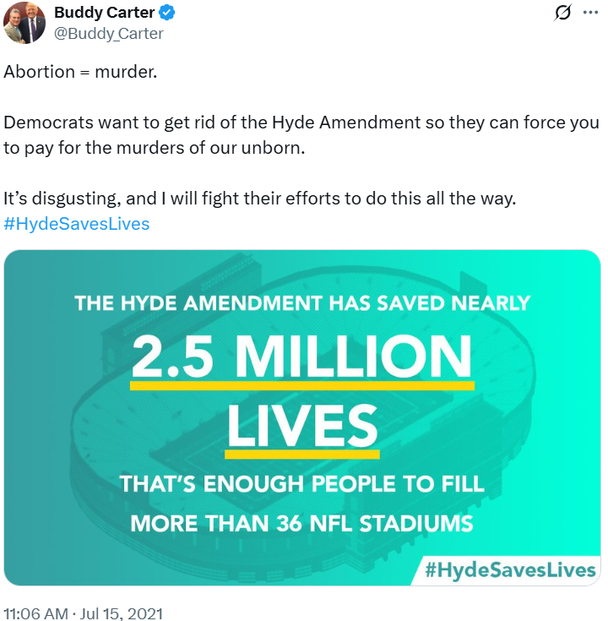

Carter Voted To Expand The Definition Of “Feticide” To Include Any Stage Of Pregnancy
2006: Carter Voted To Expand The Definition Of “Feticide” To Include Any Stage Of Pregnancy. In March 2006, Carter voted for Senate Bill 77. The bill, according to the Atlanta Journal-Constitution, “[established] penalties for killing an unborn child at any stage of pregnancy.” The House passed the bill by a vote of 155 to 0 and it became law. [Georgia Legislature, SB 77; Atlanta Journal-Constitution, 4/3/06]
- Opponents Of The Bill Argued It Would Undermine Roe V. Wade. According to the Atlanta Journal-Constitution, “And Becky Rafter, executive director of NARAL Pro-Choice Georgia, said that while she is happy that the ultrasound proposal did not pass this year, she has grave concerns about Senate Bill 77, the feticide measure. ‘The main problem, of course, is that it is undermining Roe v. Wade,’ Rafter said. ‘This bill is setting the groundwork for setting the next legislation session where conservative forces will be able to build on that to pass more heinous legislation, like the one in South Dakota.’” [Atlanta Journal-Constitution, 4/3/06]

Carter Wanted To Restrict Access To Reproductive Health Care

Carter Backed A Federal Ban On Abortions “20 Weeks Or More After Conception”
Carter Touted His “Proud” Support For The Pain-Capable Unborn Child Protection Act, “To Put A Necessary End To The Excruciating Abortion Methods Used In Late Term Pregnancies.” According to a press release from Representative Buddy Carter, “Congressman Earl L. ‘Buddy’ Carter (GA-01) voted today to extend protections for the unborn. ‘There is overwhelming scientific evidence proving that precious babies are capable of feeling pain after 20 weeks,’ said Carter. ‘As a health care professional, father, grandfather, and Congressman, I am proud to support this legislation today to put a necessary end to the excruciating abortion methods used in late term pregnancies. This is a great win in the fight to stand up for those who cannot stand up for themselves, but it does not end here. It's past time to pass permanent federal legislation to protect the sanctity of human life from conception and I look forward to the day we can finally protect innocent lives at any stage of gestation.’ The Pain-Capable Unborn Child Protection Act, which passed the House today with Carter's support, would ban abortions nationwide 20 weeks or more after conception except in cases of rape or incest or to save the life of the mother. Carter is a cosponsor of the legislation.” [Press Release – Representative Buddy Carter, 10/3/17]

Carter Urged Congress To Oppose The Federal Freedom Of Choice Act
2009: Carter Voted To Urge Congress To Oppose The Federal Freedom Of Choice Act. In March 2009, Carter voted for House Resolution 334. The resolution, according to the Georgia Legislature, “urg[ed] the Congress of the United States to oppose the Freedom of Choice Act.” The House adopted the resolution by a vote of 92 to 55. [Georgia Legislature, H.R. 334]

Carter Supported Georgia’s Heartbeat Law

Carter Claimed He Was “Unapologetically Pro-Life” And Supported Georgia’s Heartbeat Law
[AUDIO] Carter: “I'm Pro-Life There's No Question About That. I've Been Pro-Life Ever Since I Started This Gig And Was Pro-Life In The In The Georgia State Legislature. And I Remain Unapologetically Pro-Life. However, The Supreme Court Has Ruled This Is A State Issue.” “HOST: Do you support federal restrictions on the procedure on abortion? CARTER: I think the Supreme Court has ruled on that. And there's no need to second guess the Supreme Court on this. They've ruled on it. Look, I'm pro-life there's no question about that. I've been pro-life ever since I started this gig and was pro-life in the in the Georgia state legislature. And I remain unapologetically pro-life. However, the Supreme Court has ruled this is a state issue. And, you know, look, if I had been in the state legislature back when the heartbeat bill was being voted on, I would have voted for it.” [Politically Georgia, 9/3/25]

Carter Supported Georgia’s Heartbeat Law
[AUDIO] Carter “Absolutely” Supported Georgia’s ‘Heartbeat Law.’ “HOST: So, you support the 2019 law that Kemp signed into effect that restricts most abortions around six weeks? CARTER: Absolutely.” [Politically Georgia, 9/3/25]

Georgia’s Heartbeat Law Banned Abortions After Six Weeks Of Pregnancy
Georgia’s Heartbeat Law Banned Abortions After Six Weeks Of Pregnancy. According to NPR, “The Georgia Supreme Court Wednesday reinstated the state's ban on abortions after roughly six weeks of pregnancy, abruptly ending access to later abortions that had resumed days earlier. In a one-page order, the justices put a lower court ruling overturning the ban on hold while they consider an appeal. Abortion providers who had resumed performing the procedure past six weeks again had to stop. Attorneys and advocates who pushed to overturn the ban said the abrupt halt will traumatize women who must now arrange travel to other states for an abortion or keep their pregnancies.” [NPR, 11/23/22]

Carter Backed The Georgia Legislature’s Past Attempts To Restrict Reproductive Healthcare

Carter Backed State-Level Legislation To Ban Abortion Coverage For State Run Health Insurance Plans
2014: Carter Voted To Ban Coverage Of Abortions Under State Run Health Insurance Plans. In March 2014, Carter cosponsored and voted for Senate Bill 98. The bill, according to the Augusta Chronicle, “would ban coverage of abortion services in health insurance plans offered by the state and by the federal health insurance exchange, according to the bill's sponsor, Sen. Judson Hill, R-Marietta. He said the goal is to prevent the use of state and federal taxes to pay for abortions. Deal last year worked with DCH to eliminate coverage of abortion in the state employee health plan. SB 98 would codify the ban, Hill said. Georgia, like a number of other states, has opted to let the federal government run its exchange under the ACA. Individuals who sign up for coverage are eligible for federal subsidies. SB 98 is aimed at preventing the application of those subsidies for coverage of abortion services.” [Georgia Legislature, SB 98; Augusta Chronicle, 2/21/14]

Carter Backed State-Level Legislation Mandating Pre-Abortion Ultrasounds And A 24-Hour Waiting Period
2007: Carter Voted To Require Abortion Providers To Conduct Ultrasounds On Patients Prior To Performing An Abortion And Give The Opportunity To The Patient To View The Ultrasound. In April 2007, Carter voted for House Bill 147. The bill, according to the Georgia Legislature, “require[d] physicians or other qualified agents to require that pregnant females undergo an ultrasound or sonogram prior to having an abortion. [...] The woman shall at the conclusion of the ultrasound be offered the opportunity to view the fetal image and hear the fetal heartbeat.” The House passed the bill by a vote of 110 to 47 and it was ultimately signed into law. [Georgia Legislature, HB 147]
2005: Carter Voted To Require Patients Seeking An Abortion To Wait 24 Hours After Having The Risks Of An Abortion, The Gestational Age Of The Fetus, Fetal Pain, And Alternatives To Abortion Explained To Them By A Doctor. In March 2005, Carter voted for House Bill 197. The bill, according to the Atlanta Journal-Constitution, “would require physicians to offer women seeking an abortion information on the medical risks associated with abortion, the probable gestational age of the fetus, fetal pain, and alternatives to abortion, including adoption. It would require women to wait 24 hours after receiving that information.” The House passed the bill by a vote of 139 to 35 and it was ultimately signed into law. [Georgia Legislature, HB 197; Atlanta Journal-Constitution, 3/3/05]

Carter Decried Federal Funding For Planned Parenthood And Abortion Care

Carter Declared That Planned Parenthood “Should Not Be Getting One Red Cent A Year. They Should Not Be Getting Anything”
[VIDEO] Carter Declared That Planned Parenthood “Should Not Be Getting One Red Cent A Year. They Should Not Be Getting Anything.” “HOST: Planned Parenthood should not be getting $800 million a year in taxpayer money to to take the lives of 400,000 babies. CARTER: They should not be getting one red cent a year. They should not be getting anything.” [Washington Watch with Tony Perkins, 5/14/25]
Carter Declared That “Under No Circumstances Should American Taxpayers Be Responsible For Footing The Bill For Ending A Precious Life Before It Begins” And Supported “Banning All Federal Funding For Abortions.” According to Representative Buddy Carter’s website, “Under no circumstances should American taxpayers be responsible for footing the bill for ending a precious life before it begins. However, thanks to Obamacare, some Americans could end up paying for abortion services, possibly without their knowledge. I support banning all federal funding for abortions and have supported legislation to prevent this.” [Representative Buddy Carter, Issues, Protecting Life, Accessed 6/2/25]

Carter Introduced Legislation Prohibiting Federal Funding For Transportation To Abortion Care
Carter Declared That He Was “100% Pro-Life” And Touted His Bill To “Prohibit Federal Funding From Being Used For Transportation To Get An Abortion.” Congressman Buddy Carter tweeted, “I am 100% pro-life. My latest bill would prohibit federal funding from being used for transportation to get an abortion. Are you with me?” [Twitter, @Buddy_Carter, 8/5/22]
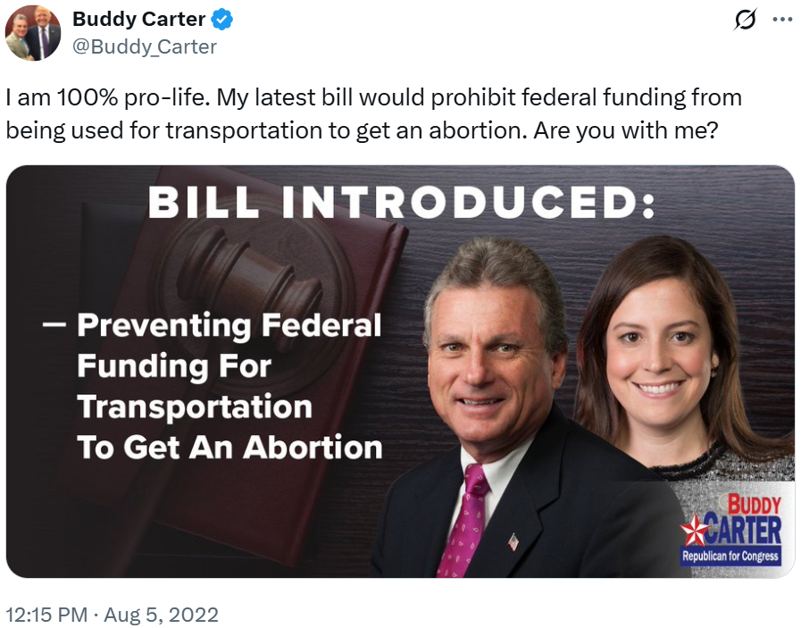

Carter Claimed Abortion Was “Not Health Care”

Carter Repeatedly Declared, “Abortion Is Not Health Care”
Carter Quote Tweeted His Support For Removing Planned Parenthood As A Medicaid Provider And Declared That, “Abortion Is Not Health Care!” Congressman Buddy Carter tweeted, “Abortion is not health care!” [Twitter, @RepBuddyCarter, 5/17/22]
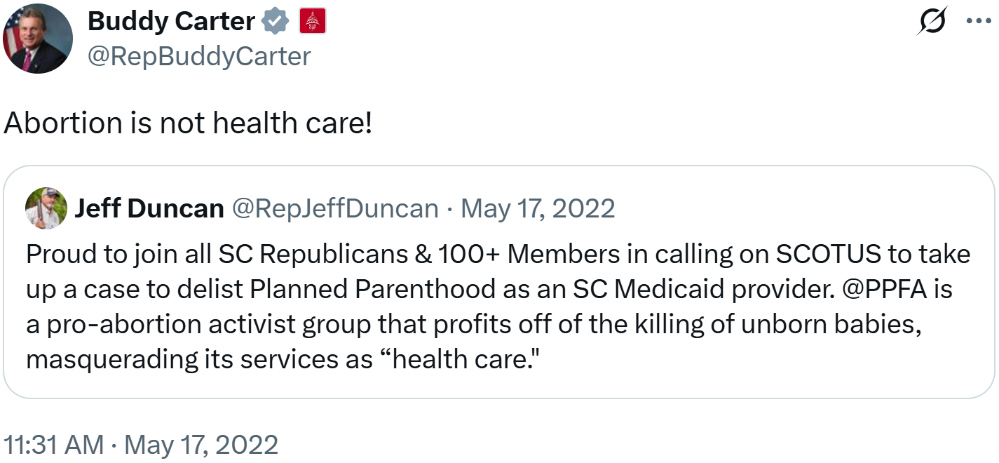
Carter Shared A Video Of His Speech On The House Floor “To Defend The Unborn” And Declared That, “Abortion Is NOT Health Care.” Congressman Buddy Carter tweeted, “Abortion is NOT health care. Pass it on.” [Twitter, @RepBuddyCarter, 12/1/21]
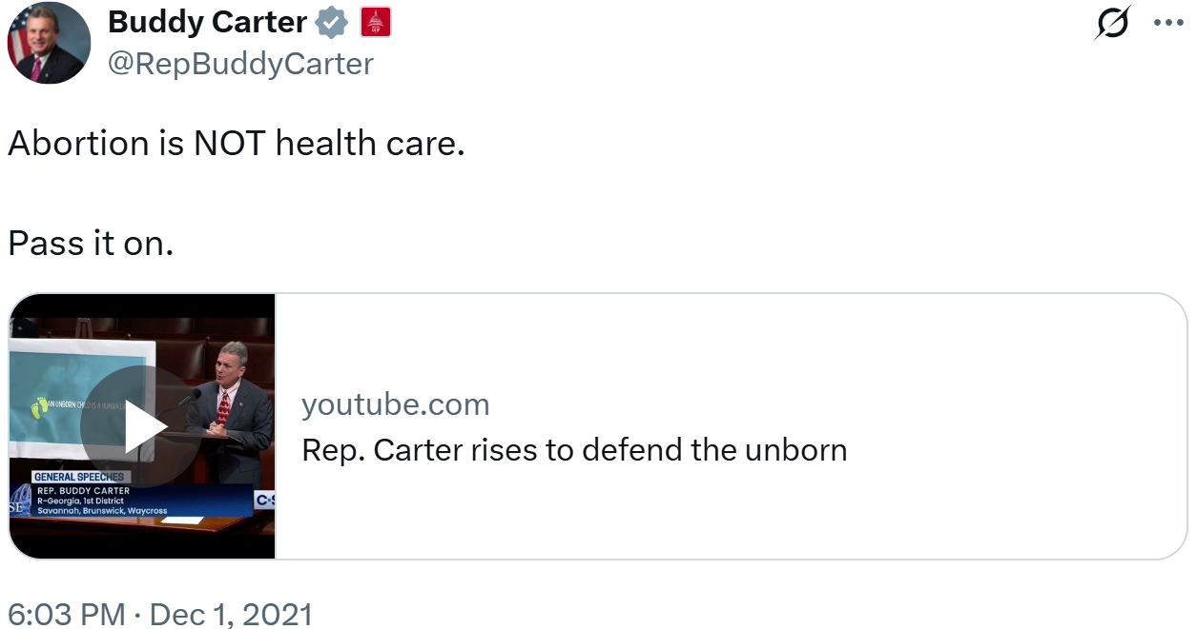

Carter Supported Opt-Outs To Allow Medical Professionals To Refuse Reproductive Health Care
[VIDEO] Carter: “As A Pharmacist, I Know How Important It Is That No Health Care Professional Be Forced To Provide Care That Is Not In The Best Interest Of The Mother And Child Or That Runs Contrary To Their Religious Beliefs.” “I'm also pro-life because as a pharmacist, I know how important it is that no health care professional be forced to provide care that is not in the best interest of the mother and child or that runs contrary to their religious beliefs. Today and every day I stand with the brave men, women and unborn children who know that every child deserves the opportunity to live a happy and fulfilling life.” [Buddy Carter Social Media Video, 1/24/25]

Carter Voted To Require Parental Abortion Notifications Regarding Minors
2005: Carter Voted To Remove An Existing Provision That Allowed Grandparents Or Other Adults Providing Care To Receive Abortion Notifications Regarding Minors Rather Than The Official Parent Or Guardian. In March 2005, Carter voted for House Bill 197. The bill, according to the Atlanta Journal-Constitution, “[took] out a provision in Georgia law that allows someone other than a parent or legal guardian --- such as a grandparent or other relative caring for the child --- to be the one notified when a minor seeks an abortion.” The House passed the bill by a vote of 139 to 35 and it was ultimately signed into law. [Georgia Legislature, HB 197; Atlanta Journal-Constitution, 3/3/05]

