Overview
In 2025, Tiffany voted for a bill that is estimated to kick 17 million Americans off their health insurance, including nearly 12 million Americans who rely on Medicaid. More than 258,00 Wisconsinites could lose their health insurance as a result of Tiffany’s vote.
Tom Tiffany called the Affordable Care Act a “problem” despite having more than 313,000 Wisconsinites enrolled in Affordable Care Act Marketplace health insurance plans. By 2034, 148,254 Medicaid recipients in Wisconsin were expected to lose their coverage due to Tiffany’s support for Trump’s tax bill.
In January 2026, Tiffany voted against extending the Affordable Care Act subsidies for three years, despite the Wisconsin Insurance Commissioner warning that the expired enhanced subsidies would increase premium costs from 30% to 800% under silver plans during the ACA’s 2026 open enrollment period. In December 2025, Tiffany voted for Republicans’ health care bill which would weaken protections for people with pre-existing conditions and allowed ACA tax credits to expire. Tiffany did not sign multiple discharge positions aimed at extending premium ACA tax credits. Tiffany’s and Republicans’ inaction over ACA subsidies created a “subsidy cliff” whereby households could lose all eligibility for assistance if they earn even $1 more than a specified income threshold. In 2025, Tiffany claimed the ACA subsidies meant the Affordable Care Act was a “real problem.”

Tiffany Voted To Take Health Insurance Away From Millions Of Americans Who Relied On Medicaid

Tiffany Voted For The “One Big Beautiful Bill,” Which Included Devastating Health Care Cuts To Fund Tax Cuts For The Wealthy

July 2025: Tiffany Voted For The Final Version Of The “One Big Beautiful Bill,” Which Would Cause 17 Million Americans To Lose Their Health Care
July 2025: Tiffany Voted For The Senate FY 2025 Budget Reconciliation Bill, The “One Big Beautiful Bill,” Which Extended $4 Trillion In Expiring Tax Cuts, Added New Tax Breaks, Appropriated $448 Billion In Defense, Border, And Immigration Enforcement Funding, Increased The SALT Deduction To $40,000, And Cut Medicaid And Other Social Programs To Offset The Costs. In July 2025, Tom Tiffany voted for, according to Congressional Quarterly, the “motion to concur in the Senate amendment to the bill that would permanently extend nearly $4 trillion in expiring individual and business tax cuts, create several new tax breaks and fund border and immigration enforcement and air traffic control upgrades. It would cut Medicaid and other safety net programs to partly offset the cost. Among other provisions, it would raise the statutory debt ceiling by $5 trillion and appropriate more than $448 billion in mandatory funding for Trump administration priorities and other needs, including $153 billion for defense, $89 billion for immigration enforcement, and $89.5 billion for border control and security. It also would increase the Wisconsin and local tax deduction cap to $40,000 annually for five years for households making up to $500,000 a year until 2030, when it would permanently revert to $10,000.” The House passed the bill by a vote of 218 to 214. The bill was ultimately signed into law. [House Vote 190, 7/3/25; Congressional Quarterly, 7/3/25; Congressional Actions, H.R. 1]
- HEADLINE: "At Least 17 Million Americans Would Lose Insurance Under Trump Plan" [Washington Post, 7/1/25]
- HEADLINE: “By The Numbers: Harmful Republican Megabill Favors The Wealthy And Leaves Millions Of Working Families Behind” [Center On Budget And Policy Priorities, 8/1/25]
- The Congressional Budget Office Estimated That 11.8 Million People Would Become Uninsured As A Result Of The Medicaid Cuts In Republicans’ Reconciliation Bill. According to the Washington Post, "The bill, which narrowly passed the Senate on Tuesday and now heads back to the House, would effectively accomplish what Republicans have long failed to do: unwind many of the key components of the ACA, President Barack Obama’s signature domestic achievement, which dramatically increased the number of Americans with access to health insurance. To start, the Congressional Budget Office estimated that the Senate version of the bill would result in 11.8 million more uninsured in 2034, mostly because of Medicaid cuts, compared with 10.9 million if the House version became law." [Washington Post, 7/1/25]
- The Bill’s $50 Billion In Rural Hospital Relief Funding Would Not Come Close To The Gap Created By Medicaid Cuts, With 300 Rural Hospitals At “Immediate Risk” Of Closure. According to the Center For American Progress, “The OBBBA includes $50 billion in relief funding for rural hospitals over a five-year period to help reduce the disastrous impacts of the bill’s roughly $1 trillion in Medicaid cuts. As of May 2025, there were approximately 2,086 rural hospitals receiving $12.2 billion a year in net revenue from Medicaid. At the median, rural hospitals’ revenue from Medicaid is $3.9 million a year.Rural hospitals have some of the lowest operating margins in the nation, especially compared with urban hospitals, meaning that any reductions in revenue could lead to closures. The average operating margin for rural hospitals was 3.1 percent in 2023, with 44 percent of rural hospitals operating with negative margins. As a result, more than 300 rural hospitals are currently at ‘immediate risk’ of closure, especially now that the OBBBA is projected to cut Medicaid spending by $1.02 trillion. The relief fund designed to blunt the negative impacts caused by the bill would not come close to filling that gap. If every rural hospital in the country received an even share of the $50 billion in relief support, it would amount to only $4.5 million every year for five years. At the close of those five years, that funding would disappear altogether.” [Center For American Progress, 7/3/25]

More Than 258,000 Wisconsinites Were Expected To Lose Health Care Coverage Under Trump’s “One Big Beautiful Bill”
Under The “One Big Beautiful Bill,” 258,454 Wisconsinites Were Expected To Lose Their Health Care By 2034, Including 110,200 ACA Enrollees And 148,254 Medicaid Recipients. According to the Joint Economic Committee Minority,
District | Wisconsin | Est. # Losing ACA Coverage | Est. # Losing Medicaid Coverage | Est. Total # Losing Insurance
WI-01 | Wisconsin | 12,400 | 19,939 | 32,339
WI-02 | Wisconsin | 12,400 | 12,366 | 24,766
WI-03 | Wisconsin | 13,600 | 19,069 | 32,669
WI-04 | Wisconsin | 13,200 | 32,348 | 45,548
WI-05 | Wisconsin | 12,800 | 10,576 | 23,376
WI-06 | Wisconsin | 13,600 | 16,545 | 30,145
WI-07 | Wisconsin | 16,900 | 18,814 | 35,714
WI-08 | Wisconsin | 15,300 | 18,597 | 33,897
All | Totals | 110,200 | 148,254 | 258,454

[Joint Economic Committee Minority, 6/25]

May 2025: Tiffany Voted For The House FY 2025 Budget Reconciliation Bill, Which Was Estimated To Increase The Uninsured Population By 8.6 Million By 2034
May 2025: Tiffany Voted For The House FY 2025 Budget Reconciliation Bill, Which Included $3.8 Trillion In Tax Cuts Offset By $1.5 Trillion In Spending Reductions To Programs Like Medicaid And The Supplemental Nutrition Assistance Program. In May 2025, Tom Tiffany voted for, according to Congressional Quarterly, “the bill that would provide for approximately $3.8 trillion in net tax cuts and $321 billion in military, border enforcement and judiciary spending, offset by $1.5 trillion in spending reductions, as instructed in the fiscal 2025 budget resolution. It would raise the statutory debt limit by $4 trillion and provide for increased spending on defense and border security, spending cuts on social safety net programs, such as Medicaid and the Supplemental Nutrition Assistance Program. It also includes a mix of tax breaks for businesses and individuals; tax increases on universities and foundations; and a phase-down of clean energy tax credits. […] It would reduce federal spending on the Supplemental Nutrition Assistance Program by requiring States to shoulder more of the cost, expand work requirements for SNAP, extend programs authorized under the 2018 farm bill, and prohibit the U.S. Department of Agriculture from increasing the cost of the Thrifty Food Program. As amended, it would cap Wisconsin and local tax deductions at $40,000 for households with incomes below $500,000.” The House passed the bill by a vote of 215 to 214. [House Vote 145, 5/22/25; Congressional Quarterly, 5/22/25; Congressional Actions, H.R. 1]
- The House GOP Budget Bill Was Estimated To Increase The Uninsured Population By 8.6 Million By 2034. According to CNN, “The Medicaid and Affordable Care Act provisions in the package could result in 8.6 million more people being uninsured in 2034, according to an early CBO estimate released by Democratic lawmakers. That number is expected to grow with the latest changes.” [CNN, 5/28/25]
- The House GOP Budget Bill Codified A Trump Administration Proposal That Restricted Access To The Affordable Care Act. According to CNN, “The bill also calls for codifying a Trump administration proposal that would make changes to the Affordable Care Act enrollment process, including shortening the open enrollment period and eliminating the ability of low-income Americans to sign up year-round.” [CNN, 5/28/25]
- The House GOP Budget Bill Made The 2017 Income Tax Breaks Permanent And Added An Estimated $3.8 Trillion To The National Debt Over 10 Years. According to CNN, “The package includes several controversial measures that would deeply cut into two of the nation’s key safety net programs – Medicaid and food stamps – while making permanent essentially all of the trillions of dollars of individual income tax breaks contained in the GOP’s 2017 Tax Cuts and Jobs Act. What’s more, it would fulfill Trump’s campaign promises to cut taxes on tips and overtime, albeit temporarily. The magnitude of the measures is evident in the estimates of the cost they would incur or the savings they would produce. […] The tax changes in the package would add $3.8 trillion to the nation’s debt over a decade, according to a Congressional Budget Office analysis released before last-minute changes were made to the bill.” [CNN, 5/28/25]

February 2025: Tiffany voted for a budget resolution that set up future medicaid cuts
February 2025: Tiffany Voted For The FY 2025 Budget Framework That Included $2 Trillion In Cuts, Raised The Statutory Debt Limit By $4 Trillion, And Required House Committees To Recommend Legislation That Would Implement Trump’s Agenda. In February 2025, Tom Tiffany voted for, according to Congressional Quarterly, “the concurrent resolution that would recommend a budget for fiscal 2025 and budget levels through fiscal 2034. The resolution would assume minimum savings of $1.5 trillion over 10 years and 2.6 percent economic growth over the same period. It also would require the statutory debt limit to be raised by $4 trillion. It also would authorize the House Ways and Means Committee to increase deficits by $4.5 trillion over 10 years to extend the 2017 tax cuts and implement new tax cuts proposed by the White House. It also would provide instructions for the budget reconciliation process through which separate legislation could be considered and passed in the Senate via a simple majority vote. The measure would deliver instructions to 11 House committees to report legislation that would implement President Donald Trump’s agenda, such as expanding tax cuts and bolstering border security and immigration enforcement. The committees would be required to report their legislative recommendations to the House Budget Committee by March 27, 2025. It also would set a $2 trillion Tom Tiffany for the spending cuts to be submitted to the House Budget Committee. The resolution also would stipulate that if the committees don't reach that Tom Tiffany, the Ways and Means’ reconciliation instructions to increase the deficit by a maximum of $4.5 trillion would be decreased by the amount the other committees come in below the Tom Tiffany. Similarly, it would stipulate that Ways and Means could increase the deficit above the $4.5 trillion level by the amount of savings the committees achieve above the $2 trillion Tom Tiffany.” The vote was on passage. The House passed the resolution by a vote of 217 to 215. [House Vote 50, 2/25/25; Congressional Quarterly, 2/25/25; Congressional Actions, H. Con. Res. 14]
- HEADLINE: "House Republican Budget Takes Away Health Care, Food Aid To Pay For Expanded Tax Cuts For Wealthy" [Center on Budget and Policy Priorities, 2/21/25]
- New York Times Reported The $880 Billion In Cuts Required By The Republican Budget Proposal Would Have To Come From Medicaid, Medicare, Or CHIP. According to the New York Times, “The budget resolution itself is silent on whether Congress cuts Medicaid, which provides health coverage to 72 million poor and disabled Americans. But it instructs the House Energy and Commerce Committee, which has jurisdiction over the program, to cut spending by $880 billion over the next decade. If the committee can’t save at least that much, the entire effort could be imperiled because of the special process Congress is using to avoid a Senate filibuster. Ten other committees have their own instructions to follow, though none have been assigned with cutting nearly as much. It’s not so simple as finding the cuts elsewhere. The special process, known as budget reconciliation, means Republicans will have to find all $880 billion from within the Energy and Commerce Committee’s jurisdiction. That leaves them with fewer options than one might think. […] If Republicans want to avoid major cuts to Medicaid, the largest pot of available money is in the other big government health insurance program: Medicare. […] Even if the committee cuts everything that’s not health care to $0, it will still be more than $600 billion short. The committee could also save around $200 billion by eliminating the Children’s Health Insurance Program, but that option has not been raised by the budget committee or anyone in House leadership. […] Even if all of these cuts, revenues and rule cancellations from outside health care can pass muster, the committee will still be left with hundreds of billions of dollars to cut to hit its goal. Mathematically, the budget committee’s instructions mean the committee would need to make major cuts to either Medicare, Medicaid or both.” [New York Times, 2/25/25]

Tiffany Called The Affordable Care Act A “Real Problem” And Supported Implementing Restrictions To Medicaid

Tiffany Claimed Democrats’ Fight For Affordable Care Act Subsidies Also Meant “Obamacare Is A Real Problem”
2025: Tiffany Alleged That Democrats’ Fight For Subsidies Also Meant “Obamacare Is A Real Problem.” According to Tiffany’s Interview on Drydenwire, “HOST: Going back to the shutdown. Obviously, this was largely, if not solely, well, largely based on the Obamacare subsidies, essentially the enhanced premium tax credits. This lasted for, what, 43 days, etc.. A lot of other things, negative impacts happened, as we all know. So we don't need to rehash all those things. Everybody understands that stuff, the SNAP things, the air traffic controllers, etc.. Did. Was it good that we did this just from a it brings awareness to the Obamacare subsidies and the importance and the need of it? TIFFANY: No, it was not a win to shut down government like that. I mean, that's why I voted to keep it open twice back in September and now in November. It was not a win for the American people. And I mean, let's be clear that Obamacare was just a pretext to shut it down by a minority of Democrats. I mean, we remember there were a few Democrats in the Senate that wanted to vote for this. There were 55 or 56 votes in the Senate. A majority wanted to do this. Chuck Schumer would not allow the vote to go forward through this arcane rule known as cloture. I mean, there were a majority of votes there. Why did he not allow the majority to rule in that case? It was a minority that was holding it up. But the pretext was Obamacare. […] And they said it is going to be Obamacare that we are going to raise as an issue. I think this has been healthy for from the standpoint of greater awareness. So. If there is a big problem with Obamacare that they're seeking to fix. Doesn't that highlight that Obamacare is a real problem? I mean, doesn’t that highlight that that there's a real problem there.” [Tom Tiffany Interview – Drydenwire, 11/13/25] (VIDEO)

2025: There Were 313,579 Wisconsinites Enrolled In An Affordable Care Act Marketplace Plan
2025: There Were 313,579 Individuals Enrolled In An Affordable Care Act Marketplace Plan In Wisconsin. According to KFF, in 2025, there were 313,579 individuals enrolled in affordable care act marketplace plan in Wisconsin.
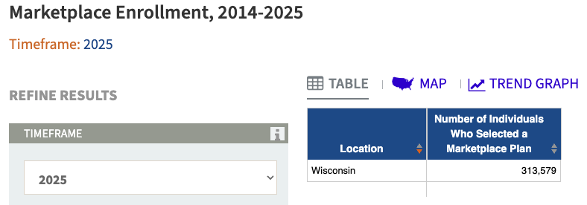
[KFF, Accessed 12/4/25]

The “One Big Beautiful Bill” And The Expiring Affordable Care Act Tax Credits Would Result In 114,000 Uninsured Wisconsinites By 2034
The “One Big Beautiful Bill” And The Expiring Affordable Care Act Tax Credits Would Result In 114,000 Uninsured Wisconsinites By 2034. According to the Center For American Progress, “The One Big Beautiful Bill Act will increase the number of Americans without health coverage in every Wisconsin Estimated increase in the uninsured population due to the OBBBA and the expiration of the ACA’s enhanced premium tax credits, 2034.”
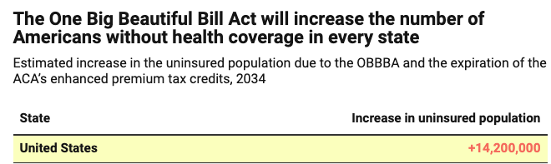

[Center For American Progress, 9/5/25]

Tiffany Supported Implementing Medicaid Work Requirements For Able-Bodied Adults And Said He Would Vote For Cuts If “Done Appropriately”

Tiffany Called For Work Requirements For Medicaid Recipients
April 2025: Tiffany Said Able-Bodied Adults On Medicaid Should Meet Work Requirements And Said He Would Vote For Spending Cuts If “Done Appropriately.” According to PBS Wisconsin, “Frederica Freyberg: ‘So as to spending reductions, would you vote for a budget that had cuts to Medicaid?’ Tom Tiffany: ‘Only if they’re done appropriately. I just identified for you $200 billion in duplicate payments that went out over a course of a number of years, a few years back to insurers that were involved with the Medicaid program. That should not be happening. The other thing that I’ve been a strong advocate for is for work requirements. If you are able bodied and you can work and you’re taking Medicaid, in other words you’re accepting getting your health care from your fellow taxpayers when you could have your own job? I believe work requirements should be put in place and I think that’s one place that we could save billions of dollars with the Medicaid program.’” [PBS Wisconsin, 4/25/25]

Under The “One Big Beautiful Bill,” 148,254 Medicaid Recipients In Wisconsin Were Expected To Lose Their Health Care By 2034
Under The “One Big Beautiful Bill,” 258,454 Wisconsinites Were Expected To Lose Their Health Care By 2034, Including 110,200 ACA Enrollees And 148,254 Medicaid Recipients. [Joint Economic Committee Minority, 6/25]

The Affordable Care Act Allowed States To Expand Medicaid, Which Dramatically Lowered The Uninsured Rate Among Low-Income Workers
The Affordable Care Act Allowed States To Expand Medicaid, And States That Expanded Medicaid Dramatically Lowered The Number Of People Without Health Insurance. According to the Center on Budget and Policy Priorities, "The Affordable Care Act (ACA) permits States to expand Medicaid coverage to adults with incomes up to 138 percent of the poverty level (about $20,780 annually for an individual or $35,630 for a family of three). States that have adopted the expansion have dramatically lowered their uninsured rates. Extensive research finds that the people who gained coverage have grown healthier and more financially secure, while long-standing racial inequities in health outcomes, coverage, and access to care have shrunk." [Center On Budget And Policy Priorities, 6/14/24]
- The Uninsured Rate Among Low-Income Workers Fell From 38 Percent In 2013 To 17 Percent In 2022, Which Coincided With Implementation Of Medicaid Expansion. According to the Center on Budget and Policy Priorities, "Millions of workers have gained coverage through Medicaid expansion, including people working in industries that provide critical goods and services such as health care, transportation, grocery stores, food manufacturers, and child care. Many have no access to health coverage through their jobs. In expansion States, the uninsured rate among low-income workers fell from 38 percent in 2013 to 17 percent in 2022; this sharp decline coincided with a large increase in the share of low-income workers enrolled in Medicaid.[16] In non-expansion States, the uninsured rate among low-income workers fell much less, from 46 percent to 31 percent. (See Figure 3.)" [Center On Budget And Policy Priorities, 6/14/24]

Tom Tiffany Allowed ACA Tax Credits To Expire, Jacking Up Premium Costs For Wisconsinites From 30% To 800% Under ACA Silver Plans

Tiffany Voted Against Extending The Affordable Care Act Tax Credits For Three Years, Even Though 22 Million Americans Relied On ACA Premium Tax Credits To Afford Health Insurance

January 2026: Tiffany Voted Against Extending The Affordable Care Act Tax Credits For Three Years
January 2026: Tiffany Voted Against Extending The Affordable Care Act Tax Credits For Three Years. In January 2026, Tiffany voted against, according to Congressional Quarterly, “the bill, as amended, that would extend for three years, through the end of calendar year 2028, the enhanced tax credits to subsidize premiums for health insurance purchased on the Affordable Health Care Act health insurance markets. It would allow taxpayers whose household income exceeds 400 percent of the federal poverty line to receive tax credits for three more years. The measure would retroactively take effect Jan. 1, 2026.” The vote was on passage. The House passed the bill by a vote of 230 to 196. [House Vote 11, 1/8/26; Congressional Quarterly, 1/8/26; Congressional Actions. H.R. 1834]
- The Bill Extended The Enhanced COVID-Era ACA Tax Credits That Republicans Let Expire At The End Of 2025, Resulting In Greater Health Costs For A Third Of All Those Insured Through The ACA Marketplace. According to Congressional Quarterly, “Congress temporarily expanded the tax credits created through the ACA (PL 111-148, PL 111-152) during the COVID-19 pandemic. The enhanced credits expired Dec. 31, meaning roughly one-third of individuals who get coverage through the ACA marketplace are facing significantly higher costs for 2026. The open enrollment period for these plans closes Jan. 15.” [Congressional Quarterly, 1/8/26]
- Seventeen Republicans Voted For Passage Of The “Clean” Extension Of ACA Subsidies, Following A Procedural Vote The Day Before That Had Support From Nine Republicans. According to Politico, “Seventeen Republicans joined Democrats in passing legislation Thursday that would revive enhanced Affordable Care Act subsidies for three years, rebuffing opposition from GOP leadership. The 230-196 vote follows a procedural vote Wednesday to advance the bill, where nine Republicans joined Democrats in favor of moving forward.” [Politico, 1/8/26]
- The Bill Would Fail In The Senate But Helped Lay The Groundwork For A Bipartisan Agreement. According to Politico, “While the measure is destined to die in the Senate, Democrats and some Republicans hope it will lay the groundwork for a bipartisan agreement to tame skyrocketing health insurance premiums — the result of Congress allowing the tax credits to lapse Dec. 31. ‘The Senate could put together a product that could ultimately get sent back over to the House that we can then conference on and hopefully move across the finish line,’ said Rep. Rob Bresnahan (R-Pa.), who supported the Democratic-led bill.” [Politico, 1/8/26]
- The Vote Increased The Likelihood That The Senate Would Consider The Extension And Pass A Bill With Some Reforms. According to Politico, “Earlier Thursday, members of the bipartisan House Problem Solvers Caucus met with senators to discuss a potential solution. Rep. Jeff Hurd (R-Colo.) said that the meeting — and senators’ plea to show a strong force on this vote in the House — influenced his decision to vote for the measure after initially being inclined to vote against it. ‘There was a sentiment conveyed that if we could get a bill out of the House that had a meaningful amount of bipartisan support, that that would increase the likelihood that the Senate would take this up, pass a bill that has some reforms in it, and send it back,’ Hurd said in an interview about the message communicated during the bicameral meeting.” [Politico, 1/8/26]

Approximately 22 Million Americans Relied On ACA Premium Tax Credits To Afford Health Insurance
Approximately 22 Million Americans Relied On ACA Premium Tax Credits To Afford Health Insurance. According to CNBC, "About 22 million Americans received premium subsidies, also known as premium tax credits, in 2025. Households can opt to receive the tax credit in one of two ways: As a lump sum during tax season or as an advanced payment. Under the latter option, by far the most popular, the federal government issues the tax credit directly to a consumer’s insurer, which then lowers the consumer’s out-of-pocket premium. Consumers receive those advanced ACA subsidies based on an estimated annual income they provide when signing up for insurance. They must reconcile those subsidies during tax season and repay any excess tax credits to the IRS." [CNBC, 1/6/26]

Wisconsin Insurance Commissioner: 277,000 ACA Participants In Wisconsin Received A Subsidy, And Without Enhanced Subsidies, Wisconsin Households Could Experience Premium Increases From 30% To 800% Under Silver Plans
Wisconsin Insurance Commissioner Report: ACA Plans For Wisconsinites Could Increase Premiums From 30% To 800% For 2026 Silver Plans Depending On The Person’s Location In Wisconsin And The Person’s Age, Family Size And Income. According to the Wisconsin Examiner, “The cost for health care coverage purchased on HealthCare.gov in Wisconsin will rise for some insurance policies by anywhere from 45% to 800% for 2026, depending on where a person lives, Gov. Tony Evers announced Monday. The increased rates will be made worse with the end of enhanced federal subsidies, provided in the form of tax credits, that have lowered insurance costs through the marketplace since 2021, Evers and Sen. Tammy Baldwin (D-Wisconsin) said during a virtual press conference Monday morning. The enhanced subsidies expire at the end of December. […] More than 310,000 Wisconsinites purchased health insurance through the marketplace for 2025, according to the Wisconsin Office of the Commissioner of Insurance (OCI). HealthCare.gov open enrollment for 2026 starts Nov. 1. OCI released a list Monday with examples of rate increases for patients of various ages and under selected scenarios based on age, family size and incomes. The examples compared rate increases across eight counties. Evers said a statewide average increase wasn’t available ‘because it’s going to impact lots of people in a lot of different ways.’ The comparisons made by OCI all reflected health plans in the Silver category on HealthCare.gov. Silver plans have a ‘moderate’ deductible and require patients to pay 30% of the cost of care (see sidebar, HealthCare.gov insurance plan categories). In a few scenarios and locations, rate increases will be lower than 10%. Those are exceptions, however. Most scenarios and locations showed premium increases ranging from more than 30% on up. Some increases were well over 100%, and one example showed an increase of more than 800% in one county. The comparisons reflect the premium cost after any subsidies are applied.” [Wisconsin Examiner, 10/27/25]
- ACA Plans In The Silver Category Had A “Moderate” Deductible And Required Patients To Pay 30% Of The Cost Of Care. According to the Wisconsin Examiner, “The comparisons made by OCI all reflected health plans in the Silver category on HealthCare.gov. Silver plans have a ‘moderate’ deductible and require patients to pay 30% of the cost of care (see sidebar, HealthCare.gov insurance plan categories).” [Wisconsin Examiner, 10/27/25]
- Wisconsin Insurance Commissioner Report: 277,000 ACA Participants Received A Subsidy In Wisconsin, And Without Enhanced ACA Subsidies, 60-Year Old Milwaukee Couples Earning $85,000 Annually Were Expected To Have A $25,000 Premium Increase Annually Under The Silver Premium. According to Fox6 News Milwaukee, “Wisconsin reports roughly 277,000 Obamacare plan participants received a subsidy. With the enhanced subsidies expiriring [sic], the Wisconsin Insurance Commissioner reports: The silver premium for a 60-year-old Milwaukee County couple making $85,000 per year will go up $25,000 per year. A Waukesha County family of four that earns $130,000 per year will see their premium go up $12,000 per year.” [Fox6 News Milwaukee, 1/1/26]
- Wisconsin Insurance Commissioner Report: Without Enhanced ACA Subsidies, A Waukesha County Family With An Income Of $130,000 Would Experience A $12,000 Premium Increase Annually. According to Fox6 News Milwaukee, “With the enhanced subsidies expiriring [sic], the Wisconsin Insurance Commissioner reports: The silver premium for a 60-year-old Milwaukee County couple making $85,000 per year will go up $25,000 per year. A Waukesha County family of four that earns $130,000 per year will see their premium go up $12,000 per year.” [Fox6 News Milwaukee, 1/1/26]

Nearly 307,000 Less Wisconsinites Enrolled In 2026 ACA Plas Than 2025 As Wisconsinites Experienced Significant Premium Increases Without The Enhanced ACA Subsidies
2026 Open Enrollment: Nearly 290,000 Wisconsinites Enrolled Through The Affordable Care Act Marketplace, Which Was Nearly 307,000 Less Wisconsinites Since 2025. According to the Milwaukee Journal Sentinel, “Nearly 290,000 Wisconsinites have signed up for health insurance sold on the marketplaces set up under the Affordable Care Act, as of Jan. 3, according to new data released by the federal Centers for Medicare and Medicaid Services. That's down from nearly 307,000 who had signed up for health plans sold on the marketplace as of the same time last year.” [Milwaukee Journal Sentinel, 1/15/26]
- Without The Enhanced ACA Subsidies, Wisconsinites Experienced Significant Increases In Premiums For 2026 ACA Plans, Up To Hundreds Of Dollars. According to the Milwaukee Journal Sentinel, “Without the enhanced subsidies, many people will see the cost of their plan more than double. Wisconsin consumers have seen significant increases in premiums, sometimes by hundreds of dollars a month, for 2026 plans sold on the marketplace.” [Milwaukee Journal Sentinel, 1/15/26]

Tiffany Voted For A Bill Which would weaken protections for people with pre-existing conditions and failed to address premium spikes

December 2025: Tiffany Voted For Republican Legislation That Would Allow ACA Tax Credits To Expire
December 2025: Tiffany Voted For Republican Legislation That Prohibited Abortion-Related Care Under ACA Plans And Allowed The ACA Tax Credits To Expire. In December 2025, Tiffany voted for, according to Congressional Quarterly, “the bill that would expand the ability of small businesses to establish association health plans and bars states from preventing small businesses from obtaining stop-loss insurance for self-funded health insurance plans. It would codify and expand rules governing employer-funded health reimbursement arrangements and would allow employees in such arrangements to pay Affordable Care Act health insurance premiums through salary reductions. It would provide funding for ACA policy cost sharing reduction payments that reduce deductibles and copayments. It would prohibit plans from providing abortion-related care. It also would require pharmacy benefit managers to provide transparency regarding prescription drug costs and the drug rebates they receive.” The vote was on passage. The House passed the bill by a vote of 216 to 211. [House Vote 349, 12/17/25; Congressional Quarterly, 12/17/25; Congressional Actions, H.R. 6703]
- HEADLINE: “House Passes GOP Health Bill Without ACA Credit Extension” [Congressional Quarterly, 12/17/25]
- The Bill Would Result In 100,000 People Losing Coverage Under The ACA As Gains In Enrollments From Association Plans Would Be Offset By The Loss Created By Cost Sharing Payments. According to Congressional Quarterly, “Overall, the CBO said, the new House bill headed to the floor Wednesday would result in about 100,000 people losing coverage, as ending silver loading offsets the gain in coverage from expanded association health plans.” [Congressional Quarterly, 12/17/25]
- The Bill Would Exempt Certain Insurance Policies Offered By Small Employers From Expansive ACA Coverage Requirements. According to Congressional Quarterly, “Provisions in the bill (HR 6703) offered by Rep. Mariannette Miller-Meeks, R-Iowa — one of her party's most vulnerable incumbents — include legislation that would expand access to association health plans and exempt certain insurance policies offered by smaller employees from expansive ACA coverage requirements.” [Congressional Quarterly, 12/17/25]
- The Bill Included Cost-Sharing Reduction Payments For Insurers. According to Congressional Quarterly, “Another key feature of Miller-Meeks' bill would fund payments to insurers to offset the ACA's required reductions in cost-sharing expenses, like deductibles and co-pays, for lower-income beneficiaries. While support for this funding has crossed party lines in the past — it was initially an Obama administration policy, opposed by Republicans and eliminated in President Donald Trump's first term — traditional partisan roles have reversed. Democrats now oppose ‘cost-sharing reduction’ payments or CSRs, making this funding a long shot for passage in the closely divided Senate.” [Congressional Quarterly, 12/17/25]
- The Bill Would Allow Association Health Care Plans To Evade Consumer Protections Under The ACA, Including “Essential Coverage” Requirements, With Critics Arguing The Bill Would Result In “Adverse Selection,” Hurting Older And Sicker Individuals. According to Congressional Quarterly, “Critics say the bill could allow association health plans to evade consumer protections enshrined in the ACA, including requirements to provide a minimum level of ‘essential’ health care benefits. The legislation would allow such plans to be self-funded or be treated as large employer plans, each of which are exempt from the essential coverage requirements. By allowing these plans to operate under different rules in order to offer lower-cost policies, it could lead to ‘adverse selection’ in health insurance markets that makes it harder for older, sicker individuals to find affordable coverage, according to the American Academy of Actuaries.” [Congressional Quarterly, 12/17/25]
- Association Health Plans Would Be Able To Set Higher Premiums Based On Factors Such As Age, Gender, And Occupation. According to Congressional Quarterly, “While the bill prohibits discrimination due to pre-existing conditions or any health-related status, association health plans could still set premiums based on other factors, including age, gender, occupation and geographic location. ‘As a result, this bill would all but invite AHPs to charge workers with more expensive health needs far higher premiums — if those workers could even afford to participate in the associations at all,’ House Education and Workforce Democrats wrote in a committee report accompanying the version of the bill that panel approved in the 118th Congress.” [Congressional Quarterly, 12/17/25]
- Democrats Opposed Stop-Loss Provisions As They Would Put Enrollees At Risk Of Losing Insurance If Medical Costs For The Group Rise. According to Congressional Quarterly, “The AFL-CIO, which opposed both bills, wrote that the stop-loss measure would leave many enrollees at risk because their insurers ‘often retain the right to drop the insurance if medical costs for the group begin to climb.’” [Congressional Quarterly, 12/17/25]
- Cost Sharing Payments Would End Silver Loading Offsets, Resulting In 300,000 People Losing Coverage. According to Congressional Quarterly, “The CBO estimated the provisions would cut spending by $31 billion over nine years — since updated to $37 billion in the latest GOP bill. It would result in some 300,000 enrollees dropping their coverage because the reduced subsidies would outweigh the lower premiums resulting from the end of silver loading, the CBO said.” [Congressional Quarterly, 12/17/25]

Center On Budget And Policy Priorities: The December 2025 Republican Health Care Bill Failed To Prevent Imminent Premium Spikes And Undermined Protections For Pre-Existing Conditions
Center On Budget And Policy Priorities: The December 2025 Republican Health Care Bill Failed To Prevent Imminent Premium Spikes For More Than 20 Million People Who Relied On ACA Marketplace Plans. According to the Center on Budget and Policy Priorities, "The health bill House Republicans are preparing to bring to the floor this week not only fails to prevent imminent premium spikes for more than 20 million people in marketplace plans, but would raise costs even higher for many marketplace enrollees and weaken pre-existing condition protections for individuals and small businesses." [Center On Budget And Policy Priorities, 12/16/25]
Center On Budget And Policy Priorities: The December 2025 Republican Health Care Bill Would Expand Association Health Plans, Which Would Result In Higher Underlying Premiums For Individuals And Small Businesses That Remained In ACA-Regulated Markets. According to the Center on Budget and Policy Priorities, "It would expand association health plans (AHPs), a type of health plan that trade associations, professional groups, and other organizations may offer their members, to cover self-employed individuals and small businesses as if they were large employers. By allowing more people to enroll in coverage not subject to ACA standards and consumer protections, this would segment insurance risk pools: individuals who are younger and healthier, or small businesses with younger or healthier employees, could get plans with lower premiums because they would be priced separately from ACA-compliant coverage and wouldn’t have to meet ACA standards such as having to cover a set of essential health benefits. As a result, individuals and small businesses remaining in ACA-regulated markets would see higher underlying premiums." [Center On Budget And Policy Priorities, 12/16/25]
Center On Budget And Policy Priorities: The December 2025 Republican Health Care Bill Would Likely Lead To Higher Premiums For Older And Sicker Small Groups And Self-Employed People, Thereby Undermining Protections For People With Pre-Existing Conditions. According to the Center on Budget and Policy Priorities, "In addition, the bill would undermine protections for people with pre-existing conditions. While it would bar AHPs from rejecting individuals or charging them more based on certain health factors, it would give them greater ability to base a small group’s or self-employed person’s costs on their health risk compared to individual or small-group coverage. This would likely lead to higher premiums for older and sicker small groups and self-employed individuals, making such arrangements more attractive to healthier individuals and groups." [Center On Budget And Policy Priorities, 12/16/25]

Congressional Budget Office Estimated The December 2025 Republican Health Care Bill Would Result In 100,000 Americans Losing Their Health Insurance
Congressional Budget Office Estimated The December 2025 Republican Health Care Bill Would Take Health Coverage From 100,000 Americans. According to Axios, "By the numbers: The GOP bill would increase the uninsured population by 100,000 and save the government $35.6 billion over 10 years, according to the Congressional Budget Office." [Axios, 12/17/25]

Tiffany Did Not Sign Discharge Petitions Aimed At Extending Premium ACA Tax Credits
Tiffany Was Not One Of The Republican Signers On A Discharge Petition For H.R. 1834 Led By House Minority Leader Hakeem Jeffries.
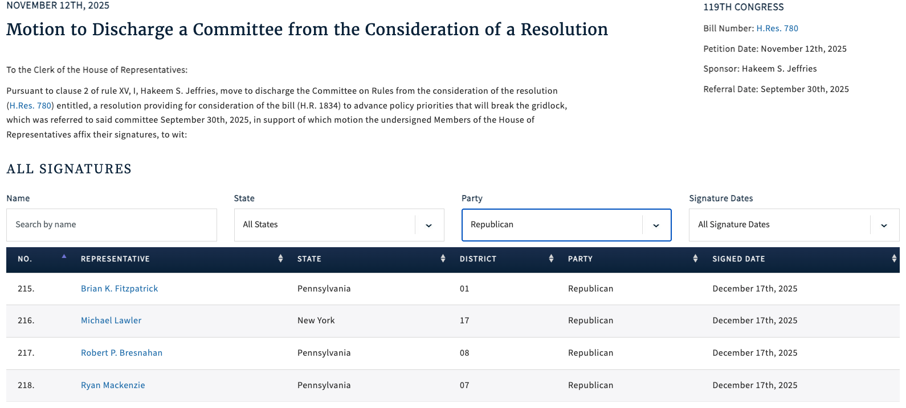
[Clerk of the U.S. House of Representatives, Discharge Petition No. 10, 11/12/25]
- House Minority Leader Jeffries’ Discharge Petition Sought To Extend ACA Premium Tax Credits For Three Years. According to Politico Pulse, "House Democrats could move as soon as tomorrow to force a vote on extending the expired Obamacare subsidies for three years, Meredith Lee Hill reports. This measure follows last month’s major setback for Speaker Mike Johnson, when four House Republicans broke from the party to support a discharge petition backed by Minority Leader Hakeem Jeffries to hold a vote." [Politico Pulse, 1/6/26]

Tiffany Was Not One Of The Republican Signers On A Discharge Petition For H.R. 3001 Led By Rep. Brian Fitzpatrick.
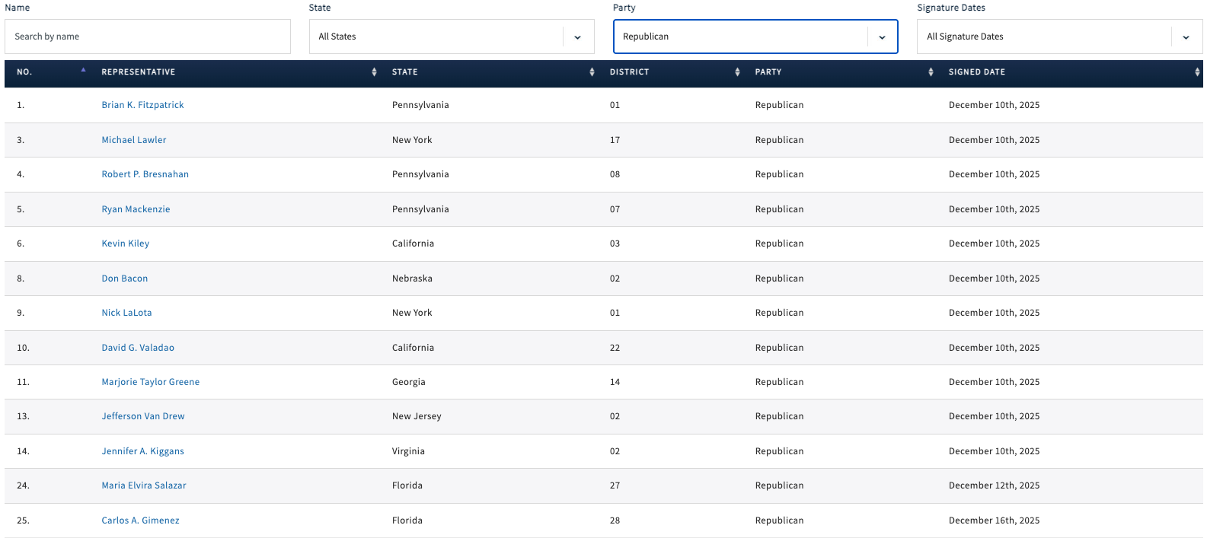
[Clerk of the U.S. House of Representatives, Discharge Petition No. 12, 12/10/25]
- December 2025: Fitzpatrick Filed A Discharge Petition Aimed At Extending ACA Premium Tax Credits For Two Years. According to a press release from Rep. Brian Fitzpatrick, "Today, Congressman Brian Fitzpatrick (PA-1) released the following statement after filing a discharge petition to bring his Bipartisan Health Insurance Affordability Act directly to the House floor for a vote, ensuring Congress takes action to prevent devastating health insurance premium increases when current protections expire at the end of the year: ‘Congress cannot sit idle while American families face a preventable crisis. Our job is to protect the people we serve, and that responsibility demands immediate action. […] Key Provisions of the Bipartisan Health Insurance Affordability Act The legislation advances five reforms designed to protect affordability, strengthen accountability, and ensure taxpayer value: Prevents premium spikes: Extends enhanced premium tax credits through 2027, to protect families from abrupt monthly cost increases. Restores Consumer Control: Stops unauthorized plan and subsidy changes by requiring consent and prompt notification before any modifications take effect. Shines Light on Middlemen: Ends hidden spread pricing, severs PBM profits from drug prices, and requires full rebate pass-through to ensure savings reach patients. Gives Families New Tools to Manage Costs: Expands access to Health Savings Accounts and simplifies premium payments to reduce disruptions in coverage. Smart Stewardship of Taxpayer Dollars: Modernizes eligibility and introduces a reasonable minimum contribution to protect long-term affordability and responsible stewardship of federal dollars." [Press Release – Rep. Brian Fitzpatrick, 12/10/25]
Tiffany Was Not One Of The Republican Signers On A Discharge Petition For H.R. 185 Led By Rep. Josh Gottheimer.
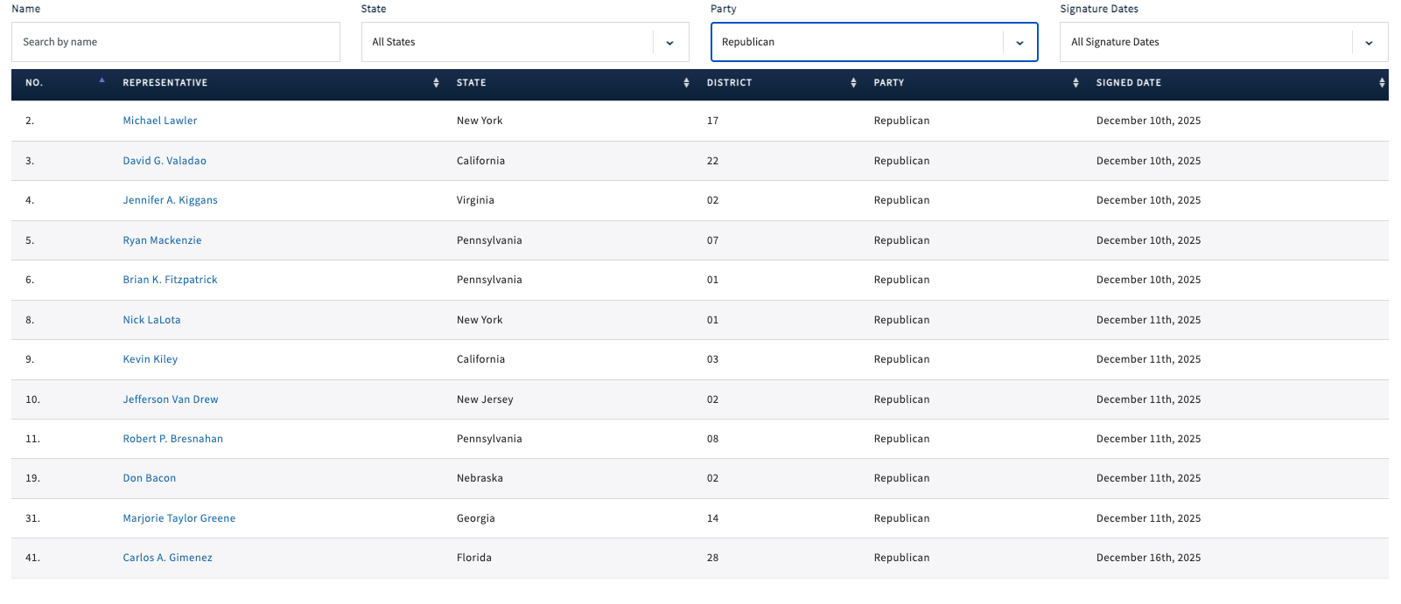
[Clerk of the U.S. House of Representatives, Discharge Petition No. 13, 12/10/25]
- December 2025: Gottheimer Filed A Discharge Petition Aimed At Extending ACA Premium Tax Credits For Two Years. According to a press release from Rep. Josh Gottheimer, "Today, December 11, 2025, U.S. Congressman Josh Gottheimer (NJ-5) released the following statement: ‘In less than three weeks, unless Congress acts now, Affordable Care Act tax credits will expire, and health insurance premiums will shoot up 175% — or $20,000 a year — for families in Jersey. This week, Congresswoman Jen Kiggans and I, with 36 of our Democratic and Republican colleagues, introduced new bipartisan legislation that includes a two-year extension of health insurance premium tax cuts for American families. It’s a commonsense proposal that will keep costs down and prevent families’ premiums from skyrocketing in January. But, the Speaker of the House is refusing to bring our legislation to the floor for a vote. So, our bipartisan group just launched a discharge petition to force an immediate vote in the House. We must get this done now. We must find common ground and lower health insurance premiums. Time is running out for families.’" [Press Release – Rep. Josh Gottheimer, 12/11/25]

Tiffany’s Inaction Created A Dramatic “Subsidy Cliff,” Whereby Households Could Lose All Eligibility For Assistance
The Expiration Of Enhanced ACA Premium Tax Credits Created A “Subsidy Cliff” Whereby If Households Earned Even $1 More Than A Specific Income Threshold, They Could Lose All Eligibility For Assistance. According to CNBC, "For the first time in years, many Americans enrolled in a health insurance plan via the Affordable Care Act marketplace will need to keep a careful accounting of their annual income — or risk a hefty federal tax bill. Enhanced ACA subsidies lapsed at the end of 2025, leaving millions of households on the hook for higher insurance premiums. The lapse also reintroduced the so-called subsidy cliff, whereby households that earn even $1 more than a specific income threshold will lose all eligibility for subsidies, also known as premium tax credits. That income cutoff, which varies by family size, is $62,600 for a single person, $84,600 for a two-person household and $128,600 for a family of four in 2026, for example." [CNBC, 1/6/26]
- More Than Two Million Americans Had Incomes Near A “Subsidy Cliff.” According to CNBC, "More than 2 million people enrolled in an ACA marketplace plan have an income near the subsidy cliff. ACA enrollees also tend to have relatively volatile incomes, making it hard to predict their annual earnings, experts said." [CNBC, 1/6/26]
Households That Went Over The Income Limit Would Have To Pay Back Any Federal Assistance They Received For Premiums, Which Could Cost Thousands Of Dollars, When They Filed Their Taxes. According to CNBC, "Households over the limit would have to pay back any federal subsidies they received for premiums — potentially worth thousands of dollars — when they file taxes next year for 2026." [CNBC, 1/6/26]
Republicans’ “One Big Beautiful Bill” Exacerbated The Problem By Stripping Away Guardrails Capping The Amount Of Excess Subsidies Households Are Required To Repay. According to CNBC, "The potential financial impact is exacerbated by a multitrillion-dollar legislative package known as the ‘big beautiful bill’ that Republicans passed over the summer, which stripped away guardrails capping the amount of excess subsidies households must repay, experts said." [CNBC, 1/6/26]

Tiffany Argued Democrats Used Affordable Care Act Subsidies To Justify A Shutdown And Influence 2025 Elections, And Claimed The Subsidies Meant The ACA Was A “Real PRoblem”

Tiffany Claimed Democrats’ Fight For Affordable Care Act Subsidies Also Meant “Obamacare Is A Real Problem”
2025: Tiffany Alleged Democrats Engineered The Government Shutdown And Used Affordable Care Act Subsidies To Influence The 2025 Elections, Also Alleging That Democrats’ Fight For Subsidies Also Meant “Obamacare Is A Real Problem.” According to Tiffany’s Interview on Drydenwire, “HOST: Going back to the shutdown. Obviously, this was largely, if not solely, well, largely based on the Obamacare subsidies, essentially the enhanced premium tax credits. This lasted for, what, 43 days, etc.. A lot of other things, negative impacts happened, as we all know. So we don't need to rehash all those things. Everybody understands that stuff, the SNAP things, the air traffic controllers, etc.. Did. Was it good that we did this just from a it brings awareness to the Obamacare subsidies and the importance and the need of it? TIFFANY: No, it was not a win to shut down government like that. I mean, that's why I voted to keep it open twice back in September and now in November. It was not a win for the American people. And I mean, let's be clear that Obamacare was just a pretext to shut it down by a minority of Democrats. I mean, we remember there were a few Democrats in the Senate that wanted to vote for this. There were 55 or 56 votes in the Senate. A majority wanted to do this. Chuck Schumer would not allow the vote to go forward through this arcane rule known as cloture. I mean, there were a majority of votes there. Why did he not allow the majority to rule in that case? It was a minority that was holding it up. But the pretext was Obamacare. But I mean, it's pretty evident. A big part of this was the Virginia and New Jersey elections. They wanted to make sure and juice elections to make sure that they won in Virginia and New Jersey because they had lost four years before in Virginia and they nearly lost the governorship in New Jersey four years previous. So they wanted to make sure that those came home. I mean, it's quite evident that was a big part of their strategy. And so they had to have a pretext. And they said it is going to be Obamacare that we are going to raise as an issue. I think this has been healthy for from the standpoint of greater awareness. So. If there is a big problem with Obamacare that they're seeking to fix. Doesn't that highlight that Obamacare is a real problem? I mean, doesn’t that highlight that that there's a real problem there? Because this remember, this was enhanced subsidies that were put in place during COVID that they're trying to extend. Why would we? COVID is no longer with us. Why would you continue enhanced subsidies due to COVID when COVID is no longer no longer the reason for shutting down our government? So. So I just think it has raised awareness. And I think a couple of things are really critical in regards to it, that people should look up ,regardless of your political affiliation. Why are people making up to $500,000 eligible for these subsidies? Why would we do that? Like people making up to $500,000 in some cases are eligible for these COVID era subsidies for Obamacare? The second thing is there's tens of billions of dollars that are going out to the insurance companies. I mean, it is staggering how much money is going to the insurance companies. And I ask Democrats like Senator Tammy Baldwin in Wisconsin, who has railed on insurance companies regularly when out on the campaign trail running for re-election, Why would you pump in all that money to those insurance companies? And that is why the president is now saying let's take those subsidies that are going to the insurance companies and give them to the American people, the people who actually we should be working for.” [Tom Tiffany Interview – Drydenwire, 11/13/25] (VIDEO)

