Overview
In 2025, Garrity supported Trump's “One Big Beautiful Bill,” which the Congressional Budget Office estimated would trigger nearly $500 billion in cuts to Medicare.

Garrity Supported Trump’s “One Big Beautiful Bill,” Which Would Trigger $500 Billion In Cuts To Medicare

Garrity Supported Republicans’ Reconciliation Bill, Which Would Trigger Nearly $500 Billion In Medicare Cuts

Garrity Publicly Backed Trump’s Tax Bill And Distorted Its Impacts
2025: Garrity Said She Was “Proud Of The U.S. Senate For Passing The Big Beautiful Bill,” Misleading That It Would Provide “Real Relief” For Pennsylvanians. According to Garrity’s Twitter, “Proud of the U.S. Senate for passing the Big Beautiful Bill and providing real relief for Pennsylvania families!”
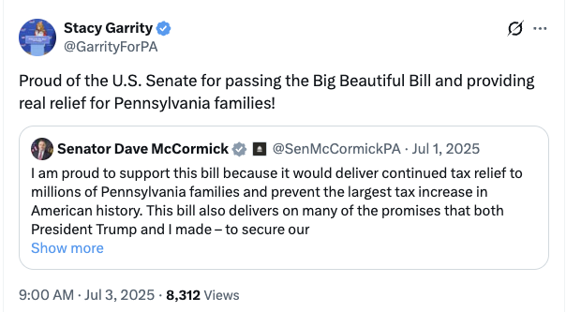
[Twitter, @GarrityForPA, 7/3/25]
2025: Garrity Supported Trump’s One Big Beautiful Bill, Claiming It Was A “Historic Plan” That Reduced “Wasteful Spending,” Extended “Middle-Class Tax Funds,” Achieved “The Biggest Deficit Reduction In Decades,” And Secured The Border. According to Garrity’s Twitter, “As PA’s Treasurer, I know firsthand how important President Trump’s One, Big Beautiful Bill is for families across our Commonwealth. It’s about securing our border, reducing wasteful spending, and putting money back into YOUR pockets. This historic plan permanently locks in Trump’s successful middle-class tax cuts, funds the largest border-security effort in American history, and achieves the biggest deficit reduction in decades. It’s real relief and real results for everyday Pennsylvanians. Members of Congress who oppose President Trump’s One, Big Beautiful Bill are risking higher taxes, weaker borders, and billions wasted on woke policies. It’s time to come together, put America First, and to do the job the American people elected Republicans to do.”
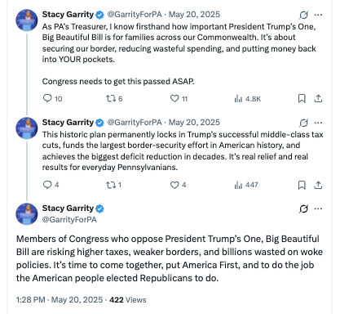
[Twitter, @GarrityForPA, 5/20/25]
2025: Garrity Was A Staunch Trump Supporter And Supported The “One Big Beautiful Bill,” Which Extended Tax Breaks For The Wealthy And Cut Health Care And Food Assistance. According to Spotlight PA, “Gov. Josh Shapiro’s most likely Republican opponent is state Treasurer Stacy Garrity, a strong Trump supporter who has aligned herself with the president on various issues. She publicly backed his ‘big, beautiful’ domestic policy law that extended tax breaks through health care and food assistance cuts, and his mass deportation plans.” [Spotlight PA, 11/17/25]

The “One Big Beautiful Bill” Would Trigger $500 Billion Cut In Medicare Funding Between 2026 And 2034
The “One Big Beautiful Bill” Sped Up The Timeline For When The Medicare Trust Fund Will Become Insolvent, And Without Additional Action, The Bill Would Trigger A $500 Billion Cut In Medicare Funding Between 2026 And 2034. According to Medicare Advocacy, “On July 4, 2025, President Trump signed into law H.R. 1 – the One Big Beautiful Bill Act (OBBB). This sweeping legislation narrowly passed Congress through a special budget process (‘reconciliation’), which allowed it to pass the Senate with a simple majority vote rather than the usual 60 votes needed to overcome a filibuster. The law extends tax cuts that were first enacted in 2017 and funds other administration priorities. To help pay for these policies, it makes unprecedented cuts to critical safety-net programs that provide health care and other assistance. […] Even with these significant cuts, the Act is still projected to add at least $3.4 trillion to the national debt.[2] It also speeds up the timeline for when Medicare’s trust fund (which pays for hospital care) will become insolvent. If Congress takes no additional action, automatic spending cuts will be triggered, reducing Medicare funding by approximately $500 billion between 2026 and 2034.” [Medicare Advocacy, 7/24/25]
- HEADLINE: "Trump And GOP’s Tax Bill Would Force Cuts To Medicare, CBO Says" [Washington Post, 5/21/25]
- Congressional Budget Office Estimated That The House Republican Reconciliation Bill Would Trigger Nearly $500 Billion In Cuts To Medicare. According to a letter the Congressional Budget Office sent to Rep. Brendan Boyle, "Today the Congressional Budget Office transmitted an estimate of the budgetary effects of the 2025 reconciliation bill, as ordered reported by the House Committee on the Budget on May 18, 2025. 1 CBO has not yet completed estimates of the effects of interactions among the titles of the legislation. This letter responds to your questions concerning the sequestration (the cancellation of budgetary resources) in accordance with the Statutory Pay-As-You-Go Act of 2010 (S-PAYGO) that would occur if an enacted bill raised deficits by $2.3 trillion over 10 years. Under S-PAYGO, the Office of Management and Budget (OMB) is required to maintain 5- and 10-year scorecards that it updates with the estimated cumulative changes in revenues and outlays generated by newly enacted legislation. […] The 4 percent maximum reduction in Medicare spending would apply to sequestration orders for years after 2026. If OMB ordered a sequestration of $230 billion for each year through 2034, the ordered reductions in Medicare spending would increase to about $75 billion in 2034 and would total roughly $490 billion over the 2027–2034 period." [Letter to Rep. Brendan Boyle – Congressional Budget Office, 5/20/25]

