Overview
In 2025, Garrity supported Trump's "One Big Beautiful Bill," which is estimated to kick 17 million Americans off their health insurance, including nearly 12 million Americans who rely on Medicaid. While Garrity praised the bill as a “historic plan,” more than 451,000 Pennsylvanians could lose their health insurance as a result of the bill. More than 496,000 Pennsylvanians were enrolled in Affordable Care Act Marketplace health insurance plans.
Garrity suggested Pennsylvania’s government should replicate the Medicaid restrictions imposed under Trump’s tax bill, even though Medicaid expansion enabled coverage for more Pennsylvanians. More than 300,000 Medicaid recipients in Pennsylvania were expected to lose their coverage due to Trump’s tax bill.

Garrity Supported Stripping Health Insurance Away From Millions Of Americans Who Relied On Medicaid

Garrity Supported Trump’s Health Care And Medicaid Cuts, Suggesting She Wanted To Replicate Medicaid Work Requirements In Pennsylvania

Garrity Supported The “One Big Beautiful Bill,” Which Extended Tax Breaks For The Wealthy And Cut Health Care And Food Assistance
2025: Garrity Said She Was “Proud Of The U.S. Senate For Passing The Big Beautiful Bill,” Misleading That It Would Provide “Real Relief” For Pennsylvanians. According to Garrity’s Twitter, “Proud of the U.S. Senate for passing the Big Beautiful Bill and providing real relief for Pennsylvania families!”
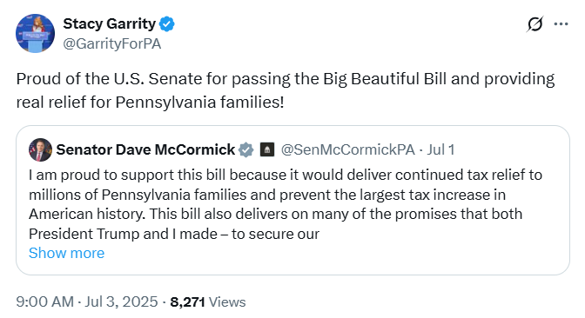
[Twitter, @GarrityForPA, 7/3/25]
2025: Garrity Supported Trump’s One Big Beautiful Bill, Claiming It Was A “Historic Plan” That Reduced “Wasteful Spending,” Extended “Middle-Class Tax Funds,” Achieved “The Biggest Deficit Reduction In Decades,” And Secured The Border. According to Garrity’s Twitter, “As PA’s Treasurer, I know firsthand how important President Trump’s One, Big Beautiful Bill is for families across our Commonwealth. It’s about securing our border, reducing wasteful spending, and putting money back into YOUR pockets. This historic plan permanently locks in Trump’s successful middle-class tax cuts, funds the largest border-security effort in American history, and achieves the biggest deficit reduction in decades. It’s real relief and real results for everyday Pennsylvanians. Members of Congress who oppose President Trump’s One Big Beautiful Bill are risking higher taxes, weaker borders, and billions wasted on woke policies. It’s time to come together, put America First, and to do the job the American people elected Republicans to do.”
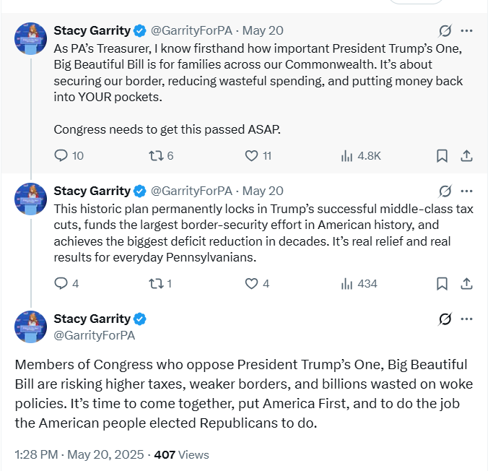
[Twitter, @GarrityForPA, 5/20/25]
2025: Garrity Was A Staunch Trump Supporter And Supported The “One Big Beautiful Bill,” Which Extended Tax Breaks For The Wealthy And Cut Health Care And Food Assistance. According to Spotlight PA, “Gov. Josh Shapiro’s most likely Republican opponent is state Treasurer Stacy Garrity, a strong Trump supporter who has aligned herself with the president on various issues. She publicly backed his ‘big, beautiful’ domestic policy law that extended tax breaks through health care and food assistance cuts, and his mass deportation plans.” [Spotlight PA, 11/17/25]
- HEADLINE: "At Least 17 Million Americans Would Lose Insurance Under Trump Plan" [Washington Post, 7/1/25]
- HEADLINE: “By The Numbers: Harmful Republican Megabill Favors The Wealthy And Leaves Millions Of Working Families Behind” [Center On Budget And Policy Priorities, 8/1/25]
- The Congressional Budget Office Estimated That 11.8 Million People Would Become Uninsured As A Result Of The Medicaid Cuts In Republicans’ Reconciliation Bill. According to the Washington Post, "The bill, which narrowly passed the Senate on Tuesday and now heads back to the House, would effectively accomplish what Republicans have long failed to do: unwind many of the key components of the ACA, President Barack Obama’s signature domestic achievement, which dramatically increased the number of Americans with access to health insurance. To start, the Congressional Budget Office estimated that the Senate version of the bill would result in 11.8 million more uninsured in 2034, mostly because of Medicaid cuts, compared with 10.9 million if the House version became law." [Washington Post, 7/1/25]
- The Bill’s $50 Billion In Rural Hospital Relief Funding Would Not Come Close To The Gap Created By Medicaid Cuts, With 300 Rural Hospitals At “Immediate Risk” Of Closure. According to the Center For American Progress, “The OBBBA includes $50 billion in relief funding for rural hospitals over a five-year period to help reduce the disastrous impacts of the bill’s roughly $1 trillion in Medicaid cuts. As of May 2025, there were approximately 2,086 rural hospitals receiving $12.2 billion a year in net revenue from Medicaid. At the median, rural hospitals’ revenue from Medicaid is $3.9 million a year.Rural hospitals have some of the lowest operating margins in the nation, especially compared with urban hospitals, meaning that any reductions in revenue could lead to closures. The average operating margin for rural hospitals was 3.1 percent in 2023, with 44 percent of rural hospitals operating with negative margins. As a result, more than 300 rural hospitals are currently at ‘immediate risk’ of closure, especially now that the OBBBA is projected to cut Medicaid spending by $1.02 trillion. The relief fund designed to blunt the negative impacts caused by the bill would not come close to filling that gap. If every rural hospital in the country received an even share of the $50 billion in relief support, it would amount to only $4.5 million every year for five years. At the close of those five years, that funding would disappear altogether.” [Center For American Progress, 7/3/25]

Meg Snead Op-Ed: Garrity’s Public Endorsement Of The “One Big Beautiful Bill” Meant She Was “Willing To Gamble With The Health Of Rural Pennsylvanians”
HEADLINE: “Stacy Garrity Can’t Champion Rural Hospitals While Cheering A Bill That Will Shut Them Down” [Meg Snead Op-Ed – Philadelphia Inquirer, 7/9/25]
Meg Snead Op-Ed: Garrity Prided Herself In Protecting Rural Hospitals, But Also Advocated For A Bill That Would Strip Health Care From 11 Million Americans, Including More Than 300,000 Pennsylvanians, And Gut Rural Hospital Funding. According to a Meg Snead op-ed from the Philadelphia Inquirer, “State Treasurer Stacy Garrity says she’s spent her life protecting rural hospitals. She prides herself on being from a rural community and argues that her roots help her understand what’s at stake for those who live in the more rustic corners of the commonwealth. She also says she’s a champion of transparency. But what’s transparent about cheering a bill that would quietly rip healthcare away from more than 11 million Americans, including over 300,000 Pennsylvanians, and gut the funding rural hospitals rely on?” [Meg Snead Op-Ed – Philadelphia Inquirer, 7/9/25]
Meg Snead Op-Ed: Garrity’s Public Endorsement Of The “One Big Beautiful Bill” Meant She Was “Willing To Gamble With The Health Of Rural Pennsylvanians For The Sake Of A Likely 2026 Gubernatorial Bid.” According to a Meg Snead op-ed from the Philadelphia Inquirer, “The so-called Big Beautiful Bill may have had a catchy name, but beneath the surface, it was a devastating proposal. […] So, who is benefiting from this bill that will rip healthcare away from hundreds of thousands of Pennsylvanians, close rural hospitals, and raise healthcare costs across Pennsylvania, all while blowing up the deficit? Trump’s wealthy friends are going to get another tax break out of all this. That’s what these healthcare cuts are paying for. Garrity doesn’t vote in Washington. But her public endorsement of this bill sent a clear signal: She’s willing to gamble with the health of rural Pennsylvanians for the sake of a likely 2026 gubernatorial bid.” [Meg Snead Op-Ed – Philadelphia Inquirer, 7/9/25]

More Than 451,000 Pennsylvanians Were Expected To Lose Health Care Coverage Under Trump’s “One Big Beautiful Bill”
Under The “One Big Beautiful Bill,” 451,279 Pennsylvanians Were Expected To Lose Their Health Care By 2034, Including 174,000 ACA Enrollees And 277,279 Medicaid Recipients. According to the Joint Economic Committee Minority,
District | State | Est. # Losing ACA Coverage | Est. # Losing Medicaid Coverage | Est. Total # Losing Insurance
PA-01 | Pennsylvania | 10,800 | 10,510 | 21,310
PA-02 | Pennsylvania | 9,600 | 27,853 | 37,453
PA-03 | Pennsylvania | 11,200 | 22,096 | 33,296
PA-04 | Pennsylvania | 10,000 | 10,571 | 20,571
PA-05 | Pennsylvania | 10,400 | 15,768 | 26,168
PA-06 | Pennsylvania | 9,200 | 12,624 | 21,824
PA-07 | Pennsylvania | 8,800 | 17,552 | 26,352
PA-08 | Pennsylvania | 10,000 | 20,499 | 30,499
PA-09 | Pennsylvania | 9,200 | 16,342 | 25,542
PA-10 | Pennsylvania | 8,000 | 15,069 | 23,069
PA-11 | Pennsylvania | 10,400 | 13,807 | 24,207
PA-12 | Pennsylvania | 13,600 | 14,810 | 28,410
PA-13 | Pennsylvania | 10,400 | 16,909 | 27,309
PA-14 | Pennsylvania | 10,400 | 17,856 | 28,256
PA-15 | Pennsylvania | 12,000 | 15,426 | 27,426
PA-16 | Pennsylvania | 9,200 | 17,816 | 27,016
PA-17 | Pennsylvania | 10,800 | 11,771 | 22,571
All | Totals | 174,000 | 277,279 | 451,279

[Joint Economic Committee Minority, 6/25]
HEADLINE: “Federal Budget Bill Could Strip 300K Pennsylvanians Of Medicaid Coverage, Push Rural Hospitals To The Brink” [Spotlight PA, 6/10/25]

The “One Big Beautiful Bill” And The Expiring Affordable Care Act Tax Credits Would Result In 447,000 Uninsured Pennsylvanians By 2034
The “One Big Beautiful Bill” And The Expiring Affordable Care Act Tax Credits Would Result In 447,000 Uninsured Pennsylvanians By 2034. According to the Center For American Progress, “The One Big Beautiful Bill Act will increase the number of Americans without health coverage in every state Estimated increase in the uninsured population due to the OBBBA and the expiration of the ACA’s enhanced premium tax credits, 2034”
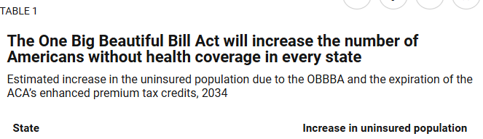
[Center For American Progress, 9/5/25]

December 2025: There Were More Than 496,000 Pennsylvanians Enrolled In An Affordable Care Act Marketplace Plan
As Of December 2025, There Were 496,661 Individuals Enrolled In An Affordable Care Act Marketplace Plan In Pennsylvania. According to KFF, in 2025, there were 496,661 individuals enrolled in affordable care act marketplace plan in Pennsylvania.
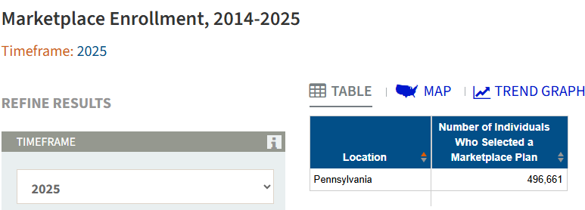
[KFF, Accessed 12/1/25]

Garrity Suggested She Wanted To Replicate Medicaid Restrictions From Trump’s Tax Bill In Pennsylvania

Garrity Wished Pennsylvania’s Government Would Replicate The Medicaid Restrictions Placed Under The “One Big Beautiful Bill”

Garrity Wanted To Replicate Work Requirements For Able-Bodied Medicaid Recipients In Pennsylvania, Like The Republican Federal Legislation
HEADLINE: “Washington Leads While Harrisburg Lags On Reform | Pennlive Letters” [Stacy Garrity Op-Ed – PennLive, 6/26/25]
Stacy Garrity Op-Ed: Garrity Touted Congress Reinstating Work Requirements For Able-Bodied Medicaid Recipients, And Lamented Such Changes Were Not Happening In Harrisburg. According to a Stacy Garrity op-ed from PennLive, “Today, Washington lawmakers hope to revive Clinton’s bipartisan legacy by reinstating commonsense work requirements for able-bodied adults without dependents. It is a path back to purpose, pride, and the restoration of the American Dream. Whether all of these proposed reforms succeed remains to be seen. But Washington is showing what it means to engage in meaningful conversation and debate on the issues that matter to hardworking families. Washington is showing what it means to lead. Harrisburg, not so much.” [Stacy Garrity Op-Ed – PennLive, 6/26/25]
August 2025: Garrity Claimed Pennsylvanians Appreciated The Tax Measures In Trump’s “One Big Beautiful Bill,” And Would Be “Okay If We Have Able Bodied People With No Dependents Working Or Volunteering 20 Hours A Week” To Remain Eligible For Medicaid. According to Garrity in an interview with WHTM, “INTERVIEWER: You've been an unabashed supporter of Donald Trump and you support his policies. And do you think that could work against you? Would you try to separate yourself on some of GARRITY: I think Pennsylvanians appreciate the no tax on tips, the no tax on overtime, the no tax on Social Security, doubling the child tax credit. And I think when I talk to Pennsylvanians, they're okay if we have able bodied people with no dependents working or volunteering 20 hours a week so that we can protect the program for the vulnerable that really rely on it.” [Stacy Garrity Interview – WHTM, 8/24/25] (VIDEO)

Under The “One Big Beautiful Bill,” More Than 300,000 Medicaid Recipients In Pennsylvania Were Expected To Lose Their Health Care By 2034
HEADLINE: “Federal Budget Bill Could Strip 300K Pennsylvanians Of Medicaid Coverage, Push Rural Hospitals To The Brink” [Spotlight PA, 6/10/25]
Pennsylvania Department Of Human Services Estimated More Than 300,000 Would Lose Medicaid Coverage Under The “One Big Beautiful Bill.” According to Spotlight PA, “President Donald Trump’s ‘big, beautiful’ budget bill could have a disastrous effect on the health of rural Pennsylvanians and the operations of the hospitals and other medical centers that care for them. […] More than 3 million people in Pennsylvania — 23% — are covered by Medicaid, according to data from the state Department of Human Services, which administers the program. The agency estimates that more than 300,000 would lose Medicaid coverage under the proposal.” [Spotlight PA, 6/10/25]
Joint Economic Committee: Under The “One Big Beautiful Bill,” 451,279 Pennsylvanians Were Expected To Lose Their Health Care By 2034, Including 174,000 ACA Enrollees And 277,279 Medicaid Recipients. [Joint Economic Committee Minority, 6/25]

The Affordable Care Act Allowed States To Expand Medicaid, Which Dramatically Lowered The Uninsured Rate Among Low-Income Workers
The Affordable Care Act Allowed States To Expand Medicaid, And States That Expanded Medicaid Dramatically Lowered The Number Of People Without Health Insurance. According to the Center on Budget and Policy Priorities, "The Affordable Care Act (ACA) permits states to expand Medicaid coverage to adults with incomes up to 138 percent of the poverty level (about $20,780 annually for an individual or $35,630 for a family of three). States that have adopted the expansion have dramatically lowered their uninsured rates. Extensive research finds that the people who gained coverage have grown healthier and more financially secure, while long-standing racial inequities in health outcomes, coverage, and access to care have shrunk." [Center On Budget And Policy Priorities, 6/14/24]
- The Uninsured Rate Among Low-Income Workers Fell From 38 Percent In 2013 To 17 Percent In 2022, Which Coincided With Implementation Of Medicaid Expansion. According to the Center on Budget and Policy Priorities, "Millions of workers have gained coverage through Medicaid expansion, including people working in industries that provide critical goods and services such as health care, transportation, grocery stores, food manufacturers, and child care. Many have no access to health coverage through their jobs. In expansion states, the uninsured rate among low-income workers fell from 38 percent in 2013 to 17 percent in 2022; this sharp decline coincided with a large increase in the share of low-income workers enrolled in Medicaid.[16] In non-expansion states, the uninsured rate among low-income workers fell much less, from 46 percent to 31 percent. (See Figure 3.)" [Center On Budget And Policy Priorities, 6/14/24]

