Overview
In 2025, Garrity supported Trump’s “One Big Beautiful Bill,” which made the largest cut to SNAP in history. Garrity praised the legislation as a “historic plan,” claiming the bill would cut “wasteful spending.” In Pennsylvania, nearly 2 million Pennsylvanians relied on SNAP to afford groceries.

Garrity Supported Stripping SNAP Benefits From Pennsylvanians And Making Food More Expensive

Garrity Said She Opposed Pennsylvania’s Lawsuit That Sought To Restore $13 Million In Federal Funding For Pennsylvania Food Banks To Buy Food From Farmers

Garrity Criticized Legal Efforts To Restore Food Aid As “Trying To Give More And More Money” Instead Of “Giving Them A Hand Up,” While Complaining Too Many Pennsylvanians Relied On SNAP
January 2026: Garrity Said She Opposed Pennsylvania’s Lawsuit That Sought To Restore $13 Million In Federal Funding For Pennsylvania Food Banks To Buy Food From Farmers, Criticizing SNAP Benefits As “Entitlements” And “Trying To Give More And More Money” Instead Of “Giving Them A Hand Up.” According to Stacy Garrity at the Pennsylvania Press Club Luncheon, “MODERATOR: Would you support the suit followed by Shapiro to force the Trump administration to restore $13 million in funding for Pennsylvania food banks to buy produce from Pennsylvania farmers? GARRITY: No, what I would do is. You know, instead of, instead of suing for more money, more money, more money. Pennsylvania has 2 million people on SNAP benefits, 1.4 million women and children. What I would look to see is, why do we have 15% of Pennsylvanians on entitlements? Instead of trying to give more and more money, why don't we help people out of poverty? Give them a hand up? That's what I would do.” [Stacy Garrity – Pennsylvania Press Club Luncheon, 1/12/26]
- January 2026: Garrity Said She Opposed Shapiro’s Lawsuit Seeking Restoration Of Federal Funding For Food Banks, Claiming Too Many Pennsylvanians Were Receiving Food Aid. According to PennLive, “Garrity also said she would not have supported Shapiro’s lawsuit to get Trump to restore federal funding for food banks, saying the commonwealth already has too many people receiving food benefits and that she would ‘give them a hand up,’ without saying exactly what this assistance would be.” [PennLive, 1/13/26]

Pennsylvania Sued The Trump Administration For “Illegally Cut Off Funding” From Pennsylvania Through A Program That Provided Aid To States To Purchase Food From Farmers To Stock Food Banks
June 2025: Pennsylvania Sued The U.S. Department Of Agriculture, Alleging The Trump Administration “Illegally Cut Off Funding” From Pennsylvania Through A Program Designed To Distribute More Than $1 Billion In Assistance To States To Buy Food From Farms For Schools, Child Care Centers, And Food Banks. According to Spotlight PA, “Pennsylvania sued the U.S. Department of Agriculture on Wednesday, saying the agency, under President Donald Trump, had illegally cut off funding to it through a program designed to distribute more than $1 billion in aid to states to purchase food from farms for schools, child care centers, and food banks. The lawsuit in federal court, announced by Gov. Josh Shapiro, a Democrat, comes three months after the USDA advised states that it was ending the pandemic-era assistance program because it no longer reflected agency priorities.” [Spotlight PA, 6/4/25]
2025: The Trump Administration’s Decision To End The Reimbursement Program Resulted In A $13 Million Loss For Pennsylvania, Which Was Funding Planned For Purchasing Food From Farms To Stock Food Banks. According to Spotlight PA, “The lawsuit, filed in federal court in Harrisburg, asks the court to reverse the USDA's decision to end the reimbursement program. […] The loss to Pennsylvania is $13 million under a three-year contract, money that the state planned to use to buy food from farms to stock food banks. States also use the money to buy food from farms for school nutrition programs and child care centers. Purchases include commodities such as cheese, eggs, meat, fruits and vegetables.” [Spotlight PA, 6/4/25]

Garrity Supported The Republican Reconciliation Bill That Cut Snap Benefits For Millions

Garrity Supported The “One Big Beautiful Bill,” Misleading It Would Cut “Wasteful Spending”
2025: Garrity Was A Staunch Trump Supporter And Supported The “One Big Beautiful Bill,” Which Extended Tax Breaks For The Wealthy And Cut Health Care And Food Assistance. According to Spotlight PA, “Gov. Josh Shapiro’s most likely Republican opponent is state Treasurer Stacy Garrity, a strong Trump supporter who has aligned herself with the president on various issues. She publicly backed his ‘big, beautiful’ domestic policy law that extended tax breaks through health care and food assistance cuts, and his mass deportation plans.” [Spotlight PA, 11/17/25]
2025: Garrity Said She Was “Proud Of The U.S. Senate For Passing The Big Beautiful Bill,” Misleading That It Would Provide “Real Relief” For Pennsylvanians. According to Garrity’s Twitter, “Proud of the U.S. Senate for passing the Big Beautiful Bill and providing real relief for Pennsylvania families!”
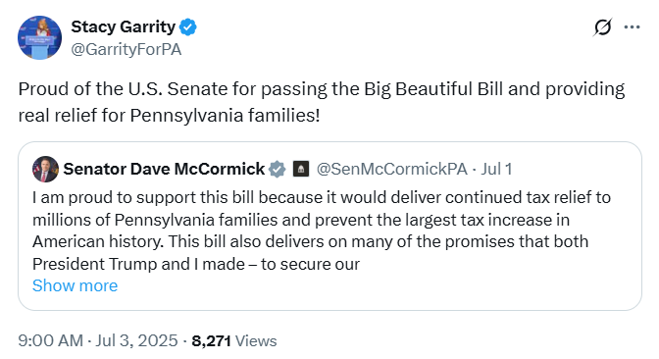
[Twitter, @GarrityForPA, 7/3/25]
2025: Garrity Supported Trump’s One Big Beautiful Bill, Claiming It Was A “Historic Plan” That Reduced “Wasteful Spending,” Extended “Middle-Class Tax Funds,” Achieved “The Biggest Deficit Reduction In Decades,” And Secured The Border. According to Garrity’s Twitter, “As PA’s Treasurer, I know firsthand how important President Trump’s One, Big Beautiful Bill is for families across our Commonwealth. It’s about securing our border, reducing wasteful spending, and putting money back into YOUR pockets. This historic plan permanently locks in Trump’s successful middle-class tax cuts, funds the largest border-security effort in American history, and achieves the biggest deficit reduction in decades. It’s real relief and real results for everyday Pennsylvanians. Members of Congress who oppose President Trump’s One, Big Beautiful Bill are risking higher taxes, weaker borders, and billions wasted on woke policies. It’s time to come together, put America First, and to do the job the American people elected Republicans to do.”
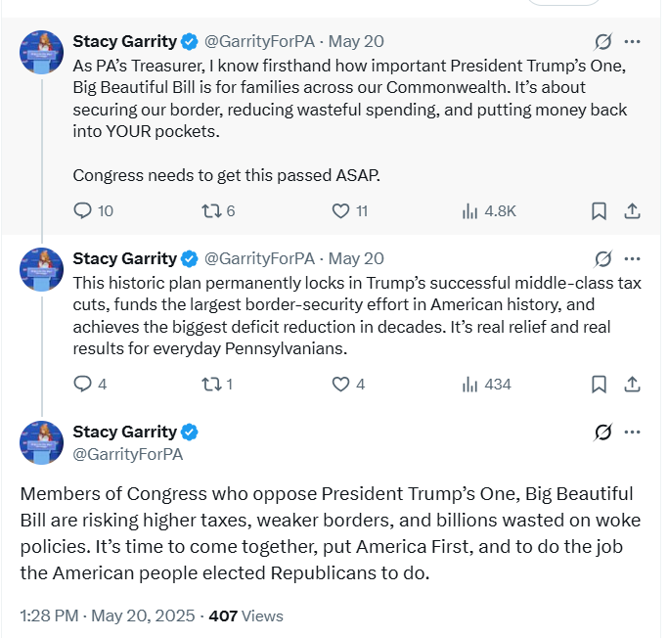
[Twitter, @GarrityForPA, 5/20/25]

The “One Big Beautiful Bill” Contained The Largest SNAP Cut In History
HEADLINE: "Trump’s ‘Big Beautiful Bill’ Cuts Food Stamps For Millions — The Average Family May Lose $146 Per Month, Report Finds" [CNBC, 7/10/25]
The GOP Reconciliation Bill Would Cut SNAP Funding By $186 Billion, Which CBPP Said Constituted The “Largest Cut To SNAP In History.” According to the Center on Budget and Policy Priorities, “The Senate Republican leadership’s reconciliation bill would dramatically raise costs and reduce food assistance for millions of people by cutting federal funding for the Supplemental Nutrition Assistance Program (SNAP) by $186 billion through 2034, according to the Congressional Budget Office (CBO), about 20 percent — the largest cut to SNAP in history. These cuts would increase poverty, food insecurity, and hunger, including among children. The so-called ‘Big Beautiful Bill’ is anything but beautiful; it would cause widespread harm by making massive cuts to Medicaid and SNAP, which would raise costs on families and make it much harder for them to afford the high cost of health care and groceries.” [Center On Budget And Policy Priorities, 6/30/25]
- 22.3 Million Families Would Lose Some Or All Of Their SNAP Benefits, With 5.3 Million Families Losing More Than $25 In Benefits Per Month, And Of Those Families, The Average Loss In Benefits Would Be $146. According to the Urban Institute, “Our preliminary estimates of the SNAP policies in the Senate bill show the following: 22.3 million US families would be affected, losing some or all of their SNAP benefits. Of the total affected families, 5.3 million would lose at least $25 in SNAP benefits per month. Among these families, 3.3 million are families with children, 3.5 million are working families, and 1.7 million are families with a full-time full-year worker. Families losing at least $25 per month would lose $146 per month on average ($1,752 for a full-year recipient). At the state level, average monthly benefit losses for families losing at least $25 per month would range from $72 in Kansas ($864 annually) to $231 in the District of Columbia ($2,772 annually).” [Urban Institute, 7/2/25]
- States That Could Not Afford To Pay The New Mandated SNAP Cost Shares May Cut The Program Entirely. According to CNBC, “Additionally, the legislation requires states to pay for a portion of benefit costs, ranging from 5% to 15%, if their payment error rate is at or over 6%. The error rates measure the accuracy of states’ eligibility and benefit payments. In fiscal year 2024, states had a 10.9% average payment error rate, with many states over 6%, according to the Department of Agriculture. States that can’t pay those shares may have to cut SNAP benefits or opt out of the program entirely, according to the Center on Budget and Policy Priorities.” [CNBC, 7/10/25]
- The House Republican Reconciliation Bill Included Nearly $300 Billion In Cuts To The Supplemental Nutrition Assistance Program. According to the Center on Budget and Policy Priorities, "The House-passed Republican reconciliation plan would cut nearly $300 billion from the Supplemental Nutrition Assistance Program (SNAP) through 2034, based on Congressional Budget Office (CBO) estimates — by far the largest cut to SNAP in history.[1] As a result of these cuts and other policies in the legislation — which are being used to pay partly for trillions in tax cuts skewed to the wealthy — millions of people would lose some or all of the food assistance they need to afford groceries, when many low-income households are struggling to afford the high cost of food and other basic needs." [Center on Budget and Policy Priorities, 5/28/25]
- HEADLINE: "House Republican Budget Takes Away Health Care, Food Aid To Pay For Expanded Tax Cuts For Wealthy" [Center on Budget and Policy Priorities, 2/21/25]
- CBPP Said The Republican Budget Resolution Outlined $230 Billion In Cuts, Primary From SNAP Benefits. According to the Center on Budget and Policy Priorities, "The House Republicans’ budget plan would give major tax cuts to high-income, wealthy households. Extending the expiring individual income and estate tax provisions for households with incomes in the top 5 percent of the income distribution (households with incomes over $321,000) costs around $1.8 trillion through 2034, accounting for 49 percent of the total $3.6 trillion cost of extension through 2034. That $1.8 trillion for wealthy and high-income households is close to the amount of the spending cuts House Republicans have outlined — including at least $880 billion primarily from Medicaid, $230 billion primarily from SNAP benefits, and $330 billion primarily from making student loans more expensive. Of the tax cuts for wealthy households, nearly $200 billion is for an estate tax giveaway that showers some $6 million per estate on the 1 in 1,000 wealthiest estates. In contrast, the average SNAP benefit is $6.20 per person per day, which helps struggling families put food on the table." [Center on Budget and Policy Priorities, 2/21/25]

Nearly 2 Million Pennsylvanians Relied On SNAP Benefits

2025: Nearly 2 Million Pennsylvanians Relied On SNAP Benefits, Including More Than 713,000 Children And 697,000 Seniors
2025: Nearly 2 Million Pennsylvanians Relied On SNAP Benefits, Including More Than 713,000 Children And 697,000 Older Adults. According a Fact Sheet from the Office of Pennsylvania Governor Josh Shapiro, “Today, the Shapiro Administration released a detailed breakdown(opens in a new tab) of the nearly two million Pennsylvanians who will lose Supplemental Nutrition Assistance Program (SNAP) benefits on November 1 as a result of Congressional Republicans’ refusal to reopen the federal government and end the federal shutdown, which will halt SNAP payments nationwide. If the Trump Administration and Republicans in Congress fail to act, nearly two million Pennsylvanians — including more than 713,000 children and 697,000 older adults — could lose access to more than $366 million in monthly food assistance beginning November 1.” [Fact Sheet – Office Of Pennsylvania Governor Josh Shapiro, 10/29/25]

2023: More Than 795,000 Households In Pennsylvania Relied On SNAP
2023: Across Pennsylvania, 795,490 Households Relied On SNAP.
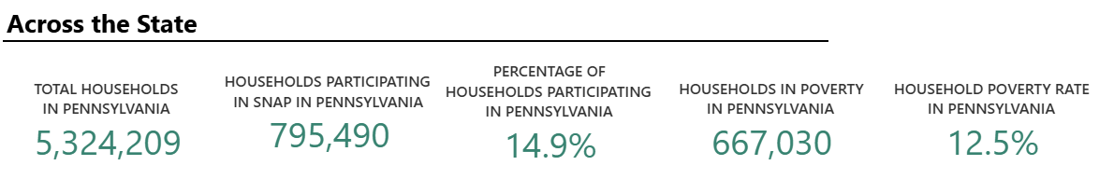
[U.S. Department of Agriculture, SNAP Community Characteristics, Accessed 12/1/25]

