Overview
In 2025, Garrity supported Trump’s “One Big Beautiful Bill,” which repealed clean energy tax credits. According to experts, the repeal of the clean energy tax credits would cause electricity costs to increase in Pennsylvania. Energy Innovation warned the new federal law was expected to decrease Pennsylvania’s generation capacity, raise wholesale electricity costs by $2 billion in 2035, and increase energy bills for Pennsylvanian households: $130 annually by 2030 and $160 by 2035. Center for American Progress warned the law was also expected to increase Pennsylvanians’ gasoline spending by $110 annually by 2030, raise costs for replacing heating, ventilation, and air conditioning units by $2,000, and increase costs to upgrade windows and insulation by $1,200.

Garrity Supported Trump’s “One Big Beautiful Bill,” Even Though Experts Warned It Would Increase Electricity Costs For Pennsylvanian Households

Garrity Supported Trump’s “One Big Beautiful Bill,” Which Cut Clean Energy Tax Credits

Garrity Applauded The Passage Of The “One Big Beautiful Bill,” Falsely Claiming It Would Reduce “Wasteful Spending” And Extend “Middle-Class Tax Funds”
2025: Garrity Said She Was “Proud Of The U.S. Senate For Passing The Big Beautiful Bill,” Misleading That It Would Provide “Real Relief” For Pennsylvanians. According to Garrity’s Twitter, “Proud of the U.S. Senate for passing the Big Beautiful Bill and providing real relief for Pennsylvania families!”
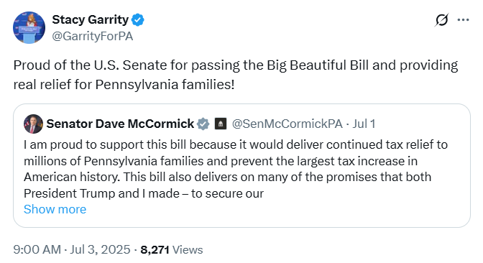
[Twitter, @GarrityForPA, 7/3/25]

2025: Garrity Supported Trump’s One Big Beautiful Bill, Claiming It Was A “Historic Plan” That Reduced “Wasteful Spending,” Extended “Middle-Class Tax Funds,” Achieved “The Biggest Deficit Reduction In Decades,” And Secured The Border. According to Garrity’s Twitter, “As PA’s Treasurer, I know firsthand how important President Trump’s One, Big Beautiful Bill is for families across our Commonwealth. It’s about securing our border, reducing wasteful spending, and putting money back into YOUR pockets. This historic plan permanently locks in Trump’s successful middle-class tax cuts, funds the largest border-security effort in American history, and achieves the biggest deficit reduction in decades. It’s real relief and real results for everyday Pennsylvanians. Members of Congress who oppose President Trump’s One, Big Beautiful Bill are risking higher taxes, weaker borders, and billions wasted on woke policies. It’s time to come together, put America First, and to do the job the American people elected Republicans to do.”
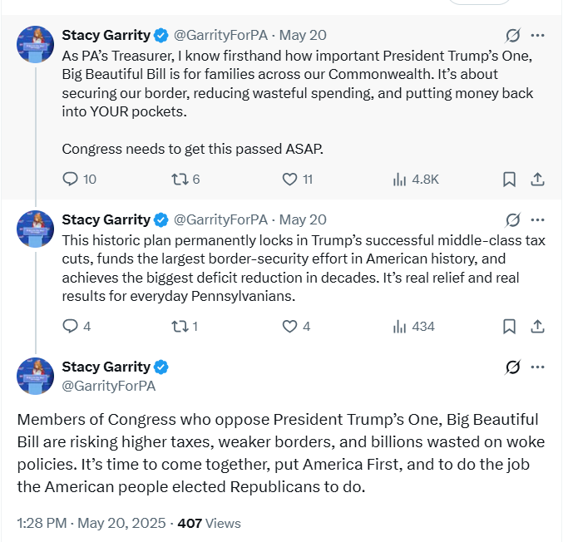
[Twitter, @GarrityForPA, 5/20/25]

The “One Big Beautiful Bill” Cut Certain Clean Energy Tax Credits While Providing Tax Breaks To The Wealthy And Large Corporations
The Republican Reconciliation Bill Restricted The Ability Of Projects To Qualify For Certain Clean Energy Tax Credits. According to Utility Dive, "The bill restricts the ability of projects to qualify for the tech-neutral clean electricity 45Y production tax credit and 48E investment tax credit, shortens the timeline for those credits, and ends the 25D residential solar credit after this year. The 25E, 30D, 30C and 45W electric vehicle credits will terminate after Sept. 30. While clean energy advocates and congressional Democrats maintain that the final version of the bill goes too far in slashing IRA credits, some Republicans wanted to see more significant cuts." [Utility Dive, 7/3/25]
HEADLINE: “By The Numbers: Harmful Republican Megabill Favors The Wealthy And Leaves Millions Of Working Families Behind” [Center On Budget And Policy Priorities, 8/1/25]
The “One Big Beautiful Bill” Provided A Tax Breaks To The Wealthy And Large Corporations, And Raised Costs For Working Class Families. According to the Center on Budget and Policy Priorities, “The harmful Republican megabill gives huge tax breaks to wealthy individuals, businesses, and large corporations while leaving behind or raising costs for millions of working families.” [Center On Budget And Policy Priorities, 8/1/25]

Energy Innovation And Center For American PRogress Warned The New Federal Law Would Decrease Generation Capacity, Increase Energy Bills, And Raise Gasoline Costs In Pennsylvania

Energy Innovation Warned The “One Big Beautiful Bill’s” Phased Out Technology-Neutral Clean Energy Tax Credits And Added “Complex Material-Sourcing Requirements,” Which Would Decrease Generation Capacity In Pennsylvania
Energy Innovation: The “One Big Beautiful Bill’s” Phase Out Of Technology-Neutral Clean Energy Tax Credits And Addition Of “Complex Material-Sourcing Requirements” Would Result In A 13 Gigawatt Decrease In Generation Capacity In Pennsylvania. According to Energy Innovation’s Economic Impacts of the “One Big Beautiful Bill Act” Energy Provisions on Pennsylvania, “By quickly phasing out technology-neutral clean energy tax credits and adding complex material-sourcing requirements, the bill will significantly hamper the development of domestic electricity generation capacity. By 2035, we forecast a 13 gigawatt decrease in generation capacity in Pennsylvania due to the measures in the reconciliation bill.” [Energy Innovation – Economic Impacts Of The “One Big Beautiful Bill Act” Energy Provisions On Pennsylvania, 7/4/25]

Energy Innovation Warned Utility Rates Were Expected To Increase By 6 To 11 Percent For Pennsylvanian Households Under The “One Big Beautiful Bill”
Energy Innovation: The “One Big Beautiful Bill” Was Expected To Increase Utility Rates By 6 To 11 Percent For Pennsylvanian Consumers. According to Energy Innovation’s Economic Impacts of the “One Big Beautiful Bill Act” Energy Provisions on Pennsylvania, “Utilities are expected to pass these costs on to consumers; we forecast the bill will raise electricity rates by 6 to 11 percent for residential, commercial, and industrial consumers in Pennsylvania.” [Energy Innovation – Economic Impacts Of The “One Big Beautiful Bill Act” Energy Provisions On Pennsylvania, 7/4/25]

Energy Innovation And Center For American Progress Warned Energy Bills Would Increase $130 Annually By 2030 And $160 By 2035 For Pennsylvanian Households Under The “One Big Beautiful Bill”
Energy Innovation: The “One Big Beautiful Bill” Was Expected To Increase Energy Bills For Pennsylvanian Households: $130 Annually By 2030 And $160 By 2035. According to Energy Innovation’s Economic Impacts of the “One Big Beautiful Bill Act” Energy Provisions on Pennsylvania, “Households in Pennsylvania will face significantly increased energy costs: We find $130 annual increases in household energy bills by 2030 and $160 by 2035.” [Energy Innovation – Economic Impacts Of The “One Big Beautiful Bill Act” Energy Provisions On Pennsylvania, 7/4/25]
Center For American Progress: The “One Big Beautiful Bill” Was Expected To Increase Electricity Costs In Pennsylvania By An Average Of $100 Annually Starting In 2026. According to the Center for American Progress’ analysis on how The Trump Administration’s One Big Beautiful Bill Act Will Drive Up Costs in Pennsylvania, “Higher household electricity costs: The OBBBA terminates federal clean energy investments that boost the supply of American-made energy. This national electricity rate hike will increase electricity costs in Pennsylvania by an average of $100 per year starting in 2026.” [Center For American Progress – The Trump Administration’s One Big Beautiful Bill Act Will Drive Up Costs In Pennsylvania, 8/6/25]

Center For American Progress Warned The “One Big Beautiful Bill” Would Result In Pennsylvanian Households Spending An Average Of $110 More Per Year By 2030 For Gasoline
Center For American Progress: The “One Big Beautiful Bill” Was Expected To Increase The Demand For Oil, Resulting In A Gasoline Spending Average Of $110 More Per Year By 2030 For Pennsylvanian Households. According to the Center for American Progress’ analysis on how The Trump Administration’s One Big Beautiful Bill Act Will Drive Up Costs in Pennsylvania, “More expensive gasoline costs: The OBBBA’s rollback of vehicle emission regulations and federal electric vehicle affordability programs will increase the demand for oil, which means Pennsylvania households will spend an average of $110 more on gasoline annually by 2030.” [Center For American Progress – The Trump Administration’s One Big Beautiful Bill Act Will Drive Up Costs In Pennsylvania, 8/6/25]

Center For American Progress Warned The “One Big Beautiful Bill’” Would Result In Pennsylvanian Households Paying $2,000 More To Replace Heating, Ventilation, And Air Conditioning Units Or $1,200 More For Upgrades To Windows And Insulation
Center For American Progress: The “One Big Beautiful Bill’s” Termination Of The Energy Efficient Home Improvement Credit Would Result In Pennsylvanian Households Paying $2,000 More To Replace Heating, Ventilation, And Air Conditioning Units Or $1,200 More For Upgrades To Windows And Insulation. According to the Center for American Progress’ analysis on how The Trump Administration’s One Big Beautiful Bill Act Will Drive Up Costs in Pennsylvania, “The OBBBA terminates the Energy Efficient Home Improvement Credit at the end of 2025, which means families making energy efficient improvements will pay $2,000 more to replace a heating, ventilation, and air conditioning unit or $1,200 more for upgrades to windows and insulation in their homes next year.” [Center For American Progress – The Trump Administration’s One Big Beautiful Bill Act Will Drive Up Costs In Pennsylvania, 8/6/25]

Energy Innovation Warned The “One Big Beautiful Bill” Would Result In Increased Wholesale Electricity Costs In Pennsylvania From $10 Billion To $12 Billion In 2035
Energy Innovation: The “One Big Beautiful Bill” Would Result In The “Loss Of Low-Cost Renewables,” And Coupled With Increases In Gas Prices, Would Increase Wholesale Electricity Costs By 9 Percent By 2030 And 18 Percent By 2035. According to Energy Innovation’s Economic Impacts of the “One Big Beautiful Bill Act” Energy Provisions on Pennsylvania, “The loss of low-cost renewables and the resulting increase in gas prices would increase electricity prices in Pennsylvania. We forecast that wholesale electricity prices increase by 9 percent by 2030 and 18 percent by 2035.” [Energy Innovation – Economic Impacts Of The “One Big Beautiful Bill Act” Energy Provisions On Pennsylvania, 7/4/25]
Energy Innovation: The “One Big Beautiful Bill” Was Expected To Increase Wholesale Electricity Costs In Pennsylvania From $10 Billion To $12 Billion In 2035. According to Energy Innovation’s Economic Impacts of the “One Big Beautiful Bill Act” Energy Provisions on Pennsylvania, “Wholesale electricity costs in Pennsylvania would balloon from $10 billion in 2035 with current policies to $12 billion in the Senate scenario, a 17-percent increase over current policies.” [Energy Innovation – Economic Impacts Of The “One Big Beautiful Bill Act” Energy Provisions On Pennsylvania, 7/4/25]

Energy Innovation Warned The “One Big Beautiful Bill” Was Expected To Cost $2.3 Billion In GDP By 2030 And $3.6 Billion In Pennsylvania
Energy Innovation: The “One Big Beautiful Bill” Would Trigger A Decline In New Energy Sources, Advanced Manufacturing And Private Investment, Which Was Expected To Cost $2.3 Billion In GDP By 2030 And $3.6 Billion In Pennsylvania. According to Energy Innovation’s Economic Impacts of the “One Big Beautiful Bill Act” Energy Provisions on Pennsylvania, “As deployment of new energy resources and advanced manufacturing decline under the bill, Pennsylvania will lose out on significant planned private investment. We forecast annual losses of $2.3 billion in GDP by 2030 and $3.6 billion by 2035 in Pennsylvania.” [Energy Innovation – Economic Impacts Of The “One Big Beautiful Bill Act” Energy Provisions On Pennsylvania, 7/4/25]

Energy Innovation Warned The “One Big Beautiful Bill’s” Energy Provisions Were Expected To Result In 16,000 Job Losses In 2030 And 21,000 Job Losses By 2035 In Pennsylvania
Energy Innovation: The “One Big Beautiful Bill’s” Energy Provisions Were Expected To Result In 16,000 Job Losses In 2030 And 21,000 Job Losses By 2035 In Pennsylvania. According to Energy Innovation’s Economic Impacts of the “One Big Beautiful Bill Act” Energy Provisions on Pennsylvania, “Summed through the budget window, energy provisions in the final bill would cost Pennsylvania $21 billion in GDP. Workers will suffer from factory closures and construction halts. We forecast job losses of 16,000 jobs in 2030 and 21,000 jobs in 2035 in Pennsylvania due to the Senate bill.” [Energy Innovation – Economic Impacts Of The “One Big Beautiful Bill Act” Energy Provisions On Pennsylvania, 7/4/25]

