Overview
Garrity was an election denier who opposed mail-in ballots, except for when Republicans used them. Although Garrity tried to walk back her election denialism, Garrity claimed Trump won the 2020 election and spoke at a rally one day before the January 6 insurrection to cast doubt on the 2020 election results.
While Garrity claimed she did not like mail-in ballots and said Trump had a “legitimate concern” over voter fraud, she also touted Republicans “stepping up” in embracing mail-in voting.

Garrity Was An Election Denier And Tried To Walk Back Her Election Denialism

Garrity Said “We Know That [Trump] Won” The 2020 Election
2022: At An Event With Trump, Garrity Said “We Know That He Won” The 2020 Election. According to the Pittsburgh Post-Gazette, “Each speaker ahead of Mr. Trump talked about election integrity efforts, and organizers played parts of a new film that alleges without evidence that there was an organized effort from left-wing groups to deliver multiple ballots at one time to drop boxes throughout states. At one point, he asked state Treasurer Stacy Garrity to come speak to the crowd. ‘We know that he won,’ Ms. Garrity said, who won her election and unseated an incumbent in the same election as Mr. Trump’s loss in 2020.” [Pittsburgh Post-Gazette, 5/6/22]

One Day Before The January 6 Insurrection, Garrity Spoke At A Rally Which Sought To Cast Doubt On The 2020 Election Results And Later Tried To Walk Back The Election Denialism

January 5, 2021: Garrity: “I’m Speaking About Election Integrity… The Election From This November Is Tarnished Forever”
January 5, 2021: One Day Before The January 6 Insurrection, Garrity Spoke At A Rally Which Sought To Cast Doubt On The 2020 Election Results. According to Spotlight PA, “Garrity, the state treasurer and likely GOP gubernatorial candidate, is a longtime Trump ally who has touted her support for the president since announcing her candidacy earlier this year. She spoke at a rally that sought to cast doubt on the results of the 2020 election, a day before the Jan. 6 attack on the U.S. Capitol and endorsed Trump for a second term.” [Spotlight PA, 11/17/25]
- January 5, 2021: Garrity: “Let There Be No Question, I’m Speaking About Election Integrity… The Election From This November Is Tarnished Forever.” According to the Pennsylvania Capital-Star, “On Jan. 5, 2021, then-Treasurer elect Stacy Garrity stood before a cold crowd at the Pennsylvania Capitol, at a rally intended to push lawmakers to decertify the results of the presidential election in Pennsylvania. ‘Let there be no question, I’m speaking about election integrity,’ Garrity said to a crowd waving Trump flags that had cheered on speaker after speaker decrying a stolen presidency. ‘The election from this November is tarnished forever.’” [Pennsylvania Capital-Star, 10/11/24]

Garrity’s Campaign Tried To Walk Back Garrity’s Election Denialism, Claiming That She Spoke About Inconsistencies In The State Senate’s 45th District
2024: Garrity’s Campaign Tried To Walk Back Garrity’s Election Denialism, Claiming That She Spoke About The “Inconsistent Application Of Ballot Counting Rules That Directly Affected The Outcome Of A State Senate Race In The 45th District” At The January 5, 2021 Rally. According to the Pennsylvania Capital-Star, “On Jan. 5, 2021, then-Treasurer elect Stacy Garrity stood before a cold crowd at the Pennsylvania Capitol, at a rally intended to push lawmakers to decertify the results of the presidential election in Pennsylvania. ‘Let there be no question, I’m speaking about election integrity,’ Garrity said to a crowd waving Trump flags that had cheered on speaker after speaker decrying a stolen presidency. ‘The election from this November is tarnished forever.’ But, according to her re-election campaign, Garrity wasn’t talking about that election. ‘Stacy Garrity spoke at the January 5 rally in Harrisburg on one issue and one issue alone: the inconsistent application of ballot counting rules that directly affected the outcome of a state senate race in the 45th District,’ said Jim Tkacik, a spokesperson for her campaign. Tkacik also said that Garrity accepts the results of the 2020 election, and will accept the results of the 2024 election, even if former President Donald Trump, the GOP nominee, loses.” [Pennsylvania Capital-Star, 10/11/24]
- When The Pennsylvania Capital-Star Questioned Garrity’s Campaign On Her Lack Of Mentioning The 45th District In Her Rally Speech, Garrity’s Campaign Responded With Saying That Garrity Recognized Biden As The “Duly Elected President Of The United States.” According to the Pennsylvania Capital-Star, “The only available video of Garrity’s speech, published by a partisan blog, appears to begin in the middle of her remarks, yet in the three minutes available, she never mentions the 45th district. When questioned about these inconsistencies, Tkacik said, ‘Treasurer Garrity has previously stated that Joe Biden is the duly elected president of the United States. Pennsylvanians are reminded of this reality every time they fill up their gas tanks or buy groceries.’” [Pennsylvania Capital-Star, 10/11/24]

Garrity Said She Opposed Pennsylvania’s Mail-In Ballot System Except For Republicans Voting By Mail

Garrity Said She Opposed Pennsylvania’s Mail-In Ballot System, But Previously Touted Republicans Embracing Mail-In Ballots In 2023

Garrity Said She Opposed Pennsylvania’s Mail-In Ballot System And Preferred Florida’s Model With Early Voting And “Faster Results”
2025: Garrity Said She Opposed Pennsylvania’s Mail-In Ballot System, Did Not Like Mail-In Ballot Generally, And Preferred Florida’s Model With Early Voting And “Faster Results.” According to Fox 43, “The treasurer also addressed election law, saying she opposes Pennsylvania’s current mail-in ballot system but would work within it as long as it remains in place. ‘I don’t like mail-in ballots, but those are the rules of the game right now,’ she said. ‘I prefer Florida’s model with early in-person voting and faster results. That’s a system we should look at.’” [Fox 43, 8/24/25]
August 2025: Garrity Said She Did Not “Like Mail-In Ballots” And Trump Had “A Legitimate Concern Around […] How You Police The Fraud,” But Noted That Mail-In Voting Was “The Rules Of The Game In Pennsylvania.” According to Garrity in an interview with WPMT, “HOST: President Donald Trump has called on mail-in voting to be eliminated despite no evidence of widespread fraud in the process. GARRITY: I don't like mail-in ballots either, but you know what? That's the rules of the game in Pennsylvania. And if you want to be on the game, you got to be on the field. Now, I think President Trump has a legitimate concern around the, you know, how you police the fraud.” [Stacy Garrity Interview – WPMT, 8/22/25] (VIDEO)

Garrity Touted That Republicans Were “Stepping Up” By Embracing Mail-in Ballots
2023: Garrity Touted That Republicans Were “Stepping Up” By Embracing Mail-in Ballots. Garrity tweeted, “You win elections by reaching voters and maximizing turnout. The surge in applications for mail-in ballots shows Republicans are stepping up our game and becoming more competitive than ever. 💪”
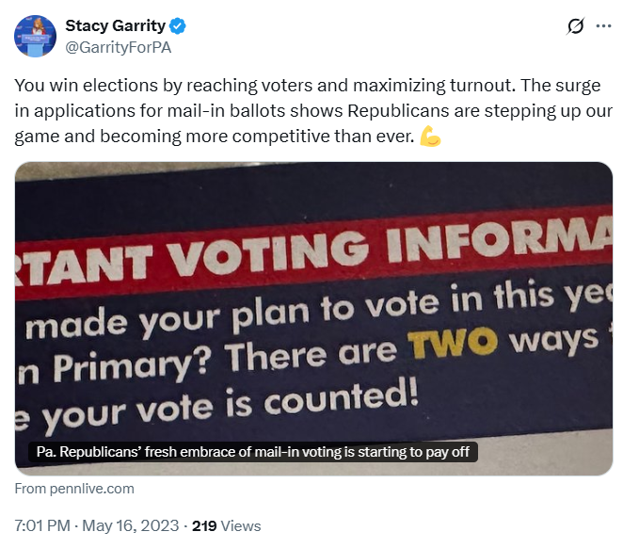
[Twitter, @GarrityForPA, 5/16/23]

