Overview
Mastriano, who made baseless claims about election fraud, supported measures that threatened the voting rights of Pennsylvanians.
- Although he voted for Act 77 in 2019, which expanded mail-in voting in Pennsylvania, Mastriano supported legislation to repeal no-excuse mail-in voting.
- Despite it violating federal law, Mastriano said he wanted every Pennsylvanian to re-register to vote.
- Mastriano introduced legislation to purge Pennsylvania’s voter rolls, and voted for a constitutional amendment to mandate voter I.D. in Pennsylvania.
- Mastriano co-sponsored and voted for legislation to ban the use of ballot drop boxes and co-sponsored and voted for legislation to ban private funds for elections administration.
- Mastriano sponsored and voted for the Poll Watcher Empowerment Act, claiming reforms to partisan election observers would “restore trust and integrity in elections.”

Mastriano Supported Measures To Further Restrict The Right To Vote In Pennsylvania

Mastriano “Spread Baseless Claims About Election Fraud”
2022: Mastriano “Spread Baseless Claims About Election Fraud.” According to NBC Philadelphia, “The sponsor, state Sen. Doug Mastriano, the Republican nominee for governor who has spread baseless claims about election fraud, said the bill would ‘restore trust and integrity in elections.’” [NBC Philadelphia, 6/7/22]

Despite Voting For Act 77, Which Expanded Mail-In Voting, Mastriano Wanted To End “No-Excuse” Mail Voting In Pennsylvania

Mastriano Supported Legislation To Repeal “No-Excuse” Mail-In Voting In Pennsylvania
2022: Mastriano: “I Welcome The End Of ‘No-Excuse’ Mail-In Voting In Pennsylvania.” According to Ballotpedia News in response to the Pennsylvania Supreme Court striking down the state no-excuse absentee voting law, “State Sen. Doug Mastriano (R) said, ‘I welcome the end of ‘no-excuse’ mail-in voting in Pennsylvania and I introduced legislation this session that does just that.’” [Ballotpedia News, 2/2/22]
2022: Mastriano Said He Supported Legislation Introduced In The Senate To “Repeal No-Excuse Mail-In Voting, Mandate Signature Verification, Establish An Elections Commission, Expand The Number Of Poll Watchers And Bolster Their Protection.” According to a press release from Mastriano, “I stand behind legislation introduced in the Senate to repeal no-excuse mail-in voting, mandate signature verification, establish an Elections Commission, expand the number of poll watchers and bolster their protection so that these unsavory practices become relics of the past.” [Press Release – Senator Mastriano, 8/3/22]

Other Republicans Scrutinized Mastriano For Supporting Act 77, Which Expanded Mail-In Ballots In Pennsylvania
2022: Montgomery County Commissioner Joe Gale Called Out Mastriano At The Susquehanna Valley Forum, Calling Him “Mail-In Mastriano” Due To His Support For Act 77. According to WKOK, “Current Montgomery County Commissioner Joe Gale called out Republicans who voted for the Act 77 mail-in voting bill during a candidates’ forum Monday night hosted by the Susquehanna Valley Conservatives, ‘And one of the candidates running for Governor is Doug Mastriano, who I call Doug ‘mail-in’ Mastriano. In my opinion, anyone who voted for that disastrous legislation should be disqualified for running for any office.” [WKOK, 4/12/22]
After Being Criticized For Voting Yes On Act-77, Mastriano Responded That The Law Was “Unconstitutionally Interpreted By The Pennsylvania Supreme Court.” According to the Philadelphia Inquirer, “‘I’m proud of my record as U.S. Attorney,’ McSwain said in a statement. ‘When I’m governor, we’re going to get back to a voting system that everyone has confidence in, and that begins with repealing the unconstitutional mail-in balloting law, Act 77, that Doug Mastriano voted for.’ Mastriano shot back that the law was unconstitutionally interpreted by the Pennsylvania Supreme Court, and added: ‘Both President Trump and I are fighting the same battles on behalf of the people.’” [Philadelphia Inquirer, 4/12/22]
- 2019: Mastriano Voted For SB 421, Ultimately Known As Act 77 Of 2019. According to the Pennsylvania General Assembly, “An Act amending the act of June 3, 1937 (P.L.1333, No.320), known as the Pennsylvania Election Code, in preliminary provisions, further providing for definitions; […] in voting by qualified absentee electors, further providing for applications for official absentee ballots, for date of application for absentee ballot, for approval of application for absentee ballot, for absentee electors files and lists, for official absentee voters ballots, for delivering or mailing ballots, for voting by absentee electors, for canvassing of official absentee ballots and for public records; providing for voting by qualified mail-in electors; […] Last Action: Act No. 77 of 2019, Oct. 31, 2019 [Pennsylvania General Assembly, SB 421, 10/31/19, Votes 10/29/19]
- Act 77 Of 2019 Enacted Several Election Law Reforms, Including No-Excuse Mail-In Voting. According to the ACLU of Pennsylvania, “The consolidated lawsuits McLinko v. Commonwealth and Bonner v. Commonwealth are state constitutional challenges to Act 77 of 2019. That law implemented numerous election law reforms, including no-excuse absentee voting, or what is sometimes called vote-by-mail.” [ACLU Of Pennsylvania, 2/18/22]

Despite It Violating Federal Law, Mastriano Wanted To Make Pennsylvania Voters Re-Register To Vote
2022: Mastriano Said He Wanted To Make Everyone In Pennsylvania Re-Register To Vote, Despite This Violating Federal Law. According to WESA, “A state senator and retired U.S. Army colonel, Mastriano says he wants to make everyone re-register if they want to vote again. The concept flatly violates federal law, legal scholars say, and may conflict with state law, not to mention constitutional protections. […] Scholars who specialize in election law said they had never heard of a state doing anything similar recently — probably because there are laws designed to prevent it. It is certainly barred by the National Voter Registration Act, at least for federal elections, and likely runs into significant protections under the federal — and possibly the state — constitution and laws, constitutional law scholars say.” [WESA, 6/5/22]
- The National Voter Registration Act Restricted States From Unilaterally Purging Voter Rolls. According to WESA, “The National Voter Registration Act allows states to remove voters from rolls at a person's request and requires states to make a ‘reasonable’ effort to keep voter registration lists free of people who died or moved away. But it also restricts the power of states to unilaterally purge voter rolls.” [WESA, 6/5/22]
Philadelphia Tribune: “Legal Scholars Say Mastriano’s Proposal Violates Federal Law And Is A Throwback To Laws Designed By White People In Past Eras To Keep Black People Or Newer European Immigrants From Voting.” According to the Philly Trib, “In a gubernatorial primary debate in April, Mastriano said that, if elected, he would require voters to ‘re-register. We’re going to start all over again.’ […] Also, someone who registers to vote must swear that they are a U.S. citizen and are asked to provide either a driver’s license number or a Social Security number. Someone who cannot provide either one must still show a form of identification that meets Pennsylvania law the first time they vote. Research also found that such laws also had a strong class bias and effectively suppressed the vote of working- and middle-class residents, in addition to minorities. […] Legal scholars say Mastriano’s proposal violates federal law and is a throwback to laws designed by white people in past eras to keep Black people or newer European immigrants from voting. [Philly Trib, 6/7/22]

Mastriano Supported Voter Roll Purges And Restrictive Voter ID Laws

Mastriano Introduced Legislation To Purge Voter Rolls And Called For Every Pennsylvanian To Re-Register To Vote

2022: Mastriano Introduced A Bill That Would Remove Deceased Voters From Voter Rolls Within 7 Days Of Their Death. According to Senator Mastriano’s Twitter, “Were you aware that over 20,000 deceased registered voters may have still been on the voter rolls shortly before the 2020 election? I’m introducing a bill to ensure timely removal of deceased voters within 7 days.”
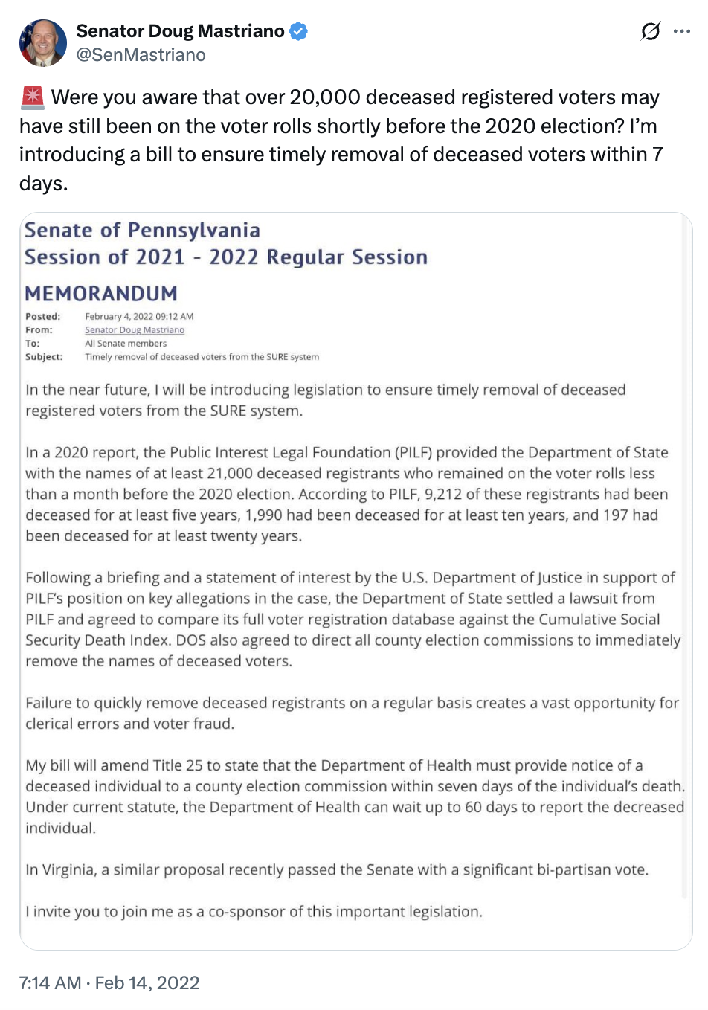
[Twitter @SenMastriano, 2/14/22]
2022: During The Debate, Mastriano Said He Would Clean Up Election Logs And Require Everyone In Pennsylvania To Re-Register To Vote. According to the Philadelphia Inquirer, “And Mastriano said he would ‘clean up the election logs’ — appearing to call for all nine million Pennsylvania registered voters to have their registrations wiped off the books. ‘We are going to reset, in fact, registration,’ he said. ‘You have to re-register. We’re going to start all over again.’” [Philadelphia Inquirer, 4/27/22]

Mastriano Voted For A Constitutional Amendment Mandating Voter ID In Pennsylvania
2022: Mastriano Called For A Constitutional Amendment That Would Require Voter ID In Pennsylvania. According to PennLive, “Mastriano on Saturday told the crowd the solution is to elect only candidates who make addressing election fraud their highest priority. He further called for a state constitutional amendment requiring voter ID in Pennsylvania.” [PennLive, 3/19/22]
2021: Mastriano Voted For SB 735, Which Would Propose A Constitutional Amendment Mandating Identification To Vote. According to the Pennsylvania General Assembly, “A Joint Resolution proposing an amendment to the Constitution of the Commonwealth of Pennsylvania, further providing for qualifications of electors. […] Constitutional Amendment: Providing for Voter Identification” [Pennsylvania General Assembly, SB 735, 6/23/21, Votes, 6/23/21]
2022: Mastriano On Voter ID: “Is It Too Much To Ask For An ID When It Comes To Exercising Something As Sacred As Safeguarding The Right To Vote.” According to Mastriano’s Facebook, “A Constitutional Amendment to require Voter ID for all forms of voting passed the Senate last week. Citizens currently need a photo ID for everyday activities such as buying a beer or cigarettes; checking into a hospital or hotel; applying for public assistance; buying a gun or hopping on an airplane. Is it too much to ask for an ID when it comes to exercising something as sacred as safeguarding the right to vote?”
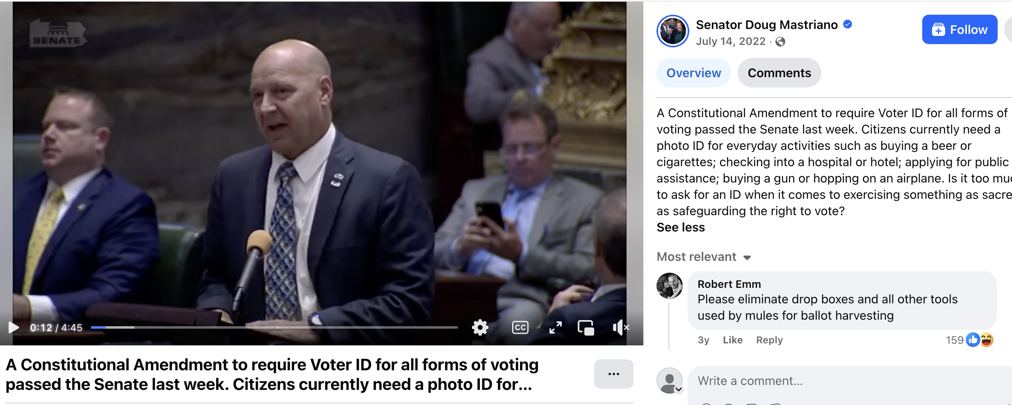
[Facebook, Senator Doug Mastriano, 7/14/22]

Mastriano Voted For Legislation To Ban Ballot Drop Boxes And Ban Private Funds For Election Administration
2022: Mastriano Voted For SB 1200, Which According To The PA Senate GOP, Would Prohibit Ballot Boxes, Requiring All Mail-In Ballots To Be Delivered To Their County’s Primary Office. According to the PA Senate GOP, “The committee also voted to approve Senate Bill 1200, sponsored by Senator Cris Dush (R-Jefferson), which would require that persons delivering mail-in ballots may only deliver such ballots at their county’s primary office.” [PA Senate GOP, 4/11/22, SB 1200, Votes, 4/13/22]
- April 2022: Mastriano Co-Sponsored Legislation That Banned The Use Of Ballot Drop Boxes, Claiming It Addressed “Ballot Harvesting” In The 2020 And 2021 Elections. According to the PA Senate GOP via Archive.org, “In a significant victory for election integrity, two bills co-sponsored by Senator Doug Mastriano passed the full Senate today. The first bill, SB 982, prohibits the use of private funds for the administration of elections. During the 2020 election, partisan liberal groups funded by Mark Zuckerberg disproportionally awarded grants to influence turnout in left-leaning counties. The second bill, SB 1200, bans the use of drop boxes and clarifies that ballots may only be dropped off to an employee at a county board of elections office. Collecting and dropping off ballots on behalf of others is illegal in Pennsylvania. This violation, known as ballot harvesting, was proven to be prevalent in the 2020 and 2021 general elections.” [PA Senate GOP via Archive.org, 4/13/22]
2022: Mastriano Voted For Senate Bill 982, Which Amended The Pennsylvania Election Code In Preliminary Provisions, Provided For Public Funding Of Elections, Established The Election Integrity Grant Program, And Provided Penalties For Violation Of Public Funding Of Elections. According to the Pennsylvania General Assembly, “Senate Bill 982… An Act amending the act of June 3, 1937 (P.L.1333, No.320), known as the Pennsylvania Election Code, in preliminary provisions, providing for public funding of elections; in county boards of elections, further providing for powers and duties of county boards; establishing the Election Integrity Grant Program; and, in penalties, providing for violation of public funding of elections.” [Pennsylvania General Assembly, SB 982, 7/11/22, Votes, 7/7/22]
- April 2022: Mastriano Co-Sponsored Legislation That Prohibited Private Funds For Administration Of Elections, In Response To Mark Zuckerberg-Funded Groups Awarding Grants To Counties During The 2020 Election. According to the PA Senate GOP via Archive.org, “In a significant victory for election integrity, two bills co-sponsored by Senator Doug Mastriano passed the full Senate today. The first bill, SB 982, prohibits the use of private funds for the administration of elections. During the 2020 election, partisan liberal groups funded by Mark Zuckerberg disproportionally awarded grants to influence turnout in left-leaning counties. The second bill, SB 1200, bans the use of drop boxes and clarifies that ballots may only be dropped off to an employee at a county board of elections office. Collecting and dropping off ballots on behalf of others is illegal in Pennsylvania. This violation, known as ballot harvesting, was proven to be prevalent in the 2020 and 2021 general elections.” [PA Senate GOP via Archive.org, 4/13/22]
- 2022: Mastriano Congratulated State Senators Lisa Baker And Kristin Phillips-Hill For The Passage Of SB 982 And Said It Was “A Big Step In Restoring Confidence In Our Elections.” According to Senator Mastriano’s Twitter, “Congratulations to @SenLisaBaker @SenatorKristin on the passage of SB 982, which is a big step in restoring confidence in our elections.”
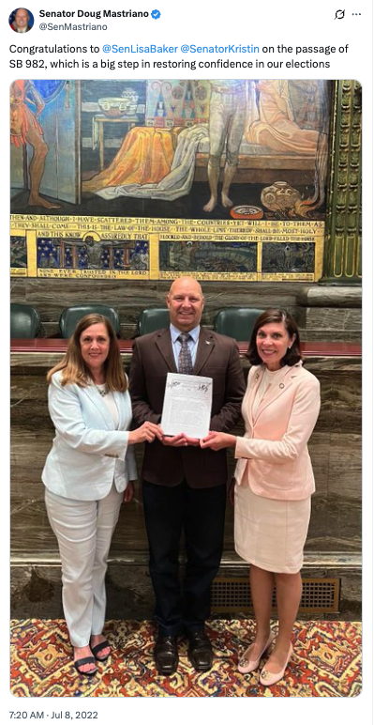
[Twitter, @SenMastriano, 7/8/22]

Mastriano Sponsored The Poll Watcher Empowerment Act
2022: Mastriano Sponsored Legislation That Ordered A “Number Of Changes To State Laws Over Partisan Election Observers In Polling Places And Election Offices” To “Restore Trust And Integrity In Elections.” According to NBC Philadelphia, “Pennsylvania's Republican-controlled Senate approved a bill Monday that orders a number of changes to state laws over partisan election observers in polling places and election offices, a throwback to complaints in 2020 by former President Donald Trump that the Democratic bastion of Philadelphia needed to be watched closely for election fraud. […] The sponsor, state Sen. Doug Mastriano, the Republican nominee for governor who has spread baseless claims about election fraud, said the bill would ‘restore trust and integrity in elections.’” [NBC Philadelphia, 6/7/22]
- Senate Bill 573, The Poll Watcher Empowerment Act Would Allow Registered Voters In Pennsylvania To Be Eligible To Be A Poll Watcher In Any Precinct Of The Commonwealth. According to the PA Senate GOP, “The State Senate approved legislation today sponsored by Senator Doug Mastriano (R-33) that would ensure poll watchers can properly safeguard the integrity of Pennsylvania’s election process. Senate Bill 573 – the Poll Watcher Empowerment Act – would allow all registered voters of Pennsylvania to be eligible to be a poll watcher in any precinct in the state of Pennsylvania.” [PA Senate GOP, 6/6/22]
- Mastriano Sponsored And Voted For The Poll Watcher Empowerment Act. According to the Pennsylvania General Assembly, “An Act amending the act of June 3, 1937 (P.L.1333, No.320), known as the Pennsylvania Election Code, in district election officers, further providing for appointment of watchers; in voting by qualified absentee electors, further providing for canvassing of official absentee ballots and mail-in ballots; and, in penalties, further providing for refusal to permit overseers, watchers, attorneys or candidates to act, for prohibiting duress and intimidation of voters and interference with the free exercises of the elective franchise and for hindering or delaying performance of duty. […] Poll Watcher Empowerment Act” [Pennsylvania General Assembly, SB 573, 6/6/22 Votes, 6/6/22]

