Overview
In 2025, Mastriano supported Trump’s tariffs, which were dooming Pennsylvanians to a trade war and rising prices.
Tariffs are contributing to higher food prices and are hurting Pennsylvania small businesses and families. From January to May 2025, Pennsylvanians faced an estimated cost of $1.6 billion in tariffs. Despite this, Mastriano called Trump’s tariffs “‘reciprocal’ to level the playing field,” even as the U.S. stock market crashed due to Trump’s escalating global trade war.

Mastriano Supported Trump’s Tariffs Despite The Harm They Could Cause To Pennsylvania’s Economy

Mastriano Supported Trump’s Devastating Tariffs

Mastriano Called Trump’s Tariffs “‘Reciprocal’ To Level The Playing Field,” And Claimed They Would Create Jobs
April 4, 2025: Mastriano Called Trump’s Tariffs “‘Reciprocal’ To Level The Playing Field,” And Claimed The Tariffs Would “Boost American Jobs, Businesses And Industry.” According to Senator Doug Mastriano’s Facebook, “Here is the list of tariffs that foreign nations have in place against the United States for decades and President Trump’s ‘reciprocal’ to level the playing field. In most cases, the others have double what Trump put in place. Unlike what Shapiro is saying, these will in tune boost American jobs, businesses and industry, which will boost our economy”
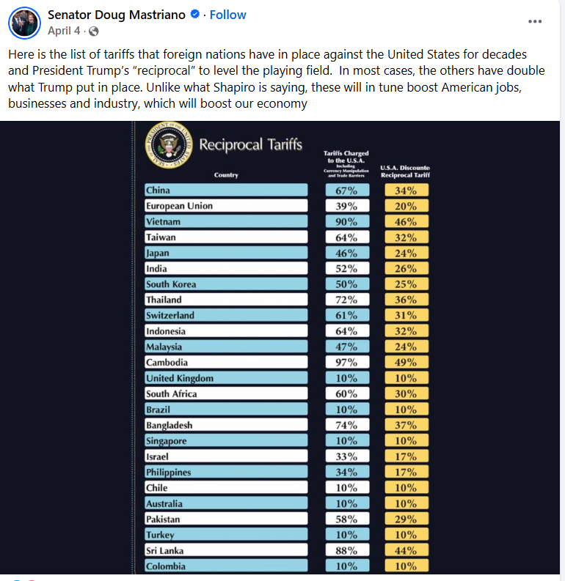
[Facebook, Senator Doug Mastriano, 4/4/25]

April 5, 2025: Mastriano Shared A TikTok “Explaining” Tariffs, Which Claimed That Tariffs Were A “Key Part Of Economic Independence.” According to Senator Doug Mastriano’s Facebook, “Tariffs explained”
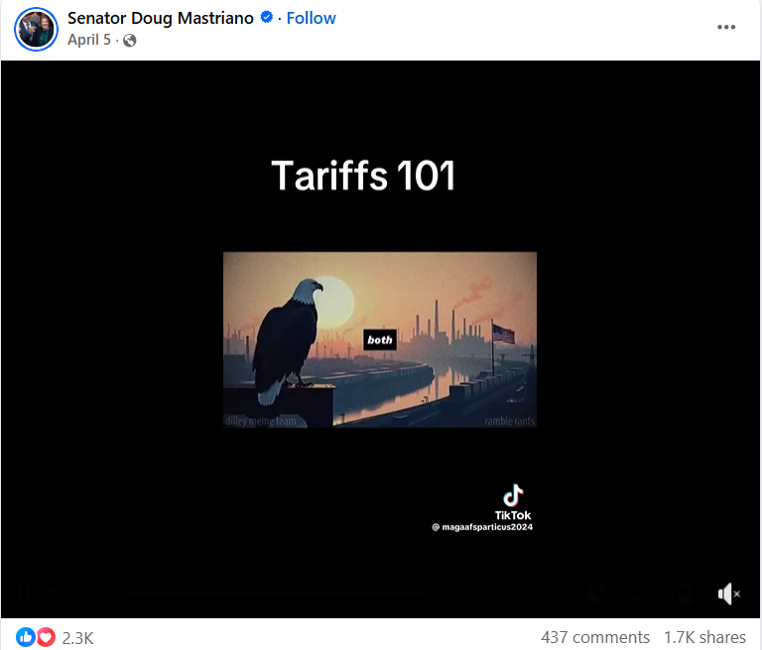
[Facebook, Senator Doug Mastriano, 4/5/25]

May 2025: Mastriano Uplifted A Video Of Trump Announcing Tariffs On Steel Imports To 50 Percent. According to Senator Doug Mastriano’s Facebook,
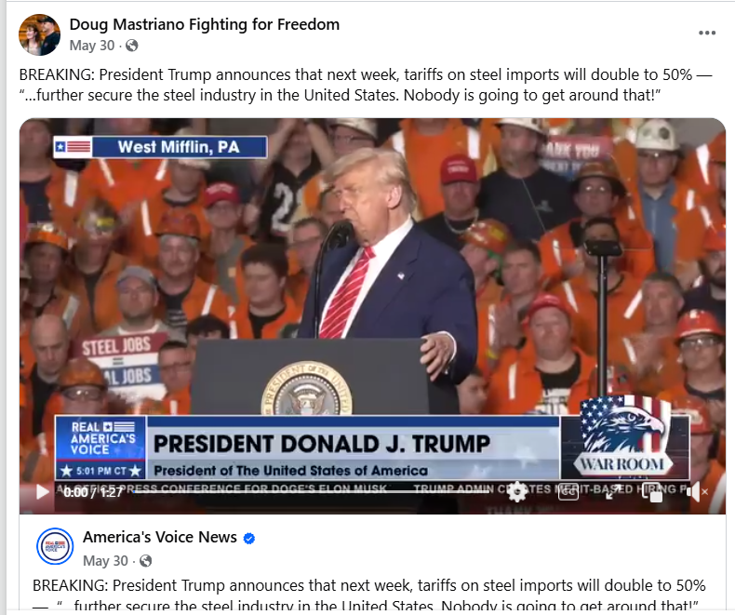
[Facebook, Doug Mastriano Fighting For Freedom, 5/30/25]

The U.S. Stock Market Crashed As Trump’s Tariffs “Escalated A Global Trade War”
April 2-4, 2025: The U.S. Stock Market Crashed As Trump’s Tariffs “Escalated A Global Trade War And Wiped Out Trillions Of Dollars In Value.” According to NPR, “Wall Street plummeted for a second straight day on Friday, as President Trump's tariffs escalated a global trade war and wiped out trillions of dollars in value from the U.S. stock market. The two-day selloff served as the financial community's most brutal warning yet about the potential fallout of Trump's trade policy. Investors, businesses, and consumers are all expressing mounting terror about how these sweeping new taxes could upend the global economy.” [NPR, 4/4/25]

Trump’s Tariffs Were Hurting Small Businesses And Families In Pennsylvania

Trump’s Tariffs Would Likely Increase Costs By $2,400 To $3,400 Per Family As Inflation Increased Due To The Tariffs
HEADLINE: “Grocery Inflation Highest Since 2022 As Trump Tariffs Pile Up” [Axios, 9/16/25]
Yale Budget Lab: Trump’s Tariffs Would Likely Increase Costs By $2,400 To $3,400 Per Family, And Lower-Income Families Would Bear A Greater Financial Burden. According to the Pennsylvania Capital-Star, “According to reporting by States Newsroom, rising prices under Trump’s tariff scenario are likely to cost an extra $2,400 to $3,400 per family, according to the Yale Budget Lab, with most of the financial burden falling on the lowest-income households.” [Pennsylvania Capital-Star, 4/7/25]
Peterson Institute On International Economics: Average American Households Would Lose More Than $1,200 From Tariffs Imposed Against China, Canada, And Mexico. According to the Pennsylvania Capital-Star, “An analysis from the Peterson Institute on International Economics estimated the typical American household would lose over $1,200, just from the 25% tariffs already imposed on China, Canada and Mexico.” [Pennsylvania Capital-Star, 4/7/25]

In The First Half Of 2025, Pennsylvanians Experienced An Estimated Tariff Impact Of $1.6 Billion
Trade Partnership Worldwide: From January To May 2025,: Pennsylvanians Experienced An Estimated Tariff Impact Of $1.6 Billion. According to Axios, “Tariffs imposed by President Trump have generated tens of billions of dollars in revenue for the government — but the burden falls far from equally on different states. The big picture: Who pays for tariffs is a long-settled issue — American businesses do, to the tune of billions of dollars. By the numbers: From Jan. 1 to May 31 of this year, Pennsylvania faced a tariff impact of $1.6 billion. Driving the news: Economic research firm Trade Partnership Worldwide shared an analysis with Axios showing the state-by-state cost of tariffs imposed by Trump during that period” [Axios, 7/16/25]

Pennsylvania Small Businesses Increased Prices Due To Trump’s Tariffs
November 2025: Zach Gieg, President Of Just Press Play In Lancaster, A Toy And Video Game Small Business, Said That Every Item In The Store Increased 10 To 15 Percent Due To Tariffs. According to Fox 43, “Retailers across Pennsylvania are stocking their shelves, as they prepare to kick off the holiday shopping season. However, many small business owners believe that tariffs will mar customers' shopping experience. ‘Ultimately, it affects the bottom line for us and our customers,’ said Zach Gieg. Gieg is the president of Just Press Play in Lancaster, a small business that sells toys, collectables and video games. He said he's seen a 10-15% markup to every item in the store, adding that most of them come from overseas. ‘When Sony raises the price of a PS5 from $499 to $549, that is absolutely a direct impact from the tariffs,’ said Gieg.” [Fox 43, 11/26/25]
November 2025: David Astuto, The Owner Of Dave's Toybox In Mount Joy, Said Japanese-Made Toys “Skyrocketed” In Price And Added That Clients Were Starting To “Cut Back On Their Spending, Due To Tariffs Causing Price Hikes In Other Areas.” According to Fox 43, “Meanwhile, David Astuto, the owner of Dave's Toybox in Mount Joy, said he's relying on domestic suppliers to avoid paying tariffs for international toys. He said items like Pokémon cards and Labubus, which are made in Japan, have skyrocketed in price. ‘It's hard for me to order them because I would have to raise the prices, and it would really hurt my customers' ability to buy stuff,’ said Astuto. Astuto added that customers are beginning to cut back on their spending, due to tariffs causing price hikes in other areas. ‘They want to buy a Lego set; they want to buy a video game system,’ said Astuto. ‘But it’s really tough for them when they have home costs that are rising.’ Retailers say they are doing their best to offer sales and eat some of the costs, so that families can get a good deal this holiday season.” [Fox 43, 11/26/25]

