Overview
Mastriano mocked the Affordable Care Act, even though it allowed Pennsylvania to expand Medicaid and increase access to health care. Mastriano compared the federal health care law to socialism and shared a post claiming it “fined” Americans “for not buying health insurance.” More than 496,000 Pennsylvanians were enrolled in Affordable Care Act Marketplace health insurance plans.
Mastriano previously announced a plan to cut Medicaid funds in order to pay for the expansion of nursing homes, even though nearly 3 million Pennsylvanians rely on Medicaid.

Mastriano Mocked The Affordable Care Act And Compared It To Socialism And Fines

Mastriano Compared The Affordable Care Act To Socialism And Claimed It “Fined” Americans
2019: Mastriano Compared The Affordable Care Act To Socialists Creating A Law To “Force” Americans To “Buy It.” According to Mastriano’s Fighting for Freedom Facebook, “Obamacare comes immediately to mind...”

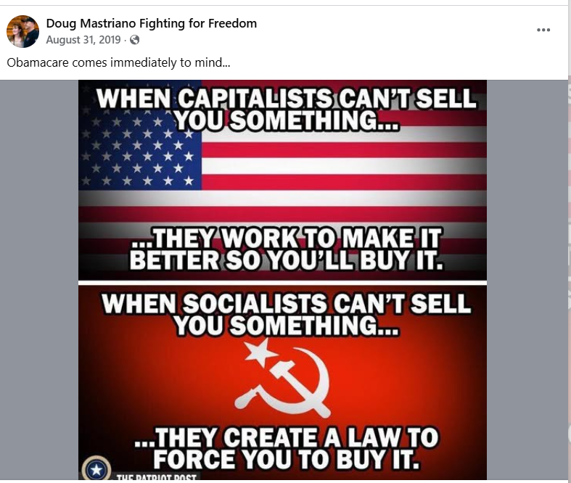
[Facebook, Doug Mastriano Fighting For Freedom, 8/31/19]
2019: Mastriano Shared A Post That Said “Democrats Voted To Fine Americans For Not Buying Health Insurance, But Want To Give It To Illegal Immigrants For Free.” According to Mastriano’s Fighting for Freedom Facebook,
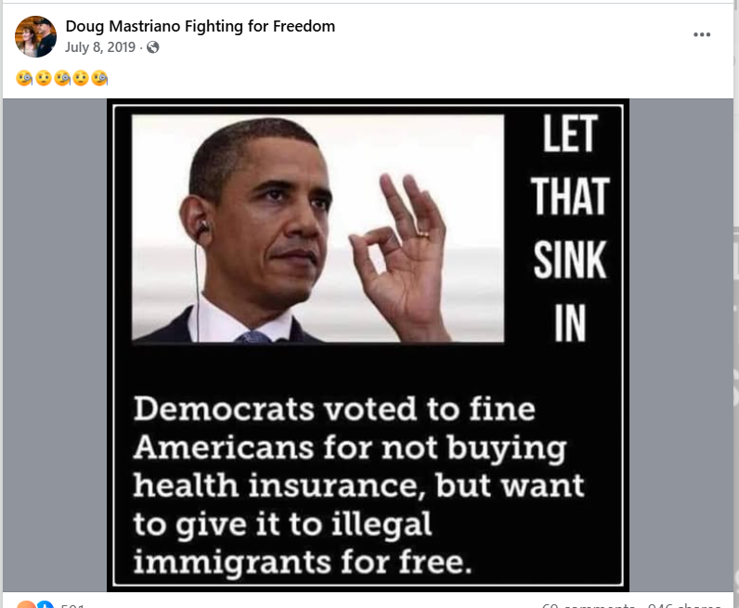
[Facebook, Doug Mastriano Fighting For Freedom, 7/8/19]

December 2025: There Were More Than 496,000 Pennsylvanians Enrolled In An Affordable Care Act Marketplace Plan
As Of December 2025, There Were 496,661 Individuals Enrolled In An Affordable Care Act Marketplace Plan In Pennsylvania. According to KFF, in 2025, there were 496,661 individuals enrolled in affordable care act marketplace plan in Pennsylvania.
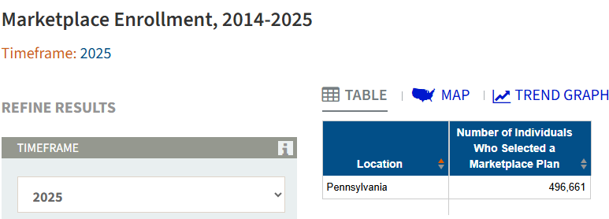
[KFF, Accessed 12/1/25]

The Affordable Care Act Allowed States To Expand Medicaid, Which Dramatically Lowered The Uninsured Rate Among Low-Income Workers
The Affordable Care Act Allowed States To Expand Medicaid, And States That Expanded Medicaid Dramatically Lowered The Number Of People Without Health Insurance. According to the Center on Budget and Policy Priorities, "The Affordable Care Act (ACA) permits states to expand Medicaid coverage to adults with incomes up to 138 percent of the poverty level (about $20,780 annually for an individual or $35,630 for a family of three). States that have adopted the expansion have dramatically lowered their uninsured rates. Extensive research finds that the people who gained coverage have grown healthier and more financially secure, while long-standing racial inequities in health outcomes, coverage, and access to care have shrunk." [Center On Budget And Policy Priorities, 6/14/24]
- The Uninsured Rate Among Low-Income Workers Fell From 38 Percent In 2013 To 17 Percent In 2022, Which Coincided With Implementation Of Medicaid Expansion. According to the Center on Budget and Policy Priorities, "Millions of workers have gained coverage through Medicaid expansion, including people working in industries that provide critical goods and services such as health care, transportation, grocery stores, food manufacturers, and child care. Many have no access to health coverage through their jobs. In expansion states, the uninsured rate among low-income workers fell from 38 percent in 2013 to 17 percent in 2022; this sharp decline coincided with a large increase in the share of low-income workers enrolled in Medicaid.[16] In non-expansion states, the uninsured rate among low-income workers fell much less, from 46 percent to 31 percent. (See Figure 3.)" [Center On Budget And Policy Priorities, 6/14/24]
- 2025: There Were Currently 2,986,000 Pennsylvanians Enrolled In PA Medicaid. [Kaiser Family Foundation, Accessed 11/19/25]

Mastriano Previously Announced A Plan To Defund Pennsylvania Medicaid In Order To Expand Nursing Homes

Mastriano’s 2022 Plan For Seniors Included “Redirect[ing]” Funds Away From Medicaid To Go Towards The Expansion Of Nursing Homes
2022: Mastriano’s Plan For Seniors Included “Redirect(ing)” Medicaid Funding To Go Towards The Expansion Of Nursing Homes. According to Mastriano’s campaign Twitter,
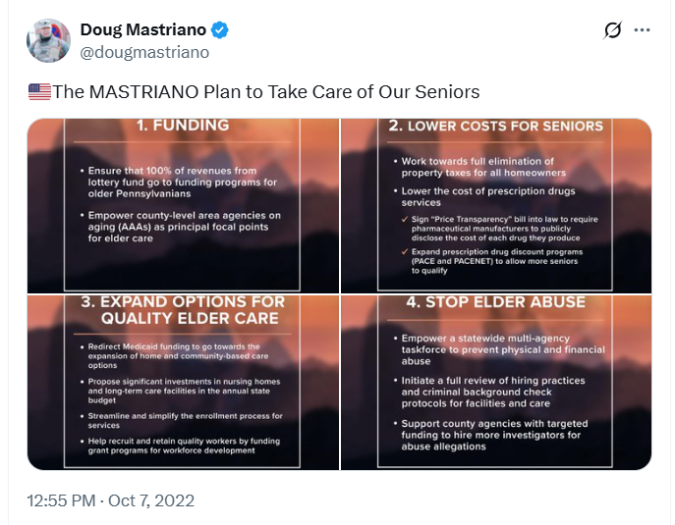
[Twitter, @dougmastriano, 10/7/22]

There Were Nearly 3 Million Pennsylvanians Enrolled In PA Medicaid
2025: There Were Currently 2,986,000 Pennsylvanians Enrolled In PA Medicaid. [Kaiser Family Foundation, Accessed 11/19/25]

