Overview
Mastriano opposed the Inflation Reduction Act’s clean energy tax credits, calling the law a “misnomer, at best, to distract from the billion in handouts it awards to green energy.” In 2025, Trump and Congressional Republicans repealed clean energy tax credits and made them harder to access, threatening clean energy jobs in Pennsylvania. Since the beginning of the Trump administration, clean energy projects that were projected to create hundreds of jobs in Pennsylvania were cancelled, such as the Mineral Basin Solar Power and Pennsylvania’s biggest solar array on the site of an old coal mine.
Mastriano also denied climate change, claiming it was a theory based on “pop science,” and voted to prevent Pennsylvania from joining the Regional Greenhouse Gas Initiative. Mastriano also introduced legislation calling for new energy plants to be exempt from EPA regulations and voted for legislation that would ease restrictions on polluters.

Mastriano Opposed Protecting Pennsylvania’s Clean Energy Jobs

Mastriano Opposed The Inflation Reduction Act’s Clean Energy Tax Credits That Supported Pennsylvania Jobs And Clean Energy Initiatives

Mastriano Called The Inflation Reduction Act A “Misnomer, At Best, To Distract From The Billions In Handouts It Awards To Green Energy”
2022: Mastriano Released An Op-Ed Titled “Pennsylvanians Losing Hope Over Inflation Woes,” And Called Biden’s Inflation Reduction Act A “Misnomer, At Best, To Distract From The Billions In Handouts It Awards To Green Energy.” According to Mastriano’s Facebook, “Op-Ed: Pennsylvanians Losing Hope Over Inflation Woes By Sen. Doug Mastriano (R-33) Empty pantries. Unfilled medications. Depleted savings. I recently poured over hundreds of comments like these from my constituents regarding the issue concerning them most: the growing toll inflation takes on their survival. […] It’s the same pattern we see at the congressional level, where President Joe Biden just signed the Inflation Reduction Act – a misnomer, at best, to distract from the billions in handouts it awards to green energy.”
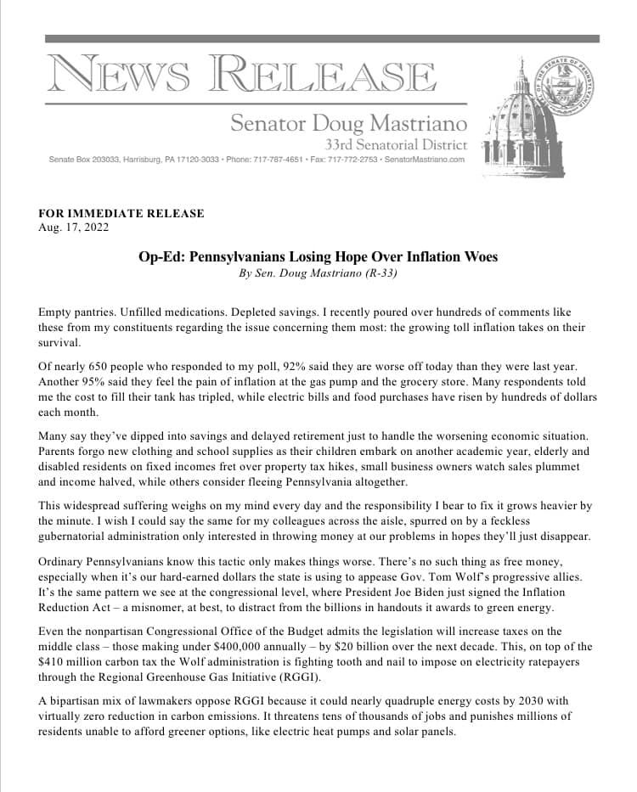
[Facebook, Senator Doug Mastriano, 8/17/22]
2022: Mastriano Issued A Statement On The Latest Inflation Data, Claiming President Biden’s Policies “Wrecked Our Economy” With “Skyrocketing Inflation.” According to Mastriano’s Facebook,

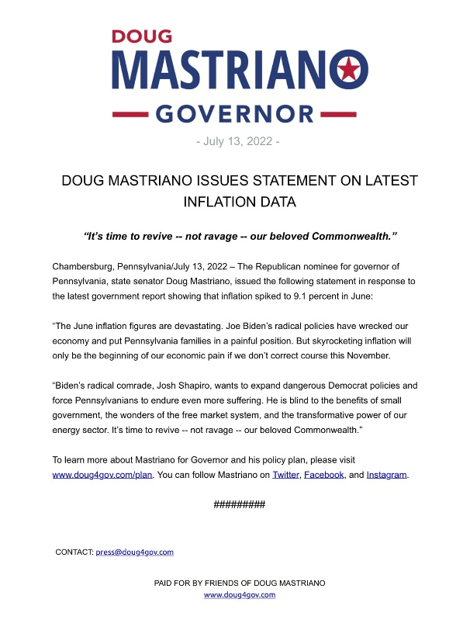
[Facebook, Doug Mastriano Fighting For Freedom, 7/13/22]
- Mastriano Said Shapiro Wanted To “Expand Dangerous Democrat Policies And Force Pennsylvanians To Endure More Suffering” And That He Was “Blind To The Benefits Of Small Government.” According to Mastriano’s Facebook, “Biden’s radical comrade, Josh Shapiro wants to expand dangerous Democrat policies and fore Pennsylvanians to endure more suffering. He is blind to the benefits of small government, the wonders of the free market system, and the transformative power of our energy sector. It’s time to revive not ravage our beloved Commonwealth.” [Facebook, Doug Mastriano Fighting For Freedom, 7/13/22]

Trump’s “One Big Beautiful Bill” Cut The Inflation Reduction Act’s Green Energy Tax Credits, Which Forced Pennsylvania Renewable Energy Projects To “Scramble”

Trump’s Tax Bill Cut Inflation Reduction Act Clean Energy Tax Credits And Federal Tax Credits For Wind, Solar, Storage, And Other Clean Energy Projects, Which Would Kill Tens Of Thousands Of Jobs
The House Republican Budget Bill Included Cuts To Inflation Reduction Act Clean Energy Tax Credits And Federal Tax Credits For Wind, Solar, Storage, And Other Clean Energy Projects. According to Utility Dive, "House Republicans on Thursday morning narrowly passed a sweeping budget bill that guts federal support for wind, solar, storage and other clean energy industries. The bill terminates most technology-neutral clean energy tax credits for projects placed in service after 2028 and those that begin construction more than 60 days after the bill’s passage. It also tightens restrictions on foreign entities’ involvement in projects, creating a ‘truly untenable’ situation for developers, Jefferies analysts said Thursday. Nuclear projects have more time to qualify for the credit. […] The bill also eliminates the Inflation Reduction Act’s tax credit transferability framework for most clean energy projects. Experts say transferability, which previously enjoyed bipartisan support, expands project financing options for small and midsize energy developers." [Utility Dive, 6/3/25]
- One Trade Association CEO Said The Bill Would Weaken Power Systems, Send Shockwaves Through The U.S. Economy, And Kill Tens Of Thousands Of Jobs. According to Utility Dive, "The House bill ‘abruptly dismantles bipartisan, long-standing tax policy that has catalyzed billions in private investment for affordable, reliable energy while sparking a rebirth of manufacturing across America,’ AEU President and CEO Heather O’Neill said. ‘If enacted as written, this bill will weaken our power system and send shockwaves throughout the U.S. economy by raising electricity prices, killing tens of thousands of jobs and ceding energy dominance to China.’" [Utility Dive, 5/22/25]
The Republican Reconciliation Bill Restricted The Ability Of Projects To Qualify For Certain Clean Energy Tax Credits And Repealed Electric Vehicle Tax Credits. According to Utility Dive, "The bill restricts the ability of projects to qualify for the tech-neutral clean electricity 45Y production tax credit and 48E investment tax credit, shortens the timeline for those credits, and ends the 25D residential solar credit after this year. The 25E, 30D, 30C and 45W electric vehicle credits will terminate after Sept. 30. While clean energy advocates and congressional Democrats maintain that the final version of the bill goes too far in slashing IRA credits, some Republicans wanted to see more significant cuts." [Utility Dive, 7/3/25]
- The Final Republican Reconciliation Bill Allowed Projects To Avoid A Requirement That They Be In Service By 2027 To Qualify For Certain Credits If They Began Construction Within A Year Of The Bill Being Signed. According to Utility Dive, "Before the House Freedom Caucus reached an agreement with House leadership to vote in favor of the bill, the caucus circulated a memo that criticized the Senate’s version of the bill for offering an exemption from the House’s onerous requirement that clean energy projects be placed in service by 2027 to qualify for the 45Y and 48E credits. The Senate version allows projects to avoid this requirement if they begin construction within a year after the bill is signed into law." [Utility Dive, 7/3/25]

Trump’s Tax Bill Forced Pennsylvania To “Scramble To Complete Renewable Energy Projects Before Tax Credits Expire” And Targeted New Solar For Schools Program
HEADLINE: “Pa. And Other States Scramble To Complete Renewable Energy Projects Before Tax Credits Expire” [Pennsylvania Capital-Star, 8/5/25]
Trump’s “One Big Beautiful Bill” Ended Several Energy Tax Credits, Including Tax Credits Used For Pennsylvania’s New Solar For Schools Program To Install Solar Panel On The Roofs Of Several Pennsylvania Schools. According to Allegheny Front, “Dozens of schools in Pennsylvania seem to be sticking with plans to install solar panels on their roofs, despite the rollback of federal clean energy tax credits in President Donald Trump’s signature budget bill. The ‘One Big Beautiful Bill’ Trump signed in July ends several energy tax credits early, including one that many schools plan to use to slash the cost of solar installations under Pennsylvania’s new Solar for Schools program. None of the schools that received grants through Solar for Schools has informed the state they are pulling out of the program due to the federal rollbacks, said Penny Ickes, spokesperson for Pennsylvania’s Department of Community and Economic Development. One district in Berks County returned grant funds to the state, but did not specify why, Ickes said.” [Allegheny Front, 9/11/25]

Since The Start Of 2025, The Trump Administration Targeted Clean Energy Projects In Pennsylvania That Were Supposed To Have Created Jobs
October 2025: Trump’s Energy Department Cancelled Projects To Manufacture Solar Panels And Install Wind And Solar Project Plants, Including $90 Million For Pennsylvania’s Solar Array On The Site Of An Old Coal Mine. According to the Washington Post, “The Energy Department on Wednesday canceled $7.56 billion in funding for 223 projects aimed at research and deployment of clean energy and other climate-friendly technology mainly in Democratic-led states. […] The cuts included several projects to manufacture solar panels and install wind and solar power plants, including $90 million to build Pennsylvania’s biggest solar array on the site of an old coal mine.” [Washington Post, 10/2/25]
October 2025: Pennsylvania Joined Lawsuits Against The Trump Administration Over Its Cancellation Of A $7 Billion Grant Program For Solar Energy Expansion In Low-Income Communities. According to the Guardian, “Nearly two dozen states are suing the Trump administration over its cancellation of a $7bn grant program aimed at expanding solar energy in low-income communities, according to court papers. In a statement on Thursday, California’s attorney general, Rob Bonta, announced two lawsuits by a group of states that received grants under the Environmental Protection Agency’s Solar for All program. The EPA’s administrator, Lee Zeldin, announced the termination of the program in August. The agency said in an email that it would not comment on pending litigation. […] In addition to California and Arizona, states participating in the lawsuits include Maryland, Colorado, Connecticut, Hawaii, Illinois, Kentucky, Maine, Massachusetts, Michigan, Minnesota, Nevada, New Jersey, New Mexico, New York, North Carolina, Oregon, Pennsylvania, Rhode Island, Vermont, Washington and Wisconsin, and the city of Washington DC.” [Guardian, 10/16/25]
October 2025: The Trump Administration Terminated Approximately $8 Billion In Clean Energy Across Blue States, Including The Mineral Basin Solar Power In Clearfield County, Pennsylvania. According to Politico, “The Trump administration’s termination of roughly $8 billion in clean energy projects in blue states will choke off funding to dozens of projects aimed at shoring up the grid and creating thousands of manufacturing jobs — and the pain is likely to stretch into more than two dozen GOP districts, according to a list obtained by POLITICO. […] Another terminated award to Mineral Basin Solar Power is listed as being in Massachusetts, but DOE documents show that the project would take place in Clearfield County, Pennsylvania, which is represented by Republican Rep. Glenn ‘G.T.’ Thompson. His office did not immediately respond to a request for comment.” [Politico, 10/2/25]

Mastriano Denied Climate Change And Supported Legislation That Harmed Pennsylvania’s Environment

Mastriano Called Climate Change A Theory Based On “Pop Science”
2022: Mastriano Called Climate Change A Theory Based On “Pop Science,” And It Was “Nonsense” That Human Activity Could Significantly Alter The Earth’s Climate. According to the Philadelphia Inquirer, “The state senator from south-central Pennsylvania, who would become the Republican nominee for governor the following month, told his supporters he wanted to pull the state out of a program to reduce greenhouse gas emissions, calling it “nonsense” that human activity could significantly alter the earth’s climate. A connection between burning fossil fuels and global warming? Merely a ‘theory,’ Mastriano said, based on ‘pop science.’” [Philadelphia Inquirer, 7/18/22]

Mastriano Supported Legislation To Keep Pennsylvania Out Of The Regional Greenhouse Gas Initiative
2022: Mastriano Introduced Legislation That Would Withdraw Pennsylvania From The Regional Greenhouse Gas Initiative. According to a press release from Senator Mastriano, “Senator Doug Mastriano (PA-33) and Senator Scott Hutchinson (PA-21) have officially introduced legislation to stabilize energy costs for Pennsylvanians, protect against market volatility in the long term, and utilize Pennsylvania’s unique natural resources to finally cement the commonwealth as a premier energy powerhouse. SB 1219 will spur natural gas production and investment, reduce regulatory and permitting burdens, open new state lands for production, and withdraw Pennsylvania from the Regional Greenhouse Gas Initiative (RGGI).” [Press Release – Senator Mastriano, 5/5/22]
2021: Mastriano Voted For SB 119, Which Would Prevent Pennsylvania From Joining The Regional Greenhouse Gas Initiative (RGGI). According to the Pennsylvania General Assembly, “An Act authorizing the Department of Environmental Protection to conduct a public comment process on and submit to the General Assembly a measure or action intended to abate, control or limit carbon dioxide emissions by imposing a revenue-generating tax or fee on carbon dioxide emissions.” [Pennsylvania General Assembly, SB 119, 3/30/22, Votes, 6/14/21]
- SB 119 Sponsors Claimed The Bill Would Mandate Legislative Approval Before Pennsylvania Adopts A Carbon Tax In An Effort To Prevent Pennsylvania From Joining The Regional Greenhouse Gas Initiative (RGGI) Without General Assembly Approval. According to the SB 119 Co-Sponsorship Memo Details via the Pennsylvania General Assembly, “A carbon tax is a major energy and fiscal policy initiative, and if such a tax is to be imposed on Pennsylvania employers, we believe it should be approved by the General Assembly. Beyond the fiscal impact on Pennsylvania manufacturers, coal and gas electric generation, consumers, and future economic investments made in our state, it also creates serious constitutional questions of checks and balances between co-equal branches of government. To support the authority of the General Assembly on this issue, we will re-introduce Senate Bill 950 from last session to delineate the process for legislative approval before Pennsylvania imposes a carbon tax on employers engaged in electric generation, manufacturing or other industries operating in the Commonwealth, or enter into any multi-state program, such as the Regional Greenhouse Gas Initiative (RGGI), that would impose such a tax.” [Pennsylvania General Assembly, SB 119 Co-Sponsorship Memo Details, 12/15/20]

Mastriano Introduced Legislation To Open New State Lands For Energy PRoduction And Called For Pennsylvania Plants To Be Exempt From EPA Rules
2022: Mastriano Announced He Would Be Introducing Legislation With Senator Hutchinson To Stabilize Energy Costs And Put Pennsylvania’s Resources To Use. According to the PA Senate GOP, “Harrisburg- Senator Doug Mastriano (PA-33) and Senator Scott Hutchinson (PA-21) announced today that they will soon introduce legislation to stabilize energy costs for Pennsylvanians, protect against economic and international volatility in the long term, and utilize Pennsylvania’s unique natural resources to finally cement the commonwealth as a premier energy powerhouse.” [PA Senate GOP, 3/14/22]
- The Bill Would Include Tax Incentives And Opening New State Lands, But Mastriano Wanted Pennsylvania Plants Exempt From EPA Rules. According to 2822 News, “Two state senators are proposing the PA Energy Independence Act in response to rising energy prices and the war in Ukraine. Scott Hutchinson and Republican governor candidate Doug Mastriano say the legislation would stabilize energy costs and put Pennsylvania’s resources to use. The bill will include tax incentives and opening new state lands for production. The Republican lawmakers also want to exempt Pennsylvania plants from the EPA’s wastewater and pollution rules.” [2822 News, 3/14/22]

Mastriano Voted For Legislation To Ease Restrictions On Polluters
2019: The Conservation Voters Of PA Warned Mastriano Voted For SB 619, Which Would Change The Definition Of Pollution And Let Polluters “Off The Hook.” According to the Conservation Voters of Pennsylvania, SB 619, “Lets polluters off the hook for many discharges and spills by changing the definition of ‘pollution’ in the Clean Streams Law. If the spill or discharge is diluted enough by a stream, Senate Bill 619 mandates that it does not need to be reported to the Pennsylvania Department of Environmental Protection or to downstream users.” [SB 619, Votes, 6/26/19, Conservation Voters of PA – 2019-2020 Scorecard, Accessed 12/8/25]

