Overview
After his failed 2022 gubernatorial bid, Mastriano compared the churches that did not publicly endorse him to enablers of the Holocaust. During his 2022 run for Pennsylvania governor, Mastriano faced several scandals that put him at odds with the Jewish community.
- Mastriano’s consultant and GAB CEO, Andrew Torba, said he did not want Jews or atheists in his movement, and Mastriano pushed back against criticism for his ties to the social media platform GAB.
- Mastriano’s campaign paid $5,000 to GAB, the same website that the Tree of Life shooter frequently used, for “consulting services.” A few days after the payment, the Founder and CEO of GAB, Andrew Torba, endorsed Mastriano’s campaign.
- Mastriano downplayed criticisms after he called Josh Shapiro’s children’s Jewish day school “privileged, exclusive, and elite.”
- At a campaign event, Mastriano said “we are starting to look like East Germany.”
- At another campaign event, Mastriano supporters were instructed to salute similar to the “Heil Hitler” salute.
- After Mastriano’s campaign event appropriated Jewish symbols, a group of Jewish organizations in Pennsylvania urged Mastriano to apologize and denounce Christian efforts to appropriate Jewish rituals.

Mastriano Compared His Failed 2022 Gubernatorial Bid To Jews During The Holocaust

Mastriano Compared Churches That Did Not Publicly Endorse His 2022 Campaign To Enablers Of The Holocaust And Persecution Of The Jewish People
HEADLINE: “Doug Mastriano Likens His Failed PA Gubernatorial Bid To Jews During The Holocaust” [Forward, 5/12/23]
2023: Mastriano Complained That Many Churches Refused To Publicly Endorse His 2022 Campaign, And Compared Them To Enablers Of The Holocaust And Persecution Of The Jewish People. According to Forward, “Doug Mastriano, a Christian nationalist state senator, recently compared his unsuccessful 2022 bid for Pennsylvania governor to Jews failed by churches that did not stand up to the Nazis. In an interview last Friday with a conservative talk radio host on Philadelphia talk radio station WWDB-AM 860, which was streamed live on his Facebook page, Mastriano complained that Pennsylvania churches and pastors refused to publicly back his campaign because they were afraid of the price they would pay. He quoted from Eric Metaxas’ book about Dietrich Bonhoeffer, a pastor and author who stood up to the Third Reich. ‘The majority of churches just wanted to be left alone,’ Mastriano said. ‘They wanted to stir and muddy the waters and stood aside, and they enabled and allowed the atrocities and a Holocaust and the persecution of the Jews to happen underneath their noses.’” [Forward, 5/12/23]

Mastriano’s Consultant And GAB CEO, Andrew Torba, Said He Did Not Want Jews Or Atheists In His Movement And Called For Christian Nationalism

Mastriano’s Consultant Andrew Torba Said That He Did Not Want Jews Or Atheists In His Movement And Claimed Him And Mastriano Excluded Non-Christian Reporters And Outlets

Jewish Groups Called On Mastriano Stop Using GAB After Mastriano’s Consultant Andrew Torba Said That He Did Not Want Jews Or Atheists In His Movement, And That The U.S. Was “An Explicitly Christian Country”
HEADLINE: “Doug Mastriano Consultant And GAB CEO: Jewish Conservatives Like Ben Shapiro Aren’t Welcome In Our Movement.” [Media Matters, 7/25/22]
2022: Mastriano’s Consultant Andrew Torba Said That He Did Not Want Jews Or Atheists In His Movement, And That “This Is An Explicitly Christian Movement Because This Is An Explicitly Christian Country.” According to Media Matters, “Torba responded to this article on July 22 by reiterating that he is against Jewish people joining his movement, stating: ‘We don't want people who are atheists. We don't want people who are Jewish. We don't want people who are, you know, nonbelievers, agnostic, whatever. This is an explicitly Christian movement because this is an explicitly Christian country.’ He also added: ‘Ben Shapiro is not welcome in the movement unless he repents and accepts Jesus Christ as his Lord and savior.’” [Media Matters, 7/25/22]
HEADLINE: “Republican Jews Call On Doug Mastriano, GOP Candidate For PA Governor To Stop Using Gab.” [Jewish Telegraphic Agency, 7/22/22]
HEADLINE: “Pittsburgh-Area Faith Leaders Decry Mastriano’s Ties To Gab, Joint Appearance With Florida Gov. DeSantis Here Friday.” [WTAE, 8/17/22]
HEADLINE: “Doug Mastriano Faces Criticism Over His Backing From Anti-Semitic Ally” [New York Times, 7/27/22]
HEADLINE: “Pittsburgh’s Jewish Community Calls Out Mastriano’s Activity On Prominent ‘Hate Speech’ Platform.” [Pittsburgh City Paper, 7/21/22]

CEO Of Gab Social Andrew Torba Said Him And Mastriano Had A “Similar Media Strategy” Where They Did Not Conduct Interviews With Reporters Or Outlets That Were Not Christian
2022: CEO Of Gab Social Andrew Torba Said Him And Mastriano Had A “Similar Media Strategy” Where They Did Not Conduct Interviews With Reporters Or Outlets That Were Not Christian. According to the Jerusalem Post, “‘My policy is not to conduct interviews with reporters who aren't Christian or with outlets who aren't Christian and Doug has a very similar media strategy where he does not do interviews with these people. He does not talk to these people. He does not give press access to these people,’ said the Gab founder.” [Jerusalem Post, 7/27/22]
- Torba Said When Non-Christian Reporters Or Outlets Contact Him He Takes It As An “Opportunity To Convert Them.” According to the Jerusalem Post, “‘These people are dishonest. They're liars. They're a den of vipers and they want to destroy you. My typical conversation with them when they email me is 'repent and accept Jesus Christ as your lord and savior.' I take it as an opportunity to try and convert them.’” [Jerusalem Post, 7/27/22]
- Torba Said Mastriano “Only Answers To Jesus Christ.” According to the Jerusalem Post, “Torba called Mastriano's opponent, Josh Shapiro, ‘a Soros puppet’ (a reference to Jewish billionaire George Soros) and reiterated claims that he was involved in voter fraud in the 2020 election. Torba stressed that Mastriano ‘answers only to Jesus Christ.’” [Jerusalem Post, 7/27/22]

Andrew Torba, The CEO Of Gab Social, Said He Was “Praying For The Local Jewish Group In My Area” Because They Condemned Him
Andrew Torba, The CEO Of Gab Social Posted A Photo Of A Newspaper With Mastriano On The Cover, And Said He Was “Praying For The Local Jewish Group In My Area” Because They Condemned Him. According to Gab Social, “I shared the Gospel of Jesus Christ and said I’m praying for the local Jewish group in my area. They condemned me and the local paper put it on the front page.” [Gab Social, @a, 8/4/22]
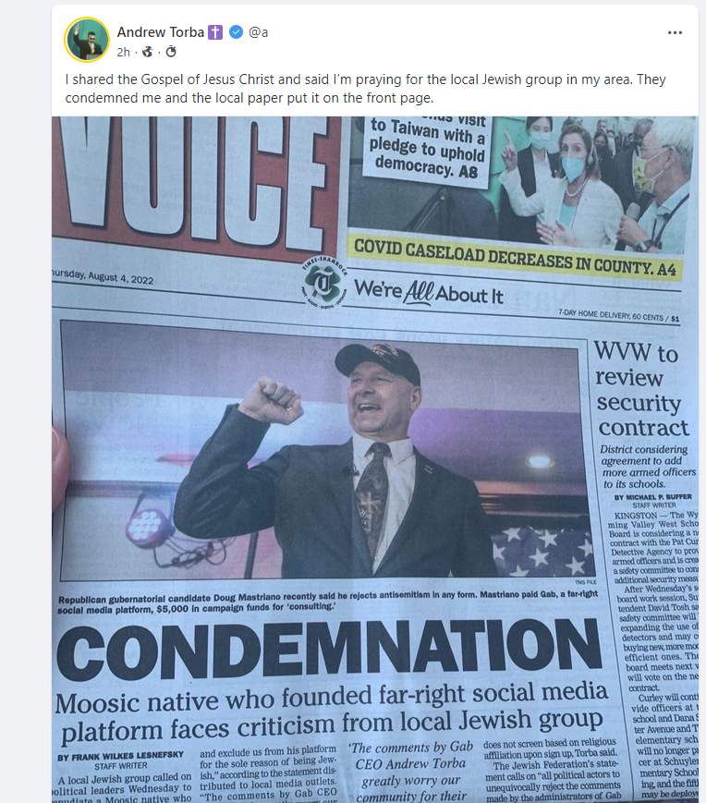
[Gab Social, @a, 8/4/22]

Mastriano Pushed Back Against Jewish Criticism Over His Association With GAB, Said Torba Did Not Speak For His Campaign, And Deleted His GAB Account
2022: Mastriano Pushed Back Against Jewish Criticism Over His Association With Gab By Referring Back To His Campaign Announcement Where A Man Wore A Tallit And Blew A Shofar. According to Forward, “The Republican nominee for governor of Pennsylvania is pushing back against Jewish criticism over his association with Gab, a social media platform rife with antisemitism, by highlighting his campaign announcement, where a man donned a tallit and blew a shofar.” [Forward, 8/3/22]
- The Man Who Blew The Shofar At Mastriano’s Announcement Event Was Not A Rabbi, And Called “Pastor Don.” According to Forward, “The person who blew the shofar at the Mastriano event was identified by the emcee as ‘Pastor Don’ and wore a Lion of Judah Messianic prayer scarf.” [Forward, 8/3/22]

2022: Mastriano Posted A Statement Saying That “Andrew Torba Doesn’t Speak For Me Or My Campaign” And That He Rejected Anti-Semitism. According to Mastriano’s Twitter,
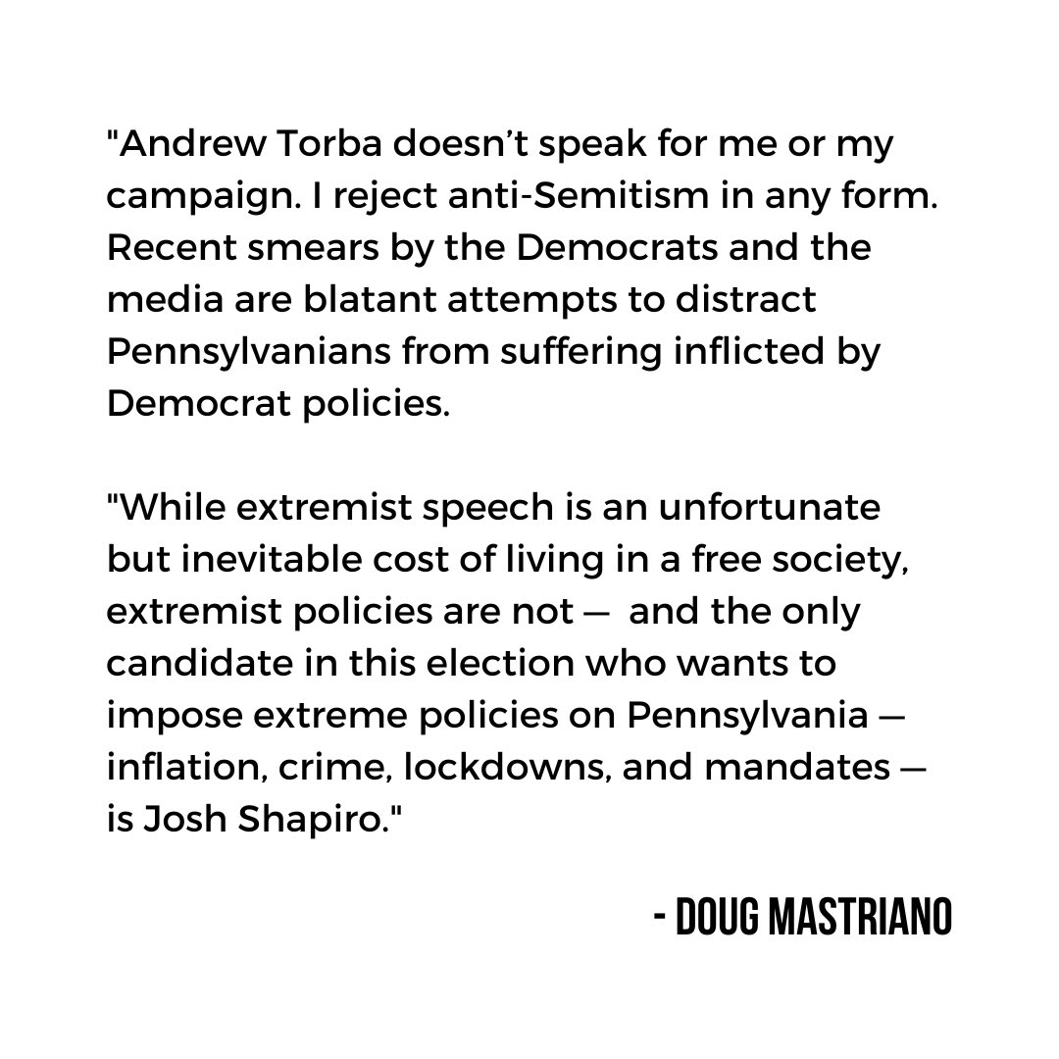
[Twitter, @dougmastriano, 7/28/22]
2022: Mastriano Said He Was “Crucified And Held Before An Inquisition” For Advertising On Gab Social, And Called The Site “A Platform Where Controversial Things Happen.” According to Go Erie, “And he took repeated shots at the ‘traditional media’ whom he accused of supporting the Democrats. ‘I was disgusted when I saw that. And nobody in the media or in the Democrat Party asked him to renounce that,’ Mastriano told the crowd of MBA members and others. ‘You know, for us, if I advertise on a platform where controversial things happen, I'm crucified and held before inquisition. You know, 'How dare he,’” [Go Erie, 8/3/22]
Mastriano Deleted His Account On Gab Social. [Gab, 7/29/22]

Mastriano Paid $5,000 To GAB, Which The Tree Of Life Shooter Used Frequently, For “Consulting Services,” And Torba Endorsed Mastriano A Few Days After The Payment
HEADLINE: “GOP Candidate For PA Governor Mastriano Paid $5,000 To The Website Used By The Tree Of Life Shooter.” [WESA, 7/13/22]
Mastriano Paid Gab, The Website Used Routinely By Robert Bowers Who Killed 11 Jewish Worshippers At The Tree Of Life Synagogue For “Consulting Services.” According to WESA, “Pennsylvania Sen. Doug Mastriano’s campaign for governor in Pennsylvania paid $5,000 for ‘consulting services’ to Gab, a social media platform that provides a home for conspiracy theories and anti-Semitic content. Gab is the website used by Robert Bowers, who is charged with killing 11 Jewish worshippers at the Tree of Life synagogue in Squirrel Hill in 2018. Bowers routinely posted anti-Semitic content on Gab before the shooting, according to archives of the posts.” [WESA, 7/13/22]
The Founder And CEO Of Gab Andrew Torba Endorsed Mastriano A Few Days After His Campaign Payment And Said The Payment Was For An Advertising Campaign. According to WESA, “But Gab founder, CEO and majority owner Andrew Torba said in an email that Mastriano’s $5,000 campaign payment on April 28 was for an advertising campaign. Torba has said he started the site as an antidote to mainstream social media sites that he believes are too liberal. […] On May 2, a few days after Mastriano’s payment to Gab, Torba interviewed Mastriano on the video posted on Gab. And then on May 12, Torba endorsed Mastriano to the website’s more than three million followers.” [WESA, 7/13/22]
- Torba Warned Mastriano That He Would Likely Be Criticized For Doing An Interview On Gab, But Mastriano Thanked Him For Providing A Space For Conservative Voices According to WESA, “During an interview with Mastriano posted on Gab on May 2, Torba warned Mastriano that he would likely be criticized for agreeing to be interviewed on Gab. ‘You may even get called a smear for doing this interview with me. So brace yourself for that,’ Torba told Mastriano. Mastriano expressed no reservations during the 16-minute interview about the content on Gab and thanked Torba for providing a space for conservative voices like his own.” [WESA, 7/13/22]

Mastriano Repeatedly Made Anti-Semitic Comments

Mastriano Called Josh Shapiro’s Children’s Jewish Day School “Privileged, Exclusive, And Elite” And Downplayed Criticism Of His Anti-Semitic Remarks
HEADLINE: “Mastriano’s Attacks On Jewish School Set Off Outcry Over Anti-Semitic Signaling.” [New York Times, 10/10/22]
2022: Mastriano Said “Apparently Now It’s Some Kind Of Racist Thing If I Talk About The School” In Reference To Calling The Jewish Day School Shapiro’s Kids Attend “Privileged, Exclusive, And Elite.” According to the New York Times, “Mr. Mastriano, who promotes Christian power and disdains the separation of church and state, has repeatedly lashed Mr. Shapiro for attending and sending his children to what Mr. Mastriano calls a ‘privileged, exclusive, elite’ school, suggesting to one audience that it evinced Mr. Shapiro’s ‘disdain for people like us.’ It is a Jewish day school, where students are given both secular and religious instruction. But Mr. Mastriano’s language in portraying it as an elitist reserve seemed to be a dog whistle. ‘Apparently now it’s some kind of racist thing if I talk about the school,’ Mr. Mastriano said at a recent event as he cast himself as a champion of school choice for all. ‘It’s a very expensive, elite school.’” [New York Times, 10/10/22]

Mastriano Said “We Are Starting To Look Like East Germany”
HEADLINE: “Doug Mastriano Says ‘We Are Starting To Look Like East Germany’ At Lehigh Valley Campaign Stop.” [Morning Call, 10/9/22]
2022: Mastriano At A Campaign Event In Allentown: “We Take Our Freedoms For Granted But We Are Starting To Look Like East Germany.” According to the Morning Call, “Mastriano spoke to about 250 supporters at the Lehigh Valley Active Life Center in Allentown, at one point saying the country is beginning to ‘look like East Germany,’ in a reference to what he called loss of freedoms. […] Mastriano, a retired Army colonel, began his speech recalling his time in the service when there was an East and West Germany and how those in the east longed for freedom. […] ‘We take our freedoms for granted but we are starting to look like East Germany’ he said.” [Morning Call, 10/9/22]

Supporters At A Mastriano Event Were Instructed To Salute In A Manner Not Seen Since The “Heil Hitler” Salute
September 2022: At A Campaign Rally For Mastriano, Supporters Were Instructed To Salute In A Manner Not Seen Since The “Heil Hitler” Salute Used By The Nazis. According to the Jewish Telegraphic Agency, “Crowds at separate rallies headlined by former President Donald Trump and his favored nominee for Pennsylvania governor, Doug Mastriano, raised their right hands in unison, creating images that critics of the two politicians compared to the Nazi salute. New York State Sen. Anna Kaplan, a Jewish Democrat, said Sunday in a statement that both rallies invoked Nazi imagery. ‘Last night at a rally held by the former President, and today at a political rally held by a candidate for Governor of Pennsylvania, supporters were urged to hold up their right hands in a unified salute that should shock the conscience of every American for its remarkable similarity to the ‘Heil Hitler’ salute used by the Nazis,’ Kaplan wrote. ‘I call on these campaigns to immediately end the use of this shocking salute in their rallies.’ A speaker at a Mastriano rally on Sunday in Chambersburg, Pennsylvania, asked the crowd to raise their right hands as he likened Mastriano’s gubernatorial bid to a bloody Civil War battle in nearby Gettysburg.” [Jewish Telegraphic Agency, 9/19/22]
- Attorney And Former Republican Ron Filipkowski Tweeted A Video Of The Campaign Rally. According to Ron Filipkowski’s Twitter, “PA MAGA Gov nominee Doug Mastriano rally: ‘Put your right hand in the air … America will have a new birth of liberty.’” [Twitter, @RonFilipkowski, 9/18/22]

[Twitter, @RonFilipkowski, 9/18/22]

Mastirano Appropriated Jewish Symbols At A Campaign EvenT
2022: A Group Of Jewish Organizations In Pennsylvania Wrote A Letter To Object Mastriano’s Appropriation Of Jewish Symbols At His Campaign Event. According to PennLive, “We, the undersigned local Jewish and other organizations of Pennsylvania, are joining together to object to State Senator Doug Mastriano’s appropriation of Jewish symbols at a recent event announcing his candidacy for Pennsylvania governor. At this event, a man associated with Mastriano’s campaign donned a tallit, or a Jewish prayer shawl, and blew a shofar. The shofar is a religious instrument that the Jewish people have used for centuries to mark important holidays, including Rosh Hashanah and Yom Kippur – two of the most important holidays on the Jewish calendar. The fringes of a tallit, which was also on display at the campaign event, represent the mitzvot: the commandments in the Torah. Wearing a tallit symbolizes a commitment to the commandments and a Jewish way of life. Sen. Mastriano, who is not Jewish, is using these sacred symbols not in a religious context, but in a political one. That a non-Jewish political figure believes it is appropriate to exploit these rituals for personal political gain is both disturbing and offensive.” [PennLive, 2/2/22]
- The Group Of Jewish Organizations Called On Mastriano To Apologize And Denounce Efforts Of Christian Activists To Appropriate Jewish Rituals. According to PennLive, “The manipulation of religious symbols for political gain should outrage Americans of all faith traditions. When candidates and their supporters use sacred symbols to advance political interests, they undermine the core values of our democracy and cause real harm to people whose traditions they exploit. We call on Mastriano to apologize for his offensive actions and to denounce all efforts by Christian activists to appropriate sacred Jewish rituals and abuse them for political purposes.” [PennLive, 2/2/22]

