Overview
Although Doug Mastriano tried to soften his tone on abortion during his 2022 gubernatorial run, Mastriano was an anti-abortion extremist.
Mastriano said he wanted “abortion to end, period,” and sponsored legislation to ban abortion at six weeks without any exceptions. Mastriano admitted his abortion ban would charge women with murder if they got abortions later in pregnancy. He also voted to create a constitutional amendment that denied Pennsylvanians of the right to an abortion, and scrutinized Governor Wolf’s legal challenges to the amendment.
Mastriano celebrated the overturning of Roe v. Wade, and called the day Roe v. Wade was first decided “one of the darkest days in American history.” He claimed that life began at conception, and called abortion a “barbaric Holocaust.” Mastriano dismissed bodily autonomy, claiming that “my body my choice is ridiculous nonsense.”

Mastriano Wanted To Ban Abortion After Six Weeks Without Exceptions And Wanted To Charge Women With Murder If They Got Abortions Later In Pregnancy

Mastriano Wanted To Ban Abortion After 6 Weeks With No Exceptions And Would Charge Women With Murder If They Got An Abortion After 6 Weeks Of Gestation

Mastriano Said He Wanted “Abortion To End, Period,” And Touted Filing A “Heartbeat Bill” To Ban Abortion After Six Weeks
2022: Mastriano Said He Wanted “Abortion To End, Period,” And Touted Filing A “Heartbeat Bill” To Further Restrict Abortion In Pennsylvania. According to Mastriano on Turley Talks, “But now the most important issue of our lifetime’s come up. Thank you to the leaker. I'm sure their their desire for this leak was nefarious, but it's going to work to our advantage. For me, it's not politics. I want abortion to end, period, but how it plays out politically since you asked about my campaign now it’s going to focus the people that are being bombarded by lies. Now, those lies are going to dissipate to the background as you talk about the right to life. And they're going to they're going to see that the material physical champion of life is, has been Doug Mastriano. One of my first pieces of legislation as a Senator three years ago was the heartbeat bill. If you look at my voting record. So I have a proven record, a demonstrated record of being very pro-life.” [Doug Mastriano, Turley Talks Facebook Live, 5/3/22] (VIDEO)
- The First Piece Of Legislation Mastriano Introduced In Harrisburg Would Have Banned Abortion After Six Weeks. According to the Philadelphia Inquirer, “State Sen. Doug Mastriano of Franklin County, polling as a front-runner in the Republican primary, noted in a televised debate last week that the first piece of legislation he introduced in Harrisburg three years ago would have banned abortions after six weeks of pregnancy.’ [Philadelphia Inquirer, 5/3/22]
- 2021-2022: Mastriano Was The Primary Sponsor Of SB 378, Which Would Prohibit Abortion As Soon As A Fetal Heartbeat Is Detected. According to the Pennsylvania General Assembly, Mastriano was the primary sponsor of SB 378, “An Act amending Title 18 (Crimes and Offenses) of the Pennsylvania Consolidated Statutes, in abortion, further providing for legislative intent, providing for fetal heartbeat examination, further providing for medical consultation and judgment, for abortion on unborn child of 24 or more weeks gestational age and for reporting.” [Pennsylvania General Assembly – SB 378, 3/10/21]
- 2022: Mastriano Was The Lead Sponsor On A Heartbeat Bill That Would Ban Abortion As Early As 6 Weeks In Pennsylvania. According to The Pennsylvania Capital Star, “Sen. Doug Mastriano, R-Franklin, who’s running for governor, is the lead sponsor on a bill that would ban abortion as early as six weeks, which is before most people know they are pregnant. Commonly dubbed ‘heartbeat bills,’ the proposals, according to medical experts, are misleading because an embryo does not yet have a developed heart at six weeks’ gestation.” [Pennsylvania Capital Star, 2/11/22]

Mastriano’s Six-Week Abortion Ban Did Not Have Exceptions And Would Treat Abortions Later Than Six Weeks As “Murder”
2022: Mastriano Said He Would “Move With Alacrity” To Ban Abortion After 6 Weeks, And That He Would Not Allow Any Exceptions For Rape, Incest, Or The Life Of The Mother. According to the Philadelphia Inquirer, “Mastriano, who has sponsored legislation that would effectively ban abortion after about six to eight weeks, said he would ‘move with alacrity’ to enact that bill. He said he wouldn’t allow any exceptions for rape, incest, or the life of the mother.” [Philadelphia Inquirer, 4/27/22]
- Mastriano: “Kathy Barnette Our Next Senator, She Was A Product Of Rape. According to My Twin Tiers, “‘I do not give way for exceptions either,’ Mastriano continued. ‘Kathy Barnette, our next senator, she was a product of rape,’ he fit in as an example just as his speaking time expired.” [My Twin Tiers, 4/27/22]
HEADLINE: “Mastriano Said In 2019 That His Bill Would Treat Abortions As Murder.” [New York Times, 9/27/22]
2019: Mastriano Co-Sponsored A Bill To Ban Abortion After The Detection Of Electrical Cardiac Activity In The Fetus, Which Was Usually Around Six Weeks. According to the New York Times, “Doug Mastriano, the far-right Republican nominee for governor in Pennsylvania, indicated in 2019 that women should be charged with murder if they violated a proposed abortion ban, a comment that Democrats on Tuesday highlighted as another example of Mr. Mastriano’s embrace of policies that are well outside the political mainstream. As a state senator in October 2019, he co-sponsored a bill to ban abortion after the detection of electrical cardiac activity in the fetus, usually around six weeks.” [New York Times, 9/27/22]
- Mastriano Responded Yes, When Asked If Under His A Bill A Woman Would Be Charged With Murder If She Were 10 Weeks Pregnant And Had An Abortion. According to the New York Times, “On the radio show Smart Talk, the host, Scott LaMar, asked Mr. Mastriano if a woman would be charged with murder if she were 10 weeks pregnant and knowingly had what would be an illegal abortion under the bill. Mr. Mastriano answered, ‘Is that a human being? Is that a little boy or girl? If it is, it deserves equal protection under the law.’ ‘So you’re saying yes?’ the host asked. ‘Yes, I am,’ Mr. Mastriano responded.”[New York Times, 9/27/22]

Mastriano Voted For An Anti-Abortion Constitutional Amendment And Scrutinized Governor Wolf For Legally Challenging The Amendment

Mastriano Voted To Create A Constitutional Amendment To Declare There Was No Right To Abortion In Pennsylvania
2022: Mastriano Voted For SB 106, Which Would Create A Constitutional Amendment To Declare That There Was No Right To Abortion In The Commonwealth Of Pennsylvania. According to the Pennsylvania General Assembly, “A Joint Resolution proposing separate and distinct amendments to the Constitution of the Commonwealth of Pennsylvania, providing that there is no constitutional right to taxpayer-funded abortion or other right relating to abortion; further providing for action on concurrent orders and resolutions, for Lieutenant Governor and for qualifications of electors; and providing for election audits.” [Pennsylvania General Assembly, SB 106, 7/8/22, Votes, 7/8/22]

Mastriano Called Governor Wolf’s Challenge Of The Anti-Abortion Amendment A “Publicity Stunt”
2022: Mastriano Released A Statement That Called Governor Wolf’s Lawsuit Challenging SB 106, Which Would Prohibit A Right To Abortion In Pennsylvania, A “Publicity Stunt.” According to a press release from Mastriano’s website, “Sen. Doug Mastriano (R-33) released the following statement in response to the Wolf administration’s lawsuit challenging Senate Bill 106, which proposes five amendments to the state constitution: ‘This lawsuit is nothing but a publicity stunt from the Wolf administration meant to generate favorable headlines that peddle misinformation about what these constitutional amendments would actually mean for Pennsylvania.’” [Press Release – Senator Mastriano, 7/30/22]

2022: Mastriano Accused Governor Wolf Of Taking “Away Pennsylvanians’ Right To Those Decisions By Running To The Courts” After The General Assembly Voted On Taxpayer-Funded Elective Abortions. According to Mastriano’s Twitter, “The General Assembly voted to give Pennsylvanians a voice on election integrity, government regulations & taxpayer-funded elective abortions. Gov. Wolf takes away Pennsylvanians’ right to those decisions by running to the courts.”
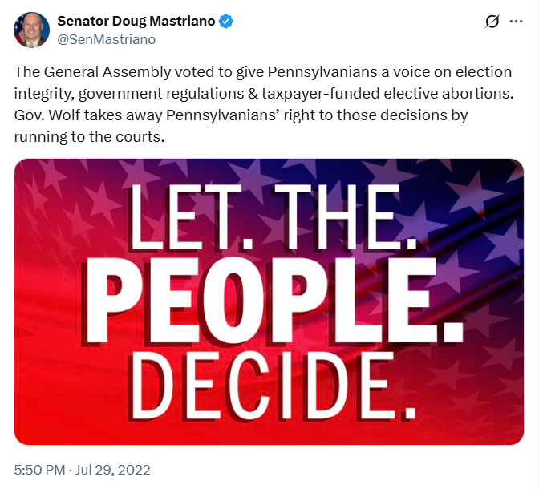
[Twitter, @SenMastriano, 7/29/22]

Mastriano Voted To Ban Abortion Based On Down Syndrome Diagnoses
2019: Mastriano Voted For HB 321 Which Would Prohibit Abortion Based On The Diagnosis Of Down Syndrome. According to the Pennsylvania General Assembly, “An Act amending Title 18 (Crimes and Offenses) of the Pennsylvania Consolidated Statutes, in abortion, further providing for definitions and for medical consultation and judgment. […] Down Syndrome Protection Legislation” [Pennsylvania General Assembly, HB 321, 4/15/19, Votes, 11/20/19]

Mastriano Lauded The Overturning Of Roe V. Wade, Believed Life Began At Conception, Dismissed Bodily Autonomy, And Called Abortion A “Barbaric Holocaust”

Mastriano Celebrated The Overturning Of Roe V. Wade
June 2022: Mastriano’s Statement On Roe V. Wade Getting Overturned: “Roe V. Wade Is Rightly Relegated To The Ash Heap Of History.” According to Mastriano’s Facebook,

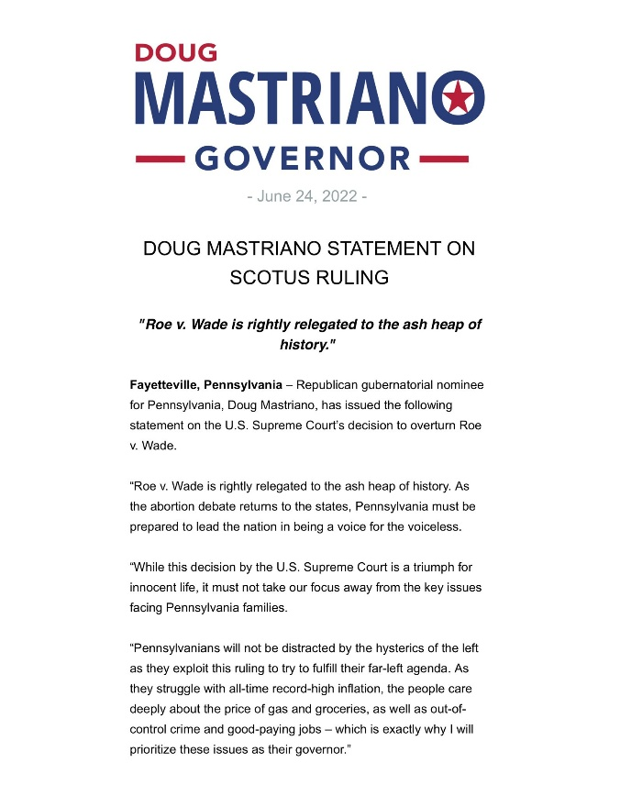
[Facebook, Doug Mastriano Fighting For Freedom, 6/24/22]

June 2022: Mastriano: “Celebrating Life!” According to Mastriano’s Facebook, “Celebrating life! ‘For you created my inmost being; you knit me together in my mother’s womb. I praise you because I am fearfully and wonderfully made.’ Psalm 139:13-14a”
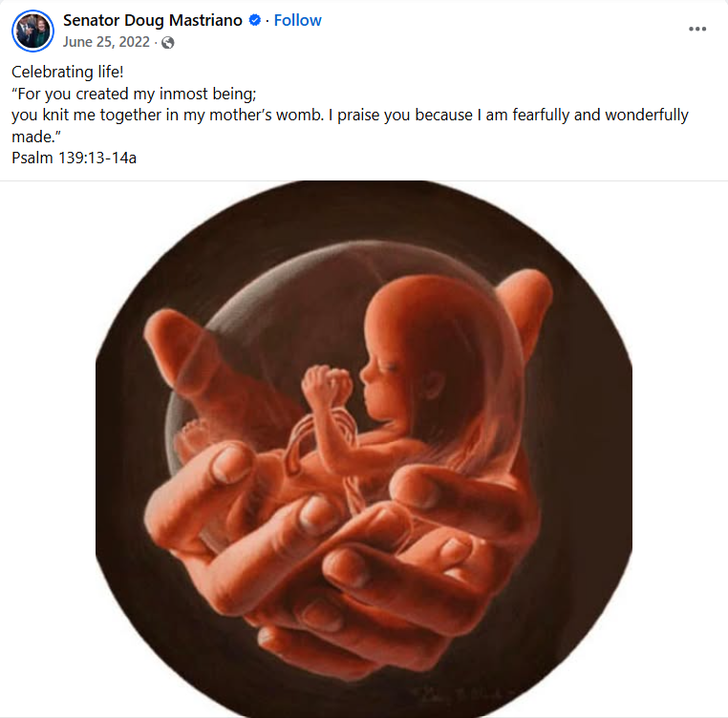
[Facebook, Senator Doug Mastriano, 6/25/22]
May 2022: Mastriano: “Breaking: Supreme Court Will Overturn Roe V. Wade. Let Us Now Pass Legislation In PA To Protect Innocent Life.” According to Mastriano’s Twitter, “Breaking: Supreme Court will overturn Roe v. Wade. Let us now pass legislation in PA to protect innocent life!”

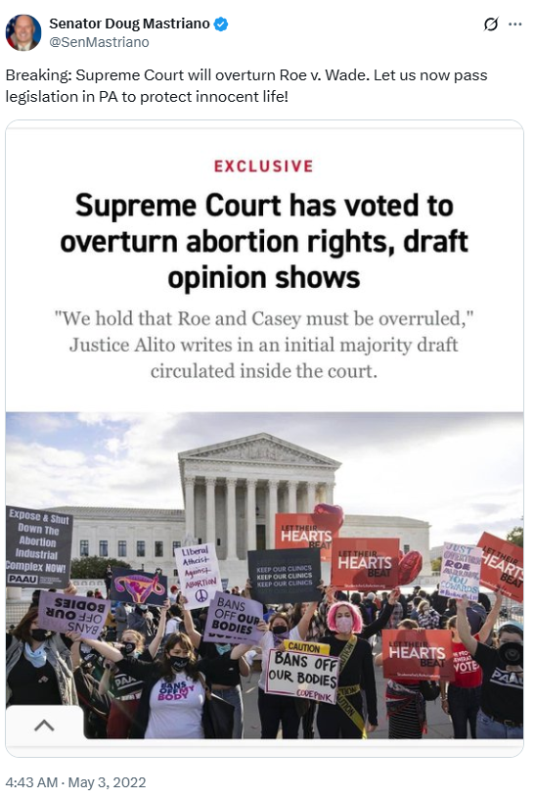
[Twitter, @SenMastriano, 5/3/22]

Mastriano Claimed That The Justices Willing To Overturn Roe V. Wade Were “Inclined To Follow The Science”
Mastriano: “It Is A Good Sign That A Majority Of The Justices At This Time Are Inclined To Follow The Science.” According to a statement Mastriano tweeted out, “My statement regarding last night’s news: […] Although the decision will not be final until June and the leaking of this document is unprecedented it is a good sign that the majority of the justices at this time are inclined to follow the science.”
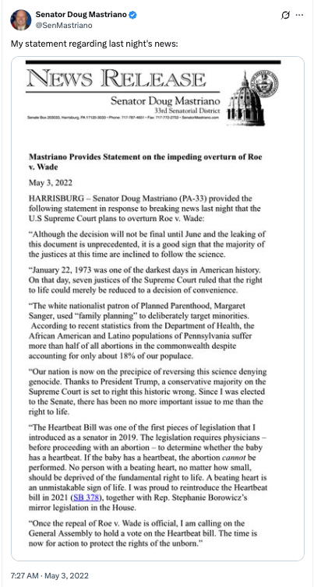
[Twitter, @SenMastriano, 5/3/22]
Mastriano: “Thanks To President Trump A Conservative Majority On The Supreme Court Is Set To Right This Historic Wrong.” According to a press release from Senator Mastriano, “Thanks to President Trump, a conservative majority on the Supreme Court is set to right this historic wrong.” [Press Release – Senator Mastriano, 5/3/22]

Mastriano Called January 22, 1973, The Day Roe V. Wade Was Decided, “One Of The Darkest Days In American History”
2022: Mastriano: “January 22, 1973 Was One Of The Darkest Days In American History.” According to a press release from Senator Mastriano, “January 22, 1973 was one of the darkest days in American history. On that day, seven justices of the Supreme Court ruled that the right to life could merely be reduced to a decision of convenience.” [Press Release – Senator Mastriano, 5/3/22]
- January 22, 1973: The U.S. Supreme Court Declared The Right To Abortion In Its Roe V. Wade Decision. According to the Associated Press, “On Jan. 22, 1973, the U.S. Supreme Court, in its Roe v. Wade decision, declared a nationwide constitutional right to abortion. (The court would overrule Roe v. Wade in 2022, in the decision Dobbs v. Jackson Women’s Health Organization.)” [Associated Press, 1/22/25]

Mastriano Believed Life Began At Conception
Mastriano: “I Believe That Life Begins At Conception.” According to Politics PA, “Doug Mastriano: ‘There is no greater issue in our generation than the right to life. That’s why I introduced the heartbeat bill as a senator. In 2022, we deny science that we’re still told it’s a blob of tissue in a woman’s womb. You know, my body my choice is ridiculous nonsense. The whole abortion movement is based off of old science. Now we know at six weeks, there’s a heartbeat. You hear a life. I believe that life begins at conception.’” [Politics PA, Archived 6/22/22]

Mastriano Used Extreme Anti-Abortion Rhetoric, Including Calling Abortion A “Barbaric Holocaust” And Dismissing Bodily Automony

Mastriano Called Abortion A “Barbaric Holocaust”
2022: After The Dobbs Leak, Mastriano Said He Would “Do Whatever It Takes To End The Barbaric Holocaust Of Abortion Happening In Our State.” According to the Philadelphia Inquirer, “After a draft opinion published by Politico on Monday appeared to show the U.S. Supreme Court was poised to strike down Roe v. Wade, Mastriano reiterated his support for legislation that would effectively ban abortion after about six to eight weeks. He has said he will ‘do whatever it takes to end the barbaric holocaust of abortion happening in our state.’” [Philadelphia Inquirer, 5/4/22]

Mastriano Claimed That Mother Teresa Told Hillary Clinton There Had Not Been A Female President Yet Because She Probably Aborted Her
2022: Mastriano Said That Mother Teresa Told Hillary Clinton That There Had Not Been A Female President Yet Because She Probably Aborted Her, And Claimed The “Cure For Cancer” Was “Probably Gone” Due To Abortion. According to Doug Mastriano at a Lycoming Meet and Greet on Facebook Live, “Whatever happened with that lingo, ‘My body, my choice.’ Well, when they're using it as somebody else's body, follow the science, DNA never exists again, fingerprints after a few weeks, unique genetic code, beautiful individual, created in God's image. Nancy Pelosi … Hillary Clinton asked Mother Theresa, I’m told, ‘Why do you think we haven’t had a female President yet?’ And Mother Teresa said in her very humble way, ‘You probably aborted her.’ I say that just because we don't know that 60 some million lives are erased in America, the potential. The cure for cancer probably gone. We just don't know.” [Doug Mastriano – Lycoming Meet and Greet FB Live, 8/21/22] (VIDEO)

Mastriano Dismissed The Belief That People Had A Right To Their Own Body
Mastriano On Abortion: “My Body My Choice Is Ridiculous Nonsense. The Whole Abortion Movement Is Based Off Of Old Science.” According to Politics PA, “Doug Mastriano: ‘There is no greater issue in our generation than the right to life. That’s why I introduced the heartbeat bill as a senator. In 2022, we deny science that we’re still told it’s a blob of tissue in a woman’s womb. You know, my body my choice is ridiculous nonsense. The whole abortion movement is based off of old science. Now we know at six weeks, there’s a heartbeat. You hear a life. I believe that life begins at conception.’” [Politics PA, Archived 6/22/22]
Mastriano: “But An Abortion Is Not A Decision That Effects Just One Body.” According to Mastriano’s article in the Northhampton News, “Another common talking point we hear is ‘My body. My choice.’ But an abortion is not a decision that effects just one body. It ends the life of a body that doesn’t get a say in the matter.” [Northhampton News- Doug Mastriano, Archived 5/9/22]

Although He Tried To Soften His Tone On Abortion In 2022, Mastriano Was An Anti-Abortion Extremist

During His 2022 Campaign, Mastriano Tried To Soften His Tone On Abortion

July 2022: News Outlets Noticed Mastriano Was Softening His Tone On Abortion
HEADLINE: “Is Republican Nominee For Governor Doug Mastriano Shifting His Tone On Abortion.” [Philadelphia Inquirer, 7/28/22]
2022: With The Reversal Of Roe V. Wade, Mastriano Tried To Pivot To Other Topics, Because Abortion Bans Were Really Unpopular In Pennsylvania. According to WHYY, “Banning abortion has always been the centerpiece of Doug Mastriano’s political career. But with Roe v. Wade overturned, he’s suddenly trying to pivot to other topics in his run for governor. WHYY’s Katie Meyer reports, there’s a good reason – abortion bans are really unpopular in Pennsylvania.” [WHYY, 7/1/22]
2022: Mastriano Called Abortion His “No. 1 Issue” But In July 2022 Interviews, Mastriano Said Governors Could Not Dictate Abortion Policy. According to the Philadelphia Inquirer, “State Sen. Doug Mastriano, the Republican nominee for governor who this spring called abortion his ‘No. 1 issue,’ seemingly tempered his tone in a pair of interviews this week, saying governors can’t dictate abortion policy.” [Philadelphia Inquirer, 7/28/22]
July 2022: In An Interview With Dom Giordano, Mastriano Said His Personal Views About Abortion Were Irrelevant Because He Could Not Do Anything With Abortion Codified Into Law. According to the Philadelphia Inquirer, “When radio host Dom Giordano pressed Mastriano on Monday on whether he would be in favor of legislation that restricts abortion but allows for some exceptions, he said: ‘In many ways, my personal views are irrelevant in the effect that I can’t do anything with abortion because it’s codified in law.’ It’s true that the governor can’t unilaterally change existing law on abortion. Current Pennsylvania law generally allows the procedure to be performed up to about 24 weeks into a pregnancy, a threshold that did not change upon the overturning of Roe.” [Philadelphia Inquirer, 7/28/22]

September 2022: Mastriano Edited His Website To Soften His Position On Abortion
HEADLINE: “Mastriano Edits Website To Soften Controversial Positions, Elevate Culture War Stances” [American Journal News, 10/7/22]
September 2022: Mastriano Edited His Website To Soften His Position On Abortion. According to American Journal News, “State Sen. Doug Mastriano, the Republican nominee for Pennsylvania governor, altered much of the language on his campaign website at the end of last month, cutting material about abortion and election conspiracy theories while adding sections on immigration, crime, and transgender rights. […] Mastriano’s position on abortion — which became one of the defining issues of the race after the Supreme Court in June overruled Roe v. Wade, the 1973 decision that found a constitutional right to abortion in the first trimester of pregnancy — has been a particular target of Democratic messaging. Until late September, Mastriano’s website included a link to a video in which he said, ‘The idea that in 2022 we deny science, that we’re still told it’s a blob of tissue in a mother’s womb — you know, my body my choice is ridiculous nonsense here.’” [American Journal News, 10/7/22]

Mastriano Switched His Tone To Emphasize The Role Of Voters In Deciding Whether To Restrict Abortion
July 2022: In An Interview With Fox News Mastriano Said The People Of Pennsylvania Were The Ones Who Get To Decide What Abortion Looks Like In Pennsylvania, Whether That Be A “Heartbeat” Or “Fetal Pain” Bill. According to the Philadelphia Inquirer, “However, in an interview this week on Fox News, Mastriano also floated the idea of ‘fetal pain’ legislation, which generally refers to banning abortion after about 20 weeks into a pregnancy. (Experts say it’s nearly impossible to pinpoint when pain perception begins in fetuses.) That measure would be far less restrictive than his heartbeat bill. ‘The people of Pennsylvania get to decide what abortion and life looks like in Pennsylvania,’ he said. ‘They’re the ones that are gonna have the say. If that’s a heartbeat bill, if that’s a fetal pain bill, that’s what comes to my desk.’” [Philadelphia Inquirer, 7/28/22]

Anti-Abortion Groups Supported Mastriano’s Campaigns And Mastriano Supported Anti-Abortion Organizations And Events

The Pennsylvania Pro-Life Federation Endorsed Mastriano’s 2022 Gubernatorial Campaign
2022: The Pennsylvania Pro-Life Federation Endorsed Mastriano For Governor. According to Mastriano’s Twitter,
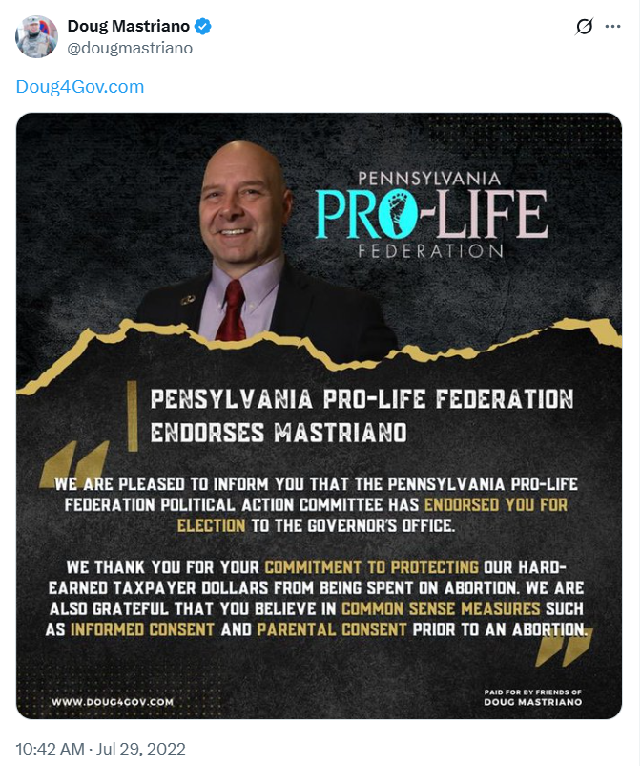
[Twitter, @dougmastriano, 7/29/22]

Mastriano Attended March For Life Events
2022: Mastriano Attended The March For Life At The Pennsylvania State Capitol In Harrisburg. According to Mastriano’s Senator Facebook account, “Fantastic March for Life event.”
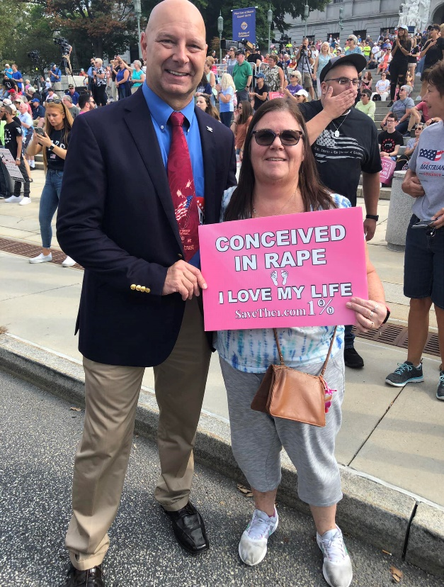
[Facebook, Senator Mastriano, 9/19/22]
- A Few Days Prior Mastriano Said He Would Not Be Able To Attend The Event And Said “The Right To Life Should Never Be Denied.” According to Mastriano’s Facebook, “While I am unable to attend this year's March for Life Rally in Harrisburg, I am in full support of this event. The right to life should never be denied.” [Facebook, Senator Mastriano, 9/16/22]
Shapiro Posted A Video Of Mastriano At The March For Life Rally Saying That “We Are Still Talking About Life,” And It Was “The Single Most Important Issue” In Our Lifetime. According to Shapiro’s campaign Twitter, “Doug Mastriano’s top priority as Governor would be to ban abortion with no exceptions — including for rape, incest, or life of the mother. He’s said it himself. Literally today.”
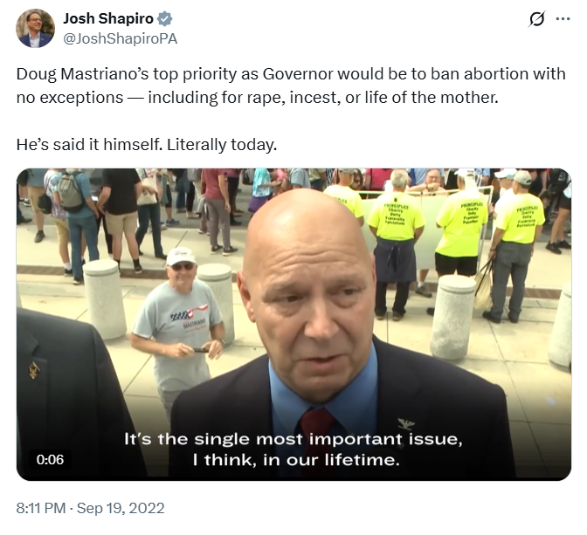
[Twitter, @JoshShapiroPA, 9/19/22]

