Overview
Mastriano was an election denier who tried to overturn Pennsylvania’s 2020 election results and was Trump’s “point person” in Pennsylvania to help organize fake electors in the commonwealth. The FBI questioned Mastriano over his involvement at the insurrection, and the January 6th committee subpoenaed Mastriano for sending fake elections, trying to overturn the election, and participating in the insurrection. Mastriano repeatedly lied about his involvement and connections to the January 6th attack on the Capitol.
- Mastriano claimed he left the riot when it no longer became peaceful but stayed long enough to see rioters breach the Capitol building.
- Mastriano claimed he did not “go beyond police lines” but was recorded crossing police lines as rioters threw police barricades to the side.
- Mastriano claimed he did not condone the violence at the Capitol building but spent more than $3,000 in campaign funds to pay for rioters to travel to the Capitol, one of whom was later arrested for carrying a weapon.
- Mastriano denied knowing Sam Lazar, an Ephrata man who was arrested for assaulting police officers at the Capitol with pepper spray, but Mastriano had been photographed several times with Lazar.

Mastriano Was An Election Denier Who Tried To Undo Pennsylvania’s 2020 Election Results

Mastriano Signed A Letter Urging Vice President Pence To Delay The 2020 Election Certification Until January 6
CNN: “Mastriano And Arizona Representative Finchem Signed A Letter To Mike Pence On January 5th Asking Him To Delay The Certification Of The Electoral Results Until January 6th.” According to CNN, “The panel says it has evidence to show that Finchem communicated with leaders from the Stop the Steal organization about an event on the US Capitol grounds on January 6 where he was slated to speak. After the Arizona election results were certified for Biden, Finchem made repeated, unsubstantiated claims about the election being stolen and helped coordinate a hearing in Phoenix where members of Trump's legal team repeated those claims. Finchem is currently running for Arizona secretary of state and has been endorsed by Trump. Mastriano and Finchem signed a letter to former Vice President Mike Pence on January 5, 2021, asking him to delay certification of the electoral results on January 6.” [CNN, 2/15/22]

Mastriano Tried To Overturn The 2020 Election Results In Pennsylvania

Mastriano Sponsored A Resolution In The Pennsylvania Legislature To Undo The Certification Of The Election And Alleged Voter Fraud In Pennsylvania
Days After Joe Biden Won The Election, Mastriano Sponsored A Resolution In The Pennsylvania Legislature To Undo The Certification Of The Election. According to WHYY, “Days after President Joe Biden’s victory was certified in Pennsylvania, Mastriano sponsored a resolution in the Legislature to undo the certification, declare the election in dispute and effectively overturn state law by empowering the Republican-controlled Legislature to pick electors. The resolution did not gather any cosponsors and died in committee without action on Nov. 30.” [WHYY, 2/15/22]
Mastriano Repeatedly Claimed That The Number Of Votes In The 2020 Election Exceeded The Number Of Registered Voters In Pennsylvania, Despite The Claim Being Debunked And Rejected By Courts. According to York Daily Record, “Mastriano and his supporters, including My Pillow founder Mike Lindell, have repeatedly made the false claim that the number of votes counted in the 2020 Pennsylvania presidential election exceeded the number of registered voters in the state. That false claim started with state Rep. Frank Ryan, R-Lebanon, who said there were 205,000 more votes than voters. It’s a claim that has been repeated by Trump, Mastriano and several of their far-right supporters. The fraud claim has been categorically debunked and rejected by courts, which said the Trump campaign failed to produce evidence of widespread fraud.” [York Daily Record, 4/14/22]
After The 2020 Election, Mastriano Emailed Three Counties Demanding All Voting Materials And Called For A Forensic Investigation Which The Counties Refused. According to the Philadelphia Inquirer, “Back in Pennsylvania, Mastriano sent letters to three counties, including Philadelphia, demanding voting equipment and virtually all election-related materials as he pursued what he called a ‘forensic investigation.’ The counties refused to comply, and Mastriano was later stripped of his committee chairmanship by Senate President Pro Tempore Jake Corman (R., Centre), who took control of the review and is now also running for governor.” [Philadelphia Inquirer, 2/16/22]
November 2020: Mastriano’s Fight To Overturn The Election Results Included Attending A Hearing In Harrisburg With Rudy Giuliani About Voter Fraud. According to The Pocono Record, “Mastriano's fight to overturn election results began in late November 2020, when he hosted a hearing in Gettysburg with Trump lawyer Rudy Giuliani. The hearing, which did not include sworn testimony, was a platform for multiple unsubstantiated claims of voter fraud.” [Pocono Record, 2/15/22]

Mastriano Joined A Lawsuit In Texas Filed Against Pennsylvania To Invalidate The Results Of The 2020 Election
November 2020: Mastriano Joined A Lawsuit In Texas Filed Against Pennsylvania To Invalidate The Results Of The 2020 Election. According to the Pittsburgh Jewish Chronicle, “The Republican candidates for governor include several state lawmakers who were involved with efforts to overturn the state’s election results in 2020, most notably state Sen. Doug Mastriano, who joined a Texas lawsuit filed against Pennsylvania seeking to invalidate the state’s results.” [Pittsburgh Jewish Chronicle, 2/8/22]

Bill Barr Testified That Mastriano Originated A False Claim That More People Voted By Mail In Pennsylvania Than Had Requested Ballots
Bill Barr Testified That Mastriano Originated A False Claim That More People Voted By Mail In Pennsylvania, Than Had Requested Ballots. According to the Ohio Capital Journal, “Former Attorney General Bill Barr testified that Mastriano, a state senator, originated a false claim that more people voted by mail in Pennsylvania than had requested mail-in ballots.” [Ohio Capital Journal, 6/16/22]
- U.S. Attorney McSwain Explained To Barr That Mastriano Was Comparing The Number Of Ballots Requested For The Primary To The Number Of Ballots Cast In The General Election. According to the Ohio Capital Journal, “Barr called McSwain, then the U.S. attorney in Philadelphia, and asked about it. McSwain explained Mastriano’s error was comparing the number of requested ballots for the 2020 GOP primary with the number of ballots cast in the general election, according to Barr.” [Ohio Capital Journal, 6/16/22]

Rudy Giuliani Included Mastriano On A Witness List For The Charges He Faced For Attempting To Overturn The 2020 Election
Rudy Giuliani Included Mastriano And His Campaign Advisor Jenna Ellis On A Witness List For The Charges He Faced In Washington D.C. For Attempting To Overturn The 2020 Election. According to Bloomberg, “Rudy Giuliani intends to defend himself against a legal ethics prosecution in Washington by calling a string of witnesses who promoted baseless claims that the 2020 election was marred by widespread fraud. A witness list submitted Friday by his lawyers to the hearing committee that will consider his case in early December features prominent conservative lawyers and activists who backed then-President Donald Trump’s ‘Stop the Steal’ effort to undo Joe Biden’s victories in key states. […] Giuliani’s proposed witnesses include Doug Mastriano the Republican candidate for governor of Pennsylvania; Christina Bobb, a lawyer recently in the spotlight for her connection to a federal criminal inquiry into Trump’s handling of government documents at his Mar-a-Lago resort; former Trump campaign lawyer Jenna Ellis.” [Bloomberg, 10/14/22]
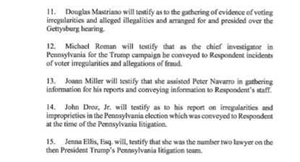
[D.C. Court of Appeals, 10/14/22]

Trump Named Mastriano His “Point Person” In Pennsylvania After The 2020 Election To Help Organize Fake Electors For The Commonwealth
Trump Named Mastriano His “Point Person” In Pennsylvania After The 2020 Election To Help Organize Fake Electors For The Commonwealth. According to the New York Times, “The dozens of emails among people connected to the Trump campaign, outside advisers and close associates of Mr. Trump show a particular focus on assembling lists of people who would claim — with no basis — to be Electoral College electors on his behalf in battleground states that he had lost. […] As they organized the fake elector scheme, lawyers appointed a ‘point person’ in seven states to help organize those electors who were willing to sign their names to false documents. In Pennsylvania, that point person was Douglas V. Mastriano, a proponent of Mr. Trump’s lies of a stolen election who is now the Republican nominee for governor.” [New York Times, 7/26/22]
- Mastriano Had Doubts About The Fake Elector Plan, And Needed Assurance From Rudy Giuliani About The Legality Of The Plan. According to the New York Times, “But even Mr. Mastriano needed assurances to go along with a plan other Republicans were telling him was ‘illegal,’ according to a Dec. 12 email sent by Ms. Bobb that also referred to Mr. Giuliani, the former mayor of New York City. ‘Mastriano needs a call from the mayor. This needs to be done. Talk to him about legalities of what they are doing,’ she wrote, adding: ‘Electors want to be reassured that the process is * legal * essential for greater strategy.’” [New York Times, 7/26/22]
- In 2020, Trump Urged Mastriano To Declare The Election Corrupt And Help Overturn The Results. According to the Philadelphia Inquirer, “Mastriano, the state senator from Franklin County, played a role in Trump’s effort to overturn the 2020 election. Trump specifically cited Mastriano and U.S. Rep. Scott Perry (R., Pa.) in a late 2020 phone call with top Justice Department officials in which Trump urged them to declare the election corrupt, according to a report by Democrats on the U.S. Senate Judiciary Committee.” [Philadelphia Inquirer, 2/8/22]

Mastriano Was Subpoenaed For His Efforts To Send False Electors, Overturn The 2020 Election, And Participating In January 6

The FBI Questioned Mastriano Over His Involvement At The January 6 Insurrection
2021: The FBI Questioned Mastriano After Photos Surfaced Of Him At The January 6 Insurrection. According to CNN, “The FBI has been conducting an expansive investigation into the January 6 riot and questioned Mastriano last summer after photos emerged of him on Capitol grounds that day, according to the source familiar with the interview, which has not been previously reported. Mastriano has not been accused of committing any crimes and cooperated fully with the FBI, according to the source. Asked about Mastriano’s interview, an FBI spokesperson told CNN that the bureau ‘cannot confirm the existence of an investigation or comment on details.’” [CNN, 6/2/22]

The January 6th Committee Subpoenaed Mastriano For His Efforts To Send False Electors, Overturn The Election, And Participating In The Insurrection

The January 6th Committee Subpoenaed Mastriano, Believing He Had Documents And Information Relevant To January 6
2022: Mastriano Was One Of Six Subpoenaed For “Efforts To Send False Slates Of Electors To Washington And Change The Outcome Of The 2020 Election.” According to the Philadelphia Inquirer, “The panel said Tuesday that it sent subpoenas to six people, including Mastriano, demanding information ‘about efforts to send false slates of electors to Washington and change the outcome of the 2020 election.’” [Philadelphia Inquirer, 2/15/22]
2022: The Congressional January 6th Committee Wrote That They Believed Mastriano Had Documents And Information Relevant To Its Investigation. According to the Philadelphia Inquirer, “‘Based on publicly available information and information produced to the Select Committee, we believe that you have documents and information that are relevant to the Select Committee’s investigation,’ Rep. Bennie Thompson (D., Miss.) wrote in a letter to Mastriano that was dated Tuesday. Citing Mastriano’s public statements and news accounts, Thompson said Mastriano participated in a plan to get the GOP-led state legislature to send a pro-Trump slate of electors to Congress on Jan. 6, spoke with former President Donald Trump in the aftermath of the election, and was present on Capitol grounds the day of the riot.” [Philadelphia Inquirer, 2/15/22]
- The Letter Noted That Mastriano Was Present Outside Of The Capitol On January 6th. According to the Philadelphia Inquirer, “The letter also notes that Mastriano appeared outside the Capitol on Jan. 6, when a pro-Trump mob stormed the Capitol and delayed certification of Biden’s victory. Mastriano has said he didn’t enter the building. ‘Based on your public statements, we understand that you were present during the attack on the U.S. Capitol on January 6, 2021, and that you witnessed agitators … getting in the face of the police and agitators … start pushing the police up the [Capitol] steps,’ the letter says.” [Philadelphia Inquirer, 2/15/22]
- Mastriano Subpoena Demanded Mastriano Share Documents By March 1st And Appear For A Deposition On March 10th. According to the Philadelphia Inquirer, “The subpoena demands Mastriano share documents by March 1 and appear for a deposition March 10. ‘We’re seeking records and testimony from former campaign officials and other individuals in various states who we believe have relevant information about the planning and implementation of those plans,’ Thompson said in a statement.” [Philadelphia Inquirer, 2/15/22]
2022: When Asked About His January 6th Subpoena, Mastriano Responded Saying “There Are No Legal Issues.” According to ABC 27, “‘You organized busses to the Capital on January 6, 2020, you’ve been subpoenaed to testify before the House committee investigating that day. To our knowledge, you have not responded to that subpoena. But what do you say to Republican voters tonight, specifically those who might be concerned that there are still legal issues ahead for you on that,’ co-host of the debate Dennis Owens asked.’ Mastriano responded, saying, ‘There are no legal issues.’ It was the first time Mastriano has commented on-air about the committee’s subpoena.” [ABC 27, 4/28/22]
- Mastriano Claimed He Was Exercising His Constitutional Right On January 6th At The Capitol. According to ABC 27, “‘I’ll delineate in the U.S. Constitution, that we have five freedoms delineated in the First Amendment — the freedom of religion, press, speech, assembly, and the right to address the government. I was there to hear my president speak, and then I was invited to speak at two locations, exercising my constitutional right, and shame on the media and the Democrats who are painting anyone who was down there as a villain,’ Mastriano said Wednesday night.” [ABC 27, 4/28/22]

Mastriano Met With The January 6 Committee For Less Than 15 Minutes
HEADLINE: “Doug Mastriano Meets With Select Committee Investigating Jan. 6, For Less Than 15 Minutes.” [Philadelphia Inquirer, 8/9/22]
HEADLINE: “Doug Mastriano, Set To Testify Next Week About Jan 6, Worries About Clips Of Testimony Leaking.” [Philadelphia Inquirer, 8/5/22]
HEADLINE: “Democrats Say Doug Mastriano Breached Police Lines During January 6. Insurrection And Should Release Video To Prove Otherwise.” [CBS Pittsburgh, 7/21/22]
2022: Mastriano’s Lawyer, Timothy Parlatore, Confirmed That Mastriano Spent Less Than 15 Minutes Speaking To The January 6th Committee. According to the Philadelphia Inquirer, “State Sen. Doug Mastriano, the Republican nominee for governor in Pennsylvania, had a very brief visit Tuesday with the congressional committee investigating the deadly Jan. 6, 2021, attack on the U.S. Capitol. His attorney, Timothy Parlatore, confirmed that Mastriano spent less than 15 minutes speaking to the Jan. 6 committee in a teleconference.” [Philadelphia Inquirer, 8/9/22]
2022: Mastriano’s Lawyer, Parlatore, Said The Committee Did Not Allow Mastriano To Record The Session, And That Mastriano Will Take The Case To Court To Challenge The Committee’s Subpoena. According to the Philadelphia Inquirer, “Parlatore, who insisted on being allowed to record Mastriano’s session, contends the committee lacks the legal authority to compel testimony. The committee last week refused to allow the recording. Parlatore said Mastriano will now take his case to court, challenging the committee’s subpoena.” [Philadelphia Inquirer, 8/9/22]

Mastriano Said He Sued The January 6th Committee For Not Letting Him Record His Interview
2022: Mastriano Issued A Statement That He Was Suing The January 6th Committee For Not Letting Him Audio Record His Interview. According to Mastriano’s campaign Twitter,
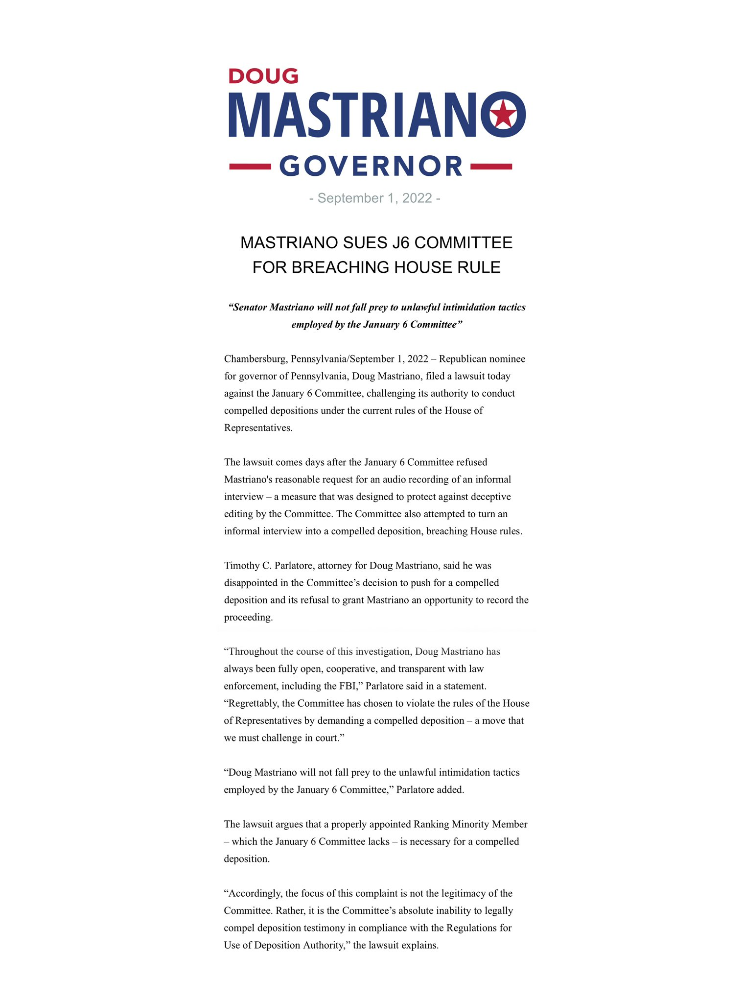
[Twitter, @dougmastriano, 9/1/22]

Mastriano Claimed He Did Not Participate In The Attack On The Capitol Despite Being Photographed Crossing Police Lines And Even Paying For Chartered Buses That Took Rioters To The Capitol

January 6, 2021: Mastriano SAID HE PLANNED TO SPEAK ON THE STEPS OF THE CAPITOL BUT CLAIMED HE LEFT WHEN He Saw Rioters Breach The Building
December 19, 2020: President Trump Called For A “Big Protest In D.C. On January 6th” To Protest The 2020 Election. According to The New York Times, “For weeks, President Trump and his supporters had been proclaiming Jan. 6, 2021, as a day of reckoning. A day to gather in Washington to ‘save America’ and ‘stop the steal’ of the election he had decisively lost, but which he still maintained — often through a toxic brew of conspiracy theories — that he had won by a landslide. […] ‘Big protest in D.C. on January 6th,’ Mr. Trump tweeted on Dec. 19, just one of several of his tweets promoting the day. ‘Be there, will be wild!’” [New York Times, 1/6/21]
January 4, 2021: Mastriano Announced He Would Go To Washington, DC And Said He Would Speak On The Steps Of The U.S. Capitol Building. According to the New Yorker, “Two days before the Capitol riots, Mastriano said that he was heading to Washington, D.C., and ‘calling out to God for divine revelation.’ He used campaign funds to charter six buses to shuttle followers to Washington, D.C., and told them that he would speak on the Capitol steps.” [New Yorker, 5/9/21]
Mastriano Claimed He Left The Capitol After Events Were No Longer Peaceful But Stayed Long Enough To See Rioters Breach The Capitol Building. According to the New Yorker, “Later that evening, Mastriano appeared on Facebook Live for his fireside chat, looking spooked. He told viewers that he had left the Capitol after he saw things ‘get weird,’ saying, ‘When it was apparent that this was no longer a peaceful protest, my wife and I left the area.’ Mastriano later told a radio interviewer that he stayed long enough to witness both the first and second breaches of the building. ‘There were several speaking events planned,’ he told me, by e-mail. ‘It was to be a peaceful gathering as it had been previously. When it no longer looked that way, the buses departed.’” [New Yorker, 5/9/21]
Mastriano Claimed That He Did Not “Enter The Capitol Building, Walk On The Capitol Steps Or Go Beyond Police Lines.” According to the Pittsburgh City Paper, “‘As a military veteran and retired colonel, I do not – nor would I ever – condone the violence we saw today. I join with all patriotic Americans in condemning what occurred in the Capitol,’ said Mastriano in a statement. ‘My position on lawlessness is equally as clear. When it was apparent that this was no longer a peaceful protest, my wife and I left the area and made our way out of the area. At no point did we enter the Capitol building, walk on the Capitol steps or go beyond police lines.’” [Pittsburgh City Paper, 1/6/21]

However, Mastriano Was Photographed Crossing Police Lines During The Attack On The Capitol
HEADLINE: “Videos Contradict State Lawmaker’s Claim He Left Capitol While It Was ‘Still Peaceful’” [HuffPost, 5/26/11]
During The January 6th Attack On The Capitol, Mastriano Was Recorded Crossing A Police Line And Standing On The Northwest Lawn Of The Capitol. According to HuffPost, “But in videos analyzed by members of the online ‘Sedition Hunters’ community and posted on social media over the weekend, Mastriano and his wife appeared to be in a crowd as it breached a police line. Mastriano was wearing one of his campaign hats and a dark-green scarf on the day. The video shows people moving forward as a man picks up and throws away the police barricades. Another image shows the couple on the northwest lawn.” [HuffPost, 5/26/11]
Mastriano Was Photographed At The January 6th Attack On The Capitol With Rick Saccone.
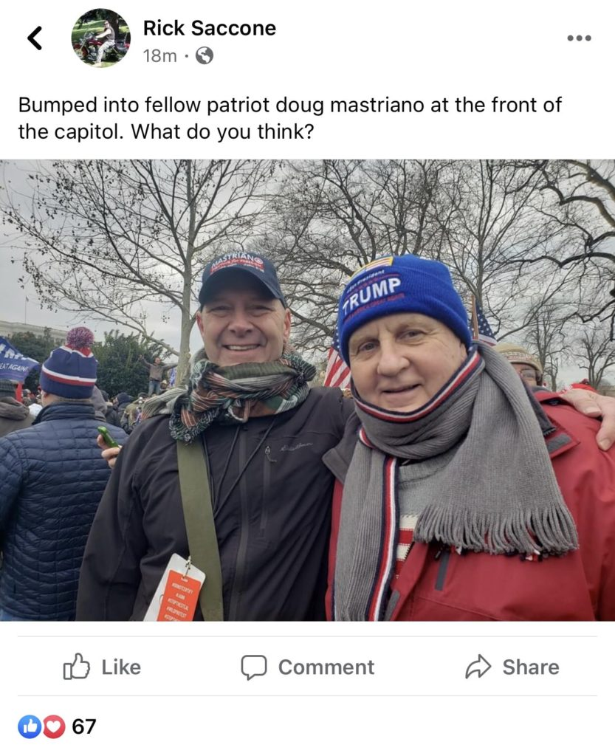
[Pennsylvania Spotlight, 5/9/21]
- Mastriano Later Said He Did Not Know Saccone “Real Well.” “During the radio interview, Senator Mastriano downplayed his connections – or knowledge – of knowing the former House Representative. Senator Mastriano called Saccone ‘a controversial figure from out west,’ and ‘I don’t know him real well.’ After his encounter with Saccone, Senator Mastriano claimed to have left the Capitol grounds to walk back to his hotel that was two miles away. That’s when his phone began blowing up with calls from family members and Senate colleagues.” [Pennsylvania Spotlight, 5/9/21]
Mastriano Was Recorded Crossing A Police Line As A Rioter Threw Police Barricades To The Side.
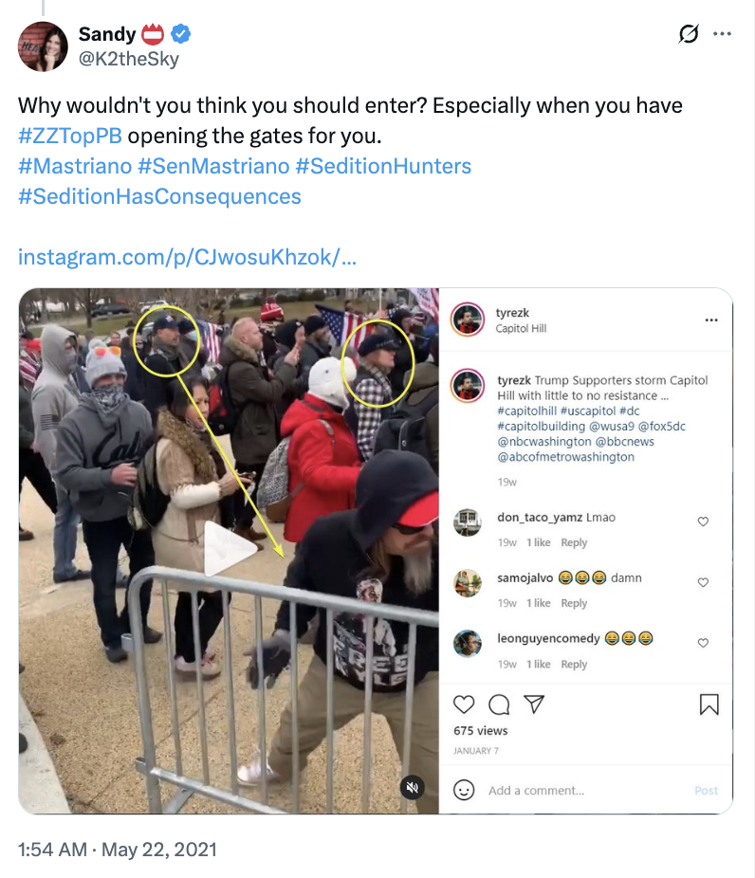
[Twitter, @K2theSky, 5/22/21]
Mastriano Was Photographed On The Lawn Outside The Capitol.
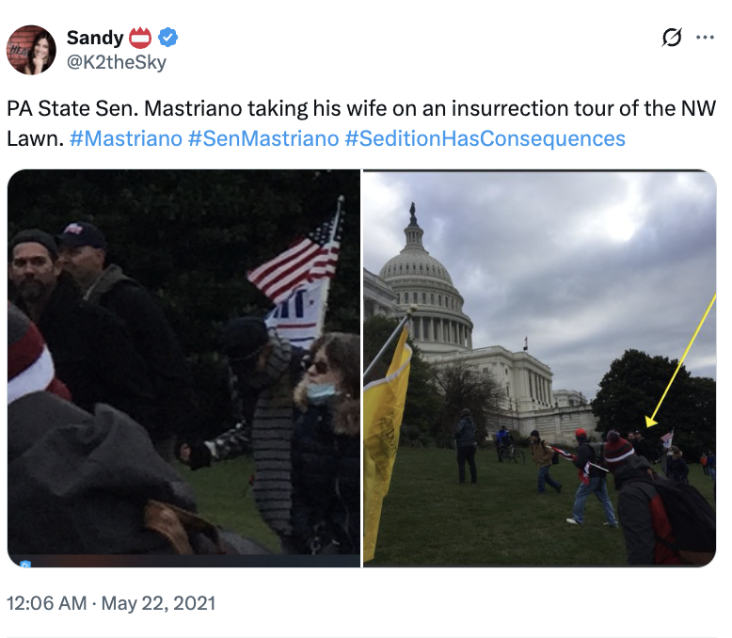
[Twitter, @K2theSky, 5/22/21]
Pennsylvania Spotlight: “Senator Mastriano Was At The Forefront Of The Deadly Insurrection, Saw The First And Second Attempt To Breach The Capitol, And Then Only Left Not After The First Few Signs Of Violence, But After Taking A Few Selfies With People He Claims To Not Know.” According to Pennsylvania Spotlight, “This new reporting demonstrates that Senator Mastriano was at the forefront of the deadly insurrection, saw the first and second attempt to breach the Capitol, and then only left not after the first few signs of violence, but after taking a few selfies with people he claims to not know. While painting a clear timeline of events, additional questions remain for Senator Mastriano about the totality of his involvement in the deadly insurrection.” [Pennsylvania Spotlight, 5/9/21]

Mastriano Spent More Than $3,000 Of Campaign Funds To Charter People To DC For The January 6 Insurrection, Some Of Whom Were Later Arrested
HEADLINE: “Mastriano Campaign Spent Thousands On Buses Ahead Of D.C. Insurrection” [WHYY, 1/12/21]
For The January 6th Protest, Mastriano Spent $3,354 Of Campaign Money To Charter Buses To Take People To Washington, DC. According to WHYY, “Campaign finance records show that State Sen. Doug Mastriano’s campaign spent thousands of dollars on charter buses ahead of the Washington D.C. rally that ended with supporters of President Donald Trump violently storming the halls of Congress last week during an insurrection. Mastriano (R-Franklin), rumored to be a future GOP gubernatorial candidate, has faced calls to resign for attending the rally. A review of the state senator’s campaign finance records shows that his committee paid $3,354 to Wolf’s Bus Lines in three installments for ‘bus reservations’ about six days before Trump’s ‘Save America’ rally.” [WHYY, 1/12/21]
At Least Two Person From Mastriano’s Chartered Buses Participated In The Attack On The Capitol With One Of Them Being Arrested For Curfew Violation And Possession Of A Weapon. According to the New Yorker, “Two days before the Capitol riots, Mastriano said that he was heading to Washington, D.C., and ‘calling out to God for divine revelation.’ He used campaign funds to charter six buses to shuttle followers to Washington, D.C., and told them that he would speak on the Capitol steps. […] James Sinclair, a man from Bensalem, Pennsylvania, who rode one of the buses to the Capitol, was arrested for a curfew violation and possession of a weapon. Sandy Weyer, a bus rider who was photographed at the door of the Capitol with her fist raised, tweeted, ‘Truth be known about storming the capitol . . . we were sick and tired of DITHERING!!!’ Rick Groves, another bus rider, told a local radio host, of the insurrection, ‘All I saw was unity and love, and it was a beautiful thing, like Woodstock almost, with Trump flags.’” [New Yorker, 5/9/21]

As He Claimed No Wrongdoing, Mastriano Called For The PROSECUTION Of Those Who Violated The Law on January 6th
Mastriano: “I Followed The Directions Of The Capitol Police And Respected All Police Lines As I Came Upon Them.” According to a press release from State Senator Dough Mastriano, “Contrary to the desperate claims of anonymous keyboard warriors, I followed the directions of the Capitol Police and respected all police lines as I came upon them. Even disingenuous internet sleuths know that police lines did shift throughout the course of the day. I followed those lines as they existed.” [Press Release – State Senator Doug Mastriano, 5/25/21]
Later In The Day On January 6th, Mastriano Denounced The Events At The Capitol And Said, “Those Who Violated Those Laws Must Be Prosecuted.” According to the Pittsburgh City Paper, “According to posts on social media, Mastriano can be seen posing for a photo with Saccone, and Mastriano is wearing one of his campaign hats. Hours after the Capitol grounds had largely been cleared, Mastriano issued a statement on social media saying ‘the violence on Capitol Hill today is unacceptable, unamerican and should be condemned by every citizen. This is not the American way.’ Later in the day on Jan. 6, Mastriano posted an official statement saying that while he and his wife were in D.C. to attend the rally, but that they both left the area when ‘it was apparent that this was no longer a peaceful protest.’ He added that ‘those who violated those laws must be prosecuted.’” [Pittsburgh City Paper, 1/6/21]

Mastriano Denied Knowing Sam Lazar, A Rioter Who Was Arrested For Pepper Spraying Police During The Attack On The Capitol, Despite Having Been Photographed Together Several Times

Samuel Lazar Was Arrested His Participation In The January 6th Riot At The U.S. Capitol And Was Recorded Pepper spraying Police

The FBI Arrested Lazar For His Participation In The Attack On The Capitol Where He Was “Pepper-Spraying Police,” “Encouraging Violence,” And “Was Among The First To Storm The Barricades”
January 2021: The FBI Sought To Arrest The Man Shown In Photograph #275 For His Participation In The January 6th Riots At The Capitol.
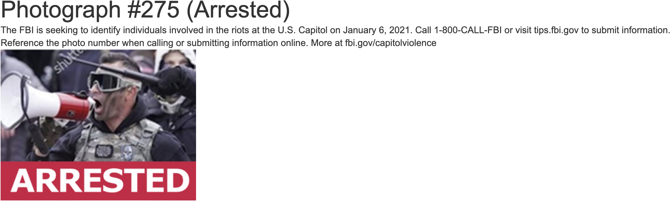
[FBI, Archived 8/17/21]
HEADLINE: “Lancaster County Man On FBI Most Wanted List In Capitol Attack, Footage Shows” [LancasterOnline, 4/12/21]
LancasterOnline Identified The Man As Samuel Lazar. According to LancasterOnline, “A man who is wanted by the FBI and is shown on video pepper-spraying police and encouraging violence near the U.S. Capitol on Jan. 6 is a staunch Trump supporter from Ephrata, video and still footage shows. LNP|LancasterOnline was able to identify the man by carefully comparing his social media posts to widely disseminated video and photos of the violent events that day, which followed a speech by then-President Donald Trump to thousands of his supporters in which he urged them to stop Congress from certifying Joe Biden’s victory in the November election. Numerous videos and photographs now inaccessible on the man’s Facebook page—which an LNP|LancasterOnline reporter and editor relied on to report a Jan. 10 story about Lancaster County residents who went to Washington, D.C.—show the man is Samuel Lazar, 35, a self-described entrepreneur.” [LancasterOnline, 4/12/21]
LancasterOnline: Lazar Was Recorded “Pepper-Spraying Police And Encouraging Violence Near The U.S. Capitol On Jan. 6.” According to LancasterOnline, “A man who is wanted by the FBI and is shown on video pepper-spraying police and encouraging violence near the U.S. Capitol on Jan. 6 is a staunch Trump supporter from Ephrata, video and still footage shows.” [LancasterOnline, 4/12/21]
The FBI Submited An Image Of Lazar “Where He Aimed A Cannister Resembling One That Holds A Chemical Irritant In The Direction Of U.S. Capitol Police And D.C. Metro Police.”
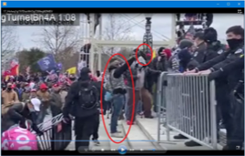
[USA v Lazar, Statement of Facts, 7/21/21]
Lazar Pepper Sprayed A Capitol Police Officer Which Blinded The Police Officer. According to documents in USA v Lazar, “As shown on Officer-1’s body worn camera, LAZAR was told to ‘get back’ and police deployed a chemical irritant causing LAZAR to retreat down the steps. LAZAR then turned to face Officer-1 and redeployed his chemical irritant toward Officer-1 and a U.S. Capitol Police Officer (‘Officer-2’) a second time, causing Officer-2 to lose the ability to see, as depicted in Figure Eight below: Officer-1 reported that he was repeatedly exposed to Oleoresin capsicum (‘OC’) spray, also known as ‘pepper spray,’ and CS gas while protecting the Capitol on January 6, 2021, which rendered him unable to see and caused him to become unsteady on his feet at times.” [USA v Lazar, Statement of Facts, 7/21/21]
HuffPost: At The January 6th Riot, Lazar Was “Among The First To Storm Through The Barricades, Yelling In An Officer’s Face, Trying To Grab A Bike Rack Away From An Officer, Using A Megaphone To Direct The Mob To Push Forward.” According to HuffPost, “Members of an online community working to identify Capitol offenders spotted the man they knew as #FacePaintBlowhard as being among the first to storm through the barricades, yelling in an officer’s face, trying to grab a bike rack away from an officer, using a megaphone to direct the mob to push forward, holding a can of what looks like pepper spray, and then spraying the can at a police line. He also helped the mob use a giant Trump sign as a battering ram against a police line. In a video shot down the street from the Capitol, Lazar told onlookers that they ‘maced ’em [law enforcement officers] right the fuck back.’” [HuffPost, 5/27/21]
Associated Press: “Lazar Is Seen Spraying What Appears To Be A ‘Chemical Irritant’ At Officers, And Then Later Boasting About Having ‘Maced’ Them, According To Court Papers.” According to the Associated Press, “In videos, Lazar is seen spraying what appears to be a ‘chemical irritant’ at officers, and then later boasting about having ‘maced’ them, according to court papers.” [Associated Press, 7/27/21]
- Lazar: “They Maced Us, Those Tyrannical Pieces Of Shit, And We Maced Them Right The Fuck Back And Now They’re Taking The Building.” According to documents in USA v Lazar, “In this video, LAZAR stated, ‘They maced us, those tyrannical pieces of shit, and we maced them right the fuck back and now they’re taking the building.’ Based on my training, experience and knowledge of the case, with this statement, LAZAR meant that U.S. Capitol Police and D.C. Metro Police deployed chemical irritant at LAZAR, and in response he intentionally deployed a chemical irritant back at the police. LAZAR then referenced that the rioters had successfully breached the Capitol building.” [USA v Lazar, Statement of Facts, 7/21/21]
HEADLINE: “Wanted Lancaster County Man With Ties To GOP Lawmaker Doug Mastriano Arrested On Capitol Riot Charges” [Philadelphia Inquirer, 7/27/21]
July 2021: Lazar Was Arrested And Charged With Assaulting Police And Obstruction Of Law Enforcement During A Civil Disorder. According to the Philadelphia Inquirer, “And yet in the six months that followed — even as he appeared on the FBI’s list of most wanted insurrection suspects, posed for photos with prominent Pennsylvania GOP candidates like 2022 gubernatorial hopeful Doug Mastriano, and featured in more videos that surfaced from the insurrection including one depicting him using a giant Trump campaign sign as a battering ram to break through police lines — Lazar remained free. That changed Tuesday as federal authorities in Washington announced they had arrested the self-described 37-year-old entrepreneur from Ephrata on charges of assaulting officers and signaled their intention to keep him in jail until trial. […] He now faces charges including assaulting police and obstruction of law enforcement during a civil disorder, the most serious of which could send him to prison for up to 20 years.” [Philadelphia Inquirer, 7/27/21]

On The Day Of The January 6th Riot, Lazar Posted On Social Media That He Was “Ready For War”
January 6, 2021: Lazar Posted On Social Media, “It’s Going To Be An Eventful Day. Donald Trump Is Going To Shock The World! We’re Ready For War, If We’re Needed.” According to LancasterOnline, “In a video from the morning of Jan. 6, Lazar said: ‘It’s going to be an eventful day. Donald Trump is going to shock the world! We’re ready for war, if we’re needed.’” [LancasterOnline, 4/12/21]
January 7, 2021: Lazar Posted On Social Media There Was “A Time For Peace And There’s A Time For War.” According to LancasterOnline, “Lazar, of Ephrata, posted to Facebook on Thursday, acknowledging the violent attack on the Capitol. He wrote: ‘I hate to see violence happening in our country at this time in our history. I wish for peace and prosperity! However just like in the bible itself it says, there is a time for peace and there’s a time for war. Our constitution allows us to abolish our govt and install a new one in it’s place.’” [LancasterOnline, 1/10/21]

On May 15, 2021, Lazar Attended A Fundraiser For Mastriano Where They Were both Photographed Together But Both Later Gave Conflicting Stories Regarding The Event
HEADLINE: “Trumper On FBI Capitol Wanted List Attends Giuliani Event For GOPer Who Pushed Big Lie” [HuffPost, 5/18/21]
HEADLINE: “Capitol Rioter Wanted By FBI Attended Giuliani Event For Trumpy Politico” [Daily Beast, 5/18/21]
HEADLINE: “Ephrata Trump Supporter Who Was At Capitol Insurrection Attended Recent Mastriano/Giuliani Fundraiser” [LancasterOnline, 5/18/21]
May 2021: Pennsylvania State Senator Doug Mastriano Hosted A Fundraiser With Rudy Giuliani In Chambersburg, Pennsylvania. According to the Erie Times-News, “When state Sen. Doug Mastriano claimed he wanted to find truth and transparency after the 2020 election, he called former President Donald Trump’s personal lawyer Rudy Giuliani. […] Now the two will be back together on Saturday. Giuliani will headline a fundraiser for Mastriano in Chambersburg as Mastriano is expected to ultimately enter the Republican primary race for Pennsylvania governor.” [Erie Times-News, 5/14/21]
May 15, 2021: Mastriano Had A Photo Taken Of Him And Lazar At The Fundraiser. [Philadelphia Inquirer, 7/27/21]
May 15, 2021: Lazar Posed For A Photo With Mastriano In The Background. [HuffPost, 5/27/21]

Mastriano Claimed He Did Not Know Lazar While Lazar Denied He Attended Mastriano’s Fundraiser
May 2021: When Asked About The Photo Taken With Lazar, Mastriano Claimed He Did Not Know Lazar. According to HuffPost, “Following the publication of this article, Mastriano sent HuffPost a statement about the photo showing him with Lazar. He said he condemned Lazar’s actions and believed ‘anyone who committed violence against law enforcement that day should be charged and held accountable.’ He said it was impossible to vet everyone he takes a photograph with and suggested he didn’t know Lazar’s identity. ‘Why would you assume that every politician who takes a picture with someone at an event automatically knows who they are or agree with what they believe?’ Mastriano said in his statement.” [HuffPost, 5/27/21]
May 2021: Lazar Later Denied He Attended Mastriano’s Fundraiser. According to HuffPost, “Reached by HuffPost on Tuesday morning, Lazar claimed he ‘wasn’t able to make it’ to the Mastriano event he was photographed at, and then hung up.” [HuffPost, 5/27/21]

Despite Mastriano’s Claim He Did Not Know Lazar, Mastriano And Lazar Had Been Photographed Together Several Times

There Were “At Least Half A Dozen Other Images” Of Mastriano And Lazar
Philadelphia Inquirer: Mastriano Claimed He Did Not Know Lazar But There Were “At Least Half A Dozen Other Images Of The Two Men Photographed Together.” According to the Philadelphia Inquirer, “It was that video, in part, that led to uncomfortable questions for Mastriano when photos surfaced of him smiling with his arm around Lazar at a May fund-raiser in Chambersburg in which Trump lawyer Rudy Giuliani was a featured guest. Mastriano later denied knowing who Lazar was. […] But the same group of online sleuths that first identified Lazar and uncovered the fund-raiser photos responded by finding at least half a dozen other images of the two men photographed together during earlier events — including a Nov. 25 state Senate hearing in Gettysburg, where Mastriano first emerged as one of the primary proponents of Trump’s stolen election lies.” [Philadelphia Inquirer, 7/27/21]

November 2020-December 2020: Mastriano And Lazar Were Photographed At Two Political Events Together
Mastriano Had Been Photographed With Lazar In November 2020 And In December 2020 At Another “Stop The Steal Rally” In Washington, DC. According to HuffPost, “As online sleuths discovered after this article was published, Mastriano didn’t just take a photo with Lazar at one event, and he seemed to have been circulating the senator’s orbit for a while. Mastriano and Lazar have been photographed together on at least three separate occasions: at an event in late November, in front of the Supreme Court during a December trip to Washington for a pro-Trump ‘Stop the Steal’ rally, and at the Giuliani event earlier this month.” [HuffPost, 5/27/21]

Mastriano And Lazar Had Several Other Photographs Together
Mastriano And Lazar Had Been Photographed Several Times Together.
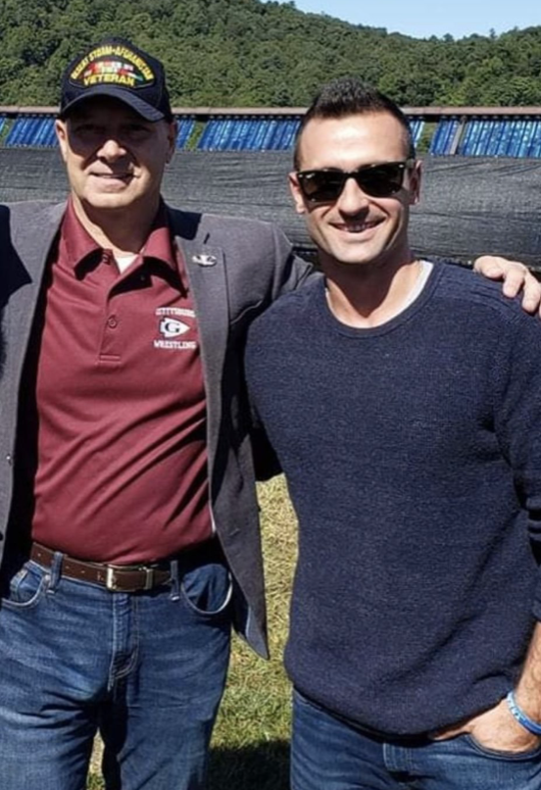

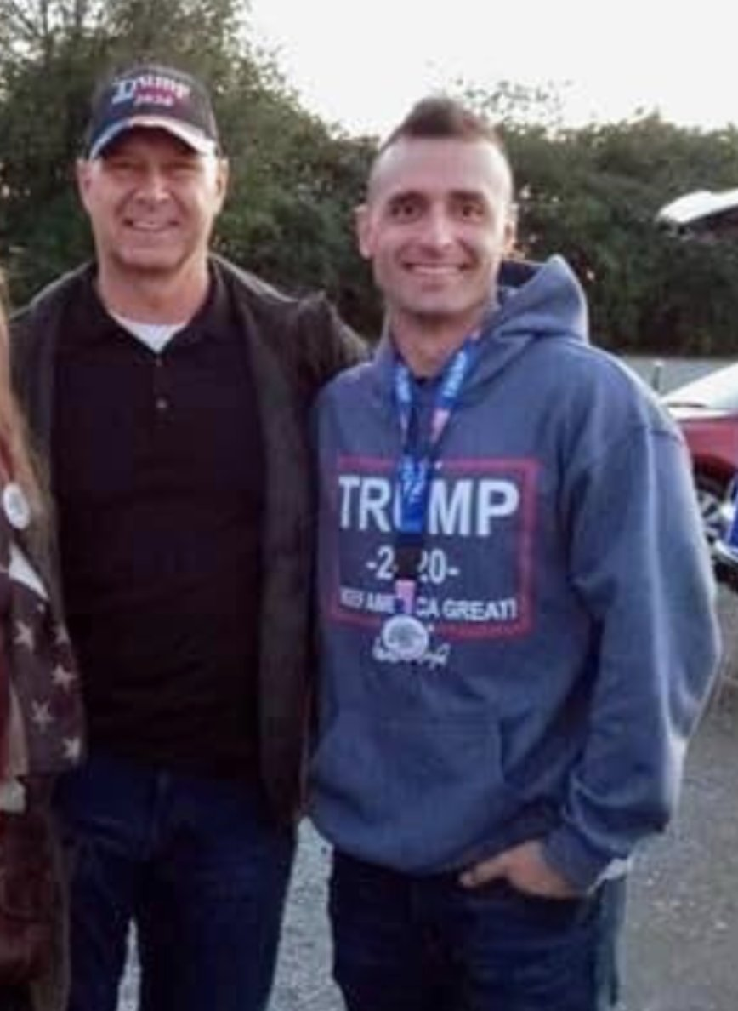

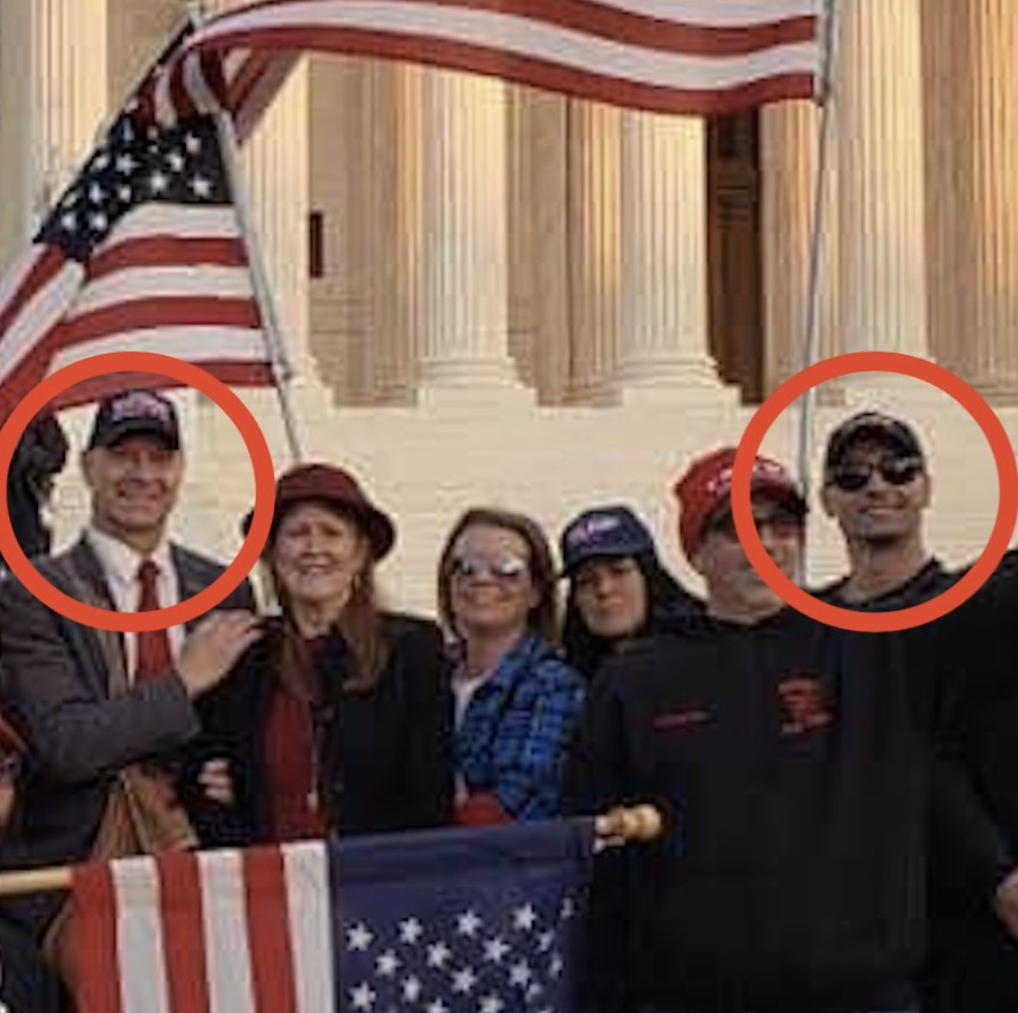
[Twitter, @ryanjreilly, 6/4/21]

Lazar’s Family Pushed Back On Mastriano’s Claim That He Did Not Know Lazar And His Family
Lazar’s Family Claimed That Mastriano Did Know Lazar And His Family. According to the Philadelphia Inquirer, “Lazar’s siblings have since decried the senator’s efforts to distance himself on Facebook and claimed in a video that Mastriano denied knowing the family of longtime supporters for political reasons.” [Philadelphia Inquirer, 7/27/21]

