Overview
In 2025, Lombardo supported Trump’s “One Big Beautiful Bill,” which made the largest cut to SNAP in history. Lombardo said “Nevadans should be excited” about the passing of the bill, and dismissed concerns about its impacts as “bickering” while nearly 160,000 Nevada households relied on SNAP to afford groceries.

Lombardo Supported A Bill That Would Strip SNAP Benefits From Millions Of Americans And Make Food More Expensive, Which Could Impact Nearly 160,000 Nevadans

Lombardo Supported The Republican Reconciliation Bill That Cut Snap Benefits For Millions

Lombardo Said “Nevadans Should Be Excited About” The “One Big Beautiful Bill”
July 2025: Lombardo Dismissed Concerns About The “One Big Beautiful Bill” As “Bickering” “Talking Heads,” And Said “Nevadans Should Be Excited About The Potential Impacts” Of The Bill. According to Lombardo’s Twitter, “As beltway talking heads bicker over today’s budget bill, it’s important to remember that President Trump just delivered on his historic promise of No Tax on Tips or Overtime. That is a huge win for hardworking Nevadans! While my administration continues to assess this bill as it moves to get signed into law, Nevadans should be excited about the potential impacts of tax cuts, investments in small business and American manufacturing, and efforts to help secure our border.”
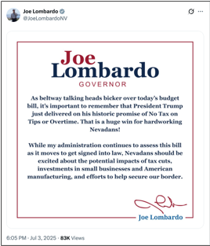
[Twitter, @JoeLombardoNV, 7/3/25]

Trump’s “One Big Beautiful Bill” Cut SNAP Benefits For Millions Of Americans
HEADLINE: “Trump’s ‘Big Beautiful Bill’ Cuts Food Stamps For Millions — The Average Family May Lose $146 Per Month, Report Finds” [CNBC, 7/10/25]
The GOP Reconciliation Bill Would Cut SNAP Funding By $186 Billion, Which CBPP Said Constituted The “Largest Cut To SNAP In History.” According to the Center on Budget and Policy Priorities, “The Senate Republican leadership’s reconciliation bill would dramatically raise costs and reduce food assistance for millions of people by cutting federal funding for the Supplemental Nutrition Assistance Program (SNAP) by $186 billion through 2034, according to the Congressional Budget Office (CBO), about 20 percent — the largest cut to SNAP in history. These cuts would increase poverty, food insecurity, and hunger, including among children. The so-called ‘Big Beautiful Bill’ is anything but beautiful; it would cause widespread harm by making massive cuts to Medicaid and SNAP, which would raise costs on families and make it much harder for them to afford the high cost of health care and groceries.” [Center On Budget And Policy Priorities, 6/30/25]
- 22.3 Million Families Would Lose Some Or All Of Their SNAP Benefits, With 5.3 Million Families Losing More Than $25 In Benefits Per Month, And Of Those Families, The Average Loss In Benefits Would Be $146. According to the Urban Institute, “Our preliminary estimates of the SNAP policies in the Senate bill show the following: 22.3 million US families would be affected, losing some or all of their SNAP benefits. Of the total affected families, 5.3 million would lose at least $25 in SNAP benefits per month. Among these families, 3.3 million are families with children, 3.5 million are working families, and 1.7 million are families with a full-time full-year worker. Families losing at least $25 per month would lose $146 per month on average ($1,752 for a full-year recipient). At the state level, average monthly benefit losses for families losing at least $25 per month would range from $72 in Kansas ($864 annually) to $231 in the District of Columbia ($2,772 annually).” [Urban Institute, 7/2/25]
- States That Could Not Afford To Pay The New Mandated SNAP Cost Shares May Cut The Program Entirely. According to CNBC, “Additionally, the legislation requires states to pay for a portion of benefit costs, ranging from 5% to 15%, if their payment error rate is at or over 6%. The error rates measure the accuracy of states’ eligibility and benefit payments. In fiscal year 2024, states had a 10.9% average payment error rate, with many states over 6%, according to the Department of Agriculture. States that can’t pay those shares may have to cut SNAP benefits or opt out of the program entirely, according to the Center on Budget and Policy Priorities.” [CNBC, 7/10/25]
- The House Republican Reconciliation Bill Included Nearly $300 Billion In Cuts To The Supplemental Nutrition Assistance Program. According to the Center on Budget and Policy Priorities, “The House-passed Republican reconciliation plan would cut nearly $300 billion from the Supplemental Nutrition Assistance Program (SNAP) through 2034, based on Congressional Budget Office (CBO) estimates — by far the largest cut to SNAP in history.[1] As a result of these cuts and other policies in the legislation — which are being used to pay partly for trillions in tax cuts skewed to the wealthy — millions of people would lose some or all of the food assistance they need to afford groceries, when many low-income households are struggling to afford the high cost of food and other basic needs.” [Center on Budget and Policy Priorities, 5/28/25]
- HEADLINE: “House Republican Budget Takes Away Health Care, Food Aid To Pay For Expanded Tax Cuts For Wealthy” [Center on Budget and Policy Priorities, 2/21/25]
- CBPP Said The Republican Budget Resolution Outlined $230 Billion In Cuts, Primary From SNAP Benefits. According to the Center on Budget and Policy Priorities, “The House Republicans’ budget plan would give major tax cuts to high-income, wealthy households. Extending the expiring individual income and estate tax provisions for households with incomes in the top 5 percent of the income distribution (households with incomes over $321,000) costs around $1.8 trillion through 2034, accounting for 49 percent of the total $3.6 trillion cost of extension through 2034. That $1.8 trillion for wealthy and high-income households is close to the amount of the spending cuts House Republicans have outlined — including at least $880 billion primarily from Medicaid, $230 billion primarily from SNAP benefits, and $330 billion primarily from making student loans more expensive. Of the tax cuts for wealthy households, nearly $200 billion is for an estate tax giveaway that showers some $6 million per estate on the 1 in 1,000 wealthiest estates. In contrast, the average SNAP benefit is $6.20 per person per day, which helps struggling families put food on the table.” [Center on Budget and Policy Priorities, 2/21/25]

159,973 Households In Nevada Relied On SNAP
2023: Across Nevada, 159,973 Households Relied On SNAP.
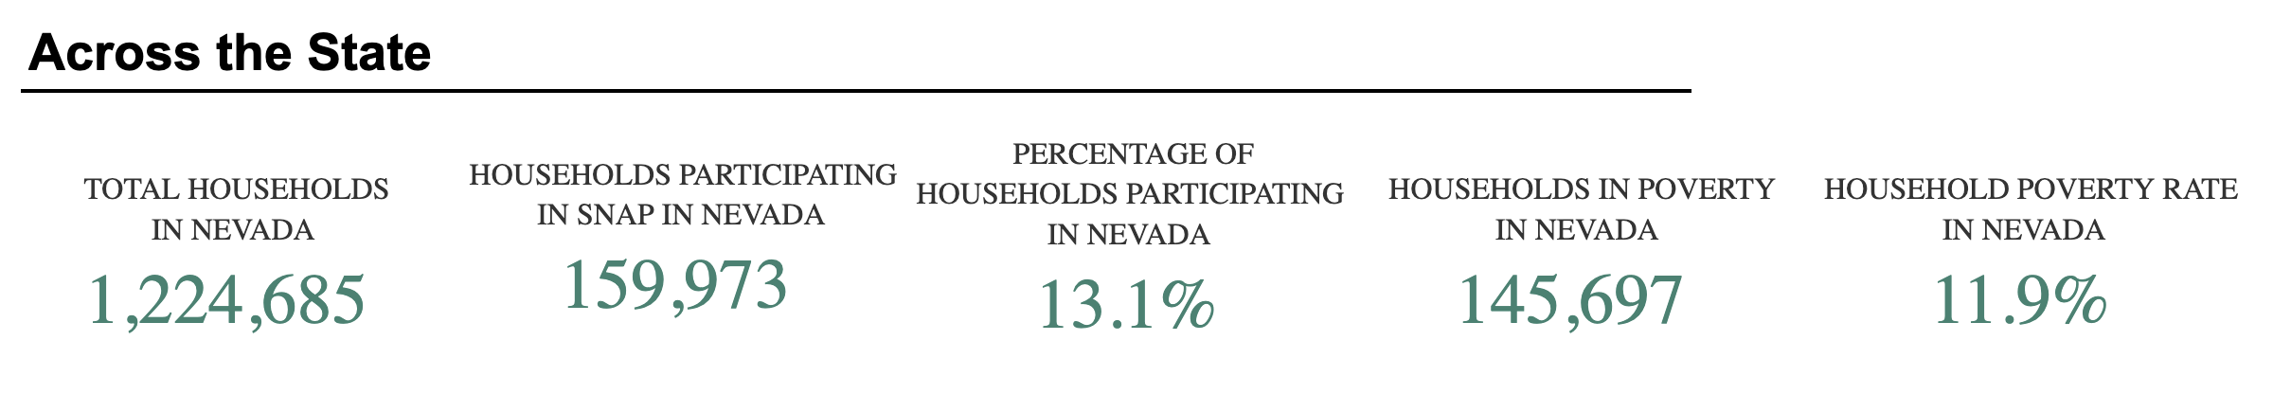
[U.S. Department of Agriculture, SNAP Community Characteristics, Accessed 12/10/25]

