Overview
As Clark County sheriff, Lombardo used his authority to increase his own salary from $141,000 in 2015 to $192,000 in 2022.
In the same breath, Lombardo called for the Nevada state legislature to increase funding for the Las Vegas Metropolitan Police Department, claiming that pandemic budget cuts were hampering the department’s “ability to police.”

Lombardo Increased His Own Salary By $51,000 As Clark County Sheriff But Claimed Budget Cuts Were Hampering The Department’s “Ability To Police”

2015-2022: Lombardo Raised His Sheriff’s Salary By $51,000

2015-2022: Lombardo’s Salary Increased From $141,000 To $192,000
2022: Lombardo Was Receiving A Salary Of $192,000 Annually. According to Lombardo’s 2022 Financial Disclosure Statement,
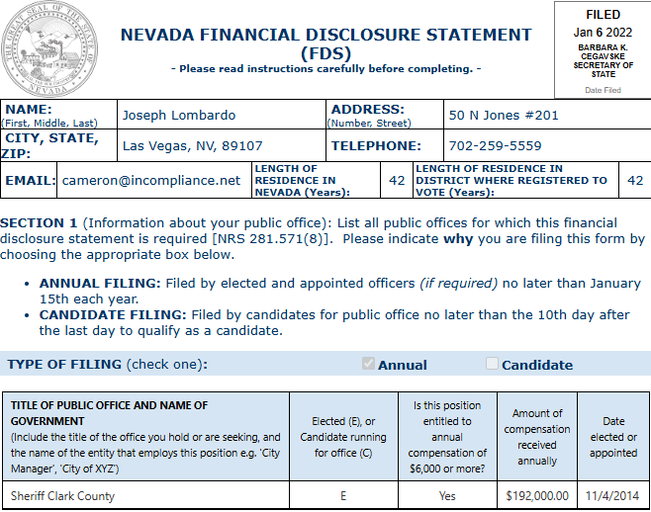
[Nevada Financial Disclosure Statement, Filed 1/6/22]
2015: Lombardo’s Salary Was $141,000 Annually. According to Lombardo’s 2015 Financial Disclosure Statement,
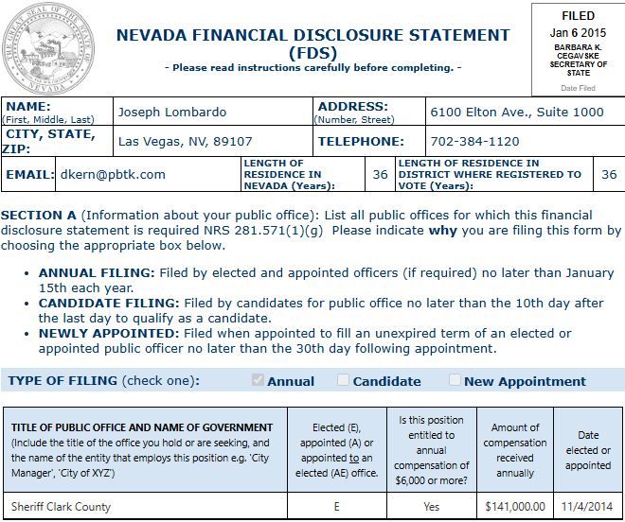
[Nevada Financial Disclosure Statement, Filed 1/6/15]

As Sheriff, Lombardo Set The Las Vegas Metropolitan Police Department’s Budget, And Thus His Own Salary
As Clark County Sheriff, Lombardo Was Responsible For Presenting The Las Vegas Metropolitan Police Department Budget To The Fiscal Affairs Committee. According to the Nevada Current, “The Las Vegas Metropolitan Police Department is requesting more than $715 million for its operating budget next year — an 8.17% increase over its current budget. In a letter accompanying the budget request, Sheriff Joe Lombardo acknowledged that the request is ‘considerably larger than recent years.’ The outgoing sheriff, who is now running for governor as a Republican, pointed to ‘contractual wage increases from settled collective bargaining agreements’ as the primary reason for the spike. Metro’s budget has increased anywhere between 0.96% to 5.56% annually since fiscal year 2014, according to past budget reports. The proposed budget includes no new funding for additional police officers, with Lombardo’s letter stating Metro expects it will take the entirety of the upcoming fiscal year to fill its existing vacancies. The budget does include 46 civil positions, which the letter says will aid in ‘partially restoring our civilian positions to pre-pandemic levels.’ Lombardo and Metro Chief Financial Officer Rich Hoggan on Monday presented the final budget request to the department’s Fiscal Affairs Committee — a five-member oversight board composed of two Clark County commissioners, two Las Vegas City Council members and a gaming executive (who fills a seat designed for a member of the general public). The committee approved the request, which will be sent to the Clark County Commission and Las Vegas City Council for inclusion within their overall budgets. Those budgets must be passed by June 1.” [Nevada Current, 4/26/22]

Lombardo Bragged About His Responsibility For “Decisions That Affect A Budget’s Bottom Line”
2021: Lombardo Said “I’m No Stranger To Tough Decisions That Affect A Budget’s Bottom Line.” According to Lombardo’s Twitter, “As Sheriff of NV’s largest county I’m no stranger to tough decisions that affect a budget’s bottom line. I know NV can do better &, as Gov. why I’ve vowed to veto any new tax increase. This includes the dangerous push for a state income tax. Nevadans deserve better. Do you agree?”
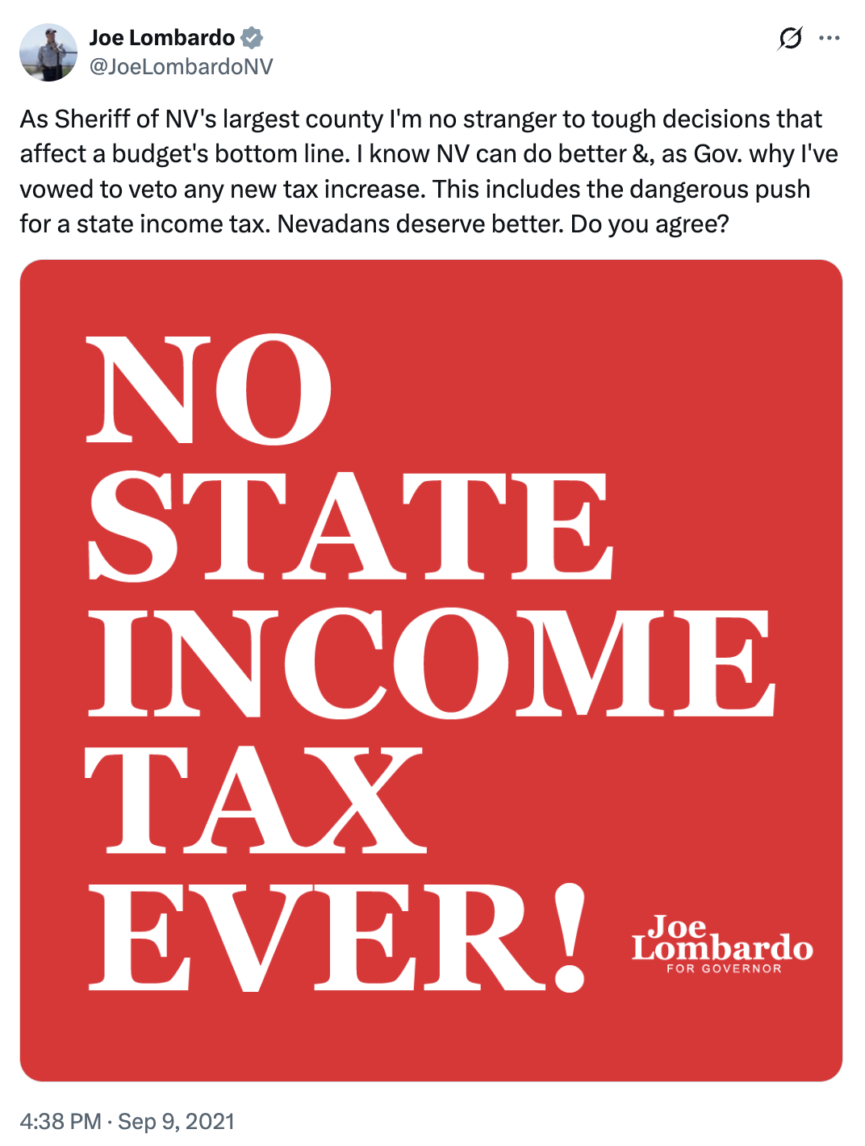
[Twitter, @JoeLombardoNV, 9/9/21]

Lombardo Called For More Police Funding After Steep Budget Cuts Following The COVID-19 Pandemic
2020: Lombardo Urged The State Legislature To Mitigate “The Damage From Steep Budget Cuts Caused By Coronavirus,” Which He Claimed Could “Hamper” The Las Vegas Metropolitan Police Department’s “Ability To Police.” According to a Lombardo guest column in the Las Vegas Sun, “The stage for adversity had already been set by the pandemic that shut down our thriving city. The protests only piled on to an already difficult set of circumstances. It seems to be a repeat of 2012, when the effects from the economic downturn hit our agency while reform measures were underway. Once again, Metro has found itself at the crossroads of change. We are confronted with two equally and important imperatives: responding to our community’s call for change in law enforcement, and mitigating the damage from steep budget cuts caused by the coronavirus, which could hamper our ability to police. […] In the search for social justice, it’s important that we don’t sacrifice the resources that lift up the very communities that are crying out for change. The fight for funding the police and the fight for social justice are related.” [Las Vegas Sun, Joe Lombardo Column, 8/10/20]

