Overview
In 2020, Lombardo claimed there was fraud “on both sides” of the presidential election. Lombardo evaded questions about election accuracy and if Nevada would conduct an Arizona-style nationwide audit of the 2020 Presidential election.
Lombardo opposed universal mail-in-voting and supported policies to restrict ballot access. Lombardo suggested that Nevada’s Signature Verification System was ineffective.
Lombardo maintained a longstanding relationship with Michael McDonald, who led Nevada’s fake elector scheme during the 2020 presidential election.

Lombardo Advanced Election Denial Claims, Worked To Roll Back Voting Access In Nevada, And Remained Closely Tied To A Fake Elector

Lombardo Suggested There Was Fraud In The 2020 Presidential Election

Lombardo Said There Was “Fraud On Both Sides” In The 2020 Election And Avoided Questions About Investigations Into The Election Results
As Part Of The Brennan Center’s Series On Election Deniers, Brennan Noted Lombardo Said There Was “Fraud On Both Sides” In The 2020 Election. According to the Brennan Center For Justice, “Although Clark County Sheriff Joe Lombardo (R) has acknowledged that Biden won, he has questioned whether it was ‘fair and square.’ He has said he didn’t know if the results were accurate, and that he believes ‘there was fraud on both sides.’” [Brennan Center For Justice, 3/29/22]
2021: Lombardo Could Not Answer If The 2020 Presidential Election Results Were Accurate, Saying “I Don’t Have The Information To Make An Informed Decision.” According to the Reno Gazette Journal, “Lombardo later told the RGJ he didn’t know if the results of November’s election were accurate. ‘I don’t have the information to make an informed decision,’ he added. ‘I don’t know the evidence associated with the investigation. ‘I personally believe there was probably fraud on both sides. We had an environment where it was easy to commit fraud. … There’s no absolute perfect system, but there’s no reason why you can’t make (fraud) harder.’” [Reno Gazette Journal, 7/1/21]
2021: Lombardo Sidestepped Questions If He Would Be Open To Including Nevada In An Arizona-Style Nationwide Audit Of 2020 Elections. According to the Nevada Independent, “When asked if Nevada should be included in a nationwide audit of the 2020 election results in the style of the controversial audit in Arizona, Lombardo said he ‘can’t opine on that because I’m not aware of that.’ The movement for audits of all 50 states has gained steam among a core subset of Republicans who believe, despite evidence to the contrary, that widespread fraud occurred in the 2020 presidential election. Though the Arizona audit, conducted by a firm with ties to the ‘Stop the Steal’ movement, showed a margin of victory for President Joe Biden wider than the official count, audit proponents cast the final report as a success that showed the final results were ‘inconclusive.’” [Nevada Independent, 10/6/21]

Lombardo Opposed “Universal Mail-In Voting” And “Ballot Harvesting”
Nevada Independent: Lombardo “Stood By Nevada’s 2020 Election Results But Said He Supported The Repeal Of Permanent Universal Mail-In Voting.” According to the Nevada Independent, “Republican gubernatorial candidate and Clark County Sheriff Joe Lombardo criticized the state’s extended mask mandate during the pandemic as ‘political theater,’ stood by Nevada’s 2020 election results but said he supported the repeal of permanent universal mail-in voting during a wide-ranging interview with The Nevada Independent on Friday… ‘I support collective bargaining. I support unionization,’ he said. ‘But the playing field has to be level. Everybody has to have equal opportunity to enter into the commerce section of the economy equally, no matter if they’re union or not.’” [Nevada Independent, 3/30/22]
Lombardo Sent Out A Fundraising Email Calling For Ending “Ballot Harvesting,” Requiring Voter ID, And Ending “Universal Mail Voting.” According to the Brennan Center for Justice,
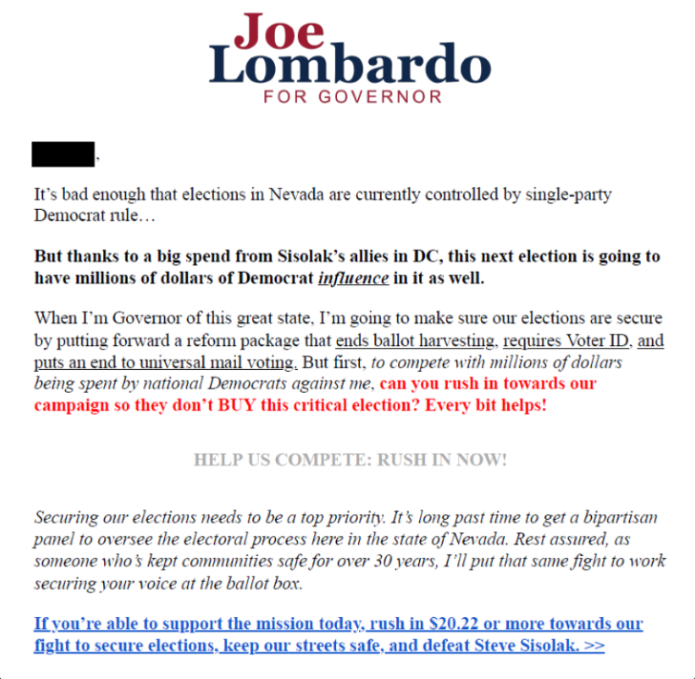
[Brennan Center For Justice, 3/29/22]

Lombardo Suggested Nevada’s Signature Verification Process Was Ineffective And Forged His Own Signature
2022: Lombardo Admitted To Forging His Own Signature In Six Elections To Test Nevada’s Signature Verification Process. According to Lombardo in an interview with The Nevada Independent, “Signature verification process. Do you feel confident in that process? I could give you an example. My last six elections, I personally adulterated my signature and I was not questioned about it once. To verify whether the process worked or not and was not confronted a single time.” [Joe Lombardo Interview – Nevada Independent, 3/30/22] (VIDEO)

Lombardo Was A “Longtime Friend” Of Fake Elector Michael McDonald
The Las Vegas Review-Journal Called McDonald A “Longtime Friend” Of Lombardo’s. According to the Las Vegas Review-Journal, “Lombardo said he made the trip up from Las Vegas to file at the state Capitol to be at ‘the seat of state government.’ ‘Why are we here today? Because Nevada’s in need of change,’ he said in brief remarks after completing paperwork in the secretary of state’s office with his wife, Donna. ‘I personally believe the leadership and experience that I bring to the table is very important for Nevada and moving forward.’ Nevada Republican Party Chairman Michael McDonald, a longtime friend, also attended as did two other sheriffs, Mike Allen of Humboldt County and Ken Furlong of Carson City.” [Las Vegas Review-Journal, 3/14/22]
- 2022: Lombardo Was Pictured With Nevada Republican Party Chair, Michael McDonald. According to the Las Vegas Review-Journal,
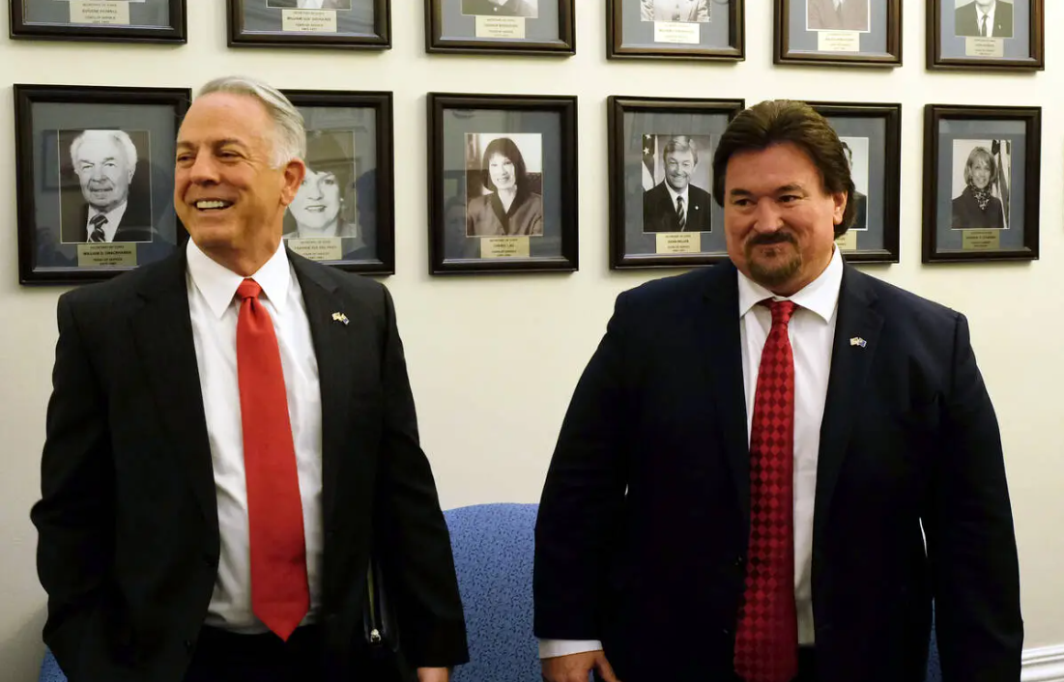
[Las Vegas Review-Journal, 3/14/22]
Michael McDonald Was One Of The Illegitimate, Self-Appointed Electors Supporting Donald Trump In December 2020. According to the Nevada Independent, “The investigation centers on the decision by McDonald and five other self-purported ‘electors’ to hold an illegitimate signing ceremony outside of the Legislature in Carson City in December 2020 that falsely pledged the state’s six electoral votes to former President Donald Trump. McDonald and DeGraffenreid were subpoenaed by a congressional committee for their role in the false elector scheme in late January.” [Nevada Independent, 6/22/22]
2022: The FBI Seized McDonald’s Phone As A Part Of The Fake Electors Investigation. According to 8 News Now, “FBI agents served a search warrant Wednesday on Nevada’s top GOP official, sources told the 8 News Now I-Team’s George Knapp. Agents seized the cell phone of state Republican chairman Michael McDonald, reportedly as part of an investigation into the fake elector scheme initiated at the end of the 2020 presidential election. A second search warrant was issued for state party secretary James DeGraffenreid, who also signed the document, but FBI agents could not locate him Wednesday, sources told Knapp. In December 2020, the 8 News Now I-Team reported the Nevada Republican Party’s six electors signed paperwork signaling their support for former President Donald Trump in a symbolic ceremony devoid of any legal merit, which was held in Carson City and coincided with the official state-sanctioned tally on Dec. 14, 2020.” [8 News Now, 6/22/22]

