Overview
Lombardo was an anti-abortion extremist who supported abortion bans and additional restrictions on reproductive care.
Lombardo, who described himself as “Catholic and pro-life,” celebrated Roe v. Wade being overturned, and supported a 13-week abortion ban ballot initiative.
Lombardo wanted to further restrict reproductive care with bans on emergency contraception and mandating waiting periods and parental notification for minors seeking an abortion. Lombardo also said he would repeal protections for patients traveling from out of state to Nevada for abortion care, along with the Nevada providers that treated those patients.

Lombardo Lauded The Overturning Of Roe V. Wade And Supported Additional Abortion Restrictions In Nevada

Lombardo Lauded The Overturning Of Roe V. Wade And Called Himself “Catholic And Pro-Life”
2022: Lombardo Celebrated The Overturning Of Roe V. Wade And Called Himself “Catholic And Pro-Life.” According to Lombardo’s Twitter, “My statement on the Supreme Court’s Dobbs Ruling:”
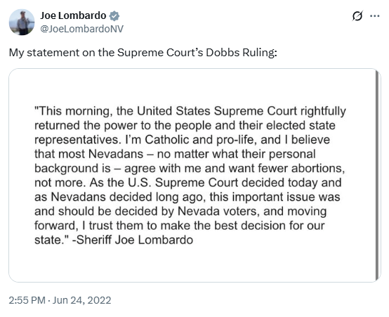
[Twitter, @JoeLombardoNV, 6/24/22]
2022: Lombardo Lauded The Overturning Of Roe V. Wade, Claiming Abortion Should Be Decided By Nevada Voters. According to the Nevada Current, “‘This morning, the United States Supreme Court rightfully returned the power to the people and their elected state representatives,’ Lombardo said last month when the high court reversed the nearly 50-year old ruling. ‘As the U.S. Supreme Court decided today and as Nevadans decided long ago, this important issue was and should be decided by Nevada voters, and moving forward, I trust them to make the best decision for our state.’” [Nevada Current, 7/28/22]

Lombardo Said He Would Support Sending Voters A 13-Week Abortion Ban Ballot Initiative In Nevada
2022: Lombardo Said He Would Support Sending Voters A 13-Week Abortion Ban Ballot Initiative In Nevada. According to Nevada Independent, “Joe Lombardo (R) Lombardo did not respond to the questionnaire. In response to the leak of the Supreme Court draft opinion, Lombardo told The Nevada Independent in an email, ‘Abortion policy is already addressed in Nevada law. The governor and legislature cannot make changes to it. The voters put it into law and only they can change it.’ In May, Las Vegas Review-Journal conservative columnist Victor Joecks wrote that when asked, Lombardo said he would support sending voters a 13-week abortion ban ballot initiative, with exceptions for physical health, rape and incest. Reached for comment about more specific details, Lombardo’s campaign confirmed his answer and said he would support giving voters the ‘ultimate decision’ on a 13-week abortion ban if it was brought forward by the Legislature or voters. ‘If the voters and the Nevada Legislature sent a bill to the governor’s office, Joe has always said that he would view it through a pro-life lens,’ Lombardo spokeswoman Elizabeth Ray said in an email to The Nevada Independent. His campaign said he supports parental notification for minors but has not taken a position on spousal notification because it was ruled unconstitutional by a federal judge in 1981.” [Nevada Independent, 5/29/22]

Lombardo Wanted To Repeal Protections For Patients Traveling From Out Of State For Reproductive Care
2022: Lombardo Said He Would Overturn Governor Sisolak’s Executive Order And Punish Nevada Abortion Providers And Those Who Travel To Nevada For Reproductive Care. According to My News 4, “If elected, Lomabrdo said he would repeal Sisolak’s recent executive order protecting the information of out-of-state abortion patients from being sent to states looking to pursue criminal charges.” [My News 4, 8/11/22]

Lombardo Supported Bans On Emergency Contraception, Mandatory Waiting Periods, And Parental Notification For Minors Seeking An Abortion
2022: Lombardo Said He Would Support Bans On Morning After Pills And Waiting Periods, And Said He Would Use A “Pro-Life” Lens For His Legislation. According to the Nevada Current, “Asked during a primary election debate if he’d support bans of morning after pills and waiting periods, Lombardo said ‘Yes, absolutely.’ Lombardo said on KLAS-TV that as governor, he would look at all legislation with ‘a pro-life lens.’” [Nevada Current, 7/28/22]
2022: Lombardo Supported Parental Notification For Minors Seeking An Abortion, And Called Opponents Of Parental Notification “Extremist.” According to Lombardo’s Twitter, “Like most Nevadans, I’m a strong supporter of parental notification, and I believe the health and safety of minors is a critical component of any healthcare policy. Steve Sisolak’s extremist stance is out of touch with what the majority of Nevadans believe.”
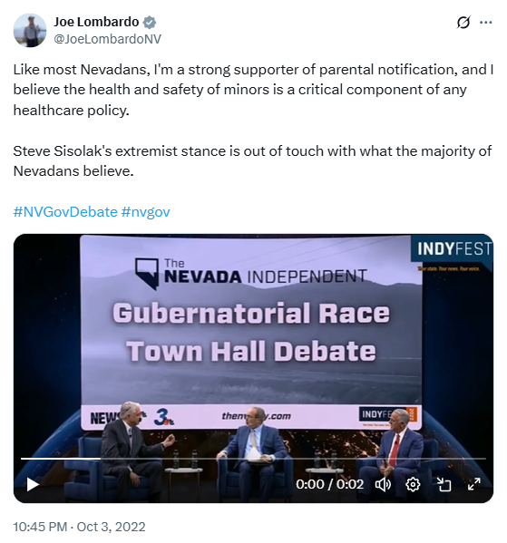
[Twitter, @JoeLombardoNV, 10/3/22]

