Overview
In 2025, Kelly Ayotte backed “some of the cuts” in Trump’s “One Big Beautiful Bill,” which was projected to kick 17 million Americans off their health insurance, including nearly 12 million Americans who rely on Medicaid. By 2034, more than 43,700 Granite Staters could lose their health insurance, including 19,029 Medicaid recipients in New Hampshire, due to Trump’s tax bill.
As governor, Ayotte signed into law a budget that increased Medicaid premiums, raised copays for lower-income residents, restored income verification checks, and required a federal waiver to impose Medicaid work requirements. In 2025, New Hampshire’s Medicaid program provided health care coverage for 181,000 Granite Staters.
Kelly Ayotte long called for repealing the Affordable Care Act and described her position as “absolutely” in favor of repeal. In the U.S. Senate, she voted multiple times to repeal the law, and backed legislation that would have eliminated Medicaid after 2017. In 2025, more than 70,300 Granite Staters were enrolled in Affordable Care Act Marketplace health insurance plans.

Kelly Ayotte Backed “Some Of The Cuts” In Trump's “One Big Beautiful Bill” And Reviewed Medicaid Impacts From The Legislation, Which Was Expected To Strip Health Care Away From More Than 43,700 Granite Staters

Kelly Ayotte Said She Was “On Board With Some Of The Cuts” In Trump’s “One Big Beautiful Bill” While Framing Medicaid Impacts As Issues For Review

Ayotte Directed Her Administration To Review Medicaid Impacts On Vulnerable Residents, Even Though She Said She Supported “Some Of The Cuts” In Trump’s Reconciliation Bill
2025: Kelly Ayotte Said She Was “On Board With Some Of The Cuts” In Trump’s Reconciliation Budget Bill But Claimed She Disagreed With The SNAP Cuts And Directed Her Administration To Review Medicaid Impacts On Vulnerable Residents. According to WMUR, “Gov. Kelly Ayotte said Wednesday her administration is already evaluating how to implement changes from President Donald Trump's tax cut and spending bill, saying there are cuts coming that she does not support. Meeting with the Executive Council in Bretton Woods, Kelly Ayotte said she is not on board with some of the cuts being made in the budget reconciliation bill Trump recently signed into law. ‘There are aspects of it, of course, that I disagree with,’ Kelly Ayotte said. ‘Like, for example, it looks like there's going to be reductions in SNAP. We're evaluating the impact on Medicaid, and this is important, because as governor of the state, my job is to make sure that we serve our most vulnerable citizens.’” [WMUR, 7/9/25]
- HEADLINE: "At Least 17 Million Americans Would Lose Insurance Under Trump Plan" [Washington Post, 7/1/25]
- HEADLINE: “By The Numbers: Harmful Republican Megabill Favors The Wealthy And Leaves Millions Of Working Families Behind” [Center On Budget And Policy Priorities, 8/1/25]
- HEADLINE: "House Republican Budget Takes Away Health Care, Food Aid To Pay For Expanded Tax Cuts For Wealthy" [Center on Budget and Policy Priorities, 2/21/25]
- The Congressional Budget Office Estimated That 11.8 Million People Would Become Uninsured As A Result Of The Medicaid Cuts In Republicans’ Reconciliation Bill. According to the Washington Post, "The bill, which narrowly passed the Senate on Tuesday and now heads back to the House, would effectively accomplish what Republicans have long failed to do: unwind many of the key components of the ACA, President Barack Obama’s signature domestic achievement, which dramatically increased the number of Americans with access to health insurance. To start, the Congressional Budget Office estimated that the Senate version of the bill would result in 11.8 million more uninsured in 2034, mostly because of Medicaid cuts, compared with 10.9 million if the House version became law." [Washington Post, 7/1/25]

More Than 43,700 Granite Staters Were Expected To Lose Health Care Coverage Under Trump’s “One Big Beautiful Bill,” Including 19,029 Medicaid Recipients
Under The “One Big Beautiful Bill,” 43,729 People In New Hampshire Were Expected To Lose Their Health Care By 2034, Including 24,700 ACA Enrollees And 19,029 Medicaid Recipients. According to the Joint Economic Committee Minority,
District | State | Est. # Losing ACA Coverage | Est. # Losing Medicaid Coverage | Est. Total # Losing Insurance
NH-01 | New Hampshire | 12,900 | 9,432 | 22,332
NH-02 | New Hampshire | 11,800 | 9,597 | 21,397
All | Totals | 24,700 | 19,029 | 43,729

[Joint Economic Committee Minority, 6/25]
Under The “One Big Beautiful Bill,” 19,029 Medicaid Recipients In New Hampshire Were Expected To Lose Their Health Care By 2034. [Joint Economic Committee Minority, 6/25]

The “One Big Beautiful Bill” And The Expiring Affordable Care Act Tax Credits Would Result In 31,000 People Uninsured In New Hampshire By 2034
The “One Big Beautiful Bill” And The Expiring Affordable Care Act Tax Credits Would Result In 31,000 Uninsured People In New Hampshire By 2034. According to the Center For American Progress, “The One Big Beautiful Bill Act will increase the number of Americans without health coverage in every state Estimated increase in the uninsured population due to the OBBBA and the expiration of the ACA’s enhanced premium tax credits, 2034”
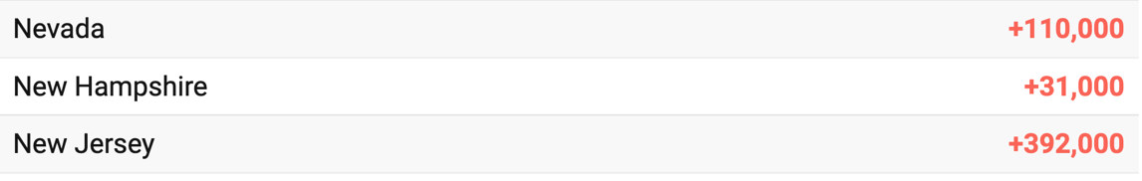
[Center For American Progress, 9/5/25]

Kelly Ayotte Increased Medicaid Premiums And Imposed Medicaid Restrictions For Granite Staters, And Supported Repealing The Affordable Care Act And Rolling Back Medicaid Expansion

As Governor, Kelly Ayotte Signed A Budget That Increased Medicaid Premiums And Reinstated Income Checks And Work Requirements

Kelly Ayotte Signed A Budget Bill That Increased Medicaid Premiums, And Required A Federal Waiver To Impose Medicaid Work Requirements And Restored Pre-Pandemic Income Checks
HEADLINE: “From Mobile Driver’s Licenses To Medicaid Rules: Budget Signed By Governor Packed With New Policies” [New Hampshire Bulletin, 7/1/25]
2025: Kelly Ayotte Signed A Budget Bill That Increased Medicaid Premiums And Reshaped Medicaid Eligibility Across New Hampshire. According to New Hampshire Bulletin, “The two budget bills signed by Gov. Kelly Ayotte Friday are sprawling — House Bill 2, the policy bills, has 162 pages of new laws. And many of the budget’s changes have already graced headlines, inspired protests, and set off debates in State House committees. Observers may know about the budget’s “bell-to-bell” cell phone ban for K-12 students, the end to New Hampshire’s yearly auto inspections mandate in January 2026, or the premiums added to Medicaid recipients that would charge $90 per month for a household of three. […] In addition to the new premiums, the budget includes other changes to New Hampshire’s Medicaid program that will affect who can participate.” [New Hampshire Bulletin, 7/1/25]
- Kelly Ayotte Unveiled A Medicaid Plan That Added Premiums For Medicaid Families And Raised Copays For Lower-Income Residents. According to New Hampshire Public Radio, “People enrolled in New Hampshire Medicaid don’t pay a monthly premium. Kelly Ayotte’s plan would change that for people over a certain income threshold. Families with children covered by Medicaid would start paying up to 5% of their annual income in premiums if they make at least 255% of the federal poverty line. That would apply to those making around $68,000 for a family of three. Adults in the state’s Medicaid expansion program, known as Granite Advantage, would also be on the hook if they earn more than the federal poverty line, which is around $15,000 for a single person. For people below those income thresholds, pharmacy copays, currently at $1 to $2, would go up to $4.” [New Hampshire Public Radio, 2/24/25]
- Kelly Ayotte Enacted A Budget That Required A Federal Waiver To Impose Medicaid Work Requirements And Restored Pre-Pandemic Income Checks. According to New Hampshire Bulletin, “To start, it includes a renewed push for a work requirement. House Bill 2 requires that the Department of Health and Human Services apply for a waiver to the Centers for Medicare and Medicaid Services (CMS) in order to impose a work requirement. That waiver application must first be approved by the state’s Joint Legislative Fiscal Committee — a powerful panel of senators and representatives — before DHHS can send it to the federal agency. Then, if the Trump administration approves, New Hampshire’s work requirement will take effect. The budget also fully restores the income verification process for Medicaid that had been in effect before COVID-19. Those verifications, which required participants to provide annual income verification, were suspended from 2020 to 2023.” [New Hampshire Bulletin, 7/1/25]

2025: New Hampshire Medicaid Covered More Than 181,000 Granite Staters And Provided Health Care For Working Families Across The State
In 2025, New Hampshire Medicaid Provided Health Coverage To More Than 181,000 Granite Staters, Including Children, Seniors, People With Disabilities, And Working Adults. According to the Kaiser Family Foundation,
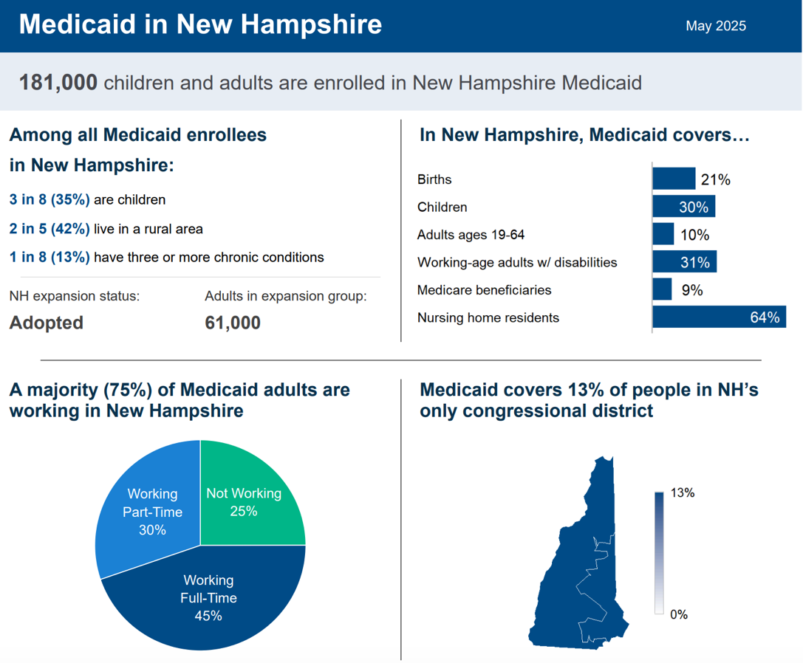
[Kaiser Family Foundation, Accessed 12/18/25]

Kelly Ayotte Voted To Repeal The Affordable Care Act And Said She “Absolutely” Supported Repealing The Health Care Law

Kelly Ayotte Said She Supported Repealing The Affordable Care Act
2015: Kelly Ayotte Supported A Bill To End Medicaid After 2017 And Repeal Key Affordable Care Act Provisions, Including Individual And Employer Mandates. According to WMUR, “U.S. Sen. Kelly Ayotte supports a plan advanced by Republican leadership this week to repeal what her spokeswoman called ‘the worst provisions’ of the Affordable Care Act, to end Medicaid after 2017 and to redirect funding from Planned Parenthood to community health centers. Ayotte’s office said Tuesday that the bill contains the same language as a bill voted on by the Senate in August that redirects funding from Planned Parenthood to community health centers and does not reduce the overall level of federal funding for women’s health services. Medicaid expansion would be continued through 2017 and then ended, presumably giving a new president time to propose a new health care reform law. It would also end the medical device tax and the ‘Cadillac tax’ for high-cost plans. If the bill passes the Senate and the House, President Obama is expected to veto it. Kelly Ayotte spokeswoman Liz Johnson told WMUR.com in a statement: ‘Sen. Kelly Ayotte supports the legislation the Senate will consider this week, which would repeal the worst provisions of Obamacare – including the individual and employer mandates, the Cadillac tax, and the medical device tax – that have resulted in lost jobs, higher costs, and less patient choice.” [WMUR, 12/2/15]
2013: When Asked Whether The Affordable Care Act Should Be Repealed, Kelly Ayotte Said “I Support Repeal, Absolutely.” According to The Hill, “In an appearance Monday on ‘CBS This Morning,’ Kelly Ayotte was asked if the healthcare law should be repealed. ‘I support repeal, absolutely. But the political reality is, right now that’s not going to happen,’ she replied.” [The Hill, 11/4/13]

Kelly Ayotte Voted To Repeal The Affordable Care Act
2015: Kelly Ayotte Voted For A Bill That Repealed Portions Of The Affordable Care Act, Including Eliminating The Act’s Medicaid Expansion In 2018. In December 2015, Kelly Ayotte voted for a bill that according to Congressional Quarterly, would have “scrap[ed] in 2018 the law’s Medicaid expansion, as well as subsidies to help individuals buy coverage through the insurance exchanges.” Additionally, according to Congressional Quarterly the bill would have “repeal[ed] portions of the 2010 health care law and block[ed] federal funding for Planned Parenthood for one year. As amended, the bill would zero-out the law’s penalties for noncompliance with the law’s requirements for most individuals to obtain health coverage and employers to offer health insurance.” The vote was on passage of a reconciliation bill. The Senate approved the bill by a vote of 52 to 47. The bill was later passed by the full Congress, which the president then vetoed. The House was not able to override the veto. [Senate Vote 329, 12/3/15; Congressional Quarterly, 12/3/15; Real Clear Politics, 12/4/15; Congressional Actions, H.R. 3762]
2013: Kelly Ayotte Voted To Repeal The Affordable Care Act And The Health Care and Education Reconciliation Act of 2010. In March 2013, Kelly Ayotte voted for an amendment that, according to Huffington Post, “sought to ‘establish a deficit-neutral reserve fund to provide for the repeal of the Patient Protection and Affordable Care Act and the Health Care and Education Reconciliation Act of 2010.’” The amendment was to the Senate Budget for FY 2014. The vote was on the amendment, which the Senate rejected by a vote of 45 to 54. [Senate Vote 51, 3/22/13; Huffington Post, 3/22/13; Congressional Actions, S. Amdt. 202; Congressional Actions, S. Con. Res. 8]
2011: Kelly Ayotte Voted For Repealing The Affordable Care Act. In February 2011, Kelly Ayotte voted for an amendment, which would, according to Congressional Quarterly, “repeal the 2010 health care overhaul law, which requires most individuals to buy health insurance by 2014, makes changes to government health care programs and sets new requirements for health insurers. The amendment would restore the provisions of law amended or repealed by the health care overhaul, and repeal certain provisions of the health care reconciliation law.” The amendment would have been made to the FAA Air Transportation Modernization and Safety Improvement Act. Sen. Kent Conrad (D-ND) had made a point of order that the amendment would increase the federal deficit, the vote was on a motion to waive those budgetary requirements. The motion failed by a vote of 47 to 51. [Senate Vote 9, 2/2/11; Congressional Quarterly, 2/2/11; Congressional Actions, S. Amdt. 13; Congressional Actions, S. 223]

Kelly Ayotte Was Criticized For Her Votes, Which Would Have Negatively Affected Substance Abuse And Mental Health Treatment
2016: Hassan Criticized Kelly Ayotte On Her Votes To End Medicaid Expansion Under The Affordable Care Act Due To The Impact On Substance Abuse And Mental Health Funding. According to The Associated Press, “But Hassan said Kelly Ayotte was a hypocrite given that she voted to end Medicaid expansion under the Affordable Care Act, which covers substance abuse and mental health treatment. Kelly Ayotte has voted repeatedly to end the expansion, though she supports doing so over a two-year period. ‘She’s now using kind of Washington-speak to tell you that because she’s willing to give you one more year on Medicaid expansion and then pull the rug out from under you, that’s somehow a good thing,’ Hassan said. ‘So for her to talk about being concerned about funding for behavioral health and substance abuse when she’s willing to take away that treatment for 50,000 hard-working Granite-Staters — medical care and that treatment — is concerning.’” [Associated Press, 10/27/16]

2025: There Were 70,337 Granite Staters Enrolled In An Affordable Care Act Marketplace Plan

2025: There Were 70,337 Individuals Enrolled In An Affordable Care Act Marketplace Plan In New Hampshire. According to KFF, in 2025, there were 70,337 individuals enrolled in affordable care act marketplace plan in New Hampshire.
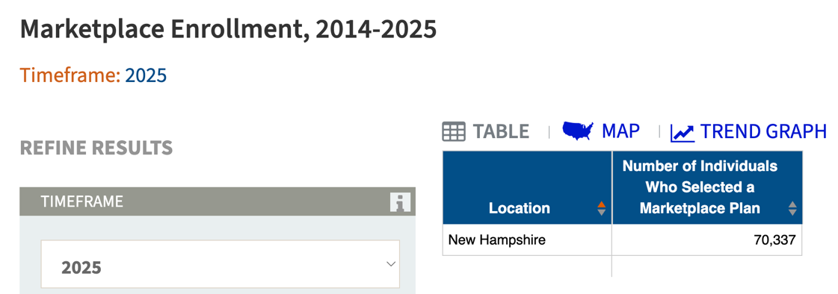
[KFF, Accessed 12/22/25]

The Affordable Care Act Allowed States To Expand Medicaid, Which Dramatically Lowered The Uninsured Rate Among Low-Income Workers
The Affordable Care Act Allowed States To Expand Medicaid, And States That Expanded Medicaid Dramatically Lowered The Number Of People Without Health Insurance. According to the Center on Budget and Policy Priorities, "The Affordable Care Act (ACA) permits states to expand Medicaid coverage to adults with incomes up to 138 percent of the poverty level (about $20,780 annually for an individual or $35,630 for a family of three). States that have adopted the expansion have dramatically lowered their uninsured rates. Extensive research finds that the people who gained coverage have grown healthier and more financially secure, while long-standing racial inequities in health outcomes, coverage, and access to care have shrunk." [Center On Budget And Policy Priorities, 6/14/24]
- The Uninsured Rate Among Low-Income Workers Fell From 38 Percent In 2013 To 17 Percent In 2022, Which Coincided With Implementation Of Medicaid Expansion. According to the Center on Budget and Policy Priorities, "Millions of workers have gained coverage through Medicaid expansion, including people working in industries that provide critical goods and services such as health care, transportation, grocery stores, food manufacturers, and child care. Many have no access to health coverage through their jobs. In expansion states, the uninsured rate among low-income workers fell from 38 percent in 2013 to 17 percent in 2022; this sharp decline coincided with a large increase in the share of low-income workers enrolled in Medicaid.[16] In non-expansion states, the uninsured rate among low-income workers fell much less, from 46 percent to 31 percent. (See Figure 3.)" [Center On Budget And Policy Priorities, 6/14/24]

