Overview
Beginning in 2019, a criminal investigation into abuse at the Sununu Youth Development Center examined allegations of a systemic cover-up during Kelly Ayotte’s tenure as attorney general. A consolidated master complaint alleged that attorneys general, including Ayotte, knew about widespread abuse and torture but failed to stop it, detailing decades of sexual, physical, and psychological abuse. While serving as attorney general, Ayotte publicly said she was “very focused” on protecting children, even as New Hampshire lacked reliable statewide data tracking child sex abuse cases.
In 2024, Republican gubernatorial candidates and survivors of abuse at the Sununu Youth Development Center publicly accused Kelly Ayotte of knowing about abuse or failing to act as New Hampshire attorney general. Protestors took to the New Hampshire State House in August 2023 and June 2024 to share stories of an alleged state-coordinated cover up of systemic sexual, emotional, and physical abuse at the Sununu Youth Development Center. Victims and advocates, including fellow Republicans Terese Bastarache and Leah Cushman, called out Ayotte for her complicity in the cover-up. Protestors circulated posters aimed specifically at Ayotte’s role in concealing the regular rape, beatings, solitary confinement, cigarette burning, and other forms of abuse they underwent at YDC. By 2024, around 1,300 former YDC inmates came forward to allege that state employees abused them as children. In 2021, 11 state employees were arrested in connection with the scandal.

Ayotte Was Likely Complicit In Covering Up Child Sexual, Emotional, And Physical Abuse In The NH Juvenile Detention System As Attorney General

A Complaint Alleged That Kelly Ayotte Knew About Widespread Child Abuse At The Sununu Youth Development Center When She Was Attorney General

The Sununu Youth Development Center Was Under Criminal Investigation Over “Allegations Of A Systemic Cover-Up Of Abuse” During Kelly Ayotte’s Tenure As New Hampshire Attorney General
Since 2019, The Sununu Youth Development Center (YDC) Was Under Criminal Investigation Over “Allegations Of A Systemic Cover-Up Of Abuse” During Kelly Ayotte’s Tenure As New Hampshire Attorney General. According to the Granite Post, “Allegations of a systemic cover-up of abuse at the Sununu Youth Development Center, which has been under criminal investigation by the state since 2019, have resurfaced from Republicans running for office in 2024, focusing on Kelly Ayotte’s role during her tenure as New Hampshire Attorney General. The accusations against Kelly Ayotte intensified during two major protests in August of 2023 and June of this year, where victims shared harrowing stories of abuse beyond a backdrop where Kelly Ayotte’s name and image was displayed prominently on posters tying her alleged complicity in the cover-up.” [Granite Post, 7/10/24]

A Consolidated Master Complaint Alleged That New Hampshire Attorneys General, Including Ayotte, Covered Up The Abuse And Torture
A Consolidated Master Complaint Alleged That Attorneys General, Including During Kelly Ayotte’s Tenure, Knew About The Abuse And Torture But Covered It Up. According to InDepthNH, “A consolidated master complaint states that the abuse had been known for decades, and covered up by those in power including attorneys general dating back several decades. The alleged abuse includes sexual abuse, physical violence, torture, excessive use of force, excessive use of solitary confinement and physical restraints, and mental abuse.” [InDepthNH, 8/25/23]
- 2005: As AG, Kelly Ayotte Claimed She Was “Very Focused” On Making Sure “That No Child Is Harmed.” According to the Union Leader, “Attorney General Kelly Ayotte said collecting better statistics is among her priorities. She said she'll continue work through the fall with officials and groups involved in the issue, including task force on child abuse that her office oversees. ‘It seems to me that in almost every session of the Legislature some consideration is given to these issues,’ she said. ‘Since I've been involved this is the first universal look at these laws, at least in the recent last few years… I think we can all agree protecting children is important across all the disciplines. We are all very focused on making sure we do all we can within our power to make sure that no child is harmed” [Union Leader, 9/25/05]
New Hampshire Did Not Keep Reliable Data On Child Sex Abuse Charges. According to the Union Leader, “As debate over child sex abuse laws picks up this year, one area that will prove difficult is digging out statistics that are consistent and comparable. The state has no central reporting system that keeps complete track of child sex abuse charges, conviction rates or average sentences handed down. The state's record keeping is scattered between state and local law enforcement and Health and Human Services. Not all police departments report to the state, so the criminal system numbers aren't reliable.” [Union Leader, 9/25/05]

Victims And Protestors Accused Kelly Ayotte Of Being Aware And Neglecting The Abuse At The Youth Development Center (YDC)

A Republican Executive Council Candidate, Victims, And PRotestors Accused Kelly Ayotte Of Being Aware Of The Abuse Or Choosing To Ignore The Allegations

June 2024: Fellow Republicans And A Victim’s Significant Other Called Out Ayotte For Covering Up The Abuse At YDC
HEADLINE: “Kelly Ayotte’s Role In Alleged YDC Cover-Up Under Fire From 2024 Republican Candidates, Victims” [Granite Post, 7/10/24]
June 2024: At A Rally Outside The New Hampshire State House, A Protest Leader Said He Would Protest At Ayotte’s Home In Nashua. According to the Union Leader, “About 75 people rallied on the street outside the State House on Wednesday, led by Frank Staples, who once was arrested for protesting outside Sununu’s house and as a juvenile was housed in one of the old YDC cottages. Staples vowed to bring the protest back when Ayotte comes to the State House Thursday to formally sign up to run. ‘We might bring this protest to her (Nashua) home. Ask Governor Sununu how he liked that,’ Staples said.” [Union Leader, 6/7/24]
June 2024: Terese Bastarache, A Republican Executive Council Candidate, And Other Speakers Accused Kelly Ayotte Of Being Aware Of The Abuse Or Choosing To Ignore The Allegations, Including Conditions Of Sexual Violence. According to the Granite Post, “Terese Bastarache, Republican Executive Council candidate for District 4, and other speakers accused Kelly Ayotte of either being aware of the abuse happening at the facility — which included rape and beatings of residents — or grossly negligent in her duties during her time as Attorney General. Bastarache described the haunting conditions of sexual violence residents of the Sununu Youth Development Center were subjected to, saying they were forced to ‘beat each other up, and whoever wasn’t knocked out got to go back to the room. But the ones that were knocked out, guess what? They got sodomized.’ Bastarache then pointed directly at a photograph of Kelly Ayotte and said, ‘The AG, who knew this was happening, wants to continue to legislate for all of us to continue to bury it for, what, another 170 years?’” [Granite Post, 7/10/24]
- GOP Executive Council Candidate Terese Bastarache: Ayotte Either Knew About The Abuse Or “Was Very Derelict In Her Duties.” According to Terese Bastarache, Republican candidate for Executive Council District 4, at a rally in Concord, NH for victims of abuse at the Manchester, NH Sununu Youth Detention Center, “We have Kelly Ayotte, who is running for governor, who was the AG. She says she didn’t know what was going on, she didn’t know this was happening. Okay, if that’s the case – which I find very hard to believe – but if that’s the case, she was very derelict in her duties.” [Absolute Defiance – YDC Abuse Victims Rally, 6/5/24] (VIDEO)
- Victim’s Significant Other: It Was “Not Enough” For Ayotte To Claim She Did Not Know About The Abuse. According to Ashley George, stated significant other of Charles Glen, who she claimed was a victim of YDC abuse and John Doe no. 9 in a lawsuit brought against the state of New Hampshire, “Why must the taxpayer suffer for the corruption, culpability of state actors? Yes, money will help, but it is not the solution. It will not solve the Kelly Ayotte or John Stevens problem. […] It is not enough for Kelly Ayotte, the head of the New Hampshire Attorney General’s office between 2004 and 2009 to say she didn’t know kids were being beaten, kids were being raped. It is not enough for John Stevens, head of DHHS during 2003 to 2007 to say he didn’t know. And if you didn’t know, you were derelict in your duties. You were negligent in your duties. You may have even been reckless in your duties.” [Absolute Defiance – YDC Abuse Victims Rally, 6/5/24] (VIDEO)

June 2024: Protestors Circulated Flyers Aimed Directly At Ayotte’s Complicity
YDC Victim Advocates Posted A Flyer Featuring Ayotte Behind Bars And The Slogan “Ayotte Is Complicit.” According to Patch,
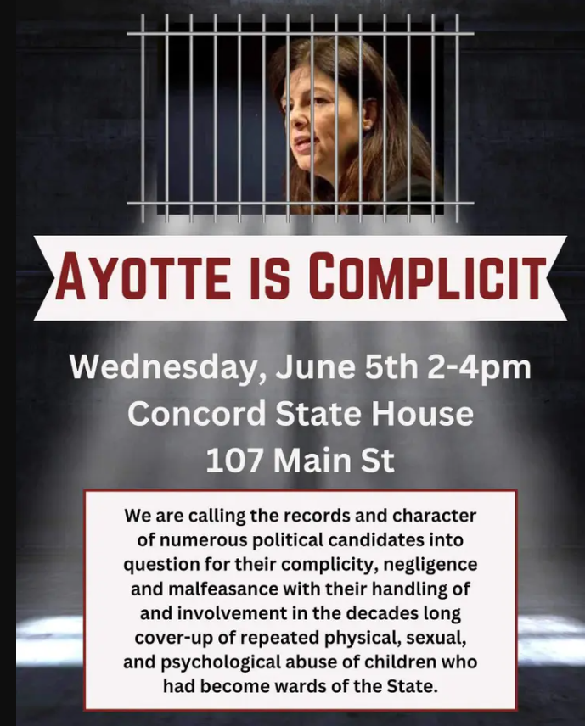
[Patch, Archived 7/21/24]
Ayotte Appeared On A Poster Reading “America’s Most Corrupt Complicit Government Officials” During NH Rep. Leah Cushman’s (R) Protest Speech In Concord. According to a screenshot of a video recording of a protest on June 5, 2024 with Ayotte’s picture outlined in green [not part of the original video],
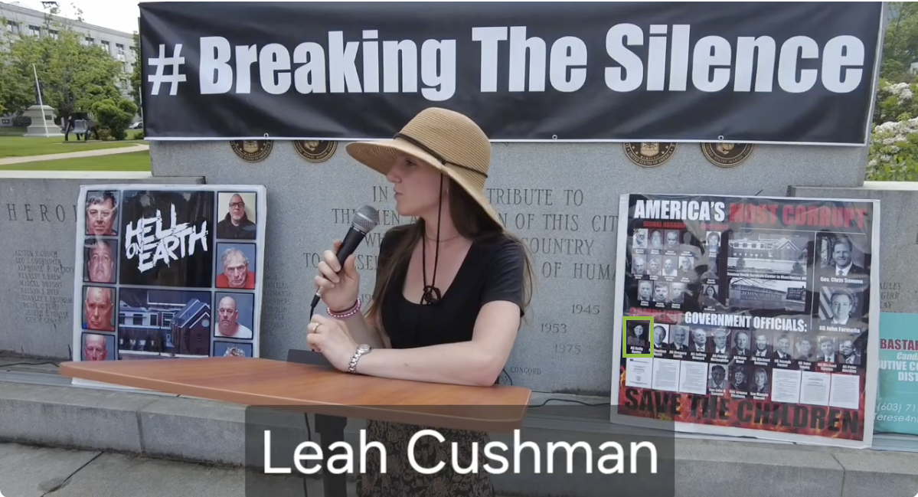
[Absolute Defiance – YDC Abuse Victims Rally, 6/5/24] (VIDEO)

August 2023: Victim Advocates Organized A Rally With Images Suggesting Ayotte’s Guilt
August 2023: At A Rally Outside The New Hampshire State House, Ayotte’s Visage Appeared In Posters Among Government Officials Accused Of Complicity In The Alleged Abuse At The Youth Development Center (YDC). According to InDepthNH, “Survivors of the notorious Youth Development Center in Manchester who were allegedly abused for years by state employees held a rally at the State House Friday urging the state to stop the harmful impacts it continues to inflict on survivors. […] One poster listed not only some of the alleged perpetrators but also Gov. Chris Sununu, Attorney General John Formella, and former Attorney General Kelly Ayotte, who is now running for governor, and others” [InDepthNH, 8/25/23]
Bastarache Pointed At Ayotte When Claiming That Government Officials Covered Up DCYF Abuse And Referenced Ayotte’s Term In Office. According to Terese Bastarache, “We treat the dogs of SPCA far better than we do our children. […] And we have people on this board [*points to Ayotte’s picture*] who are looking to run for office, who knew about this in 2009 and stayed silent.”
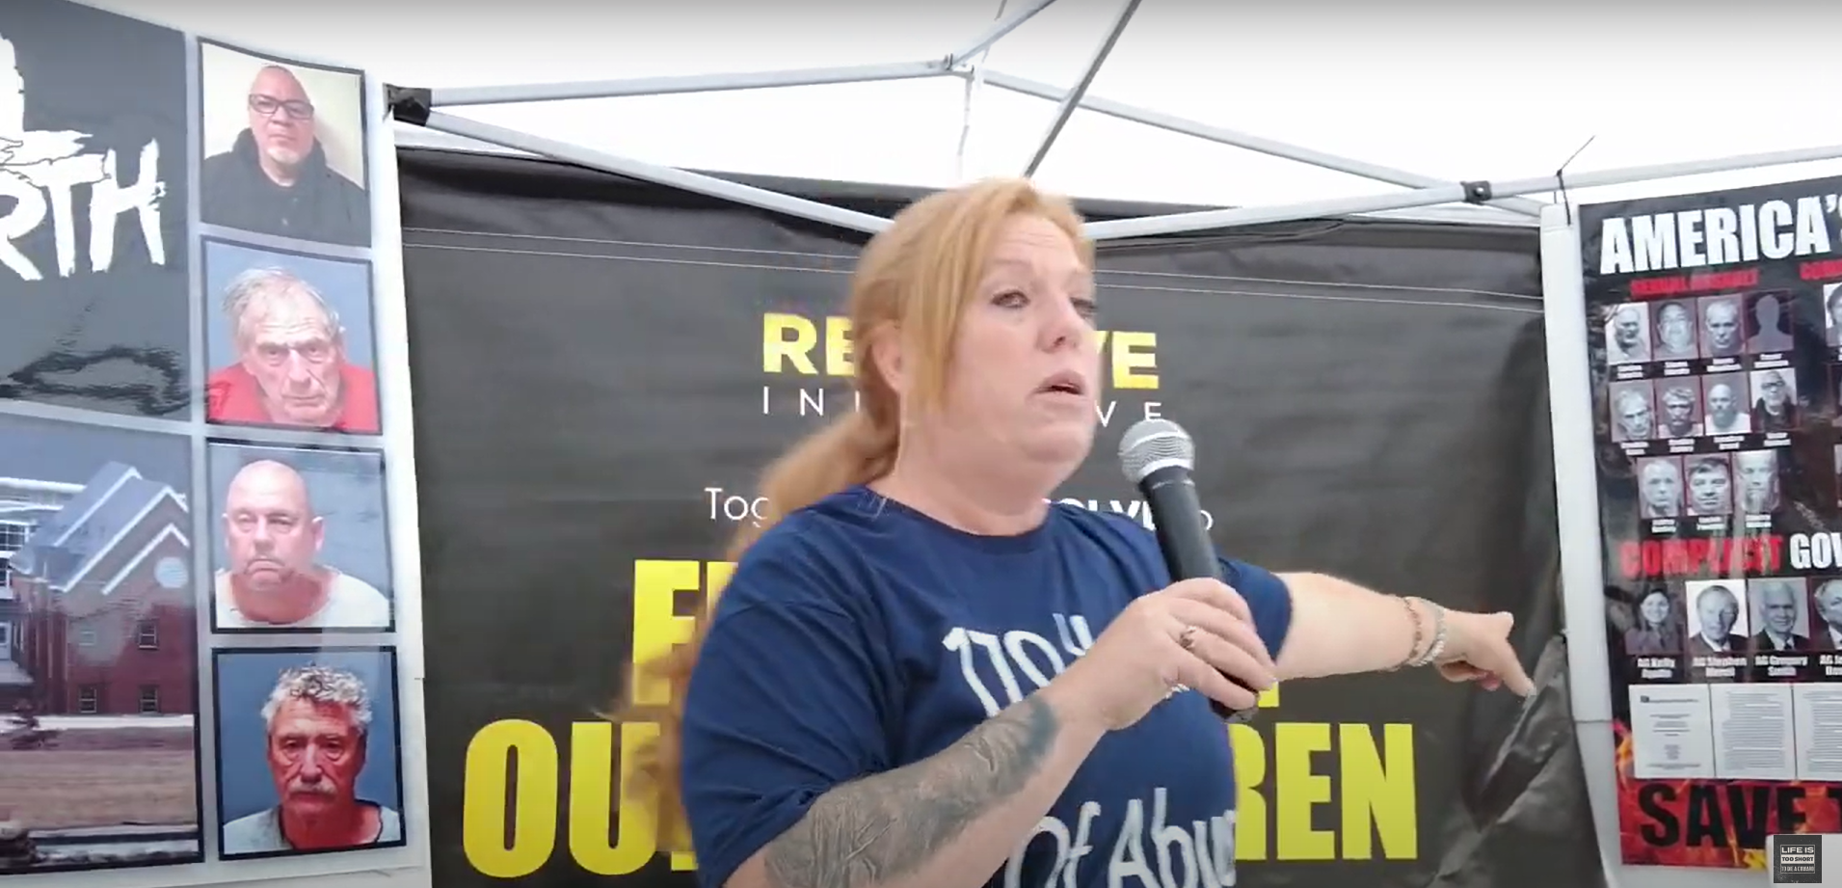
[Absolute Defiance – Rally For The Victims Of YDC, 8/26/23] (VIDEO)

At Least 1,300 Victims Accused State Employees Of Rape, Beatings, And Other Child Abuse At A NH Juvenile Detention Facility

State Employees At The Sununu Youth Services Center (Formerly YDC) Routinely Perpetrated Horrific Acts Of Sexual, Physical, And Emotional Abuse Against Children
2021: 11 State Workers Were Arrested For Crimes Related To Abuse At YDC. According to InDepthNH, “There were 11 former state workers arrested in 2021 for crimes related to the abuse, but many remain free, said one man who identified as a victim.” [InDepthNH, 8/25/23]
By 2024, At Least Around 1,300 Adults Came Forward To Allege Abuse, Rape, And Other Maltreatment From YDC Personnel. According to InDepthNH, “Asbury is one of the only 11 men charged by the state for alleged abuse at YDC, despite hundreds of more alleged abusers being named by survivors. There are currently about 1,300 adults who claim they were abused as children while held at YDC. Allegations against Asbury, including his threats of retaliation against staff who reported him, were forwarded to the New Hampshire Attorney General’s Office for investigation in 1994, according to Brien’s testimony. Asbury wasn’t charged until 2021, after the state created a Task Force to investigate the tidal wave of allegations then surfacing. Asbury is currently facing charges he assisted in the rape of at least one boy.” [InDepthNH, 4/26/24]
Hundreds Of Allegations Included Rape, Beatings, Broken Bones, And Cigarette Burning. According to the U.S. News & World Report, “At least 356 lawsuits have been filed by plaintiffs who allege sexual assault and have yet to turn 40. Not all of them identify alleged perpetrators by name, but the 242 who do accuse dozens of staffers, nearly all of them at the youth center but some at group homes and residential treatment centers with state contracts. At least a dozen more turned 40 this year, putting their cases out of range for criminal charges. […] The allegations out of the Sununu Center are horrifying: Former residents say they were gang raped, beaten while being raped and forced to sexually abuse each other. Staff members are accused of choking children, beating them unconscious, burning them with cigarettes and breaking their bones.” [U.S. News & World Report, 12/21/23]

New Hampshire Set Up A $100 Million Settlement Fund, An Insufficient Amount To Cover The 1,000+ Planned Claims
The State Of New Hampshire Set Up A $100 Million Settlement Fund For Victims. According to InDepthNH and the YDC Claims Administration and Settlement Fund, “The state has set up a $100 million settlement fund which is seen as inadequate by many of the survivors.” [InDepthNH, 8/25/23 ; NH YDC Claims Administration and Settlement Fund, Accessed 1/7/26]
The Administrator Of The Victims Fund Warned That $100 Million Was Not Enough For The More Than 1,000 Planned Claims. According to New Hampshire Public Radio, “The administrator of the compensation fund for people abused at the former Youth Development Center says its $100 million budget may not be enough. In testimony before the legislature’s Joint Fiscal Committee, John Broderick told top lawmakers Friday the state should consider spending more and lifting damage caps to persuade victims to settle claims outside of court. Broderick stressed that, so far, few victims have settled. ‘If you look at the amount of claims filed, the gross amount of all the claims sought, already, for 92 claims, it's $82 million,’ Broderick said. ‘You can do the math.’ Another 1,000 people who allege they were physically and sexually abused at the state's lone youth detention center, stretching back for decades, are planning to sue the state.” [NHPR, 8/11/23]

David Meehan Was Awarded $38 Million After Coming Forward About Hundreds Of Rape Incidents
Youth Development Center Victim David Meehan Alleged That He Was Raped Hundreds Of Times. According to Spectrum News NY 1, “Meehan was 14 when he was sent to what was then called the Youth Development Center in Manchester in 1995. Over the next three years, he alleges he was routinely beaten, raped hundreds of times and held for months in solitary confinement. According to his lawsuit, one worker who subjected him to nearly daily abuse initially gained his trust by giving him snacks and arranging for him to play basketball with local high schoolers. He accuses other workers of standing guard or holding him down during assaults, and says when he told a supervisor how he got a black eye and split lip, the man cut him off and said, ‘Look little fella, that just doesn’t happen.’” [Spectrum News NY 1, 4/9/24]
A Jury Awarded Meehan $38 Million: The Largest Verdict For A Contested Personal Injury Case In State History. According to the Union Leader, “A jury Friday awarded $38 million to David Meehan, a former resident of the Youth Development Center who alleged he was physically and sexually abused during the 1990s. ‘The $38 million verdict is the largest verdict in a contested personal injury case in the history of New Hampshire,’ said a statement from Meehan’s attorneys, Rus Rilee of Rilee & Associates and David Vicinanzo of Nixon Peabody LLP.” [Union Leader, 5/14/24]

