Overview
In 2025, Lindell’s media company supported Trump’s “One Big Beautiful Bill,” which made the largest cut to SNAP in history. LindellTV praised the Trump administration for implementing stronger proof-of-identity requirements and exposing “SNAP fraud.” In Minnesota, more than 186,000 households relied on SNAP to afford groceries.

LindellTV Supported Stripping SNAP Benefits From Minnesotans And Making Food More Expensive

LindellTV Supported Trump’s “One Big Beautiful Bill,” Which Cut Snap Benefits For Millions

July 2025: LindellTV Praised Trump’s “One Big Beautiful Bill,” Which Contained The Largest SNAP Cut In History
July 2025: LindellTV Praised Trump’s “One Big Beautiful Bill” As A “Victory For Working Americans” And Defeating “The Radical Left.” According to LindellTV’s Twitter, “BREAKING: The House PASSES President Trump’s One Big Beautiful Bill It’s official- the One Big Beautiful Bill has just passed the House of Representatives. This historic legislation delivers: – The largest middle-class tax cut in American history – Relief on tips, overtime, and Social Security taxes – Major rollbacks of Biden-era regulations – A bold return to America First economic policy The bill now heads to @POTUS @realDonaldTrump's desk for signature. Victory for working Americans. Defeat for the radical left.”
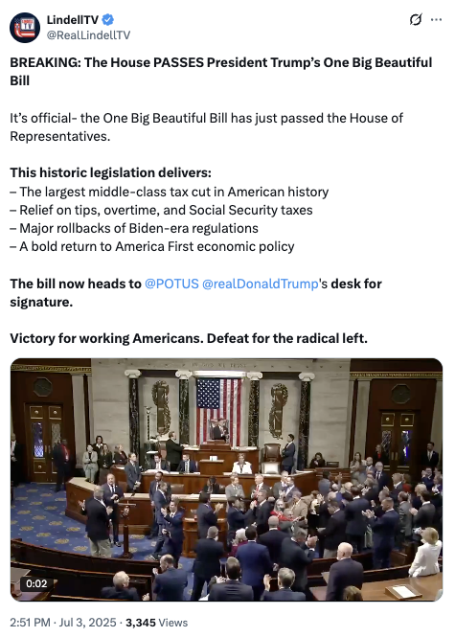
[Twitter, @RealLindellTV, 7/3/25]
- HEADLINE: "Trump’s ‘Big Beautiful Bill’ Cuts Food Stamps For Millions — The Average Family May Lose $146 Per Month, Report Finds" [CNBC, 7/10/25]
- The GOP Reconciliation Bill Would Cut SNAP Funding By $186 Billion, Which CBPP Said Constituted The “Largest Cut To SNAP In History.” According to the Center on Budget and Policy Priorities, “The Senate Republican leadership’s reconciliation bill would dramatically raise costs and reduce food assistance for millions of people by cutting federal funding for the Supplemental Nutrition Assistance Program (SNAP) by $186 billion through 2034, according to the Congressional Budget Office (CBO), about 20 percent — the largest cut to SNAP in history. These cuts would increase poverty, food insecurity, and hunger, including among children. The so-called ‘Big Beautiful Bill’ is anything but beautiful; it would cause widespread harm by making massive cuts to Medicaid and SNAP, which would raise costs on families and make it much harder for them to afford the high cost of health care and groceries.” [Center On Budget And Policy Priorities, 6/30/25]
- 22.3 Million Families Would Lose Some Or All Of Their SNAP Benefits, With 5.3 Million Families Losing More Than $25 In Benefits Per Month, And Of Those Families, The Average Loss In Benefits Would Be $146. According to the Urban Institute, “Our preliminary estimates of the SNAP policies in the Senate bill show the following: 22.3 million US families would be affected, losing some or all of their SNAP benefits. Of the total affected families, 5.3 million would lose at least $25 in SNAP benefits per month. Among these families, 3.3 million are families with children, 3.5 million are working families, and 1.7 million are families with a full-time full-year worker. Families losing at least $25 per month would lose $146 per month on average ($1,752 for a full-year recipient). At the state level, average monthly benefit losses for families losing at least $25 per month would range from $72 in Kansas ($864 annually) to $231 in the District of Columbia ($2,772 annually).” [Urban Institute, 7/2/25]
- States That Could Not Afford To Pay The New Mandated SNAP Cost Shares May Cut The Program Entirely. According to CNBC, “Additionally, the legislation requires states to pay for a portion of benefit costs, ranging from 5% to 15%, if their payment error rate is at or over 6%. The error rates measure the accuracy of states’ eligibility and benefit payments. In fiscal year 2024, states had a 10.9% average payment error rate, with many states over 6%, according to the Department of Agriculture. States that can’t pay those shares may have to cut SNAP benefits or opt out of the program entirely, according to the Center on Budget and Policy Priorities.” [CNBC, 7/10/25]

LindellTV Supported Restricting SNAP Benefits And Called For Stricter Proof-Of-Identity Rules
April 2025: LindellTV Called Stricter Proof-Of-Identity Rules To Receive SNAP Benefits “A Major Step Toward Protecting American Taxpayers And Restoring Fairness To Federal Aid Programs.” According to LindellTV’s Twitter, “USDA Moves to Block Illegal Aliens from Food Stamp Benefits The USDA, under Secretary Brooke Rollins, is cracking down on illegal aliens receiving SNAP benefits. States must now enforce stricter proof-of-identity rules to ensure only eligible citizens get assistance. Millions in improper payments went to non-citizens under the Biden administration. This new policy is a major step toward protecting American taxpayers and restoring fairness to federal aid programs. Follow Lindell TV for more coverage.”
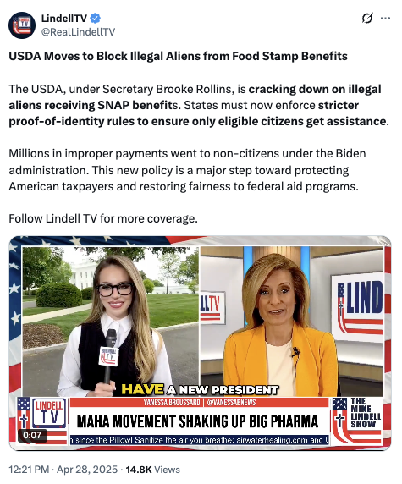
[Twitter, @RealLindellTV, 4/28/25]
November 2025: LindellTV Praised “The Trump Administration’s Major Reforms To Food Policy,” Including Exposing “SNAP Fraud.” According to LindellTV’s Twitter, “186,000 Dead on SNAP: Sec. Rollins Breaks Down Trump Admin’s Food Reform Agenda Our reporter, @CaraCastronuova, interviewed @USDA @SecRollins to talk about the Trump administration's major reforms to food policy, inflation, and the Make America Healthy Again movement. Here’s what @SecRollins told us: SNAP fraud exposed: ‘186,000 dead people were receiving food stamps. We’ve already made 123 arrests.’ Egg prices down 86%, dairy down, inflation dropping fast: ‘We inherited a mess. But 10 months in, inflation is at 2.7% - down from 9% under @JoeBiden.’ Natural farming & health revolution: ‘We're investing in local, sustainable farming and partnering with leaders like @SecKennedy to fight the chronic health crisis in America.’ The system was bloated, broken, and corrupt - now it’s being reformed.”
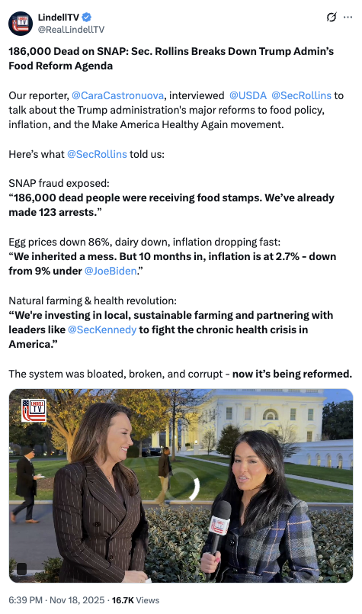
[Twitter, @RealLindellTV, 11/18/25]

186,237 Households In Minnesota Relied On SNAP
2023: Across Minnesota, 186,237 Households Relied On SNAP.
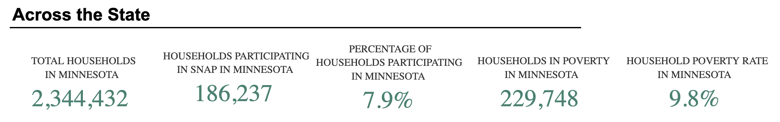
[U.S. Department of Agriculture, SNAP Community Characteristics, Accessed 1/12/26]

