Overview
In 2025, Lindell’s media company supported Trump’s “One Big Beautiful Bill,” which was estimated to kick 17 million Americans off their health insurance, including nearly 12 million Americans who rely on Medicaid. More than 161,000 Minnesotans could lose their health insurance as a result of the bill.
LindellTV opposed Medicaid expansion and the Affordable Care Act, saying they were “riddled with fraud.” More than 151,000 Minnesotans were enrolled in Affordable Care Act Marketplace health insurance plans. LindellTV called Medicaid work requirements a “key win,” even though more than 108,000 Medicaid recipients in Minnesota were expected to lose their coverage by 2034 due to Trump’s tax bill.

LindellTV Supported Taking Health Insurance Away From Millions Of Americans Who Relied On Medicaid

LindellTV Praised Trump’s “One Big Beautiful Bill,” Which Included Devastating Health Care Cuts To Fund Tax Cuts For The Wealthy

July 2025: LindellTV Praised Trump’s “One Big Beautiful Bill,” Which Would Cause 17 Million Americans To Lose Their Health Insurance, As A “Victory For Working Americans”
July 2025: LindellTV Praised Trump’s “One Big Beautiful Bill” As A “Victory For Working Americans” And Defeating “The Radical Left.” According to LindellTV’s Twitter, “BREAKING: The House PASSES President Trump’s One Big Beautiful Bill It’s official- the One Big Beautiful Bill has just passed the House of Representatives. This historic legislation delivers: – The largest middle-class tax cut in American history – Relief on tips, overtime, and Social Security taxes – Major rollbacks of Biden-era regulations – A bold return to America First economic policy The bill now heads to @POTUS @realDonaldTrump's desk for signature. Victory for working Americans. Defeat for the radical left.”
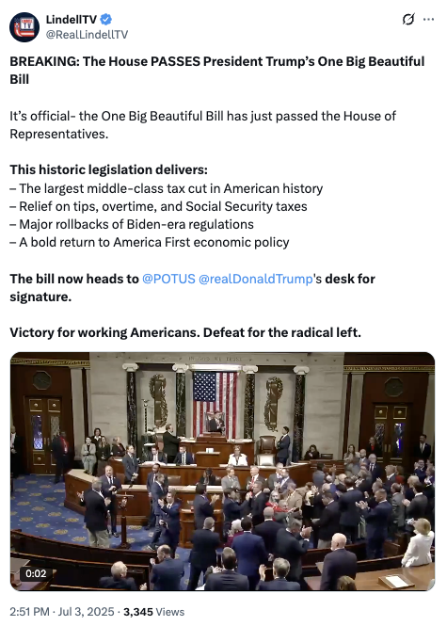
[Twitter, @RealLindellTV, 7/3/25]
- HEADLINE: "At Least 17 Million Americans Would Lose Insurance Under Trump Plan" [Washington Post, 7/1/25]
- HEADLINE: “By The Numbers: Harmful Republican Megabill Favors The Wealthy And Leaves Millions Of Working Families Behind” [Center On Budget And Policy Priorities, 8/1/25]
- The Congressional Budget Office Estimated That 11.8 Million People Would Become Uninsured As A Result Of The Medicaid Cuts In Republicans’ Reconciliation Bill. According to the Washington Post, "The bill, which narrowly passed the Senate on Tuesday and now heads back to the House, would effectively accomplish what Republicans have long failed to do: unwind many of the key components of the ACA, President Barack Obama’s signature domestic achievement, which dramatically increased the number of Americans with access to health insurance. To start, the Congressional Budget Office estimated that the Senate version of the bill would result in 11.8 million more uninsured in 2034, mostly because of Medicaid cuts, compared with 10.9 million if the House version became law." [Washington Post, 7/1/25]
- The Bill’s $50 Billion In Rural Hospital Relief Funding Would Not Come Close To The Gap Created By Medicaid Cuts, With 300 Rural Hospitals At “Immediate Risk” Of Closure. According to the Center For American Progress, “The OBBBA includes $50 billion in relief funding for rural hospitals over a five-year period to help reduce the disastrous impacts of the bill’s roughly $1 trillion in Medicaid cuts. As of May 2025, there were approximately 2,086 rural hospitals receiving $12.2 billion a year in net revenue from Medicaid. At the median, rural hospitals’ revenue from Medicaid is $3.9 million a year.Rural hospitals have some of the lowest operating margins in the nation, especially compared with urban hospitals, meaning that any reductions in revenue could lead to closures. The average operating margin for rural hospitals was 3.1 percent in 2023, with 44 percent of rural hospitals operating with negative margins. As a result, more than 300 rural hospitals are currently at ‘immediate risk’ of closure, especially now that the OBBBA is projected to cut Medicaid spending by $1.02 trillion. The relief fund designed to blunt the negative impacts caused by the bill would not come close to filling that gap. If every rural hospital in the country received an even share of the $50 billion in relief support, it would amount to only $4.5 million every year for five years. At the close of those five years, that funding would disappear altogether.” [Center For American Progress, 7/3/25]

More Than 161,000 Minnesotans Were Expected To Lose Health Care Coverage Under Trump’s “One Big Beautiful Bill”
Under The “One Big Beautiful Bill,” 161,247 Minnesotans Were Expected To Lose Their Health Care By 2034, Including 53,200 ACA Enrollees And 108,047 Medicaid Recipients. According to the Joint Economic Committee Minority,
District | State | Est. # Losing ACA Coverage | Est. # Losing Medicaid Coverage | Est. Total # Losing Insurance
MN-01 | Minnesota | 7,100 | 12,517 | 19,617
MN-02 | Minnesota | 5,100 | 10,263 | 15,363
MN-03 | Minnesota | 5,500 | 10,290 | 15,790
MN-04 | Minnesota | 6,300 | 15,959 | 22,259
MN-05 | Minnesota | 8,300 | 15,188 | 23,488
MN-06 | Minnesota | 6,300 | 12,994 | 19,294
MN-07 | Minnesota | 7,900 | 15,298 | 23,198
MN-08 | Minnesota | 6,700 | 15,538 | 22,238
All | Totals | 53,200 | 108,047 | 161,247

[Joint Economic Committee Minority, 6/25]

The “One Big Beautiful Bill” And The Expiring Affordable Care Act Tax Credits Would Result In 179,000 Additional Uninsured Minnesotans By 2034
The “One Big Beautiful Bill” And The Expiring Affordable Care Act Tax Credits Would Result In 179,000 Additional Uninsured Minnesotans By 2034. According to the Center For American Progress, “The One Big Beautiful Bill Act will increase the number of Americans without health coverage in every state Estimated increase in the uninsured population due to the OBBBA and the expiration of the ACA’s enhanced premium tax credits, 2034”
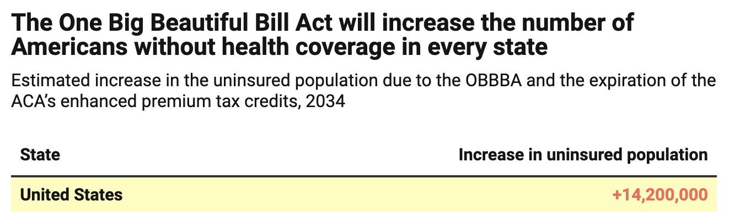
[Center For American Progress, 9/5/25]

LindellTV Opposed The Affordable Care Act And Supported Medicaid Work Restrictions

LindellTV Claimed The Affordable Care Act Was “Riddled With Fraud”
2025: LindellTV Claimed The Affordable Care Act Was “Riddled With Fraud,” Citing A Study Claiming “90 Percent Of Obamacare Subsidies Were Actually Granted Without Any Documentation.” According to LindellTV’s Twitter, “WATCH: Our reporter pressed Rep. Sarah McBride on a shocking OBAMACARE revelation and the only defense was to call it 'BULLSH*T.' Our reporter, @AlisonintheKnow, asked @SarahEMcBride: ‘A government watchdog group set up a number of fake accounts and discovered that 90% of Obamacare subsidies were actually granted without any documentation. No Social Security number, no income verification. What do you make of this? And why do you guys want to continue to extend a program that's clearly failed the American people, especially for another three years?’ Our reporter even presented the study (covered by @NYT ). @SarahEMcBride's response? ‘That study sounds like bullsh*t.’ ‘Sounds like the methodology is questionable.’ No refutation. No facts. And when asked why they’re pushing to extend this broken system for another 3 years, she dodged again, blaming Republicans and refusing to engage on the core issue. This is your tax dollars with democratic officials at work. No accountability. No answers. Just more subsidies for a system riddled with fraud.”
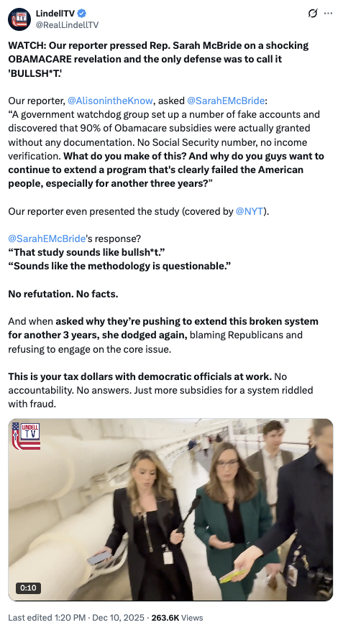
[Twitter, @RealLindellTV, 12/10/25]

LindellTV Supported Medicaid Work Requirements And “Anti-Fraud” Reforms
September 2025: LindellTV Claimed Democrats Were “Threatening To Shut Down The Government To Undo The Anti-Fraud Medicaid Reforms In The ‘One Big Beautiful Bill,’” And Wanted To “Restore The Very Provisions That Allowed States To Offer Medicaid To Illegal Immigrants.” According to LindellTV’s Twitter, “The ‘Schumer Shutdown’ is Here Democrats are threatening to shut down the government to undo the anti-fraud Medicaid reforms in the ‘one big beautiful bill’ - reforms that stopped taxpayer funded benefits from flowing to illegal immigrants. When our reporter pressed @RepMaxineWaters on whether Democrats are prioritizing health care for illegal aliens over keeping the government open, she snapped: ‘Stop it right there… you’re just trying to get controversy.’ Senators @MarkWarner and @RonWyden also insisted our question was ‘factually wrong’ - yet they’re fighting to restore the very provisions that allowed states to offer Medicaid to illegal immigrants before the bill cut it off. This isn’t about ‘health care for all.’ It’s a partisan power play to undo hard won reforms, restore benefits to non-citizens, and risk a shutdown rather than admit defeat on their open borders agenda.”
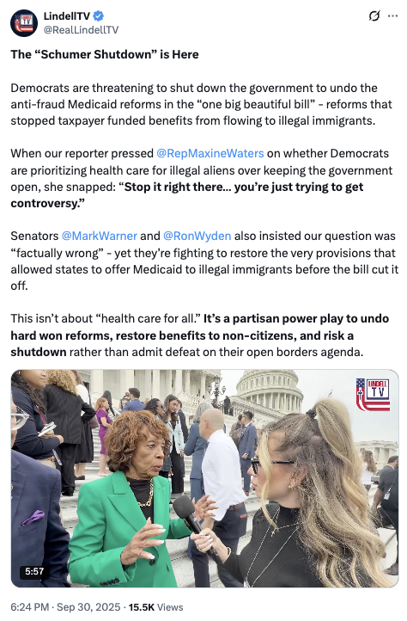
[Twitter, @RealLindellTV, 9/30/25]
July 2025: LindellTV Called The Medicaid Work Requirements In Trump’s “One Big Beautiful Bill” A “Key Win.” According to LindellTV’s Twitter, “President Trump’s One Big Beautiful Bill Heads Back to the House After Senate Passage The bill is on track to meet the July 4 deadline, with final House approval expected soon. Key wins: - Trump tax cuts made permanent - No taxes on tips or overtime - Border wall funding and immigration enforcement - Medicaid work requirements - Illegal aliens removed from Medicaid rolls - AI deregulation provision struck down @elonmusk blasted the bill over spending. @POTUS @realDonaldTrump fired back, pointing to Musk’s reliance on taxpayer subsidies.”
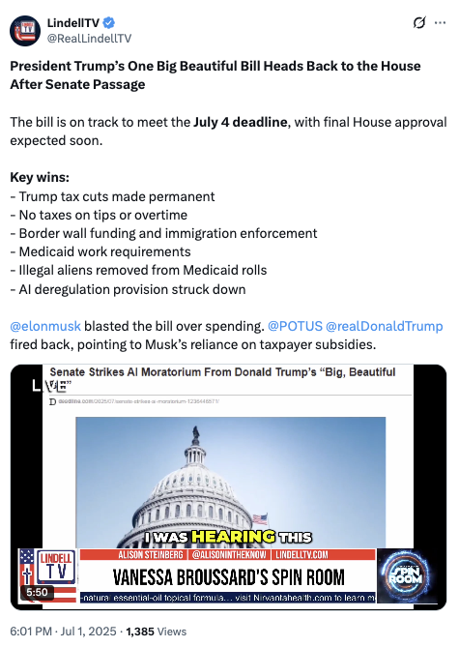
[Twitter, @RealLindellTV, 7/1/25]

2025: There Were 151,512 Minnesotans Enrolled In An Affordable Care Act Marketplace Plan
2025: There Were 151,512 Individuals Enrolled In An Affordable Care Act Marketplace Plan In Minnesota. According to KFF, in 2025, there were 151,512 individuals enrolled in affordable care act marketplace plan in Minnesota.
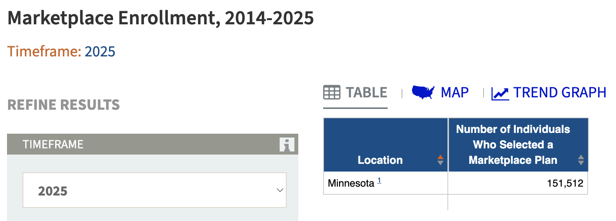
[KFF, Accessed 1/14/26]

Under The “One Big Beautiful Bill,” 108,047 Medicaid Recipients In Minnesota Were Expected To Lose Their Health Care By 2034
Under The “One Big Beautiful Bill,” 161,247 Minnesotans Were Expected To Lose Their Health Care By 2034, Including 53,200 ACA Enrollees And 108,047 Medicaid Recipients. [Joint Economic Committee Minority, 6/25]

The Affordable Care Act Allowed States To Expand Medicaid, Which Dramatically Lowered The Uninsured Rate Among Low-Income Workers
The Affordable Care Act Allowed States To Expand Medicaid, And States That Expanded Medicaid Dramatically Lowered The Number Of People Without Health Insurance. According to the Center on Budget and Policy Priorities, "The Affordable Care Act (ACA) permits states to expand Medicaid coverage to adults with incomes up to 138 percent of the poverty level (about $20,780 annually for an individual or $35,630 for a family of three). States that have adopted the expansion have dramatically lowered their uninsured rates. Extensive research finds that the people who gained coverage have grown healthier and more financially secure, while long-standing racial inequities in health outcomes, coverage, and access to care have shrunk." [Center On Budget And Policy Priorities, 6/14/24]
- The Uninsured Rate Among Low-Income Workers Fell From 38 Percent In 2013 To 17 Percent In 2022, Which Coincided With Implementation Of Medicaid Expansion. According to the Center on Budget and Policy Priorities, "Millions of workers have gained coverage through Medicaid expansion, including people working in industries that provide critical goods and services such as health care, transportation, grocery stores, food manufacturers, and child care. Many have no access to health coverage through their jobs. In expansion states, the uninsured rate among low-income workers fell from 38 percent in 2013 to 17 percent in 2022; this sharp decline coincided with a large increase in the share of low-income workers enrolled in Medicaid.[16] In non-expansion states, the uninsured rate among low-income workers fell much less, from 46 percent to 31 percent. (See Figure 3.)" [Center On Budget And Policy Priorities, 6/14/24]

