Overview
Lindell’s 2026 campaign platform promised to cut “wasteful spending” and cut income, business, and sales taxes, which primarily funded education and health and human services in Minnesota, among other state agencies.
LindellTV promoted DOGE even though it resulted in federal funding cuts that were affecting the federal government’s ability to deliver services to seniors. More than 1.15 million Minnesotans relied on Social Security benefits. DOGE also cut funding to AmeriCorps, affordable housing nonprofits, and National Endowment for the Humanities grants. Federal layoffs threatened the livelihoods of 20,000 federal employees in Minnesota and canceled leases for 11 federal offices.

Lindell Advocated For Massive Cuts To The State Budget That Will Have Horrific Consequences For Public Services

Lindell’s 2026 Campaign Platform Featured Plans To Cut Funding For Crucial State Agencies

Lindell’s Campaign Platform Promised To Cut Taxes That Funded State Services

Lindell Pledged To Cut Income, Business, And Sales Taxes
2026: Lindell’s Campaign Platform Prioritized Cutting Income, Business, And Sales Taxes. According to Mike Lindell for Governor, “Minnesota deserves a governor who will stand for you, reducing income and business taxes will ignite the investment needed to grow our economy. Cutting sales taxes for in-person purchases to 5%, and current motor vehicle registration fees in half lowers the cost of living immediately.” [Mike Lindell For Governor, Archived 1/6/26]

Tax Revenue Made Up 96 Percent Of Minnesota’s General Fund
Minnesota’s Largest Single Fund, The General Fund, Was Made Up Of Individual Income Taxes, Retail Sales Taxes, Business Taxes, And Other Taxes. According to Minnesota Management and Budget, “The state's largest single fund is the General Fund. State collections of individual income taxes, retail sales taxes, business taxes, and other taxes are deposited into this fund. Expenditures from the state General Fund can be made for any authorized state activity subject to legislative appropriation limits.” [Minnesota Management And Budget, Accessed 1/16/26]
2026-2027: Taxes Made Up 96 Percent Of Minnesota’s General Fund. According to Minnesota Management and Budget,
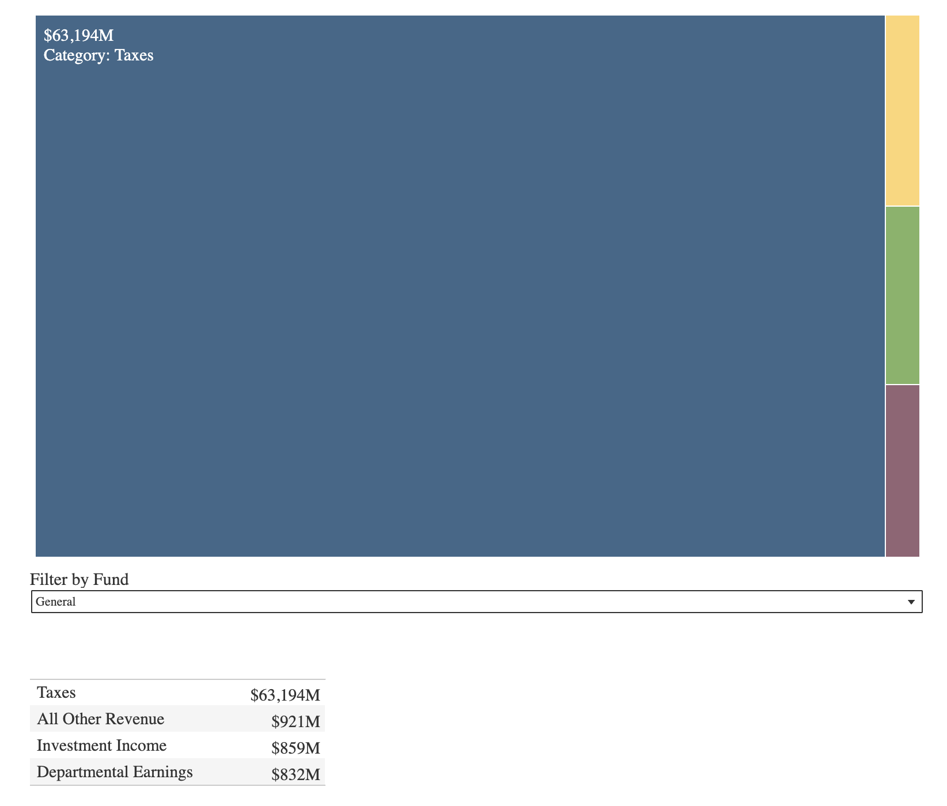
[Minnesota Management And Budget, Accessed 1/16/26]

Minnesota’s General Fund Primarily Funded Education And Health And Human Services
2026-2027: Education And Health And Human Services Made Up 73 Percent Of Expenditures From Minnesota’s General Fund. According to Minnesota Management and Budget,
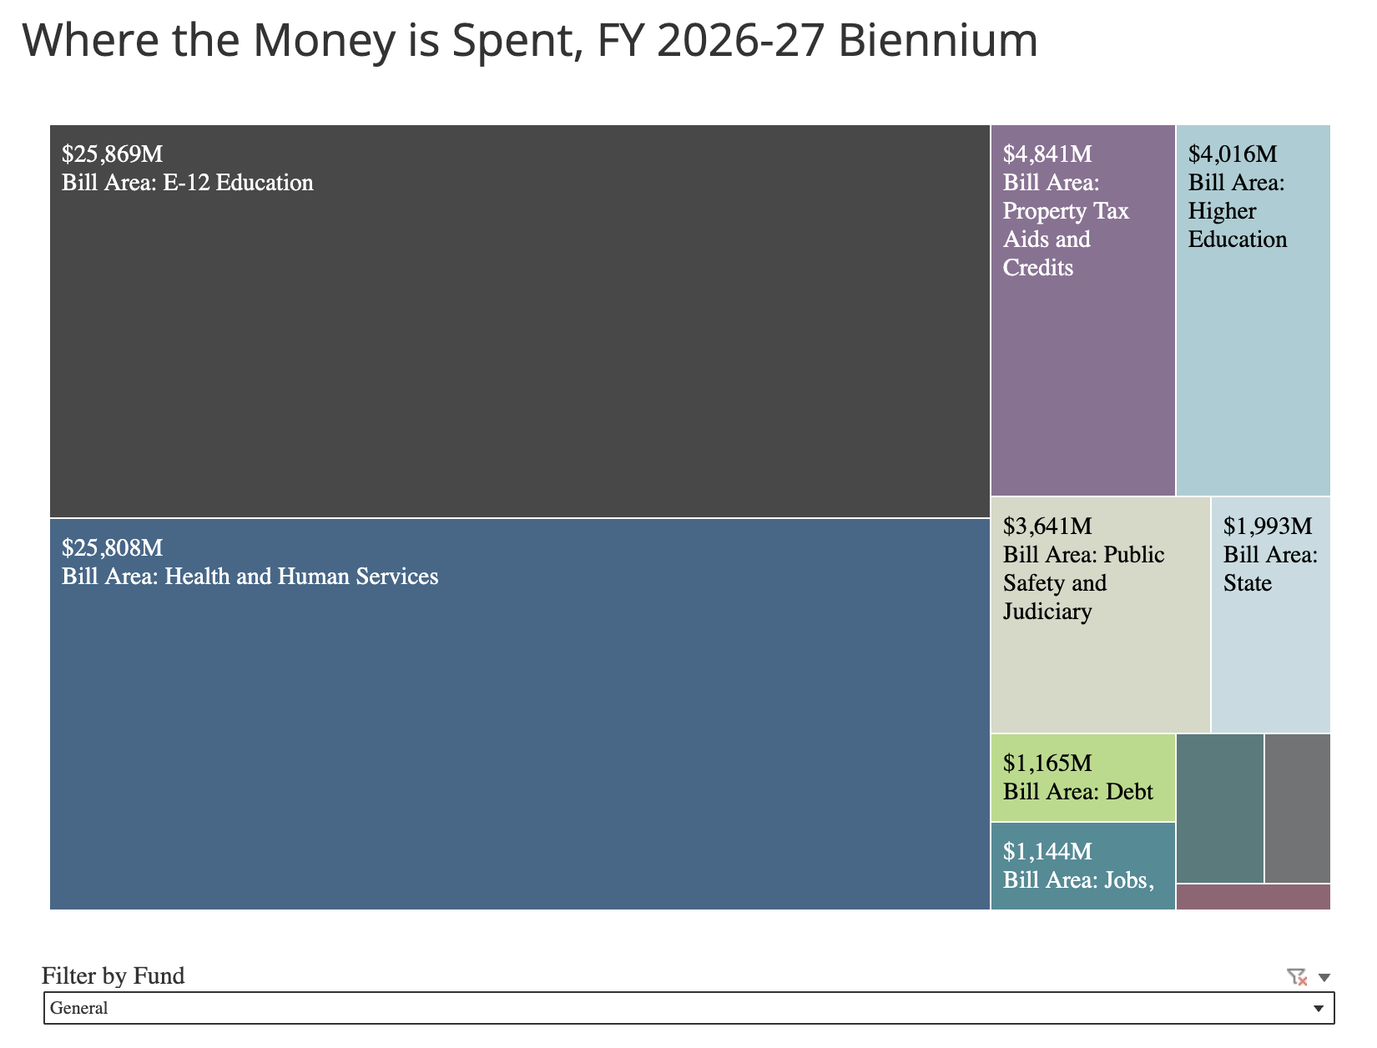
[Minnesota Management And Budget, Accessed 1/16/26]

Lindell’s Platform Included Promises To Cut “Wasteful Spending At The State, County, City And School District Levels”
2026: Lindell’s Campaign Platform Prioritized Addressing “Wasteful Spending At The State, County, City And School District Levels.” According to Mike Lindell for Governor, “Minnesota deserves a governor who will stand for you ready to get control of property taxes and the wasteful spending at the State, County, City and School District levels.” [Mike Lindell For Governor, Archived 1/6/26]

Trump’s DOGE Cuts “Closed Offices, Canceled Programs And Deprived People Of Food, Medicine, And Other Aid,” But “Amounted To Little In The Scale Of The Federal Budget”
Trump Established The Department Of Government Efficiency To “Cut Government Waste And Slash Federal Regulations.” According to NPR, “The Department of Government Efficiency, or DOGE, was created by Trump via an executive order on his first day back in office. Trump put tech billionaire and adviser Elon Musk in charge and vowed to use the unit to cut government waste and slash federal regulations.” [NPR, 2/4/25]
Federal DOGE Put U.S.A.I.D. “Through The Wood Chipper” And Made Cuts “That Closed Offices, Canceled Programs And Deprived People Of Food, Medicine, And Other Aid,” Which “Amounted To Little In The Scale Of The Federal Budget.” According to The New York Times, “Many of the largest savings that DOGE claimed turned out to be wrong. And while the group did make thousands of smaller cuts, jolting foreign aid recipients, American small businesses and local service providers, those amounted to little in the scale of the federal budget. […] Despite all that, the DOGE effort led to some actual cuts that closed offices, canceled programs and deprived people of food, medicine and other aid. For people depending on those funds, the effects were sudden and devastating. DOGE initially terminated nearly every contract and grant at the U.S.A.I.D. and sought to lay off most staff members, as Mr. Musk put the agency ‘through the wood chipper.’ Some aid programs were later revived. But thousands were canceled.” [New York Times, 12/23/25]

LindellTV Praised Trump’s DOGE As DOGE Policies Resulted In The Mass Layoff Of Minnesotans And Threatened Services At The Social Security Administration And Minnesota Organizations

LindellTV Praised DOGE For Defunding USAID, NPR, And PBS
2025: LindellTV Praised DOGE For Defunding USAID, NPR, And PBS. According to LindellTV’s Twitter, “The House just approved HRes590 (216–213), locking in the first wave of budget cuts under @DOGE’s leadership. USAID – DEFUNDED @NPR – DEFUNDED @PBS – DEFUNDED No more taxpayer dollars flowing to bloated bureaucracies or politicized media. This $9 BILLION cuts package now heads to @POTUS’s desk for final approval. @realDonaldTrump: ‘Republicans have tried doing this for 40 years and failed… BUT NO MORE. THIS IS BIG!’”
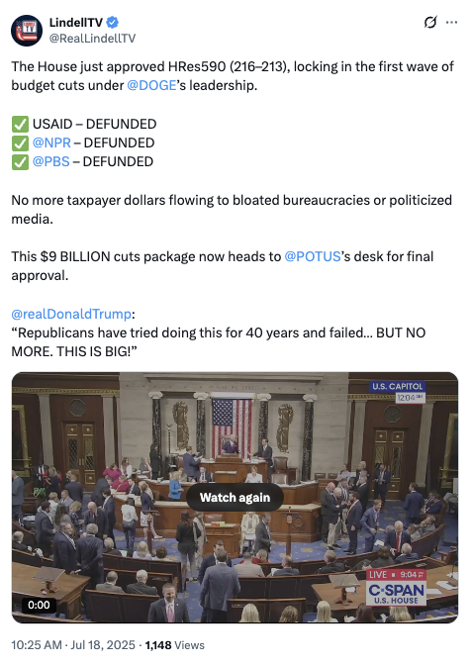
[Twitter, @RealLindellTV, 7/18/25]

At The Social Security Administration, Doge Forced Mass Layoffs, Longer Wait Times And Frequent Website Crashes
HEADLINE: "Social Security Stops Reporting Call Wait Times And Other Metrics" [Washington Post, 6/20/25]
HEADLINE: "As Social Security Services Are Cut Back, Millions Of Seniors Face Long Drives" [Axios, 6/8/25]
HEADLINE: "Social Security Website Keeps Crashing, As DOGE Demands Cuts To IT Staff" [Washington Post, 4/7/25]
HEADLINE: "Social Security Faces Thousands More Job Cuts Even With Service In Tailspin" [Washington Post, 4/4/25]
The Center On Budget And Policy Priorities Said The Trump Administration Had Pushed Out 7,000 Social Security Workers. According to the Center on Budget and Policy Priorities, "Over the past five months, the Trump Administration has forced the Social Security Administration (SSA) through a radical transformation that threatens to disrupt services for the largely older and severely disabled people who most rely on the agency.[1] The Trump Administration and its so-called Department of Government Efficiency (DOGE) have created huge gaps in customer service and support by indiscriminately pushing out 7,000 workers to hit an arbitrary staffing reduction target. This is the largest staffing cut in SSA’s history.[2] (See Figure 1.)" [Center on Budget and Policy Priorities, 6/23/25]
The Social Security Administration Website Crashed Four Times In Ten Days In March 2025 Because Servers Were Overloaded. According to the Washington Post, "The Social Security Administration website crashed four times in 10 days this month because the servers were overloaded, blocking millions of retirees and disabled Americans from logging in to their online accounts. In the field, office managers have resorted to answering phones in place of receptionists because so many employees have been pushed out. Amid all this, the agency no longer has a system to monitor customer experience because that office was eliminated as part of the cost-cutting efforts led by Elon Musk. And the phones keep ringing. And ringing." [Washington Post, 3/25/25]
Field Office Managers At Social Security Offices Had To Answer Phones In Place Of Receptionists Because DOGE Had Pushed Out So Many Federal Employees. According to the Washington Post, "The Social Security Administration website crashed four times in 10 days this month because the servers were overloaded, blocking millions of retirees and disabled Americans from logging in to their online accounts. In the field, office managers have resorted to answering phones in place of receptionists because so many employees have been pushed out. Amid all this, the agency no longer has a system to monitor customer experience because that office was eliminated as part of the cost-cutting efforts led by Elon Musk. And the phones keep ringing. And ringing." [Washington Post, 3/25/25]
DOGE Eliminated The Social Security Administration’s System To Monitor Customer Experience. According to the Washington Post, "The Social Security Administration website crashed four times in 10 days this month because the servers were overloaded, blocking millions of retirees and disabled Americans from logging in to their online accounts. In the field, office managers have resorted to answering phones in place of receptionists because so many employees have been pushed out. Amid all this, the agency no longer has a system to monitor customer experience because that office was eliminated as part of the cost-cutting efforts led by Elon Musk. And the phones keep ringing. And ringing." [Washington Post, 3/25/25]
Early February-Late March 2025: AARP Said More Than 2,000 People Per Week Had Called Expressing Concerns About Whether They Would Continue To Get Their Social Security Benefits. According to the Washington Post, "Alarmed lawmakers are straining to answer questions back home from angry constituents. Calls have flooded into congressional offices. AARP announced Monday that more than 2,000 people a week have called the retiree organization since early February — double the usual number — with concerns about whether benefits they paid for during their working careers will continue. Social Security is the primary source of income for about 40 percent of older Americans." [Washington Post, 3/25/25]

More Than 1.15 Million Minnesotans Relied On Social Security Benefits
In Minnesota, 1,152,818 Individuals Relied On Social Security Benefits. According to the Social Security Administration, in 2024, 1,152,818 Minnesotans received Social Security benefits. [Social Security Administration, Minnesota, 2024]

DOGE Cut Federal Funding For Minnesota Organizations Including AmeriCorps, Affordable Housing Nonprofits, And National Endowment For The Humanities Grants

AmeriCorps Cuts Impacted 14,000 Volunteers And Members That Served 2,100 Organizations In Minnesota
April 2025: DOGE Cut Funding For AmeriCorps, Which Affected 14,000 Volunteers And Members In Minnesota That Served 2,100 Nonprofit And Faith-Based Organizations. According to The Minnesota Star Tribune, “An independent federal agency that champions community-based service and volunteerism, AmeriCorps placed at least 85% of its workforce on administrative leave last month with the warning that their jobs would be eliminated by June 24. And the latest blow landed on Friday when about $400 million in grant funding nationwide was terminated effective immediately. The DOGE mandate affects some 14,000 volunteers and members in Minnesota serving 2,100 locations, including schools, food banks, homeless shelters, health clinics, youth centers, veterans’ facilities, and other nonprofit and faith-based organizations, according to its annual report.” [Minnesota Star Tribune, 4/30/25]

DOGE Cut A $3.8 Million Grant For A Minnesota Affordable Housing Development
April 2025: DOGE Cut A $3.8 Million Grant Intended To Pay For Needed Repairs To A Minnesota Affordable Housing Development. According to the Minnesota Reformer, “In October, the U.S. Department of Housing and Urban development gave the building’s nonprofit owner a $3.8 million grant to pay for needed repairs and upgrades, including a new heating system and windows. But the money never came through because the Trump administration has ‘permanently frozen’ the funds, CommonBond Communities president and CEO Deidre Schmidt said Monday. The grant money came from HUD’s Green and Resilient Retrofit Program, which provided grants and loans to finance energy efficiency upgrades at affordable housing developments nationwide. Vista Village was the only Minnesota-based project to receive an award through the competitive program. Congress authorized $1 billion for the Green and Resilient Retrofit Program in 2022 as part of the Inflation Reduction Act. In March, the Associated Press reported that the program was being ‘terminated’ at the direction of DOGE.” [Minnesota Reformer, 4/14/25]

National Endowment For The Humanities Cuts Eliminated Grants For The Norwegian American Historical Association, The Minnesota Humanities Center, And The Minnesota Historical Society
April 2025: DOGE Cut A $300,000 National Endowment For The Humanities Grant For The Minnesota-Based Norwegian American Historical Association. According to MinnPost, “A year ago, the Northfield-based Norwegian American Historical Association hailed the approval of a nearly $300,000 grant from the National Endowment for the Humanities (NEH), a federal agency that promotes history, culture and the arts. That grant would allow the society to digitize and preserve five collections that document the efforts of Norwegian Americans to help occupied Norway – and its resistance fighters – during World War II. One collection is a compilation of papers from the American Relief for Norway (ARFN), a group founded by Minnesotans to relieve distress among the people of Norway. […] Another collection is about the Camp Little Norway Association, an organization of Minnesotans of Norwegian descent who supported a training base for the Royal Norwegian Air Force in Toronto. But last Wednesday, Norwegian American Historical Association Executive Director Amy Boxrud received an email that said the multiyear grant had been canceled, leaving the efforts to preserve those historical documents and many others in doubt.” [MinnPost, 4/8/25]
April 2025: DOGE Cut $1.2 Million In Funding For The Minnesota Humanities Center From The National Endowment For The Humanities. According to MinnPost, “NEH has also provided grants to every state humanities council for decades. Those have all been canceled, including those for the Minnesota Humanities Center, which will lose $1.2 million in annual funding. Kevin Lindsey, the CEO of the Minnesota Humanities Center, said he found out his NEH grant was canceled like Boxrud did — through an email from DOGE. The money the center receives was used to give grants to other nonprofits working on projects involving culture, history and the arts, and to fund its own projects, such as a proposed film about slavery in the years just before the Civil War.” [MinnPost, 4/8/25]
April 2025: DOGE Cut A $300,000 National Endowment For The Humanities Grant For The Minnesota Historical Society. According to MinnPost, “Since 2007, the Minnesota Historical Society has received eight grants from the NEH for its ambitious project to digitize more than 120 newspapers. But, like other NEH grant recipients, the society received notice last week that its eighth grant, in the amount of $300,000, had been canceled. ‘The loss of these funds will result in fewer newspaper pages being digitized and available for research,’ said Minnesota History Society Director Kent Whitworth.” [MinnPost, 4/8/25]

DOGE Cuts Targeted 20,000 Federal Workers In Minnesota And Canceled The Leases Of 11 Federal Offices
February 2025: DOGE Ordered The Firing Of All Probationary Employees Out Of Minnesota’s 20,000 Federal Employees. According to The Minnesota Star Tribune, “The cuts are part of President Donald Trump’s widescale effort to downsize the federal workforce, specifically an edict from the self-styled Department of Government Efficiency, led by Elon Musk, to fire all probationary employees. That includes new employees and also experienced federal workers who took new positions, including promotions, within the past year. There are about 20,000 federal civilian employees in Minnesota. It’s not known how many of those are probationary, but roughly two dozen spoke to the Minnesota Star Tribune about losing their jobs and all knew of others in their departments who had been dismissed.” [Minnesota Star Tribune, 2/20/25]
- Minnesota’s Fired Federal Employees Received No Severance Pay And Were Told They Were Terminated For Not Meeting Performance Needs. According to The Minnesota Star Tribune, “‘The awful thing is our termination letters say it was because of performance [and] not meeting performance needs. This obviously isn’t the reason,’ Severson said. […] Those who spoke to the Star Tribune worked in wide-ranging jobs, from assisting military veterans and people with disabilities to helping fulfill small-business loans. All said they received no severance, and some who chose to take an earlier offer of a buyout with pay through September said they no longer qualified.” [Minnesota Star Tribune, 2/20/25]
March 2025: DOGE Canceled The Leases Of 11 Federal Offices In Minnesota, And Left Employees Of Those Offices Unsure If It Meant They Would Lose Their Jobs. According to CBS News, “The U.S. General Services Administration's (GSA) website shows seven properties in Minnesota that are considered ‘not core to government operations’ and are ‘designated for disposal.’ Additionally, the new Department of Government Efficiency (DOGE) says it has canceled leases at 11 properties in the North Star state, including the St. Paul headquarters of the Mississippi National River and Recreation Area and a South St. Paul USDA office that ensures farm animals being raised for food are safe. […] The White House's Department of Government Efficiency, known as DOGE, says it'll save about $1.5 million a year canceling the 11 leases. Employees at some of the offices told WCCO they're completely in the dark about the plans to close and don't know if it means they'll lose their jobs.” [CBS News, 3/7/25]

