Overview
In 2025, Lindell’s media company supported Trump’s “One Big Beautiful Bill,” which repealed clean energy tax credits and made them harder to access, threatening clean energy jobs in Minnesota.
In 2024, Minnesota’s clean energy industry grew two times faster than the state’s overall workforce, adding 1,700 jobs. However, Energy Innovation predicted the “one big beautiful bill” would kill 23,000 jobs and increase household energy bills by $2.7 billion over the next decade in Minnesota.

LindellTV Supported Cutting Tax Credits That Supported Minnesota’s Clean Energy Jobs

LindellTV Was In Favor Of Cutting Clean Energy Tax Credits That Supported Minnesota Jobs

LindellTV Praised The “One Big Beautiful Bill” As A “Victory For Working Americans”
July 2025: LindellTV Praised Trump’s “One Big Beautiful Bill” As A “Victory For Working Americans” And Defeating “The Radical Left.” According to LindellTV’s Twitter, “BREAKING: The House PASSES President Trump’s One Big Beautiful Bill It’s official- the One Big Beautiful Bill has just passed the House of Representatives. This historic legislation delivers: – The largest middle-class tax cut in American history – Relief on tips, overtime, and Social Security taxes – Major rollbacks of Biden-era regulations – A bold return to America First economic policy The bill now heads to @POTUS @realDonaldTrump's desk for signature. Victory for working Americans. Defeat for the radical left.”

[Twitter, @RealLindellTV, 7/3/25]

LindellTV Reported On Conservative Push Back To The “Gutted” “One Big Beautiful Bill,” Including Extending Certain “Green Energy Tax Credits”
July 2025: LindellTV Reported On Conservative Push Back To The “Gutted” “One Big Beautiful Bill,” Including Extending Certain “Green Energy Tax Credits” Which Republicans Called “Fiscally Criminal.” According to LindellTV’s Twitter, “BREAKING: Trump’s ‘Big, Beautiful Bill’ Gutted by Senate - Conservatives Push Back Reporting from Capitol Hill as backlash builds over the Senate’s version of @realDonaldTrump's signature legislation. After passing 51–50 with @VP @JDVance's tie-breaking vote, the bill now returns to the House- but not without controversy. What changed: - Key border security provisions removed - $1 trillion added to the deficit - Green energy tax credits extended - Spending cuts weakened, $5 trillion debt ceiling hike House conservatives are calling it ‘fiscally criminal’ and may tank the bill unless it’s fixed. @POTUS is still pushing for a July 4th win. LindellTV Reporter: @alisonintheknow”
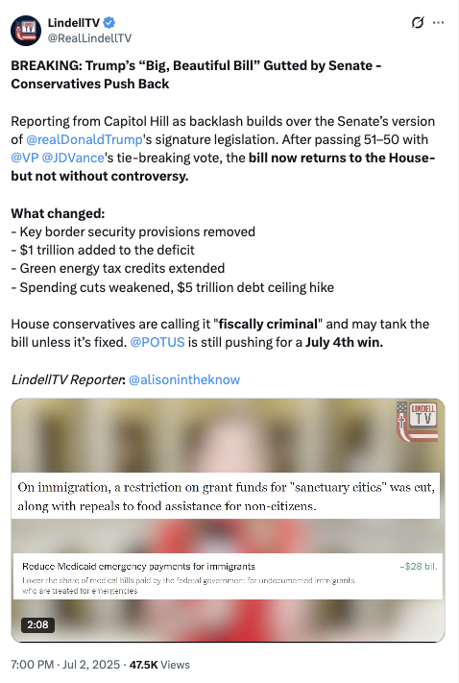
[Twitter, @RealLindellTV, 7/2/25]

The “One Big Beautiful Bill” Cut Inflation Reduction Act Clean Energy Tax Credits And Made It Harder For Projects To Qualify For Clean Energy Tax Credits
The Republican Reconciliation Bill Restricted The Ability Of Projects To Qualify For Certain Inflation Reduction Act Clean Energy Tax Credits And Repealed Electric Vehicle Tax Credits. According to Utility Dive, "The bill restricts the ability of projects to qualify for the tech-neutral clean electricity 45Y production tax credit and 48E investment tax credit, shortens the timeline for those credits, and ends the 25D residential solar credit after this year. The 25E, 30D, 30C and 45W electric vehicle credits will terminate after Sept. 30. While clean energy advocates and congressional Democrats maintain that the final version of the bill goes too far in slashing IRA credits, some Republicans wanted to see more significant cuts." [Utility Dive, 7/3/25]
- The Final Republican Reconciliation Bill Allowed Projects To Avoid A Requirement That They Be In Service By 2027 To Qualify For Certain Credits If They Began Construction Within A Year Of The Bill Being Signed. According to Utility Dive, "Before the House Freedom Caucus reached an agreement with House leadership to vote in favor of the bill, the caucus circulated a memo that criticized the Senate’s version of the bill for offering an exemption from the House’s onerous requirement that clean energy projects be placed in service by 2027 to qualify for the 45Y and 48E credits. The Senate version allows projects to avoid this requirement if they begin construction within a year after the bill is signed into law." [Utility Dive, 7/3/25]
The House Republican Budget Bill Included Cuts To Federal Tax Credits For Wind, Solar, Storage, And Other Clean Energy Projects. According to Utility Dive, "House Republicans on Thursday morning narrowly passed a sweeping budget bill that guts federal support for wind, solar, storage and other clean energy industries. The bill terminates most technology-neutral clean energy tax credits for projects placed in service after 2028 and those that begin construction more than 60 days after the bill’s passage. It also tightens restrictions on foreign entities’ involvement in projects, creating a ‘truly untenable’ situation for developers, Jefferies analysts said Thursday. Nuclear projects have more time to qualify for the credit." [Utility Dive, 6/3/25]
- One Trade Association CEO Said The Bill Would Weaken Power Systems, Send Shockwaves Through The U.S. Economy, And Kill Tens Of Thousands Of Jobs. According to Utility Dive, "The House bill ‘abruptly dismantles bipartisan, long-standing tax policy that has catalyzed billions in private investment for affordable, reliable energy while sparking a rebirth of manufacturing across America,’ AEU President and CEO Heather O’Neill said. ‘If enacted as written, this bill will weaken our power system and send shockwaves throughout the U.S. economy by raising electricity prices, killing tens of thousands of jobs and ceding energy dominance to China.’" [Utility Dive, 5/22/25]

The “One Big Beautiful Bill” Provided A Tax Breaks To Wealthy Individuals And Large Corporations
HEADLINE: “By The Numbers: Harmful Republican Megabill Favors The Wealthy And Leaves Millions Of Working Families Behind” [Center On Budget And Policy Priorities, 8/1/25]
The “One Big Beautiful Bill” Provided A Tax Breaks To Wealthy Individuals And Large Corporations, And Raised Costs For Working Class Families. According to the Center on Budget and Policy Priorities, “The harmful Republican megabill gives huge tax breaks to wealthy individuals, businesses, and large corporations while leaving behind or raising costs for millions of working families.” [Center On Budget And Policy Priorities, 8/1/25]

Energy Innovation Predicted the Bill Would Kill 23,000 Clean Energy Jobs In Minnesota After The Clean Energy Industry Grew Two Times Faster Than The State’s Workforce In 2024
2025: Energy Innovation Predicted The Republican Budget Bill Would “Kill Nearly 23,000 Minnesota Jobs, Slash State Gross Domestic Product By $22 Billion, And Raise Household Energy Bills By $2.7 Billion” Over The Next Decade. According to the Minnesota Reformer, “The $4 trillion GOP budget bill that squeaked through the U.S. Senate this week yesterday would ‘help usher in a golden age for American workers, farmers and families,’ according to House Ways and Means Committee Chair Jason Smith, R-Missouri. One nonpartisan think tank disagrees, strongly. Energy Innovation says the bill will kill nearly 23,000 Minnesota jobs, slash state gross domestic product by $22 billion and raise household energy bills by $2.7 billion — a 28% increase — over the next decade.” [Minnesota Reformer, 7/3/25]
2024: Minnesota Added Nearly 1,700 Clean Energy Jobs, Growing The Clean Energy Industry Two Times Faster Than The State’s Total Workforce. According to MPR News, “A new report says Minnesota added nearly 1,700 clean energy jobs last year, outpacing the overall state economy — although federal policy shifts could mean a slowdown is ahead. Clean Energy Economy Minnesota, an industry-led nonprofit, annually estimates the number of people working in clean energy fields, including solar and wind energy, electric vehicle manufacturing and energy efficiency. Its latest report released Wednesday estimates that number grew to almost 64,000 in 2024, a 2.6 percent increase from the previous year. Jobs in clean energy-related fields grew more than two times faster than the state's total workforce. However, the report doesn’t reflect the effects of President Donald Trump’s tax and spending act, which Congress passed in July. It ended some tax credits for clean energy projects on Dec. 31.” [MPR News, 10/15/25]

