Overview
In April 2025, Demuth refused to acknowledge Trump’s tariffs, which doomed Minnesotans to a trade war and rising prices. Since Canada, Mexico, and China were Minnesota’s largest trading partners, tariffs impacted the state’s agricultural industry, oil imports, and the ore industry.
In December 2025, Demuth denied claims that Trump’s tariffs made Minnesota less affordable, even though the U.S. stock market crashed due to Trump’s escalating global trade war earlier in the year.

Demuth Dodged Questions On Trump’s Tariffs And Dismissed The Harm They Caused To Minnesota’s Economy

Demuth Dodged Tariff Questions And Dismissed The Economic Impacts Of Tariffs Even Though The Stock Market Crashed

Demuth Dodged Questions On Tariffs And Dismissed The Impact Of Trump’s Tariffs On Affordability
April 2025: Demuth Avoided Questions About Tariffs And Said “State Lawmakers Should Remain Focused On Factors They Can Control And ‘What Is Known At This Time.’” According to Axios, “GOP state legislative leaders avoided weighing in directly on the issue Wednesday when asked about tariffs after a meeting with the governor. House Speaker Lisa Demuth (R-Cold Spring) said while Republicans plan to ‘keep an eye on what's happening at the federal level,’ state lawmakers should remain focused on factors they can control and ‘what is known at this time.’” [Axios, 4/4/25]
December 2025: Demuth Denied Walz’s Claims That Trump’s Tariffs Made Minnesota Less Affordable, And Said It Was Instead Due To Tax Increases. According to Demuth’s Twitter, “Governor Walz - Minnesota is less affordable because of the last seven years that you’ve been governor. Property taxes increased by $1B this year because of DFL mandates. Car registration fees skyrocketed under DFL policies. You spent an $18B surplus, and added $10B in new taxes and fees and still managed to put Minnesota into a defict. Last year, after we ended the DFL’s monopoly on the legislature, you still wanted to balance the budget on the backs of hard working Minnesotans by increasing taxes even more. That’s why we drew a line in the sand and said no more. Because House Republicans stood firm, we delivered the largest budget reduction in the history of the state with nothing more than a 67-67 tied house. We protected nonpublic schools from your attempt to defund mental health and other supports. And we ended taxpayer funding of free health care for adult illegal immigrants. We cannot afford any more Tim Walz budgets. Speaker of the House Lisa Demuth”
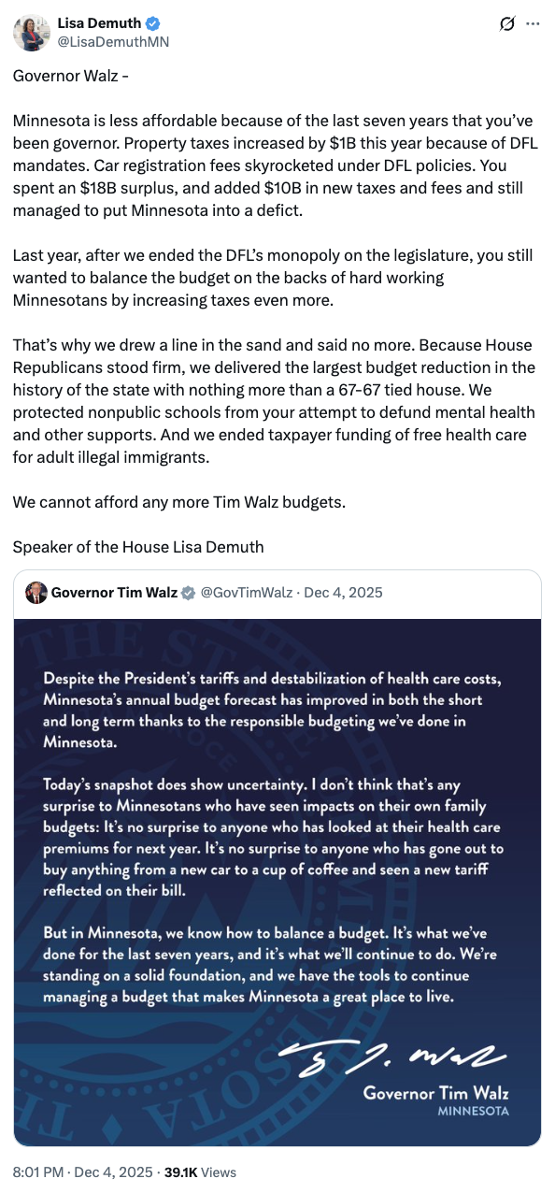
[Twitter, @LisaDemuthMN, 12/4/25]
April 2-4, 2025: The U.S. Stock Market Crashed As Trump’s Tariffs “Escalated A Global Trade War And Wiped Out Trillions Of Dollars In Value.” According to NPR, “Wall Street plummeted for a second straight day on Friday, as President Trump's tariffs escalated a global trade war and wiped out trillions of dollars in value from the U.S. stock market. The two-day selloff served as the financial community's most brutal warning yet about the potential fallout of Trump's trade policy. Investors, businesses, and consumers are all expressing mounting terror about how these sweeping new taxes could upend the global economy.” [NPR, 4/4/25]

Trump’s Tariffs Impacted Minnesota Families And The State’s Agricultural Industry, Oil imports, and The Ore industry
April 2025: Gas Prices In Minnesota Rose Five Percent Due To Canadian Tariffs. According to The Minnesota Star Tribune, “Minnesota and many Midwest states depend on Canadian oil for gasoline. Gas prices have risen 5% in Minnesota since Canadian tariffs started in March following an initial pause, according to GasBuddy.” [Minnesota Star Tribune, 4/9/25]
Canadian Tariffs Impacted Minnesota’s Imported Products Like Oil And Oats, As Well As The State’s Ore Industry. According to The Minnesota Star Tribune, “Most of the oil refined into gasoline in Minnesota comes from Canada, the state’s largest trading partner. General Mills sources many of its oats for the nation’s top-selling cereal, Cheerios, from the country. And companies involved in the auto industry have a strong relationship with Canadian firms, as does the Iron Range ore industry.” [Minnesota Star Tribune, 4/9/25]
2023: Minnesota Imported $14.1 Billion, $3.3 Billion, And $6 Billion In Goods From Canada, Mexico, And China, Respectively. According to The Minnesota Star Tribune, “Canada and Mexico are Minnesota’s top trading partners, with China third. Combined, the state imports far more than it exports to those countries. In 2023, Minnesota imported $14.1 billion worth of goods from Canada and exported $7 billion, according to census data. Oil is the largest share of Canadian imports. The state imported $3.3 billion from Mexico, roughly the same level as Minnesota exported to the country in 2023. Minnesota’s annual imports from China through November 2024 reached $6 billion. The state exported $2.4 billion to China in 2023.” [Minnesota Star Tribune, 4/9/25]
- 2023: Minnesota Exported $7 Billion, $3.3 Billion, And $2.4 Billion In Goods To Canada, Mexico, And China, Respectively. According to The Minnesota Star Tribune, “Canada and Mexico are Minnesota’s top trading partners, with China third. Combined, the state imports far more than it exports to those countries. In 2023, Minnesota imported $14.1 billion worth of goods from Canada and exported $7 billion, according to census data. Oil is the largest share of Canadian imports. The state imported $3.3 billion from Mexico, roughly the same level as Minnesota exported to the country in 2023. Minnesota’s annual imports from China through November 2024 reached $6 billion. The state exported $2.4 billion to China in 2023.” [Minnesota Star Tribune, 4/9/25]
As Of September 2025, China Booked Zero Shipments Of American Soybeans, Down From More Than 12 Million Tons In 2024, Which Helped Minnesota Generate More Than $3.2 Billion In Agricultural Sales That Year. According to The Minnesota Star Tribune, “Historically, Minnesota sends two out of every three rows of soybeans overseas, typically to feed livestock. China has often bought the bulk of those exports. As of early September, Chinese buyers have yet to book any shipments of American soybeans from the upcoming harvest. That’s a far cry from the 12 million to 13 million tons they’d booked by this time last year, traders told Reuters this week. […] Soybeans earned Minnesota more than $3.2 billion in agricultural sales in 2024, according to the Department of Agriculture.” [Minnesota Star Tribune, 9/11/25]

