Overview
In 2025, Demuth supported Trump’s “One Big Beautiful Bill,” which made the largest cut to SNAP in history. Demuth also supported Trump’s efforts to reverify SNAP recipients’ eligibility to root out ineligible individuals from the program. In Minnesota, more than 186,000 households relied on SNAP to afford groceries.

Demuth Supporting Stripping SNAP Benefits From Minnesotans And Making Food More Expensive

Demuth Supported The House Republican Reconciliation Bill That Cut Snap Benefits For Millions

July 2025: Demuth Supported The Final Version Of The “One Big Beautiful Bill,” Which Contained The Largest SNAP Cut In History
July 2025: Demuth Supported The “One Big Beautiful Bill,” Saying It Benefitted Minnesotans. According to MinnPost, “Demuth and Rep. Harry Niska, R-Ramsey and the GOP floor leader, provided a joint statement that concluded, ‘On balance, this bill appears to benefit Minnesotans.’ ‘While we’re still looking at the broader impacts of the bill, there are a lot of great policies included for Minnesotans including extending low and middle-income tax cuts and reducing the federal tax on tips and overtime so people can keep more of their hard-earned money, increasing the child tax credit, and implementing requirements that ensure that those on Medicaid who are single and able to work are doing so,’ Demuth and Niska state.” [MinnPost, 7/21/25]
- HEADLINE: "Trump’s ‘Big Beautiful Bill’ Cuts Food Stamps For Millions — The Average Family May Lose $146 Per Month, Report Finds" [CNBC, 7/10/25]
- The GOP Reconciliation Bill Would Cut SNAP Funding By $186 Billion, Which CBPP Said Constituted The “Largest Cut To SNAP In History.” According to the Center on Budget and Policy Priorities, “The Senate Republican leadership’s reconciliation bill would dramatically raise costs and reduce food assistance for millions of people by cutting federal funding for the Supplemental Nutrition Assistance Program (SNAP) by $186 billion through 2034, according to the Congressional Budget Office (CBO), about 20 percent — the largest cut to SNAP in history. These cuts would increase poverty, food insecurity, and hunger, including among children. The so-called ‘Big Beautiful Bill’ is anything but beautiful; it would cause widespread harm by making massive cuts to Medicaid and SNAP, which would raise costs on families and make it much harder for them to afford the high cost of health care and groceries.” [Center On Budget And Policy Priorities, 6/30/25]
- 22.3 Million Families Would Lose Some Or All Of Their SNAP Benefits, With 5.3 Million Families Losing More Than $25 In Benefits Per Month, And Of Those Families, The Average Loss In Benefits Would Be $146. According to the Urban Institute, “Our preliminary estimates of the SNAP policies in the Senate bill show the following: 22.3 million US families would be affected, losing some or all of their SNAP benefits. Of the total affected families, 5.3 million would lose at least $25 in SNAP benefits per month. Among these families, 3.3 million are families with children, 3.5 million are working families, and 1.7 million are families with a full-time full-year worker. Families losing at least $25 per month would lose $146 per month on average ($1,752 for a full-year recipient). At the state level, average monthly benefit losses for families losing at least $25 per month would range from $72 in Kansas ($864 annually) to $231 in the District of Columbia ($2,772 annually).” [Urban Institute, 7/2/25]
- States That Could Not Afford To Pay The New Mandated SNAP Cost Shares May Cut The Program Entirely. According to CNBC, “Additionally, the legislation requires states to pay for a portion of benefit costs, ranging from 5% to 15%, if their payment error rate is at or over 6%. The error rates measure the accuracy of states’ eligibility and benefit payments. In fiscal year 2024, states had a 10.9% average payment error rate, with many states over 6%, according to the Department of Agriculture. States that can’t pay those shares may have to cut SNAP benefits or opt out of the program entirely, according to the Center on Budget and Policy Priorities.” [CNBC, 7/10/25]

Demuth Supported Trump’s Efforts To Review SNAP Recipients’ Eligibility And Remove people From The Program
December 2025: Demuth Criticized Minnesota Attorney General Keith Ellison For Filing A Lawsuit Against The Trump Administration’s Efforts To Review The Eligibility Of SNAP Recipients And Remove People From The Program. According to Demuth’s Twitter, “Why is @keithellison filing a lawsuit to stop @SecRollins & the @USDA from verifying eligibility of SNAP recipients & removing ineligible individuals from the program? Quote Attorney General Keith Ellison @AGEllison Once again, the Trump Administration is threatening to let the needy go hungry. Donald Trump is doing whatever he can to keep vulnerable people hungry and scheming new ways to punish the states that want to keep them fed.”
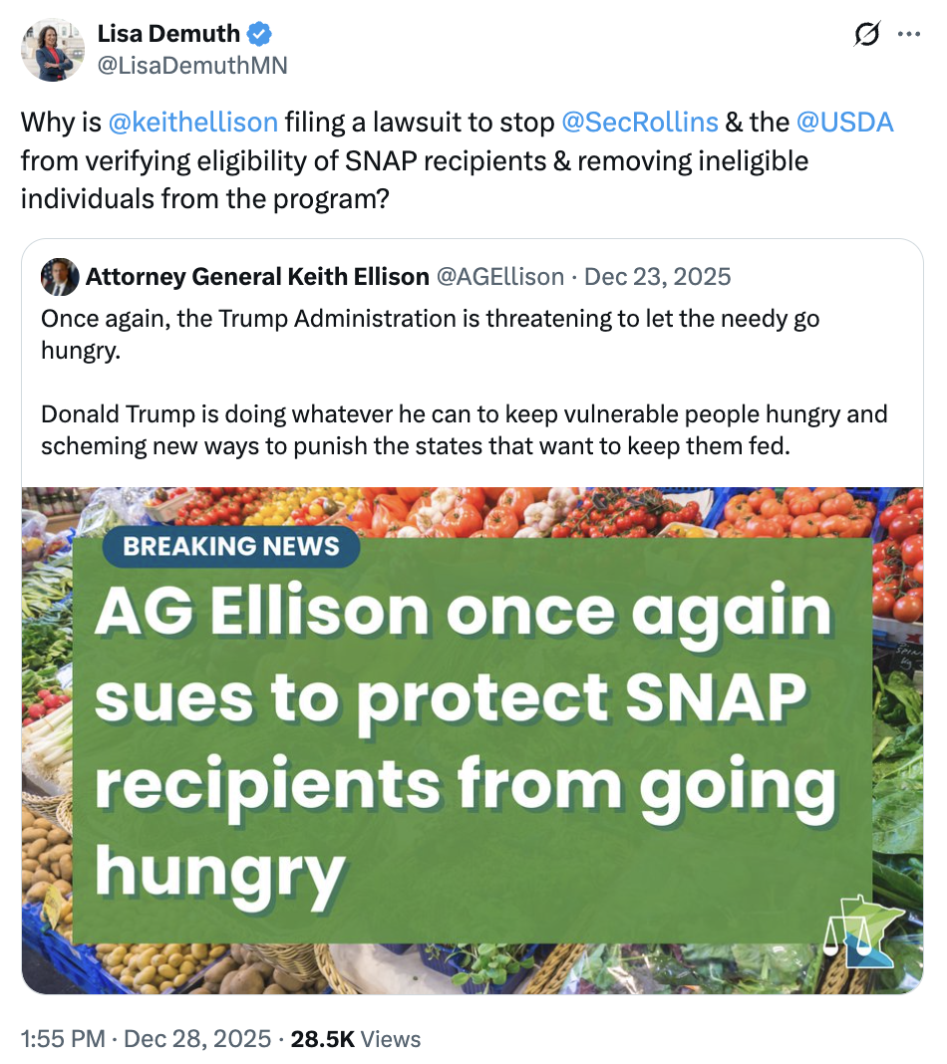
[Twitter, @LisaDemuthMN, 12/28/25]

186,237 Households In Minnesota Relied On SNAP
2023: Across Minnesota, 186,237 Households Relied On SNAP.
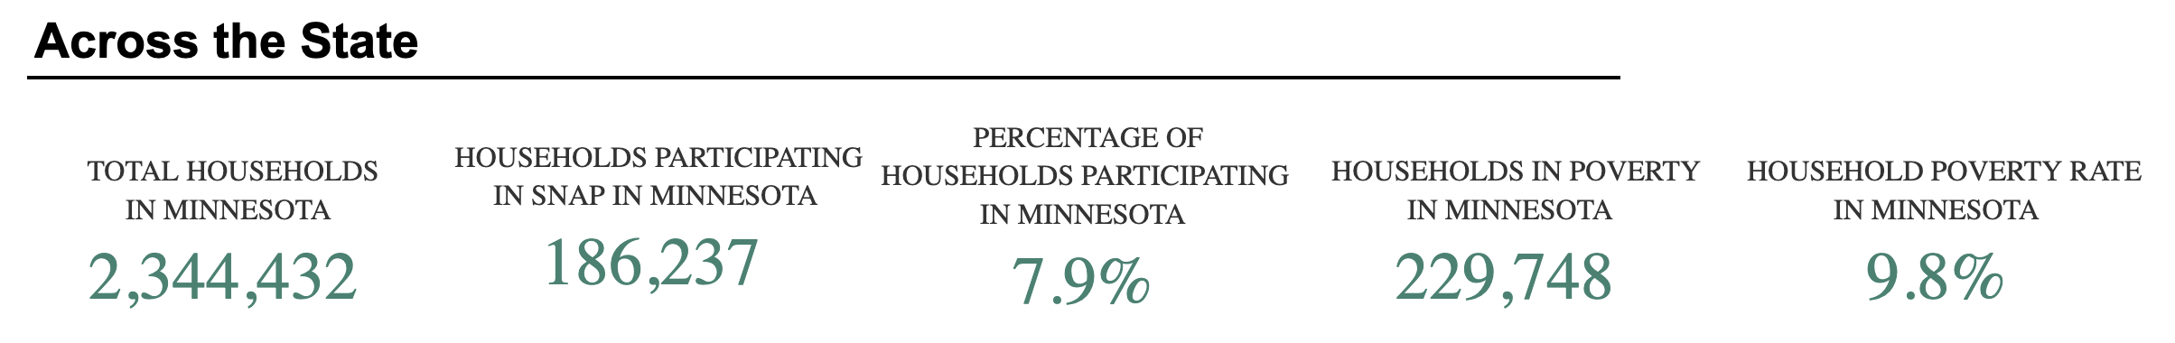
[U.S. Department of Agriculture, SNAP Community Characteristics, Accessed 1/12/26]

