Overview
In 2025, Demuth supported Trump’s “One Big Beautiful Bill,” which was estimated to kick 17 million Americans off their health insurance, including nearly 12 million Americans who rely on Medicaid. More than 161,000 Minnesotans could lose their health insurance as a result of the bill.
Demuth opposed the Affordable Care Act and said she wanted to “overhaul” Minnesota’s health care system and return to “what was working before the Affordable Care Act.” More than 151,000 Minnesotans were enrolled in Affordable Care Act Marketplace health insurance plans. Demuth said Medicaid work requirements would benefit Minnesotans, even though more than 108,000 Medicaid recipients in Minnesota were expected to lose their coverage by 2034 due to Trump’s tax bill.

Demuth Supported Trump’s “One Big Beautiful Bill,” Which Stripped Health Insurance Away From Millions Of Americans Who Relied On Medicaid

Demuth Supported The “One Big Beautiful Bill,” Which Included Devastating Health Care Cuts To Fund Tax Cuts For The Wealthy

July 2025: Demuth Supported The “One Big Beautiful Bill,” Which Would Cause 17 Million Americans To Lose Their Health Care
July 2025: Demuth Supported The “One Big Beautiful Bill,” Saying It Benefitted Minnesotans. According to MinnPost, “Demuth and Rep. Harry Niska, R-Ramsey and the GOP floor leader, provided a joint statement that concluded, ‘On balance, this bill appears to benefit Minnesotans.’ ‘While we’re still looking at the broader impacts of the bill, there are a lot of great policies included for Minnesotans including extending low and middle-income tax cuts and reducing the federal tax on tips and overtime so people can keep more of their hard-earned money, increasing the child tax credit, and implementing requirements that ensure that those on Medicaid who are single and able to work are doing so,’ Demuth and Niska state.” [MinnPost, 7/21/25]
- Demuth Praised The Bill For “Extending Low And Middle-Income Tax Cuts” And Implementing Medicaid Work Requirements. According to MinnPost, “Demuth and Rep. Harry Niska, R-Ramsey and the GOP floor leader, provided a joint statement that concluded, ‘On balance, this bill appears to benefit Minnesotans.’ ‘While we’re still looking at the broader impacts of the bill, there are a lot of great policies included for Minnesotans including extending low and middle-income tax cuts and reducing the federal tax on tips and overtime so people can keep more of their hard-earned money, increasing the child tax credit, and implementing requirements that ensure that those on Medicaid who are single and able to work are doing so,’ Demuth and Niska state.” [MinnPost, 7/21/25]
- HEADLINE: "At Least 17 Million Americans Would Lose Insurance Under Trump Plan" [Washington Post, 7/1/25]
- HEADLINE: “By The Numbers: Harmful Republican Megabill Favors The Wealthy And Leaves Millions Of Working Families Behind” [Center On Budget And Policy Priorities, 8/1/25]
- The Congressional Budget Office Estimated That 11.8 Million People Would Become Uninsured As A Result Of The Medicaid Cuts In Republicans’ Reconciliation Bill. According to the Washington Post, "The bill, which narrowly passed the Senate on Tuesday and now heads back to the House, would effectively accomplish what Republicans have long failed to do: unwind many of the key components of the ACA, President Barack Obama’s signature domestic achievement, which dramatically increased the number of Americans with access to health insurance. To start, the Congressional Budget Office estimated that the Senate version of the bill would result in 11.8 million more uninsured in 2034, mostly because of Medicaid cuts, compared with 10.9 million if the House version became law." [Washington Post, 7/1/25]
- The Bill’s $50 Billion In Rural Hospital Relief Funding Would Not Come Close To The Gap Created By Medicaid Cuts, With 300 Rural Hospitals At “Immediate Risk” Of Closure. According to the Center For American Progress, “The OBBBA includes $50 billion in relief funding for rural hospitals over a five-year period to help reduce the disastrous impacts of the bill’s roughly $1 trillion in Medicaid cuts. As of May 2025, there were approximately 2,086 rural hospitals receiving $12.2 billion a year in net revenue from Medicaid. At the median, rural hospitals’ revenue from Medicaid is $3.9 million a year.Rural hospitals have some of the lowest operating margins in the nation, especially compared with urban hospitals, meaning that any reductions in revenue could lead to closures. The average operating margin for rural hospitals was 3.1 percent in 2023, with 44 percent of rural hospitals operating with negative margins. As a result, more than 300 rural hospitals are currently at ‘immediate risk’ of closure, especially now that the OBBBA is projected to cut Medicaid spending by $1.02 trillion. The relief fund designed to blunt the negative impacts caused by the bill would not come close to filling that gap. If every rural hospital in the country received an even share of the $50 billion in relief support, it would amount to only $4.5 million every year for five years. At the close of those five years, that funding would disappear altogether.” [Center For American Progress, 7/3/25]

More Than 161,000 Minnesotans Were Expected To Lose Health Care Coverage Under Trump’s “One Big Beautiful Bill”
Under The “One Big Beautiful Bill,” 161,247 Minnesotans Were Expected To Lose Their Health Care By 2034, Including 53,200 ACA Enrollees And 108,047 Medicaid Recipients. According to the Joint Economic Committee Minority,
District | State | Est. # Losing ACA Coverage | Est. # Losing Medicaid Coverage | Est. Total # Losing Insurance
MN-01 | Minnesota | 7,100 | 12,517 | 19,617
MN-02 | Minnesota | 5,100 | 10,263 | 15,363
MN-03 | Minnesota | 5,500 | 10,290 | 15,790
MN-04 | Minnesota | 6,300 | 15,959 | 22,259
MN-05 | Minnesota | 8,300 | 15,188 | 23,488
MN-06 | Minnesota | 6,300 | 12,994 | 19,294
MN-07 | Minnesota | 7,900 | 15,298 | 23,198
MN-08 | Minnesota | 6,700 | 15,538 | 22,238
All | Totals | 53,200 | 108,047 | 161,247

[Joint Economic Committee Minority, 6/25]

The “One Big Beautiful Bill” And The Expiring Affordable Care Act Tax Credits Would Result In 179,000 Additional Uninsured Minnesotans By 2034
The “One Big Beautiful Bill” And The Expiring Affordable Care Act Tax Credits Would Result In 179,000 Additional Uninsured Minnesotans By 2034. According to the Center For American Progress, “The One Big Beautiful Bill Act will increase the number of Americans without health coverage in every state Estimated increase in the uninsured population due to the OBBBA and the expiration of the ACA’s enhanced premium tax credits, 2034”
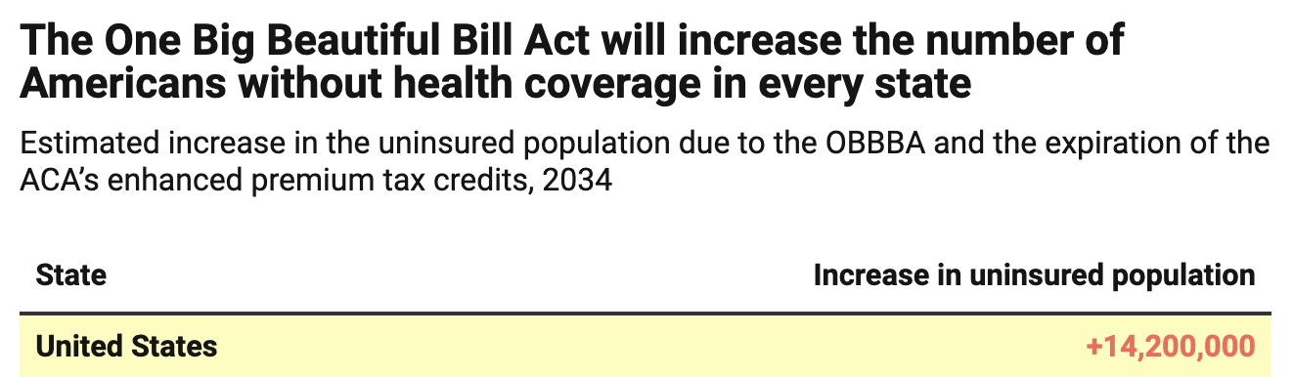
[Center For American Progress, 9/5/25]

Demuth Wanted To Return Minnesota’s Health Care System To “Before The Affordable Care Act” And Supported Medicaid Work Requirements

Demuth Wanted To Return Minnesota’s Health Care System To “Before The Affordable Care Act”
October 2018: Demuth Wanted To Completely “Overhaul” Minnesota’s Health Care System To “What Was Working Before The Affordable Care Act.” According to the St. Cloud Times, “Demuth would like a ‘complete overhaul of our current system,’ she said Friday. She would look at what was working before the Affordable Care Act and try to revive the Minnesota programs that worked.” [St. Cloud Times, 10/21/18]

Demuth Praised The “One Big Beautiful Bill’s” Medicaid Work Requirements
Demuth Praised The “One Big Beautiful Bill” For “Implementing Requirements That Ensure That Those On Medicaid Who Are Single And Able To Work Are Doing So.” According to MinnPost, “Demuth and Rep. Harry Niska, R-Ramsey and the GOP floor leader, provided a joint statement that concluded, ‘On balance, this bill appears to benefit Minnesotans.’ ‘While we’re still looking at the broader impacts of the bill, there are a lot of great policies included for Minnesotans including extending low and middle-income tax cuts and reducing the federal tax on tips and overtime so people can keep more of their hard-earned money, increasing the child tax credit, and implementing requirements that ensure that those on Medicaid who are single and able to work are doing so,’ Demuth and Niska state.” [MinnPost, 7/21/25]

2025: There Were 151,512 Minnesotans Enrolled In An Affordable Care Act Marketplace Plan
2025: There Were 151,512 Individuals Enrolled In An Affordable Care Act Marketplace Plan In Minnesota. According to KFF, in 2025, there were 151,512 individuals enrolled in affordable care act marketplace plan in Minnesota.
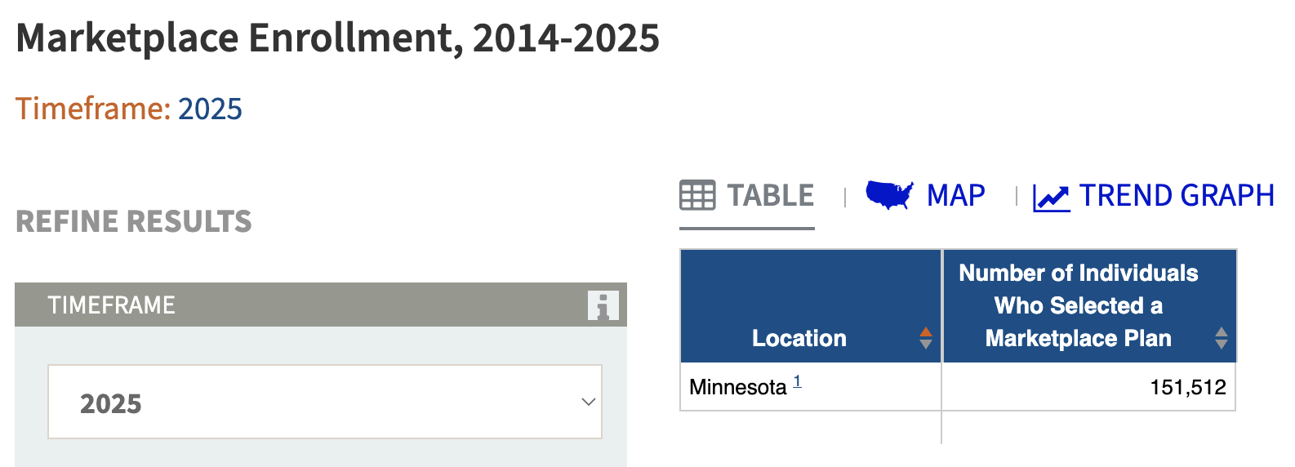
[KFF, Accessed 1/14/26]

Under The “One Big Beautiful Bill,” 108,047 Medicaid Recipients In Minnesota Were Expected To Lose Their Health Care By 2034
Under The “One Big Beautiful Bill,” 161,247 Minnesotans Were Expected To Lose Their Health Care By 2034, Including 53,200 ACA Enrollees And 108,047 Medicaid Recipients. [Joint Economic Committee Minority, 6/25]

The Affordable Care Act Allowed States To Expand Medicaid, Which Dramatically Lowered The Uninsured Rate Among Low-Income Workers
The Affordable Care Act Allowed States To Expand Medicaid, And States That Expanded Medicaid Dramatically Lowered The Number Of People Without Health Insurance. According to the Center on Budget and Policy Priorities, "The Affordable Care Act (ACA) permits states to expand Medicaid coverage to adults with incomes up to 138 percent of the poverty level (about $20,780 annually for an individual or $35,630 for a family of three). States that have adopted the expansion have dramatically lowered their uninsured rates. Extensive research finds that the people who gained coverage have grown healthier and more financially secure, while long-standing racial inequities in health outcomes, coverage, and access to care have shrunk." [Center On Budget And Policy Priorities, 6/14/24]
- The Uninsured Rate Among Low-Income Workers Fell From 38 Percent In 2013 To 17 Percent In 2022, Which Coincided With Implementation Of Medicaid Expansion. According to the Center on Budget and Policy Priorities, "Millions of workers have gained coverage through Medicaid expansion, including people working in industries that provide critical goods and services such as health care, transportation, grocery stores, food manufacturers, and child care. Many have no access to health coverage through their jobs. In expansion states, the uninsured rate among low-income workers fell from 38 percent in 2013 to 17 percent in 2022; this sharp decline coincided with a large increase in the share of low-income workers enrolled in Medicaid.[16] In non-expansion states, the uninsured rate among low-income workers fell much less, from 46 percent to 31 percent. (See Figure 3.)" [Center On Budget And Policy Priorities, 6/14/24]

