Overview
In 2025, Demuth claimed she helped provide information to conservative YouTuber Nick Shirley for his video exposing alleged day care fraud in Minnesota. Shirley repeatedly denied working with Demuth, saying he had “no idea who this lady is,” and accusing her of “clout chasing” to boost her campaign.
In his video, Shirley, a self-proclaimed “journalist” who previously paid Hispanic migrants to protest outside the White House, claimed many of the day care facilities he visited were committing fraud because there were no children inside. In reality, one of the centers was closed when Shirley arrived, two were non-operational, and another had security footage showing children were present, contrary to Shirley’s claims. Additionally, five of the facilities he visited had already been investigated for fraud and cleared of any wrongdoing. Shirley’s also video featured David Hoch as the main source, a right-wing lobbyist who said every Somali in Minnesota was “engaged in fraud,” and called the Somali community “demon Muslims.”

Demuth Lied About Helping YouTuber Nick Shirley Create A Video Exposing Day Care Fraud, Which Was Fraught With Misinformation And Non-Credible Sources

Demuth Claimed Her Staff And The Republican Caucus Helped Compile Information For Nick Shirley’s Video, A Conservative Youtuber, Exposing Alleged Day Care Fraud In Minnesota
December 2025: Demuth Claimed Her Caucus Worked With Nick Shirley, A Conservative YouTuber, To Expose Fraud In Minnesota Day Care Facilities. According to The Hill, “Minnesota House Speaker Lisa Demuth (R) said Monday that her caucus pointed conservative YouTuber Nick Shirley in the direction of day care facilities in the state amid concerns over fraud. Demuth said at a virtual press conference that the state GOP has been ‘working with’ Shirley to address fraud in the state. ‘Our caucus has been working to expose fraud for years, including working with Nick Shirley and agency whistleblowers to get the information out to the public and to hold the Walz administration accountable,’ she said, referring to Democratic Gov. Tim Walz. State Rep. Ryan Niska (R) clarified later in the press conference that staffers within the caucus provided information to a man identified in Shirley’s video as David.” [The Hill, 12/31/25]
January 2026: Demuth Said Her Staff Helped Compile Some Of The Information Used In Shirley’s Video On Alleged Day Care Fraud, And Said She Would Continue To Share Public Information “With Anyone […] Who Is Interested In Helping To Expose Fraud.” According to Demuth’s Twitter, “While I appreciate the DFL attacking me as they try to deflect attention from Walz’s fraud scandal, @nickshirleyy deserves all the credit for shining a nationwide spotlight on this issue. Some of the information used in Nick's video was compiled by our staff, whose emails and work were referenced multiple times in the video. It’s public information we have shared and will continue to share with anyone - media or citizen journalists alike - who is interested in helping to expose fraud.”
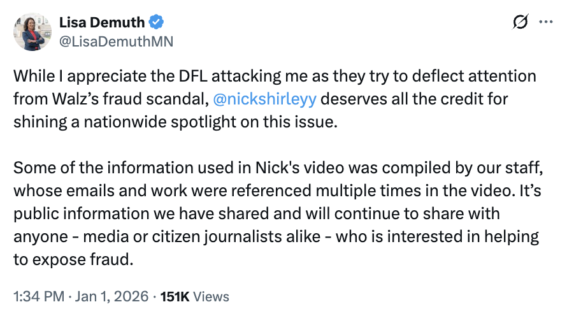
[Twitter, @LisaDemuthMN, 1/1/26]

Shirley Repeatedly Denied Working With Demuth, Accusing Her Of “Clout Chasing” And “Lying To Make Herself Look Good For Her Campaign”
January 2026: Shirley Denied Working With Demuth, Saying “I Have No Idea Who This Lady Is, She Is Lying To Make Herself Look Good For Her Campaign.” According to Shirley’s Twitter, “BREAKING: @MPRnews reports that Minnesota House GOP leader Lisa Demuth acknowledged the Repubican Party’s involvement in @nickshirleyy viral daycare video, saying, ‘We worked with Nick Shirley on this.’ That matters, because the video has been widely framed as independent citizen journalism. Minnesota officials have said fraud investigations were already underway long before the video, and inspections have not backed up many of the claims made about the specific daycare centers shown. Still, the video fueled widespread outrage and targeted scrutiny of Somali-owned childcare providers. With a top Republican now on record confirming coordination, this reframes the entire narrative. This wasn’t just a lone YouTuber uncovering something new. A political party acknowledges involvement in producing or shaping media that went viral (not organically) and helped drive public backlash. Nick shirley @nickshirleyy This is completely false. I have no idea who this lady is, she is lying to make herself look good for her campaign. Shame on her!”
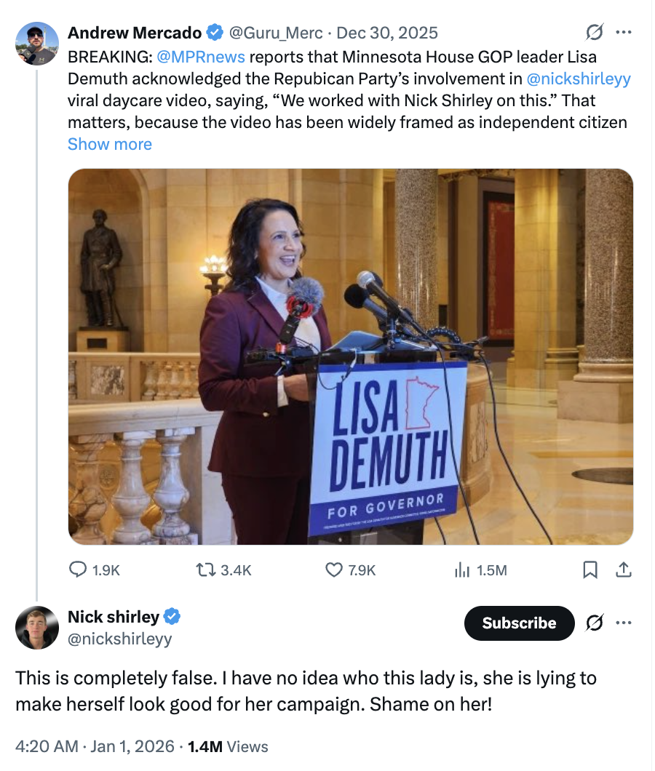
[Twitter, @nickshirleyy, 1/1/26]
January 2026: Shirley Accused Demuth Of “Clout Chasing” And Noted That Demuth Did Not Appear In His Video. According to Shirley’s Twitter, “Lisa Demuth, GOP candidate for MN Governor, bragged that she used her position as Speaker to collaborate with a YouTube conspiracy theorist and spread disinformation that would help her campaign. Nick shirley @nickshirleyyThis is completely false I have no idea who she is and she doesn’t appear in the video I made. Shes clout chasing for whatever her political motive is.”
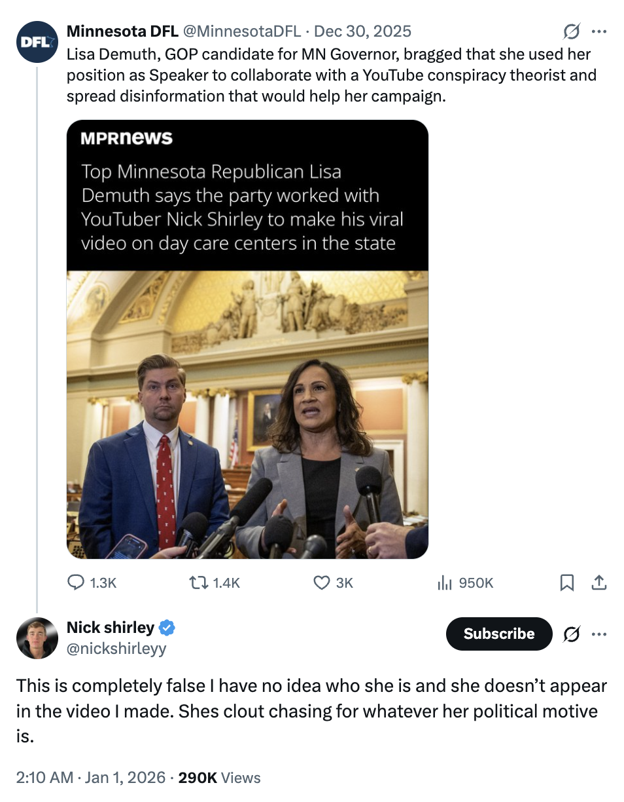
[Twitter, @nickshirleyy, 1/1/26]

Shirley Said He Had “No Prior Knowledge About” Demuth
January 2026: Shirley Told Demuth He “Had No Prior Knowledge About You Or Your Stuff.” According to Shirley’s Twitter, “The media and others have become so against fraud and people who speak out they are trying anyway to deflect from the situation. I was taken back when I saw the articles from the Fraud Supporting Media yesterday, I had no prior knowledge about you or your stuff but THANK YOU for making the information public so David and I could expose the fraud on a national level. Best of luck in your election, I hope it’s fair and Tim lears his listen!”
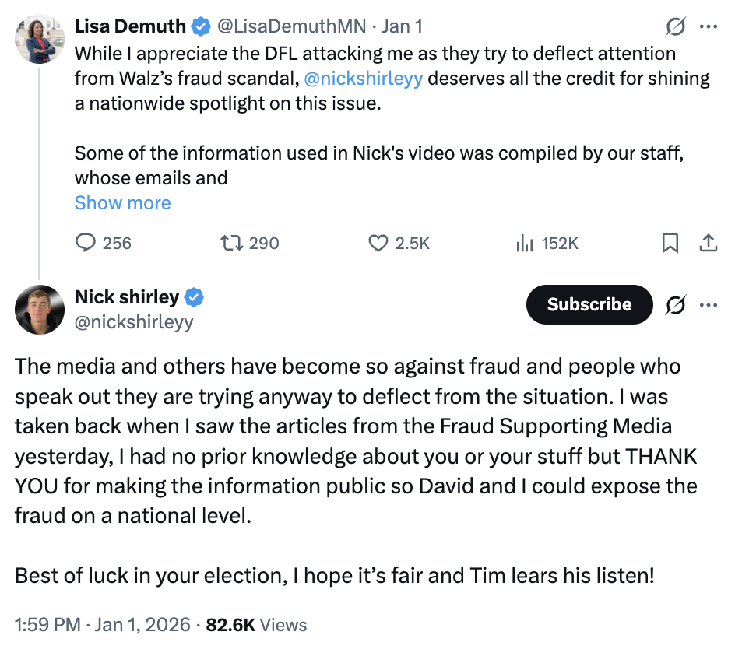
[Twitter, @nickshirleyy, 1/1/26]

Shirley’s Video Used Misleading Footage, Falsely Claiming There Were No Children Inside Day Care Facilities, And Did Not Prove That Any Of The Day Cares He Visited Committed Fraud

Some Day Care Facilities Shirley Visited Were Closed, Non-Operational, Or Had Proof That Children Were Inside Despite Shirley Falsely Claiming There Were None
Shirley’s Video Featured A Day Care Center That Was Closed When He Arrived, Two Non-Operational Facilities, And A Day Care Facility That Had Security Footage Of Children Being Dropped Off The Same Day Shirley Claimed That No Children Were Inside. According to Weaponized, “Shirley‘s video has now been pretty thoroughly taken apart by numerous news organizations, and many of his core claims have been debunked or at least called into serious doubt. In one case, Shirley arrived when the facility was closed. In another instance, security footage from the daycare center shows children being dropped off on the same day Shirley was there claiming that no children were anywhere to be seen. In two other cases, Shirley showed up to non-operational child care facilities. While there have been proven and prosecuted cases of fraud in publicly-funded programs in Minnesota, Shirley’s video doesn’t prove that it’s happening at the daycares he went to.” [Weaponized, 1/1/26]

Some Day Care Facilities Shirley Visited Had Already Been Cleared Of Any Wrongdoing In Minnesota’s Nonprofit Fraud Scandal
Five Of The Day Care Centers Featured In Shirley’s Video Had Previously Been Investigated For Fraud And Were Cleared Of Wrongdoing. According to The Daily Beast, “The claims made in the video have been thoroughly discredited, while the story itself is at least five years old. Five of the centers Shirley visited have previously been the subject of federal investigation into fraudulent benefit claims and cleared of wrongdoing, while dozens of individuals were otherwise convicted.” [Daily Beast, 1/2/26]
Five The Of The Day Care Centers Shirley Visited Received Funds From Feeding Our Future, The Nonprofit At The Center Of A Minnesota Fraud Scandal, But None Were Accusing Of Wrongdoing. According to The Minnesota Star Tribune, “Five of the 10 child care businesses Shirley featured in his video operated as meal sites for Feeding Our Future, the nonprofit at the center of a fraud scandal that has resulted in more than 50 convictions so far. Altogether, those five businesses received nearly $5 million from Feeding Our Future between 2018 and 2021, according to trial evidence. None of the five businesses in Shirley’s video that received funds from Feeding Our Future have been accused of wrongdoing. Prosecutors have also said hundreds of people involved in the fraud may never be charged.” [Minnesota Star Tribune, 12/31/25]

One Day Care Director Refused To Open The Door Because Shirley Was Accompanied By Masked Men
ABC Learning Center Director Ahmed Hasan Said He Did Not Want To Let Shirley And His Associates Inside Because Some Were Masked And Waiting In Vehicles, And Hasan Thought They Might Be ICE Agents. According to The Minnesota Star Tribune, “Shirley also went to ABC Learning Center in south Minneapolis on the same day in mid-December. Director Ahmed Hasan said they’ve had similar visits from other ‘content creators,’ but the others didn’t have enough followers to create the kind of chaos that Shirley did. Hasan said Shirley, a man identified as ‘David’ and a third man came to the front door while five more men waited in a van and car, some of them wearing masks. Hasan said there were children inside, but they weren’t about to let strangers inside, given the recent immigration crackdown. They thought the masked men in the vehicles might be ICE agents.” [Minnesota Star Tribune, 12/31/25]

Shirley And His “Source” In The Video Both Had Posted Right-Wing And Racist Content On Their Social Media

Shirley Previously Paid Hispanic Migrants To Protest Outside The White House In Support Of Joe Biden
2025: Shirley Was A Self-Proclaimed “Journalist” Who Created A Video Showing Hispanic Migrants He Paid 20 Dollars To Protest In Front Of The White House In Support Of Joe Biden. According to The Daily Beast, “The ‘journalist’ at the center of a viral clash over alleged Somalian welfare fraud once paid Hispanic laborers to protest outside the White House in support of President Joe Biden. […] Last year, in a video titled ‘I Took Migrants to Visit Joe Biden,’ Shirley rounded up people in Washington, D.C., loaded them into a van, and brought them to the White House to demand an audience with Joe Biden. He pays them all $20 for their time.” [Daily Beast, 1/2/26]

The Main Source Of Shirley’s Video Made Racist Comments About the Somali Community In Minnesota
The Main Source Of Shirley’s Day Care Fraud Video Was David Hoch, A Right-Wing Lobbyist Who Claimed On Social Media “EVERY Somali In MN Is Engaged In Fraud,” And Referred To The Somali Community As “Demon Muslims.” According to The Intercept, “Shirley’s main source is a lobbyist and one-time right-wing candidate for Minnesota attorney general whose full name is David Hoch. Accounts bearing his name have a long online history posting about the Somali community in Minnesota. A TikTok and a recently deleted Instagram account posted almost exclusively on the subject — including derogatory statements about Somalis and Muslims. ‘EVERY Somali in MN is engaged in fraud. ALL of them,’ Hoch posted on the now-deleted Instagram account. In November, he posted, ‘Even the Blacks have had enough of the demon Muslims.’” [Intercept, 1/3/26]

