Overview
Demuth was an out-of-touch anti-abortion extremist, who equated the presence of a heartbeat to life.
In 2021, as a state lawmaker, Demuth introduced legislation to prohibit “abortions when a fetal heartbeat is detected.”
In 2023, Demuth opposed Minnesota’s PRO Act, which protected reproductive rights under state law. Demuth claimed the legislation allowed for “abortion services far beyond” existing law and had “zero guardrails.”
In 2022, Demuth stated her personal opinion on abortion was, “as long as there’s a heartbeat, there is life,” and she praised anti-abortion advocates that “champion the unborn.”

Demuth Introduced Legislation To Impose An Abortion Ban And Opposed Protections For Reproductive Rights

Demuth Introduced A “Heartbeat” Abortion Ban
January 2021: Demuth Introduced H.F. 262, Which Prohibited “Abortions When A Fetal Heartbeat Is Detected.” According to the Journal of the Minnesota House, “Demuth introduced: H. F. No. 262, A bill for an act relating to health; prohibiting abortions when a fetal heartbeat is detected with certain exceptions; providing penalties; proposing coding for new law in Minnesota Statutes, chapter 145. The bill was read for the first time and referred to the Committee on Health Finance and Policy.” [Journal Of The House – Minnesota Legislature, pg. 177, 1/21/21]

Demuth Opposed The PRO Act, Which Protected Reproductive Rights In Minnesota State Law

Demuth Claimed The PRO Act Allowed For “Abortion Services Far Beyond” Minnesota’s Existing Law And Had “Zero Guardrails”
January 2023: Demuth Urged Walz To Veto The PRO Act, Saying It Allowed For “Abortion Services Far Beyond” Minnesota’s Existing Law, And Went Against Walz’s Pledge To Maintain “The Timelines Outlined By Current Law.” According to a press release from Demuth’s legislative office, “Dear Neighbor, Just wanted to share with you a letter Senate Republican Leader Mark Johnson and I sent the governor today, urging him to veto a bill House and Senate Democrats approved pertaining to abortion. In short, we have strong concerns H.F. 1 contains zero guardrails, lacks licensing and inspection oversight at facilities conducting abortions and has no age considerations. More details on this issue are below in the letter to the governor itself. Sincerely, Lisa […] Governor Tim Walz, We are writing you today, urging you to veto the PRO Act on the basis of previous promises you have made to Minnesotans. While running for re-election, you assured Minnesotans that you did not believe abortion should be permitted up-to-the-moment-of-birth, and instead supported ‘maintaining the timelines outlined by current law.’ Under current law, abortion is illegal in Minnesota after viability. If the health or life of the mother was in danger, late-term abortions must be performed in a hospital. The PRO Act allows abortion services far beyond these commonsense, consensus guidelines. As the PRO Act was being rushed through the legislature, Republicans offered reasonable amendments with guardrails to protect women and children, much of which would have aligned with your previously stated position. These amendments included prohibiting third trimester abortions with exceptions for the life of the mother, a ban on gruesome partial birth abortions, and a requirement that all abortion facilities be licensed to ensure women are provided the safest environment possible. Sadly, each of these amendments were struck down by a Democrat majority. Without these reasonable protections, the PRO Act goes well beyond current law and is in direct contradiction with your previously stated position that you made clear as you appealed to Minnesotans for a second term. Signing the PRO Act into law would be breaking your word to Minnesota voters. We urge you to veto this extreme law.” [Press Release – Lisa Demuth’s Legislative Office, 1/30/23]
- Demuth Claimed The PRO Act Contained “Zero Guardrails, Lacks Licensing And Inspection Oversight At Facilities Conducting Abortions, And Has No Age Considerations.” According to a press release from Demuth’s legislative office, “Dear Neighbor, Just wanted to share with you a letter Senate Republican Leader Mark Johnson and I sent the governor today, urging him to veto a bill House and Senate Democrats approved pertaining to abortion. In short, we have strong concerns H.F. 1 contains zero guardrails, lacks licensing and inspection oversight at facilities conducting abortions and has no age considerations. More details on this issue are below in the letter to the governor itself. Sincerely, Lisa” [Press Release – Lisa Demuth’s Legislative Office, 1/30/23]
- Minnesota’s PRO Act Created A State Law Protecting Reproductive Rights The Minnesota Supreme Court Already Established In Doe V. Gomez And Did Not “Change The Current Landscape Of Reproductive Freedom In Minnesota.” According to MPR News, “‘[The bill] does guarantee the fundamental right for every Minnesotan to make personal and private decisions about their reproductive health. What it does not do is change the current landscape of reproductive freedom in Minnesota,’ said Rep. Carlie Kotyza-Witthuhn, DFL-Eden Prairie, during the House debate on the bill. ‘This is a secondary level of protection to the constitutional freedoms we currently enjoy based on the legal precedent of Doe v. Gomez at the Minnesota Supreme Court.’ The bill’s supporters say it’s important to enact because courts can change, and that means that the current right to an abortion under the Minnesota Constitution could be overturned by a future court. The PRO Act would also guarantee the right to carry a pregnancy to term, access birth control, sterilization or family planning help, along with other reproductive care options. And it would prohibit local governments from enacting policies that infringe on a person’s right to access abortion and reproductive care.” [MPR News, 1/27/23]

Demuth Equated The Presence Of A Heartbeat To Life And Praised Anti-Abortion Advocates Who “Champion The Unborn”

Demuth: “As Long As There’s A Heartbeat, There Is Life”
December 2022: Demuth Said Her Personal Stance On Abortion Was “As Long As There’s A Heartbeat, There Is Life.” According to MinnPost, “MP: You supported a fetal heartbeat bill, were the lead sponsor on that. Do you think that kind of bill goes too far now? Do you expect to sponsor something like that again? Demuth: Personally, I am pro-life. Our caucus is pro-life. My reasoning for sponsoring that bill is I was told by a number of people within first responders in different conversations that, for them, they keep doing their life saving methods and the way that they are working, as long as there is a heartbeat, there’s life. And that really rang true in my mind. So when I look at the fetal heartbeat bill, as long as there’s a heartbeat, there is life. That is my personal stance. But like I said, Minnesotans are kind of in the middle. So I think more discussion as we go forward. Again, we are a pro-life caucus, but we need to make sure that we’re not being extreme up to the moment of birth. We need to put some guardrails and some safety in there.” [MinnPost, 12/5/22]

Demuth Praised Attendees Of The March For Life Rally In St. Paul “To Champion The Unborn”
January 2023: Demuth Praised Attendees Of The March For Life Rally In St. Paul “To Champion The Unborn.” According to Demuth’s Twitter, “The annual March for Life rally in St. Paul might have an even higher sense of purpose this year. I sincerely thank the people who are attending today to champion the unborn.”
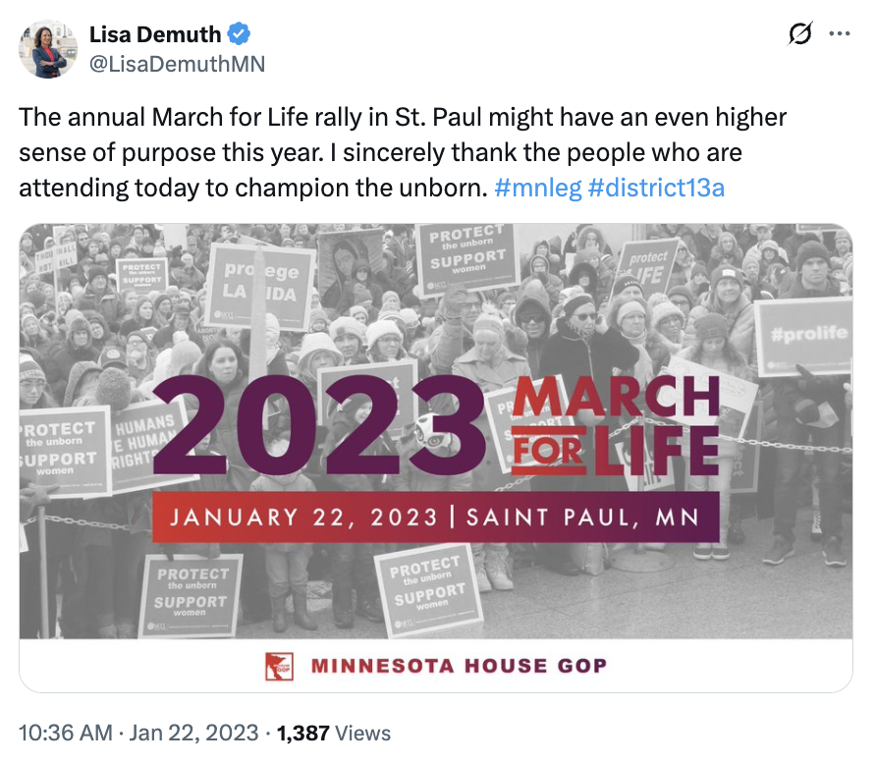
[Twitter, @LisaDemuthMN, 1/22/23]

