Overview
In 2025, Mike Cox supported Trump’s “One Big Beautiful Bill,” which was estimated to kick 17 million Americans off their health insurance, including nearly 12 million Americans who rely on Medicaid. More than 424,000 Michiganders could lose their health insurance and hundreds of rural hospitals could close, including at least three hospitals in Michigan as a result of Trump’s tax bill. By 2034, 237,708 Medicaid recipients in Michigan were expected to lose their coverage under the “One Big Beautiful Bill.”
As Michigan attorney general, Cox tried to strike down the Affordable Care Act through legal challenges alongside other Republican attorneys general, even though Michigan Governor Granholm claimed he lacked the authority since she supported the health care law. His fight against the Affordable Care Act would have impeded the health care access for more than 531,000 Michiganders currently enrolled in Affordable Care Act Marketplace health insurance plans.

Mike Cox Supported Stripping Health Insurance Away From Millions Of Americans Who Relied On Medicaid

Mike Cox Supported The “One Big Beautiful Bill,” Which Included Devastating Health Care Cuts To Fund Tax Cuts For The Wealthy
May 2025: Mike Cox Supported The “One Big Beautiful Bill,” Claiming It Was The “Largest Tax CUT For Working Families In American History.” According to Mike Cox’s Twitter, “Passed by one vote! And now you’re going to put this in jeopardy by abandoning your seat in Congress when the margins are tighter than ever? You asked @realDonaldTrump for his support and millions $$ in ads and now want to desert the Trump agenda to Make America Great Again? House Republicans just delivered the largest tax CUT for working families in American history. [...] @JohnJamesMI This morning, we PASSED President @realDonaldTrump’s One Big Beautiful Bill. I’m PROUD to have voted YES for the Michiganders who gave us the mandate to MAKE AMERICA GREAT AGAIN!”
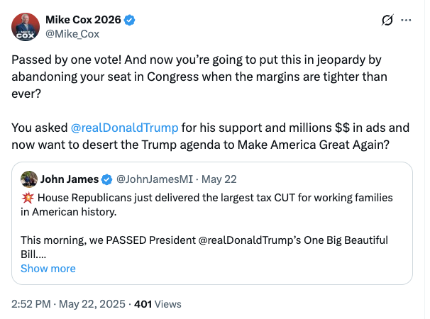
[Twitter, @Mike_Cox, 5/22/25]
HEADLINE: "At Least 17 Million Americans Would Lose Insurance Under Trump Plan" [Washington Post, 7/1/25]
HEADLINE: “By The Numbers: Harmful Republican Megabill Favors The Wealthy And Leaves Millions Of Working Families Behind” [Center On Budget And Policy Priorities, 8/1/25]
The Congressional Budget Office Estimated That 11.8 Million People Would Become Uninsured As A Result Of The Medicaid Cuts In Republicans’ Reconciliation Bill. According to the Washington Post, "The bill, which narrowly passed the Senate on Tuesday and now heads back to the House, would effectively accomplish what Republicans have long failed to do: unwind many of the key components of the ACA, President Barack Obama’s signature domestic achievement, which dramatically increased the number of Americans with access to health insurance. To start, the Congressional Budget Office estimated that the Senate version of the bill would result in 11.8 million more uninsured in 2034, mostly because of Medicaid cuts, compared with 10.9 million if the House version became law." [Washington Post, 7/1/25]
The House GOP Budget Bill Made The 2017 Income Tax Breaks Permanent And Added An Estimated $3.8 Trillion To The National Debt Over 10 Years. According to CNN, “The package includes several controversial measures that would deeply cut into two of the nation’s key safety net programs – Medicaid and food stamps – while making permanent essentially all of the trillions of dollars of individual income tax breaks contained in the GOP’s 2017 Tax Cuts and Jobs Act. What’s more, it would fulfill Trump’s campaign promises to cut taxes on tips and overtime, albeit temporarily. The magnitude of the measures is evident in the estimates of the cost they would incur or the savings they would produce. […] The tax changes in the package would add $3.8 trillion to the nation’s debt over a decade, according to a Congressional Budget Office analysis released before last-minute changes were made to the bill.” [CNN, 5/28/25]
HEADLINE: "House Republican Budget Takes Away Health Care, Food Aid To Pay For Expanded Tax Cuts For Wealthy" [Center on Budget and Policy Priorities, 2/21/25]
New York Times Reported The $880 Billion In Cuts Required By The Republican Budget Proposal Would Have To Come From Medicaid, Medicare, Or CHIP. According to the New York Times, "The budget resolution itself is silent on whether Congress cuts Medicaid, which provides health coverage to 72 million poor and disabled Americans. But it instructs the House Energy and Commerce Committee, which has jurisdiction over the program, to cut spending by $880 billion over the next decade. If the committee can’t save at least that much, the entire effort could be imperiled because of the special process Congress is using to avoid a Senate filibuster. Ten other committees have their own instructions to follow, though none have been assigned with cutting nearly as much. It’s not so simple as finding the cuts elsewhere. The special process, known as budget reconciliation, means Republicans will have to find all $880 billion from within the Energy and Commerce Committee’s jurisdiction. That leaves them with fewer options than one might think. […] If Republicans want to avoid major cuts to Medicaid, the largest pot of available money is in the other big government health insurance program: Medicare. […] Even if the committee cuts everything that’s not health care to $0, it will still be more than $600 billion short. The committee could also save around $200 billion by eliminating the Children’s Health Insurance Program, but that option has not been raised by the budget committee or anyone in House leadership. […] Even if all of these cuts, revenues and rule cancellations from outside health care can pass muster, the committee will still be left with hundreds of billions of dollars to cut to hit its goal. Mathematically, the budget committee’s instructions mean the committee would need to make major cuts to either Medicare, Medicaid or both." [New York Times, 2/25/25]

More Than 424,000 Michiganders Were Expected To Lose Health Care Coverage Under Trump’s “One Big Beautiful Bill”
Under The “One Big Beautiful Bill,” 424,308 People In Michigan Were Expected To Lose Their Health Care By 2034, Including 186,600 ACA Enrollees And 237,708 Medicaid Recipients. According to the Joint Economic Committee Minority,
District | State | Est. # Losing ACA Coverage | Est. # Losing Medicaid Coverage | Est. Total # Losing Insurance
MI-01 | Michigan | 17,400 | 17,875 | 35,275
MI-02 | Michigan | 12,500 | 19,021 | 31,521
MI-03 | Michigan | 13,800 | 16,080 | 29,880
MI-04 | Michigan | 14,300 | 16,187 | 30,487
MI-05 | Michigan | 12,500 | 17,920 | 30,420
MI-06 | Michigan | 12,900 | 10,507 | 23,407
MI-07 | Michigan | 11,600 | 13,145 | 24,745
MI-08 | Michigan | 11,600 | 22,524 | 34,124
MI-09 | Michigan | 15,200 | 13,664 | 28,864
MI-10 | Michigan | 17,000 | 18,318 | 35,318
MI-11 | Michigan | 16,500 | 12,983 | 29,483
MI-12 | Michigan | 16,100 | 25,959 | 42,059
MI-13 | Michigan | 15,200 | 33,525 | 48,725
All | Totals | 186,600 | 237,708 | 424,308

[Joint Economic Committee Minority, 6/25]
- The House GOP Budget Bill Was Estimated To Increase The Uninsured Population By 8.6 Million By 2034. According to CNN, “The Medicaid and Affordable Care Act provisions in the package could result in 8.6 million more people being uninsured in 2034, according to an early CBO estimate released by Democratic lawmakers. That number is expected to grow with the latest changes.” [CNN, 5/28/25]
- The House GOP Budget Bill Codified A Trump Administration Proposal That Restricted Access To The Affordable Care Act. According to CNN, “The bill also calls for codifying a Trump administration proposal that would make changes to the Affordable Care Act enrollment process, including shortening the open enrollment period and eliminating the ability of low-income Americans to sign up year-round.” [CNN, 5/28/25]

Under The “One Big Beautiful Bill,” More Than 237,700 Medicaid recipients Were Expected To Lose Coverage By 2034, And At Least Three Rural Hospitals In Michigan Were At Risk Of CLosure
Under The “One Big Beautiful Bill,” 237,708 Medicaid Recipients In Michigan Were Expected To Lose Their Coverage By 2034. [Joint Economic Committee Minority, 6/25]
July 2025: Trump’s “One Big Beautiful Bill” Threatened To Shut Down Three Michigan Rural Hospitals And 300 More Nationwide. According to Michigan Public, “Federal lawmakers have released findings from University of North Carolina researchers indicating that President Donald Trump’s ‘Big Beautiful Bill’ could place over 300 rural hospitals across the U.S., including three in Michigan, at risk of closure and service reductions. The three Michigan hospitals are McLaren Central Michigan in Mount Pleasant, University of Michigan Health-Sparrow Carson City Hospital, and Ascension Borgess-Lee Hospital in Dowagiac.” [Michigan Public, 7/15/25]
- The Bill’s $50 Billion In Rural Hospital Relief Funding Would Not Come Close To The Gap Created By Medicaid Cuts, With 300 Rural Hospitals At “Immediate Risk” Of Closure. According to the Center For American Progress, “The OBBBA includes $50 billion in relief funding for rural hospitals over a five-year period to help reduce the disastrous impacts of the bill’s roughly $1 trillion in Medicaid cuts. As of May 2025, there were approximately 2,086 rural hospitals receiving $12.2 billion a year in net revenue from Medicaid. At the median, rural hospitals’ revenue from Medicaid is $3.9 million a year. Rural hospitals have some of the lowest operating margins in the nation, especially compared with urban hospitals, meaning that any reductions in revenue could lead to closures. The average operating margin for rural hospitals was 3.1 percent in 2023, with 44 percent of rural hospitals operating with negative margins. As a result, more than 300 rural hospitals are currently at ‘immediate risk’ of closure, especially now that the OBBBA is projected to cut Medicaid spending by $1.02 trillion. The relief fund designed to blunt the negative impacts caused by the bill would not come close to filling that gap. If every rural hospital in the country received an even share of the $50 billion in relief support, it would amount to only $4.5 million every year for five years. At the close of those five years, that funding would disappear altogether.” [Center For American Progress, 7/3/25]

The “One Big Beautiful Bill” And The Expiring Affordable Care Act Tax Credits Would Result In 392,000 Uninsured Michiganders By 2034
The “One Big Beautiful Bill” And The Expiring Affordable Care Act Tax Credits Would Result In 392,000 Uninsured Michiganders By 2034. According to the Center For American Progress, “The One Big Beautiful Bill Act will increase the number of Americans without health coverage in every state Estimated increase in the uninsured population due to the OBBBA and the expiration of the ACA’s enhanced premium tax credits, 2034”
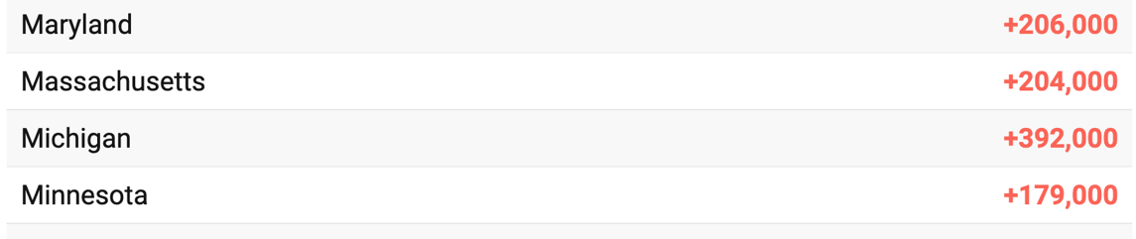
[Center For American Progress, 9/5/25]

Mike Cox Previously Legally Challenged The Affordable Care Act, Which Would Have Threatened The Health Care Access For More Than 531,000 Michiganders Who Currently Held ACA Plans

As Michigan Attorney General, Mike Cox Legally challenged The Affordable Care Act

As Michigan Attorney General, Mike Cox Filed A Lawsuit Against The Affordable Care Act, Claiming The Health Care Law Was An “Unprecedented Overreach”
2010: Mike Cox Joined Republican Attorneys General To Sue The Affordable Care Act, Claiming The Health Care Law Was An “Unprecedented Overreach By Congress And The President.” According to the WKAR, “Cox joined Republican attorneys general from at least a dozen other states who filed suit after President Barack Obama signed the bill Tuesday. Cox said the overhaul is an ‘unprecedented overreach by Congress and the President.’” [WKAR, 3/24/10]
2010: Cox Said His Michigan Attorney General’s Office Continued To “Fight Obamacare.” According to Cox’s Twitter, “My office continues to fight Obamacare. Today, Nolan Finley wrote a good reminder about the real costs of the law: http://bit.ly/aGlcR0”
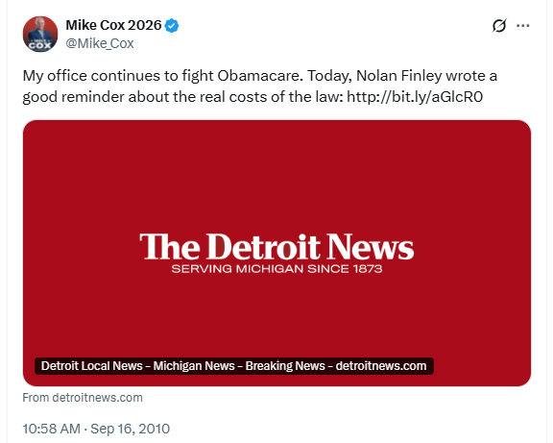
[Twitter, @Mike_Cox, 9/16/10]
2009: Cox Called The Affordable Care Act “Leisure Suits, Billy Beer, And Big Govt.” According to Cox’s Twitter, “Bailout/stimulus/tripling natl debt/growing jobless rate/obamacare. Sounds like the 70s! Say NO to leisure suits, Billy Beer, and big govt”
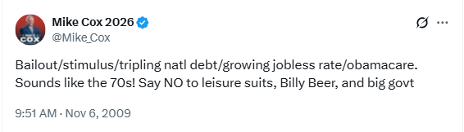
[Twitter, @Mike_Cox, 11/6/09]

Then-Governor Granholm Said Cox Did Not Have The Authority To Sue The Affordable Care Act
2010: Then-Governor Granholm Said Cox Did Not Have The Authority To Sue Against The Affordable Care Act Since She Supported The Health Care Law And His Legal Efforts Went Against The Interests Of Michiganders. According to the WKAR, “Gov. Jennifer Granholm says Michigan Attorney General Mike Cox doesn't have authority to join a lawsuit against the federal health care overhaul. The Democratic governor told The Associated Press on Wednesday that Cox, a Republican running for governor, should retain outside counsel if he wants to fight the law. Interviewed in Traverse City, Granholm said she and the executive branch are Cox's main clients. Granholm favors the health care overhaul. She said Cox wasn't representing her or Michigan citizens who would benefit from the law.’” [WKAR, 3/24/10]

In 2025, More Than 531,000 Michiganders Relied On The Affordable Care Act For Health Insurance
2025: 531,083 Michiganders Were Enrolled In Affordable Care Act Marketplace Health Insurance Plans. According to KFF, in 2025, there were 531,083 people in Michigan who were enrolled in Affordable Care Act Marketplace health insurance plans.
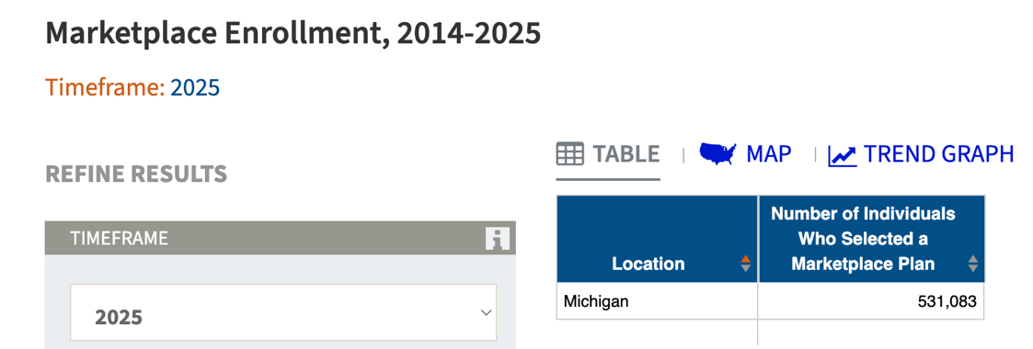
[KFF, Accessed 12/5/25]

The Affordable Care Act Allowed States To Expand Medicaid, Which Has Dramatically Lowered The Uninsured Rate Among Low-Income Workers
The Affordable Care Act Allowed States To Expand Medicaid And States That Did Had Dramatically Lowered The Number Of People Without Health Insurance. According to the Center on Budget and Policy Priorities, "The Affordable Care Act (ACA) permits states to expand Medicaid coverage to adults with incomes up to 138 percent of the poverty level (about $20,780 annually for an individual or $35,630 for a family of three). States that have adopted the expansion have dramatically lowered their uninsured rates. Extensive research finds that the people who gained coverage have grown healthier and more financially secure, while long-standing racial inequities in health outcomes, coverage, and access to care have shrunk." [Center on Budget and Policy Priorities, 6/14/24]
- The Uninsured Rate Among Low-Income Workers Fell From 38 Percent In 2013 To 17 Percent In 2022, Which Coincided With Implementation Of Medicaid Expansion. According to the Center on Budget and Policy Priorities, "Millions of workers have gained coverage through Medicaid expansion, including people working in industries that provide critical goods and services such as health care, transportation, grocery stores, food manufacturers, and child care. Many have no access to health coverage through their jobs. In expansion states, the uninsured rate among low-income workers fell from 38 percent in 2013 to 17 percent in 2022; this sharp decline coincided with a large increase in the share of low-income workers enrolled in Medicaid.[16] In non-expansion states, the uninsured rate among low-income workers fell much less, from 46 percent to 31 percent. (See Figure 3.)" [Center on Budget and Policy Priorities, 6/14/24]

