Overview
In 2025, Mike Cox praised Trump’s “Department of Government Efficiency” as DOGE-driven cuts and downsizing were affecting the federal government’s ability to deliver services to seniors. More than 2.3 million Michiganders relied on Social Security benefits.
Cox pledged to “DOGE” Michigan’s government and urged DOGE audits of state grants and firings of Michigan state workers, even though Trump’s DOGE resulted in massive federal funding cuts to Michigan programs and nonprofits. Trump’s DOGE initiative also threatened the livelihoods of more than 76,000 federal workers across the state.

Mike Cox Praised DOGE And The Trump Administration Despite The Harm It Was Causing To The Social Security Administration

Mike Cox Said He Would “DOGE State Government,” Similarly To Trump’s DOGE

Mike Cox Said Michigan Needed A Governor Willing To “DOGE State Government” And Compared His Approach To Trump’s And Musk’s DOGE
February 2025: Mike Cox Said Michigan Needed A Governor Willing To “DOGE State Government” And Compared His Approach To Donald Trump’s And Elon Musk’s DOGE. According to Cox’s Twitter, “DOGE is really the will to question and cut. Trump has it. Elon has it. We need a Governor who will DOGE state government. It is simply challenging assumptions. That is what I did when I reduced AG employees by 20% yet did more.”

[Twitter, @Mike_Cox, 2/18/25]

At The Social Security Administration, Doge Forced Mass Layoffs, Longer Wait Times And Frequent Website Crashes
HEADLINE: "Social Security Stops Reporting Call Wait Times And Other Metrics" [Washington Post, 6/20/25]
HEADLINE: "As Social Security Services Are Cut Back, Millions Of Seniors Face Long Drives" [Axios, 6/8/25]
HEADLINE: "Social Security Website Keeps Crashing, As DOGE Demands Cuts To IT Staff" [Washington Post, 4/7/25]
HEADLINE: "Social Security Faces Thousands More Job Cuts Even With Service In Tailspin" [Washington Post, 4/4/25]
The Center On Budget And Policy Priorities Said The Trump Administration Had Pushed Out 7,000 Social Security Workers. According to the Center on Budget and Policy Priorities, "Over the past five months, the Trump Administration has forced the Social Security Administration (SSA) through a radical transformation that threatens to disrupt services for the largely older and severely disabled people who most rely on the agency.[1] The Trump Administration and its so-called Department of Government Efficiency (DOGE) have created huge gaps in customer service and support by indiscriminately pushing out 7,000 workers to hit an arbitrary staffing reduction target. This is the largest staffing cut in SSA’s history.[2] (See Figure 1.)" [Center on Budget and Policy Priorities, 6/23/25]
The Social Security Administration Website Crashed Four Times In Ten Days In March 2025 Because Servers Were Overloaded. According to the Washington Post, "The Social Security Administration website crashed four times in 10 days this month because the servers were overloaded, blocking millions of retirees and disabled Americans from logging in to their online accounts. In the field, office managers have resorted to answering phones in place of receptionists because so many employees have been pushed out. Amid all this, the agency no longer has a system to monitor customer experience because that office was eliminated as part of the cost-cutting efforts led by Elon Musk. And the phones keep ringing. And ringing." [Washington Post, 3/25/25]
Field Office Managers At Social Security Offices Had To Answer Phones In Place Of Receptionists Because DOGE Had Pushed Out So Many Federal Employees. According to the Washington Post, "The Social Security Administration website crashed four times in 10 days this month because the servers were overloaded, blocking millions of retirees and disabled Americans from logging in to their online accounts. In the field, office managers have resorted to answering phones in place of receptionists because so many employees have been pushed out. Amid all this, the agency no longer has a system to monitor customer experience because that office was eliminated as part of the cost-cutting efforts led by Elon Musk. And the phones keep ringing. And ringing." [Washington Post, 3/25/25]
DOGE Eliminated The Social Security Administration’s System To Monitor Customer Experience. According to the Washington Post, "The Social Security Administration website crashed four times in 10 days this month because the servers were overloaded, blocking millions of retirees and disabled Americans from logging in to their online accounts. In the field, office managers have resorted to answering phones in place of receptionists because so many employees have been pushed out. Amid all this, the agency no longer has a system to monitor customer experience because that office was eliminated as part of the cost-cutting efforts led by Elon Musk. And the phones keep ringing. And ringing." [Washington Post, 3/25/25]
Early February-Late March 2025: AARP Said More Than 2,000 People Per Week Had Called Expressing Concerns About Whether They Would Continue To Get Their Social Security Benefits. According to the Washington Post, "Alarmed lawmakers are straining to answer questions back home from angry constituents. Calls have flooded into congressional offices. AARP announced Monday that more than 2,000 people a week have called the retiree organization since early February — double the usual number — with concerns about whether benefits they paid for during their working careers will continue. Social Security is the primary source of income for about 40 percent of older Americans." [Washington Post, 3/25/25]

More Than 2.3 Million Michiganders Relied on social security benefits
In Michigan, 2,339,826 People Relied On Social Security Benefits. According to the Social Security Administration, in 2024, 2,339,826 Michiganders received Social Security benefits. [Social Security Administration, MI, 2024]

Mike Cox Pledged To “DOGE” The Michigan Government, Even Though Trump’s DOGE Policies Resulted In The Mass Layoff Of Michiganders And Threatened Services

Mike Cox Pledged To “Doge” Michigan’s Government And State GRants

Mike Cox Pledged To Conduct DOGE Audits Of State Grants And Called For Layoffs And Prosecution
January 2026: Mike Cox Pledged To Conduct DOGE Audits Of State Grants And Called For Firings And Criminal Prosecutions If Elected Governor. According to Cox’s Twitter, “I’m going to DOGE and fly-spec every dime of grant money allocated by Whitmer’s corrupt and inept administration. Time to end waste, fraud and abuse. Prosecute the crooks and fire the incompetents.”
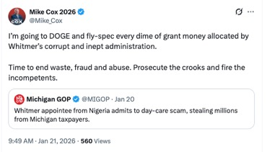
[Twitter, @Mike_Cox, 1/21/26]

Mike Cox Pledged To “DOGE” State Government
2025 Website: Cox Pledged To “DOGE” State Government, “Streamline Licensing,” And “Cut Red Tape” While Claiming He Reduced Staff And Improved Efficiency As Attorney General. According to Mike Cox’s Campaign Website, “Government should exist to serve citizens, not itself. Yet under Governor Whitmer, Lansing hired more bureaucrats while our roads fell apart and student performance dipped. I’ll cut red tape, streamline licensing, and refocus agencies on actually fixing problems—so Michiganders can get back to work and thrive. As Attorney General, I reduced the staff by 20% while handling more cases than ever before. As an owner of a very successful business for the past 14 years, I know how to do more with less.”
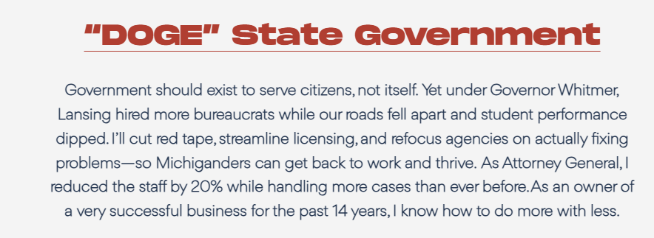
[Mike Cox 2026, On The Issues, Archived 11/10/25]
2025: Cox Proposed Overhauling State Government Through His “DOGE” Plan. According to Detroit News, “Cox, the original ‘tea party candidate,’ proposes eliminating the personal income tax entirely, reinstituting Right to Work and ‘DOGE’-ing state government. He cited reductions he made in his office as attorney general while increasing its caseload. ‘If we have a good economy, we’re going to keep our kids from leaving,’ Cox says. ‘Three of my four kids don’t live in Michigan — and that kills me, right? Unfortunately, I’m not the only one.’” [Detroit News, 4/15/25]

DOGE Cut $390 Million In Federal Funding From MIchigan Department of Health and Human Services
HEADLINE: “Michigan Health Department Appears To Lose $390 Million In Grant Funds, According To DOGE” [Michigan Public, 3/27/25]
March 2025: DOGE Abruptly Cut More Than $390 Million In Federal Health Grants To Michigan With No Explanation. According to Michigan Public, “More than $390 million in federal grants to the Michigan Department of Health and Human Services appears to have been abruptly discontinued this week, according to the Department of Government Efficiency (DOGE) website. The site, which has been riddled with major inaccuracies and overinflated numbers in the past, says the cuts were from grants administered by the federal Health and Human Services department, but gives no specifics as to which state programs the grants covered.” [Michigan Public, 3/27/25]

DOGE Cuts Slashed Federal Funding For Michigan’s Community And Cultural Programs
April 2025: DOGE Cuts Wiped Out Most Of The Michigan Humanities Council’s Budget And Forced Cancellation Of Its Statewide Reading Program. According to Bridge Michigan, “The Michigan Humanities council lost the roughly $900,000 remaining of its $1.5 million annual federal operations grant, 90% of the organization’s total budget. Among the initial casualties: The nonprofit is scrapping its annual Great Michigan Read, a statewide program that’s offered free books and programming centered around a specific book related to Michigan each year since 2007.” [Bridge Michigan, 4/16/25]
April 2025: Michigan AmeriCorps Programs Lost $15 Million After Federal Budget Cuts Targeted Community Services. According to Bridge Michigan, “Michigan is expected to lose about $15 million in grant funding for AmeriCorps projects, which range from assisting seniors to reading tutors for children, as part of a larger effort by the federal government to slash the agency’s overall budget.” [Bridge Michigan, 4/29/25]

DOGE Cuts Targeted 76,219 Federal Workers In Michigan
April 2025: DOGE Cuts Could Impact 76,219 Michigan Federal Workers. According to M Live, “From 2019 through 2023, Michigan averaged 76,219 federal workers in all 83 counties, according to U.S. Census data.” [M Live, 4/23/25]
- 2025: Federal Workforce Numbers In Michigan Were Expected To Drop Under Trump’s DOGE Cuts And Firings. According to M Live, “Those numbers frequently fluctuate, due to factors like budget constraints, technology changes or notably, the COVID-19 pandemic. In 2025, they may decrease more significantly, after attempts by President Donald Trump and the Department of Government Efficiency (DOGE) to overhaul the federal government through widespread firings of federal workers and cuts to spending.” [M Live, 4/23/25]

