Overview
Mike Cox was an out-of-touch anti-abortion extremist, who believed life began at conception.
In 2006, as Michigan attorney general, Mike Cox defended Michigan’s “Legal Birth Definition Act.” Cox filed a brief in support of his appeal to the federal ruling that struck the law down as unconstitutional. Pro-abortion groups warned the law was too broad and would ban all abortions.
Cox maintained longstanding relationships with anti-abortion organizations, including the Right to Life. In 2010, Michigan Right to Life endorsed Cox and Right to Life spent more than $71,000 supporting Cox’s 2010 gubernatorial run. In 2025, Cox continued to participate in Michigan Right to Life events, seeking to advance the anti-abortion agenda. In 2025, Cox attended Protect Life Michigan’s anti-abortion event, where they discussed how to change the minds of students in support of abortion rights.

Mike Cox Believed Life Began At Conception And Defended Michigan’s Unconstitutional Anti-Abortion Law That Was Too Broad And Could Have Banned All Abortions

Mike Cox Believed Life Began At Conception
2010: In Response To His Right To Life Michigan Endorsement, Mike Cox Declared That “True Justice Requires” Protected “Every Human Life, From Conception To Natural Death.” According to Mlive, “Cox, who defended a 2004 citizen-initiated ban on certain late-term abortion procedures that was overturned in federal court, said Friday ‘true justice requires that we recognize, protect and defend every human life, from conception to natural death.’” [Mlive, 6/11/10]

As Michigan Attorney General, Mike Cox Defended Michigan’s Unconstitutional “Legal Birth Definition Act,” A Broad Abortion Law That Critics Warned Would Ban All Abortions
As Michigan Attorney General, Cox Defended The 2004 Ban On Abortion Later In Pregnancy That Was Overturned In Federal Court. According to Mlive, “Cox, who defended a 2004 citizen-initiated ban on certain late-term abortion procedures that was overturned in federal court, said Friday ‘true justice requires that we recognize, protect and defend every human life, from conception to natural death.’” [Mlive, 6/11/10]
- 2006: As Michigan Attorney General, Cox Filed A Brief In Support Of His Appeal Of A Federal Ruling That Declared The “Legal Birth Definition Act” Unconstitutional. According to Michigan Lawyers Weekly, “Attorney General Mike Cox filed a brief backing his appeal of a ruling that declared a Michigan abortion law unconstitutional. ‘I am asking the federal appellate court to uphold the will of the people,’ the Republican said of the law approved by the Legislature in 2004. In September, U.S. District Court Judge Denise Page Hood in Detroit ruled the Legal Birth Definition Act placed an ‘undue burden’ on women’s right to choose. Hood said the law was confusing and vague and its exceptions for the health or life of a mother were meaningless and unconstitutional. Proponents of the law said they were attempting to ban a procedure they call ‘partial-birth’ abortion, but critics said it banned all abortions. Previous attempts by state lawmakers to stop the abortion procedure were struck down by federal courts in 1997 and 2001.” [Michigan Lawyers Weekly, 3/6/06]
- 2006: Cox Argued Michigan’s Law Only Banned “Intact Dilation And Extractions” And Effectively Protected Women’s Lives And Their Health, While Pro-Abortion Groups Warned The Law Was Too Broad And Banned All Abortions. According to Michigan Lawyers Weekly, “Proponents of the law said they were attempting to ban a procedure they call ‘partial-birth’ abortion, but critics said it banned all abortions. […] In his brief before the 6th U.S. Circuit Court of Appeals, Cox points to a January ruling by the U.S. Supreme Court, which said that lower courts in addressing flaws in abortion laws do not have to strike down an entire law. Instead, the justices said that other ‘modest’ options are available. Cox argues the Michigan law only bans the abortion procedure doctors label ‘intact dilation and extraction,’ or D&X, and not other procedures that are constitutionally protected. The law can be construed to adequately protect a woman’s life and health, Cox says. The American Civil Liberties Union of Michigan, Center for Reproductive Rights and Planned Parenthood Federation of America, who sued to block the law, have argued it is too broad.” [Michigan Lawyers Weekly, 3/6/06]

Mike Cox Maintained A Longstanding Relationship With Anti-Abortion Groups

Cox Had More Than A Decade-Long Relationship With The Michigan Right To Life, Which Spent More Than $71,000 Supporting Cox’s 2010 Gubernatorial Bid

In 2010, The Anti-Abortion Group Right To Life Spent More Than $71,000 Supporting Cox For Governor
2010: The Right To Life Spent $71,370 Supporting Cox For Michigan Governor During The Republican Primary. According to WEMU, “In 2010, the same year voters elected eight Right to Life-backed Democrats to the Legislature, they also chose a Republican who had been opposed by Right to Life for the governor’s office. That Republican was a businessman from Ann Arbor named Rick Snyder. In the primary election in 2010, Right to Life spent $26,428 opposing Snyder and $71,370 supporting one of his opponents, Republican Attorney General Mike Cox.” [WEMU, 9/9/19]
HEADLINE: “Right To Life Endorses Mike Cox, Leaves Out Other GOP Gubernatorial Candidates Group Had Backed In Past” [Mlive, 6/11/10]
2010: Cox Earned The Endorsement Of Michigan Right To Life Of Over Three Other Republican Primary Candidates. According to Mlive, “In receiving the backing Friday from Right to Life of Michigan, Attorney General Mike Cox picked up one of the most coveted endorsements of the 2010 Republican primary campaign. Rather than back all of the candidates that met its criteria, the anti-abortion group's political action committee chose to support Cox over three other candidates it has supported in the past -- U.S. Rep. Pete Hoekstra, R-Holland, state Sen. Tom George of the Kalamazoo area and Oakland County Sheriff Mike Bouchard. […] RTL's endorsement in a Republican primary is significant given the organization's capacity to independently communicate with its thousands of members.” [Mlive, 6/11/10]
2010: Cox Shared The News About A “Strong” Endorsement From Michigan Right To Life. According to Mike Cox’s Facebook, “Great news, Gun Owners of America endorsed my campaign. Another strong endorsement along with MI Right to Life and the MI Chamber.”
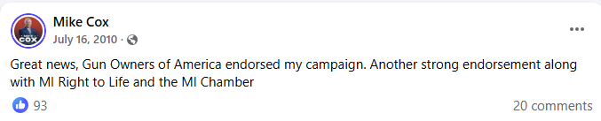
[Facebook, Mike Cox, 7/16/10]
Right To Life President Barbara Listing And Chairman Paul Miller Praised Cox’s “Support And Leadership” In Defending “The Civil Rights Of The Unborn.” According to Mlive, “‘The years ahead will bring us new opportunities to defend the civil rights of the unborn, handicapped and elderly frail,’ said Right to Life President Barbara Listing and PAC Chairman Paul Miller in a statement. ‘Mike Cox's support and leadership will be absolutely essential in restoring the basic right to life to the most helpless members of our human family.’” [Mlive, 6/11/10]

In 2025, Cox Continued To Participate In Right To Life Of Michigan Anti-Abortion Events
As Of September 2025, Cox Continued To Engage With Right To Life Of Michigan And Spoke At The Group’s Macomb County Dinner, Applauding Women Who Decided Against Abortion. According to Cox’s Facebook, “Spent the day with stops in Jackson and Macomb counties. Met with job creators in Jackson about out of control state regulation driving up the cost of affordability for ordinary folks in Michigan. At Macomb Right to Life Dinner Right to Life of Michigan in Clinton Township. Good folks who focus on ‘Life: The Other Choice’ by focusing on policies that support women who choose life. That means everything from prenatal care to diapers to other forms of post-natal.”
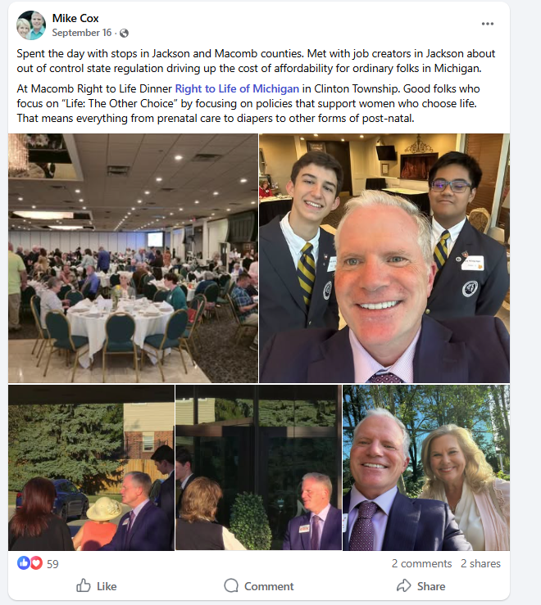
[Facebook, Mike Cox, 9/10/25]

In 2025, Cox Attended Protect Life Michigan’s Anti-Abortion “Protect Life” Dinner
May 10, 2025: Cox Attended An Anti-Abortion “Protect Life” Dinner. According to Cox’s Facebook, “At Protect Life Dinner in Lansing. A great organization that focuses on persuasion and peer counseling to change hearts and minds. Met so many good people with good hearts. Also fun to make new friends & meet old friends like Mikhail Fedewa, U.S. Representative Tom Barrett, & his mom and dad, Mike Shirkey, and Katie Wilcox.”
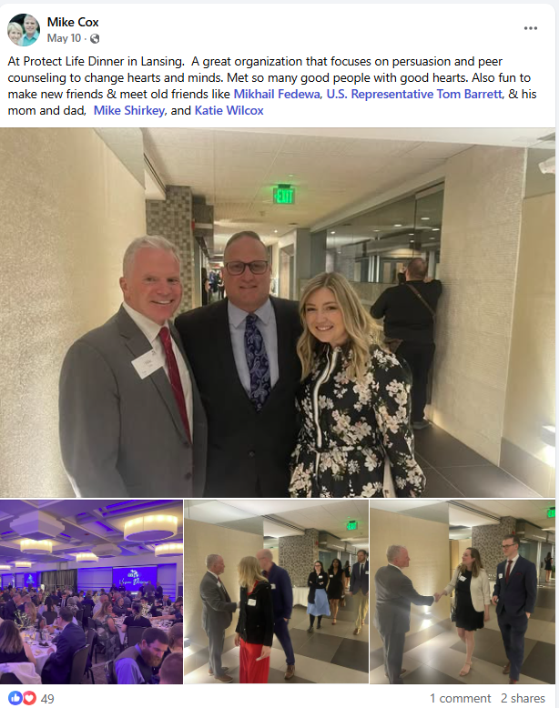
[Facebook, Mike Cox, 5/10/25]
May 10, 2025: The Protect Life Michigan Event Discussed Strategy On “Changing Pro-Choice Minds On Campus” And “Fuel The Resistance” Of Anti-Abortion Student Activists. According to the Protect Life Michigan Dinner,

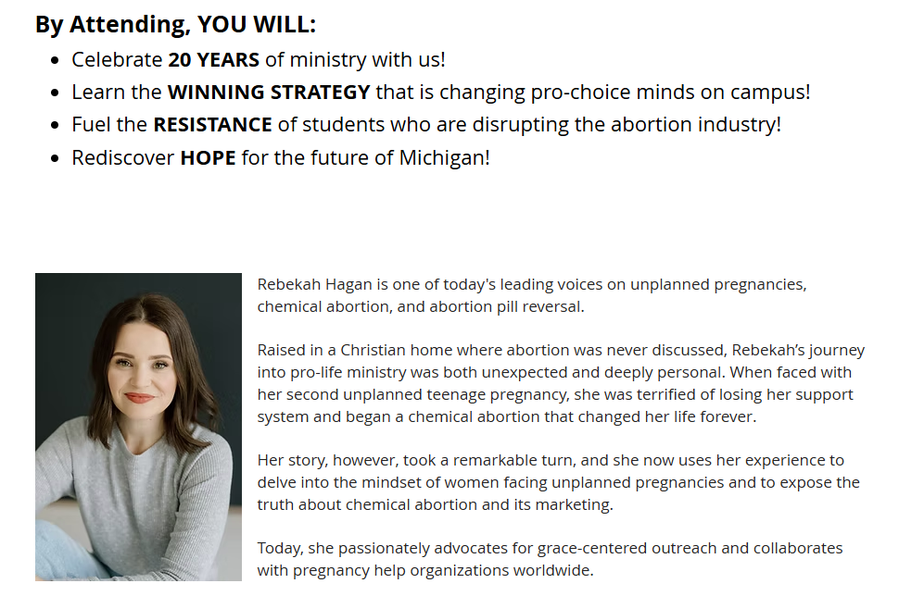
[Protect Life Michigan, Dinner, Archived 4/5/25]

