Overview
In 2025, John James supported Trump’s “Department of Government Efficiency” as DOGE-driven cuts and downsizing were affecting the federal government’s ability to deliver services to seniors. More than 2.3 million Michiganders relied on Social Security benefits.
John James praised Elon Musk as a symbol of American innovation and promoted DOGE even though it resulted in massive federal funding cuts to Michigan programs and nonprofits. John James dismissed the layoffs while Trump’s DOGE initiative threatened the livelihoods of more than 76,000 federal workers across the state.

John James Praised DOGE And The Trump Administration Despite The Harm It Was Causing To The Social Security Administration

John James Praised Elon Musk And Dogecoin For “Making America Great Again”
May 2025: John James Praised Elon Musk For Turning Dogecoin Into “A Mission To The Moon And Making America Great Again.” According to John James’ Twitter, “Elon Musk took a joke coin with a Shiba Inu mascot and turned it into a conversation about decentralized currency, innovation, space travel — and yes, Saving America. Only in America could a meme become a mission to the moon and Making America Great Again. Hats off to @elonmusk for making DOGE the most entertaining economics lesson in human history.”

[Twitter, @John JamesMI, 5/22/25]

At The Social Security Administration, Doge Forced Mass Layoffs, Longer Wait Times And Frequent Website Crashes
HEADLINE: "Social Security Stops Reporting Call Wait Times And Other Metrics" [Washington Post, 6/20/25]
HEADLINE: "As Social Security Services Are Cut Back, Millions Of Seniors Face Long Drives" [Axios, 6/8/25]
HEADLINE: "Social Security Website Keeps Crashing, As DOGE Demands Cuts To IT Staff" [Washington Post, 4/7/25]
HEADLINE: "Social Security Faces Thousands More Job Cuts Even With Service In Tailspin" [Washington Post, 4/4/25]
The Center On Budget And Policy Priorities Said The Trump Administration Had Pushed Out 7,000 Social Security Workers. According to the Center on Budget and Policy Priorities, "Over the past five months, the Trump Administration has forced the Social Security Administration (SSA) through a radical transformation that threatens to disrupt services for the largely older and severely disabled people who most rely on the agency.[1] The Trump Administration and its so-called Department of Government Efficiency (DOGE) have created huge gaps in customer service and support by indiscriminately pushing out 7,000 workers to hit an arbitrary staffing reduction target. This is the largest staffing cut in SSA’s history.[2] (See Figure 1.)" [Center on Budget and Policy Priorities, 6/23/25]
The Social Security Administration Website Crashed Four Times In Ten Days In March 2025 Because Servers Were Overloaded. According to the Washington Post, "The Social Security Administration website crashed four times in 10 days this month because the servers were overloaded, blocking millions of retirees and disabled Americans from logging in to their online accounts. In the field, office managers have resorted to answering phones in place of receptionists because so many employees have been pushed out. Amid all this, the agency no longer has a system to monitor customer experience because that office was eliminated as part of the cost-cutting efforts led by Elon Musk. And the phones keep ringing. And ringing." [Washington Post, 3/25/25]
Field Office Managers At Social Security Offices Had To Answer Phones In Place Of Receptionists Because DOGE Had Pushed Out So Many Federal Employees. According to the Washington Post, "The Social Security Administration website crashed four times in 10 days this month because the servers were overloaded, blocking millions of retirees and disabled Americans from logging in to their online accounts. In the field, office managers have resorted to answering phones in place of receptionists because so many employees have been pushed out. Amid all this, the agency no longer has a system to monitor customer experience because that office was eliminated as part of the cost-cutting efforts led by Elon Musk. And the phones keep ringing. And ringing." [Washington Post, 3/25/25]
DOGE Eliminated The Social Security Administration’s System To Monitor Customer Experience. According to the Washington Post, "The Social Security Administration website crashed four times in 10 days this month because the servers were overloaded, blocking millions of retirees and disabled Americans from logging in to their online accounts. In the field, office managers have resorted to answering phones in place of receptionists because so many employees have been pushed out. Amid all this, the agency no longer has a system to monitor customer experience because that office was eliminated as part of the cost-cutting efforts led by Elon Musk. And the phones keep ringing. And ringing." [Washington Post, 3/25/25]
Early February-Late March 2025: AARP Said More Than 2,000 People Per Week Had Called Expressing Concerns About Whether They Would Continue To Get Their Social Security Benefits. According to the Washington Post, "Alarmed lawmakers are straining to answer questions back home from angry constituents. Calls have flooded into congressional offices. AARP announced Monday that more than 2,000 people a week have called the retiree organization since early February — double the usual number — with concerns about whether benefits they paid for during their working careers will continue. Social Security is the primary source of income for about 40 percent of older Americans." [Washington Post, 3/25/25]

More Than 2.3 Million Michiganders Relied on social security benefits
In Michigan, 2,339,826 People Relied On Social Security Benefits. According to the Social Security Administration, in 2024, 2,339,826 Michiganders received Social Security benefits, including 170,536 Michiganders in the 10th congressional district. [Social Security Administration, MI, 2024]

John James Promoted Trump’s DOGE Even Though Its Policies Resulted In The Mass Layoff Of Michiganders And Threatened Services

John James Advocated For Trump’s DOGE Cuts And Dismissed Concerns Over Federal Layoffs
2025: John James Threatened Lansing With “The DOGE Treatment” And Complained About State Spending And Job Losses. According to John James’ Twitter, “Lansing oughta get the DOGE treatment! 👀 $20 BILLION more in Michigan’s annual budget today than just five years ago! The ‘damned roads’ still aren’t fixed, Michigan’s hemorrhaging jobs to other states and our schools are in the bottom 5 in the country. Yet, our Governor, AG & SoS in Lansing had enough money to give the CCP land & tax breaks, let a Chinese national vote in our last election, and weaponized our justice system against political opponents while letting violent criminals walk early. Michigan deserves transparency and accountability.”

[Twitter, @John JamesMI, 2/21/25]
May 2025: John James Dismissed Concerns About DOGE Job Cuts And Told Supporters To “Ignore The Crocodile Tears And Faux Outrage.” According to John James’ Twitter, “Ignore the crocodile tears and faux outrage and remember this clip from my friend @senrogerhauck when DOGE comes to Lansing in two years.”
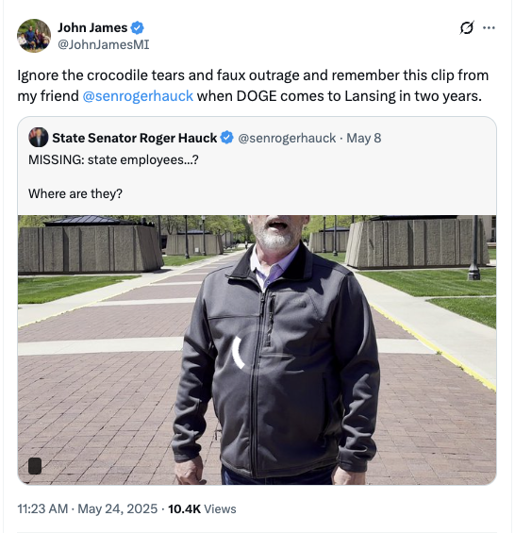
[Twitter, @John JamesMI, 5/24/25]

DOGE Cut $390 Million In Federal Funding From MIchigan Department of Health and Human Services
HEADLINE: “Michigan Health Department Appears To Lose $390 Million In Grant Funds, According To DOGE” [Michigan Public, 3/27/25]
March 2025: DOGE Abruptly Cut More Than $390 Million In Federal Health Grants To Michigan With No Explanation. According to Michigan Public, “More than $390 million in federal grants to the Michigan Department of Health and Human Services appears to have been abruptly discontinued this week, according to the Department of Government Efficiency (DOGE) website. The site, which has been riddled with major inaccuracies and overinflated numbers in the past, says the cuts were from grants administered by the federal Health and Human Services department, but gives no specifics as to which state programs the grants covered.” [Michigan Public, 3/27/25]

DOGE Cuts Slashed Federal Funding For Michigan’s Community And Cultural Programs
April 2025: DOGE Cuts Wiped Out Most Of The Michigan Humanities Council’s Budget And Forced Cancellation Of Its Statewide Reading Program. According to Bridge Michigan, “The Michigan Humanities council lost the roughly $900,000 remaining of its $1.5 million annual federal operations grant, 90% of the organization’s total budget. Among the initial casualties: The nonprofit is scrapping its annual Great Michigan Read, a statewide program that’s offered free books and programming centered around a specific book related to Michigan each year since 2007.” [Bridge Michigan, 4/16/25]
April 2025: Michigan AmeriCorps Programs Lost $15 Million After Federal Budget Cuts Targeted Community Services. According to Bridge Michigan, “Michigan is expected to lose about $15 million in grant funding for AmeriCorps projects, which range from assisting seniors to reading tutors for children, as part of a larger effort by the federal government to slash the agency’s overall budget.” [Bridge Michigan, 4/29/25]

DOGE Cuts Targeted 76,219 Federal Workers In Michigan
April 2025: DOGE Cuts Could Impact 76,219 Michigan Federal Workers. According to M Live, “From 2019 through 2023, Michigan averaged 76,219 federal workers in all 83 counties, according to U.S. Census data.” [M Live, 4/23/25]
- 2025: Federal Workforce Numbers In Michigan Were Expected To Drop Under Trump’s DOGE Cuts And Firings. According to M Live, “Those numbers frequently fluctuate, due to factors like budget constraints, technology changes or notably, the COVID-19 pandemic. In 2025, they may decrease more significantly, after attempts by President Donald Trump and the Department of Government Efficiency (DOGE) to overhaul the federal government through widespread firings of federal workers and cuts to spending.” [M Live, 4/23/25]

