Overview
John James was an anti-abortion extremist who declared he was “100% pro-life” and compared abortion to “genocide.”
John James supported the overturning of Roe v. Wade, claimed “life begins at conception,” and opposed abortion exceptions for rape and incest. He pledged to only support judges who supported abortion restrictions. While in Congress, John James voted to ban the abortion drug Mifepristone.
John James supported efforts to defund Planned Parenthood and eliminating federal funding for abortion providers.
John James maintained deep ties with Right to Life of Michigan that financially supported his campaigns and promoted their extreme anti-abortion movement.

John James Was An Anti-Abortion Extremist, Declared He Was “100% Pro-Life,” And Supported Overturning Roe V. Wade And Restricting Abortion Access

John James Declared He Was “100% Pro-Life” And Compared Abortion To “Genocide”
2018: John James Compared Abortion To “Genocide” And Said Allowing It To Continue Would Prevent Him From Being A “Good And Faithful Servant.” According to M Live, “The Michigan Democratic Party released audio from a July 13, 2018 campaign event John James attended in Lansing, which drew criticism from anti-abortion groups this week. ‘They want to do away with our children -- 50 million dead since Roe v. Wade,’ John James said at the event. ‘That’s unacceptable. I have to recount, not to anybody in this room or anybody in Washington, but with the Lord. I want to hear seven words: Well done my good and faithful servant. Standing by and letting this genocide continue stands in the way of that happening.’” [M Live, 11/28/19]
2019: John James Campaign Spokesperson Abby Walls Said He Was “100% Pro-Life” And “Not Shy About His Convictions” On Abortion. According to M Live, “John James campaign spokesperson Abby Walls said abortion is an issue he feels strongly about. Walls said John James isn’t shy about his convictions and is ‘100% pro-life.’” [M Live, 11/28/19]
2018: John James Declared He Was “100% Pro-Life.” According to John James’ Twitter, “I am proud to have the exclusive endorsement of Right to Life. I am 100% Pro-Life. @NRLC @Right_to_Life #LetsFlyMI #TeamJohn James #MISen.”
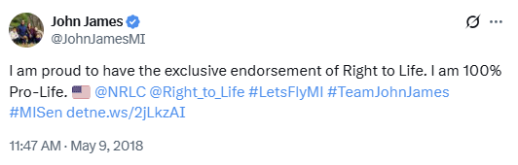
[Twitter, @John JamesMI, 5/9/18]

John James Supported Overturning Roe V. Wade And Claimed “Life Begins At Conception”
John James Repeatedly Denounced Roe V. Wade And Declared He Was “100% Pro-Life” Because “Life Begins At Conception And Ends At A Natural Death”
2018: John James Said He Was “Against Roe V. Wade” And Declared “We Have An Obligation To Protect The Born And The Unborn.” According to John James on a Fox News interview, “I'm against Roe v. Wade because I believe--check this out--we're only taking a look at one life. We have an obligation to protect the born and the unborn and my values come from my faith and I believe that life begins at conception and ends at a natural death. We need to do more to address women's health, to give women better options, but one of those options should not be extinguishing a life…I believe that right now, the question that's in front of us is making sure that we wrap our arms around the mothers and the unborn to make sure that we don't have to make that terrible choice.” [John James Interview – WJBK (FOX), 7/22/18] (VIDEO)
2018: John James Marked The 45th Anniversary Of Roe v. Wade And Declared He Was “100% Pro-Life” Because “Life Begins At Conception And Ends At A Natural Death.” According to John James’ Twitter, “This week marks the 45th anniversary of #RoevWade. I am 100% #ProLife because I believe life begins at conception and ends at a natural death. We will not stop fighting until we end abortion, for it is our sacred duty to protect the most vulnerable among us; the unborn. #LetsFly.”
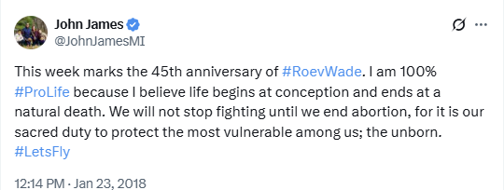
[Twitter, @John JamesMI, 1/23/18]

John James Opposed Abortion In Cases Of Rape And Incest

John James Opposed Abortion Exceptions For Rape And Incest, But Claimed He Supported An Exception For When The Life Of The Mother Was At Risk
2018: John James Said He Only Supported Exceptions For Abortion When The Life Of The Mother Was At Risk. According to the Detroit Free Press, “Also, Pensler, 61, would make exceptions in cases of rape or incest; James, 37, would only make exceptions in cases where the life of the pregnant woman is at risk. James opened the debate during a special taping of ‘Off the Record’ with host Tim Skubick by hammering Pensler on the issue, saying ‘nobody believes’ that he is no longer a supporter of abortion rights. ‘We need to start understanding that this isn't just a label,’ James said in the East Lansing studios of WKAR-TV. ‘These are values that are rooted very deeply in who we are.’” [Detroit Free Press, 7/6/18]
2018: John James Supported Exceptions For Abortions When A Mother’s Life Was In Danger. According to the Detroit Free Press, “Also of note: Pensler says that although he’s anti-abortion, he supports exceptions for women who become pregnant through rape or incest, a position he said John James doesn’t share. John James’ campaign said he would grant an exception to abortion prohibitions when a mother’s life is in danger.” [Detroit Free Press, 7/5/18]

John James Advocated For Abortion Restrictions And Said He Would Only Support Judges Who Wanted Abortion Outlawed
2018 Detroit Free Press: “John James Made It Clear He Couldn't Support Any Judge Who Didn't Openly Call For Abortion To Be Outlawed Except In Almost All Cases.” According to the Detroit Free Press, “John James made it clear he couldn't support any judge who didn't openly call for abortion to be outlawed except in almost all cases. ‘I believe that everyone in the Senate should have to defend life,’ he said. ‘We need to do everything we can to preserve and protect life.’” [Detroit Free Press, 7/5/18]
2017: John James Was Touting Himself As A “Pro-Business Conservative” Who Favored Abortion Restrictions. According to The Detroit Free Press, “An Iraq War veteran and helicopter pilot, John James of Farmington Hills is president of John James Group International, based in Detroit, which provides supply chain management services. He is touting himself as a ‘pro-business conservative’ who favors abortion restrictions and promises to support the Second Amendment right to keep and bear arms.” [Detroit Free Press, 12/15/17]

John James Voted For A Ban On The Sale Of Mifepristone In The FY 2024 Agriculture Appropriations Bill

John James Voted For The FY 2024 Agriculture Appropriations Bill That Targeted Mifepristone Access
2023: John James Voted For Passing FY 2024 Agriculture Appropriations Bill Which Targeted Mifepristone Access. In September 2023, John James voted for: “Passage of the bill that would provide roughly $22 billion in discretionary funding in fiscal 2024 for the Agriculture Department and related agencies. The bill would provide $6.2 billion to the Food and Drug Administration, including $3 billion in discretionary budget authority and $3.2 billion in user fees; $3.4 billion for Agriculture Department rural development activities; $1.5 billion for the Agricultural Research Service; and $1 billion for the Food Safety and Inspection Service. It would provide $122 billion for the Supplemental Nutrition Assistance Program, $32 billion for child nutrition programs, and $6 billion for the Women, Infants, and Children program. It would direct the USDA to take necessary actions to prohibit the purchase of U.S. agricultural land by non-resident aliens and foreign businesses associated with Russia, North Korea, Iran and China; nullify the FDA’s January 2023 rule allowing medical providers to dispense the abortion drug mifepristone without an in-person consultation; prohibit the use of funds for programs that promote critical race theory; and prohibit the use of funds to establish any office of diversity, equity and inclusion, among other policy provisions. As amended, the bill would prohibit the use of funds for carrying out various Biden administration executive orders related to climate change and sex discrimination, finalizing regulations that result in an annual effect on the economy of $100 million or more, implementing the USDA COVID-19 workplace safety policy, or for any operations of the Civilian Climate Corps, among other restrictions. It also would reduce the salary of Deputy Undersecretary of Agriculture for Food and Nutrition Service Stacy Dean to $1.” The bill was rejected by a vote of 191-237. [H.R. 4368, Vote #507, 9/28/25]
- The FY 2024 Agriculture Appropriations Bill Included A Provision To Ban Mifepristone From Being Sold In Retail Pharmacies Or By Mail. According to Fox 59, “A provision in the legislation would nullify a Biden administration rule allowing mifepristone to be sold in retail pharmacies and by mail with prescriptions from a certified health care provider.” [Fox 59, 9/27/23]
- Planned Parenthood: “‘Abortion Pill’ Is The Common Name For Using Two Different Medicines To End A Pregnancy: Mifepristone And Misoprostol.” According to Planned Parenthood, “‘Abortion pill’ is the common name for using two different medicines to end a pregnancy: mifepristone and misoprostol. You can also use misoprostol alone to have an abortion. First, you take a pill called mifepristone. Pregnancy needs a hormone called progesterone to grow normally. Mifepristone blocks your body’s own progesterone, stopping the pregnancy from growing. Then you take the second medicine, misoprostol, either right away or up to 48 hours later. This medicine causes cramping and bleeding to empty your uterus. It’s kind of like having a really heavy, crampy period, and the process is very similar to an early miscarriage. If you don’t have any bleeding within 24 hours after taking misoprostol, call your nurse or doctor.” [Planned Parenthood - The Abortion Pill, Accessed 11/5/25]

John James Supported Efforts To Defund Planned Parenthood And Eliminate Federal Funding For Abortion Providers

John James Supported Ending Federal Funding For Planned Parenthood
2018: John James Bemoaned A Fact That GOP-Controlled Congress Continued To Fund Planned Parenthood, And Called It A “Tragedy.” According to Breitbart, “John James bemoans the fact that Washington Republicans keep funding Planned Parenthood. ‘I think that is a tragedy,’ he says. ‘I will do everything I can to fight for life when I get to D.C. The Right to Life Michigan endorsement is very special – it means a lot to me. I’m 100 percent pro-life, I always have been, and I always will be.’” [Breitbart, 4/27/18]
2018: John James Expressed Support For Trump’s Efforts To Pull Funding For Planned Parenthood. According to the Mining Journal, “A member of the audience asked how John James thinks the Trump Administration is doing in Washington. John James said it’s been ‘remarkably tragic and quite amazing of what our president has been able to accomplish in 18 months (while he’s) being attacked globally and domestically.’ ‘You know, pulling funding for Planned Parenthood, signing a Right-to-try bill that will help people continue to live, putting Neil Gorsuch on the Supreme Court, rolling back 22 harmful regulations for every one that we make, standing up to Syria for gassing their people twice in a year … I guarantee you, if the same things our president was doing came out of the former president’s mouth then it would be completely interpreted differently,’ John James said.” [Mining Journal, 6/4/18]

John JAmes Opposed Taxpayer Funding For Abortions And For Organizations Which Provide Abortions
2018: John James Said He Opposed Taxpayer Funding For Abortions And For Organizations Which Provide Abortions. According to Breitbart, “John James says he opposes the use of taxpayer funds to perform or promote abortions, or to fund organizations such as Planned Parenthood. ‘I am the only pro-life candidate in the Michigan Senate race,’ he asserts. ‘I’m excited to go to Washington and be that additional vote in the Senate to get all the help we can.’” [Breitbart, 4/27/18]

John James Maintained Deep Ties With Right To Life Of Michigan And Promoted Their Extreme Anti-Abortion Movement

Between 2018 – 2022, John James Maintained Endorsements And Financial Support From Right To Life Of Michigan
2022: Right To Life Of Michigan Endorsed John James. According to John James’ Twitter, “Mothers first, babies always. Life is sacred and we must protect the vulnerable. I am committed to protect the mother and her baby - both before and after birth. Thank you Michigan Right to Life for your support!”
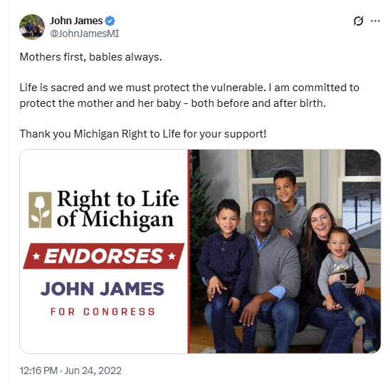
[Twitter, @John JamesMI, 6/24/22]
2018-2020: John James Continued To Hold Strong Ties With Anti-Abortion Groups, Like Right To Life Of Michigan, That Spent Tens Of Thousands Backing His Campaigns. According to M Live, “John James has strong ties to anti-abortion organizations, which have spent tens of thousands of dollars to support his campaigns in 2018 and 2020. John James was endorsed by Right to Life of Michigan’s political action committee earlier this year. He was the only Senate candidate the PAC endorsed in the last cycle.” [M Live, 11/28/19]

John James Promoted The March For Life And Praised Young Activists Who “Stand Up For Life”
2018: John James Said His Team “Was Proud” To “Send Of 4 Busses Full Of Students Traveling Overnight To Washington DC To Attend” The March For Life. According to a tweet from John James, “#TeamJohn James was proud send off 4 buses full of students traveling overnight to Washington, DC to attend the @March_for_Life. Encouraging to see so many young people stand up for life! We were sure to supply them w/some energy for the trip! #ProLife #WhyWeMarch #LetsFly #MISen.”
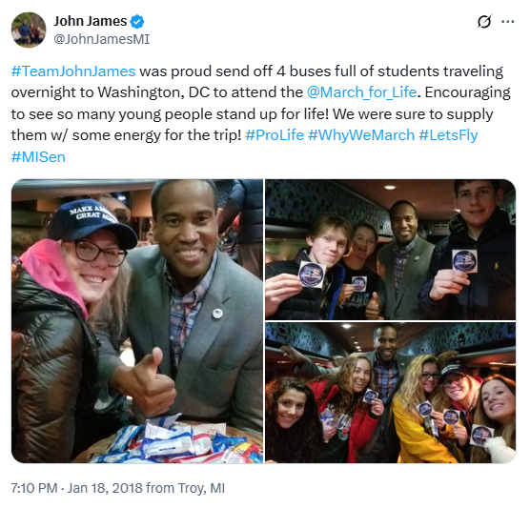
[Twitter, @John JamesMI, 1/18/18]
2018: John James Said It Was “Encouraging To See So Many Young People Stand Up For Life!” According to a tweet from John James, “#TeamJohn James was proud send off 4 buses full of students traveling overnight to Washington, DC to attend the @March_for_Life. Encouraging to see so many young people stand up for life! We were sure to supply them w/some energy for the trip! #ProLife #WhyWeMarch #LetsFly #MISen.” [ John James – Twitter, 1/18/18]

