Overview
In 2024, Jonathan Bush belittled food stamps as a “wealth distribution mechanism” and criticized government assistance while more than 77,400 households in Maine relied on SNAP to meet basic food needs.

Jonathan Bush Criticized Food Stamps While More Than 77,400 Maine Households Relied On SNAP To Afford Groceries And Feed Their Families

Jonathan Bush Criticized Food Stamps As A “Wealth Distribution Mechanism”
2024: Jonathan Bush Criticized Food Stamps As A “Wealth Distribution Mechanism” While Attacking Government Assistance. According to a Jonathan Bush interview with Barron’s, “HOST: But wait, wasn't Obamacare successful? And isn't that the government getting more into the business? BUSH: Obamacare was successful at wealth redistribution, and it's fun. They call it the ‘Affordable Care Act.’ They didn't call it the ‘Less Expensive Care Act.’ So Obamacare did nothing to make healthcare itself more affordable. They just put money, tax dollars, into it to subsidize people based on their income. So as a wealth distribution mechanism, I'd say it's, you know, better than food stamps. It's a very successful, popular wealth redistribution mechanism, as is, you know, Medicare.” [Jonathan Bush Interview – Barron’s, 10/17/24] (VIDEO)

More Than 77,400 Households In Maine Relied On SNAP
2023: Across Maine, 77,416 Households Relied On SNAP.
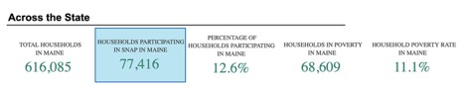
[U.S. Department of Agriculture, SNAP Community Characteristics, Accessed 1/15/26]

