Overview
In 2025, Burt Jones supported Trump’s “One Big Beautiful Bill,” which is estimated to kick 17 million Americans off their health insurance, including nearly 12 million Americans who rely on Medicaid. More than 624,000 Georgians could lose their health insurance as a result of the bill. More than 1.5 million Georgians were enrolled in Affordable Care Act Marketplace health insurance plans.
Jones opposed Medicaid expansion and touted similar work restrictions in Georgia’s Pathways Program, which cost an additional $54.2 million to implement. By 2034, more than 93,400 Medicaid recipients in Georgia were expected to lose coverage due to Trump’s tax bill.

Burt Jones Supported Stripping Health Insurance Away From Millions Of Americans Who Relied On Medicaid

Burt Jones Touted The “One Big Beautiful Bill,” Which Would Leave 17 Million Americans Without Health Insurance

Jones Touted The “One Big Beautiful Bill,” Claiming It Was The “LARGEST Tax Cut In History”
2025: Jones Touted The “One Big Beautiful Bill” With Vance, And Claimed It Was The “LARGEST Tax Cut In History.” According to Jones’ campaign Twitter, “Excited to welcome back to Georgia my friend @VP as we tout the Big Beautiful Bill for delivering the LARGEST tax cut in history! The Trump administration will bring Georgia into the Golden Age of manufacturing and high paying jobs!”
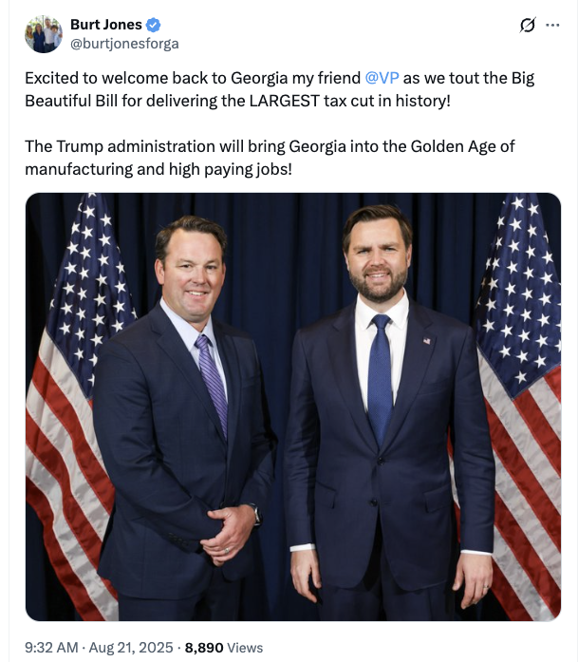
[Twitter, @burtjonesforga, 8/21/25]

At Least 17 Million Americans Would Lose Insurance Under Trump’s Tax Bill, Including Nearly 12 Million Medicaid Recipients
HEADLINE: “At Least 17 Million Americans Would Lose Insurance Under Trump Plan” [Washington Post, 7/1/25]
HEADLINE: “By The Numbers: Harmful Republican Megabill Favors The Wealthy And Leaves Millions Of Working Families Behind” [Center On Budget And Policy Priorities, 8/1/25]
HEADLINE: “House Republican Budget Takes Away Health Care, Food Aid To Pay For Expanded Tax Cuts For Wealthy” [Center On Budget And Policy Priorities, 2/21/25]
The Congressional Budget Office Estimated That 11.8 Million People Would Become Uninsured As A Result Of The Medicaid Cuts In Republicans’ Reconciliation Bill. According to the Washington Post, “The bill, which narrowly passed the Senate on Tuesday and now heads back to the House, would effectively accomplish what Republicans have long failed to do: unwind many of the key components of the ACA, President Barack Obama’s signature domestic achievement, which dramatically increased the number of Americans with access to health insurance. To start, the Congressional Budget Office estimated that the Senate version of the bill would result in 11.8 million more uninsured in 2034, mostly because of Medicaid cuts, compared with 10.9 million if the House version became law.” [Washington Post, 7/1/25]
The House GOP Budget Bill Made The 2017 Income Tax Breaks Permanent And Added An Estimated $3.8 Trillion To The National Debt Over 10 Years. According to CNN, “The package includes several controversial measures that would deeply cut into two of the nation’s key safety net programs – Medicaid and food stamps – while making permanent essentially all of the trillions of dollars of individual income tax breaks contained in the GOP’s 2017 Tax Cuts and Jobs Act. What’s more, it would fulfill Trump’s campaign promises to cut taxes on tips and overtime, albeit temporarily. The magnitude of the measures is evident in the estimates of the cost they would incur or the savings they would produce. […] The tax changes in the package would add $3.8 trillion to the nation’s debt over a decade, according to a Congressional Budget Office analysis released before last-minute changes were made to the bill.” [CNN, 5/28/25]
The Bill’s $50 Billion In Rural Hospital Relief Funding Would Not Come Close To The Gap Created By Medicaid Cuts, With 300 Rural Hospitals At “Immediate Risk” Of Closure. According to the Center For American Progress, “The OBBBA includes $50 billion in relief funding for rural hospitals over a five-year period to help reduce the disastrous impacts of the bill’s roughly $1 trillion in Medicaid cuts. As of May 2025, there were approximately 2,086 rural hospitals receiving $12.2 billion a year in net revenue from Medicaid. At the median, rural hospitals’ revenue from Medicaid is $3.9 million a year.Rural hospitals have some of the lowest operating margins in the nation, especially compared with urban hospitals, meaning that any reductions in revenue could lead to closures. The average operating margin for rural hospitals was 3.1 percent in 2023, with 44 percent of rural hospitals operating with negative margins. As a result, more than 300 rural hospitals are currently at ‘immediate risk’ of closure, especially now that the OBBBA is projected to cut Medicaid spending by $1.02 trillion. The relief fund designed to blunt the negative impacts caused by the bill would not come close to filling that gap. If every rural hospital in the country received an even share of the $50 billion in relief support, it would amount to only $4.5 million every year for five years. At the close of those five years, that funding would disappear altogether.” [Center For American Progress, 7/3/25]

More Than 624,000 Georgians Were Expected To Lose Health Care Coverage Under Trump’s “One Big Beautiful Bill”
Under The “One Big Beautiful Bill,” 624,029 Georgians Were Expected To Lose Their Health Care By 2034, Including 530,600 ACA Enrollees And 93,429 Medicaid Recipients. According to the Joint Economic Committee Minority,
District | State | Est. # Losing ACA Coverage | Est. # Losing Medicaid Coverage | Est. Total # Losing Insurance
GA-01 | Georgia | 33,000 | 7,364 | 40,364
GA-02 | Georgia | 38,300 | 9,245 | 47,545
GA-03 | Georgia | 31,400 | 5,947 | 37,347
GA-04 | Georgia | 44,500 | 6,726 | 51,226
GA-05 | Georgia | 41,200 | 5,928 | 47,128
GA-06 | Georgia | 31,000 | 2,617 | 33,617
GA-07 | Georgia | 62,000 | 6,807 | 68,807
GA-08 | Georgia | 33,400 | 8,318 | 41,718
GA-09 | Georgia | 40,800 | 6,639 | 47,439
GA-10 | Georgia | 31,400 | 6,337 | 37,737
GA-11 | Georgia | 33,900 | 4,462 | 38,362
GA-12 | Georgia | 32,600 | 8,326 | 40,926
GA-13 | Georgia | 45,300 | 7,370 | 52,670
GA-14 | Georgia | 31,800 | 7,343 | 39,143
All | Totals | 530,600 | 93,429 | 624,029
[Joint Economic Committee Minority, 6/25]
- The House GOP Budget Bill Was Estimated To Increase The Uninsured Population By 8.6 Million By 2034. According to CNN, “The Medicaid and Affordable Care Act provisions in the package could result in 8.6 million more people being uninsured in 2034, according to an early CBO estimate released by Democratic lawmakers. That number is expected to grow with the latest changes.” [CNN, 5/28/25]
- The House GOP Budget Bill Codified A Trump Administration Proposal That Restricted Access To The Affordable Care Act. According to CNN, “The bill also calls for codifying a Trump administration proposal that would make changes to the Affordable Care Act enrollment process, including shortening the open enrollment period and eliminating the ability of low-income Americans to sign up year-round.” [CNN, 5/28/25]
- New York Times Reported The $880 Billion In Cuts Required By The Republican Budget Proposal Would Have To Come From Medicaid, Medicare, Or CHIP. According to the New York Times, “The budget resolution itself is silent on whether Congress cuts Medicaid, which provides health coverage to 72 million poor and disabled Americans. But it instructs the House Energy and Commerce Committee, which has jurisdiction over the program, to cut spending by $880 billion over the next decade. If the committee can’t save at least that much, the entire effort could be imperiled because of the special process Congress is using to avoid a Senate filibuster. Ten other committees have their own instructions to follow, though none have been assigned with cutting nearly as much. It’s not so simple as finding the cuts elsewhere. The special process, known as budget reconciliation, means Republicans will have to find all $880 billion from within the Energy and Commerce Committee’s jurisdiction. That leaves them with fewer options than one might think. […] If Republicans want to avoid major cuts to Medicaid, the largest pot of available money is in the other big government health insurance program: Medicare. […] Even if the committee cuts everything that’s not health care to $0, it will still be more than $600 billion short. The committee could also save around $200 billion by eliminating the Children’s Health Insurance Program, but that option has not been raised by the budget committee or anyone in House leadership. […] Even if all of these cuts, revenues and rule cancellations from outside health care can pass muster, the committee will still be left with hundreds of billions of dollars to cut to hit its goal. Mathematically, the budget committee’s instructions mean the committee would need to make major cuts to either Medicare, Medicaid or both.” [New York Times, 2/25/25]

The “One Big Beautiful Bill” And The Expiring Affordable Care Act Tax Credits Would Result In 499,000 Uninsured Georgians By 2034
The “One Big Beautiful Bill” And The Expiring Affordable Care Act Tax Credits Would Result In An Additional 499,000 Uninsured Georgians By 2034. According to the Center For American Progress, “The One Big Beautiful Bill Act will increase the number of Americans without health coverage in every state Estimated increase in the uninsured population due to the OBBBA and the expiration of the ACA’s enhanced premium tax credits, 2034”
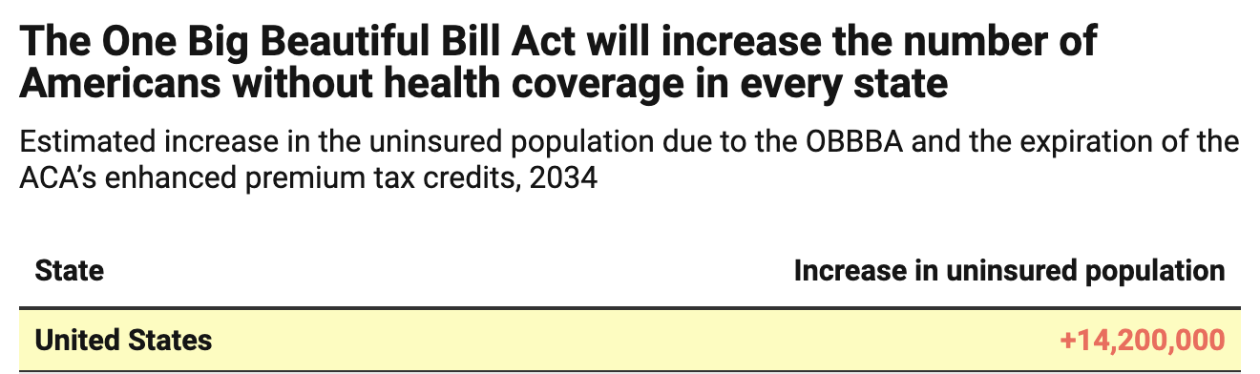
[Center For American Progress, 9/5/25]

December 2025: There Were 1,510,852 Georgians Enrolled In An Affordable Care Act Marketplace Plan
As Of December 2025, There Were 1,510,852 Individuals Enrolled In An Affordable Care Act Marketplace Plan In Georgia. According to KFF, in 2025, there were 1,510,852 individuals enrolled in affordable care act marketplace plan in Georgia.
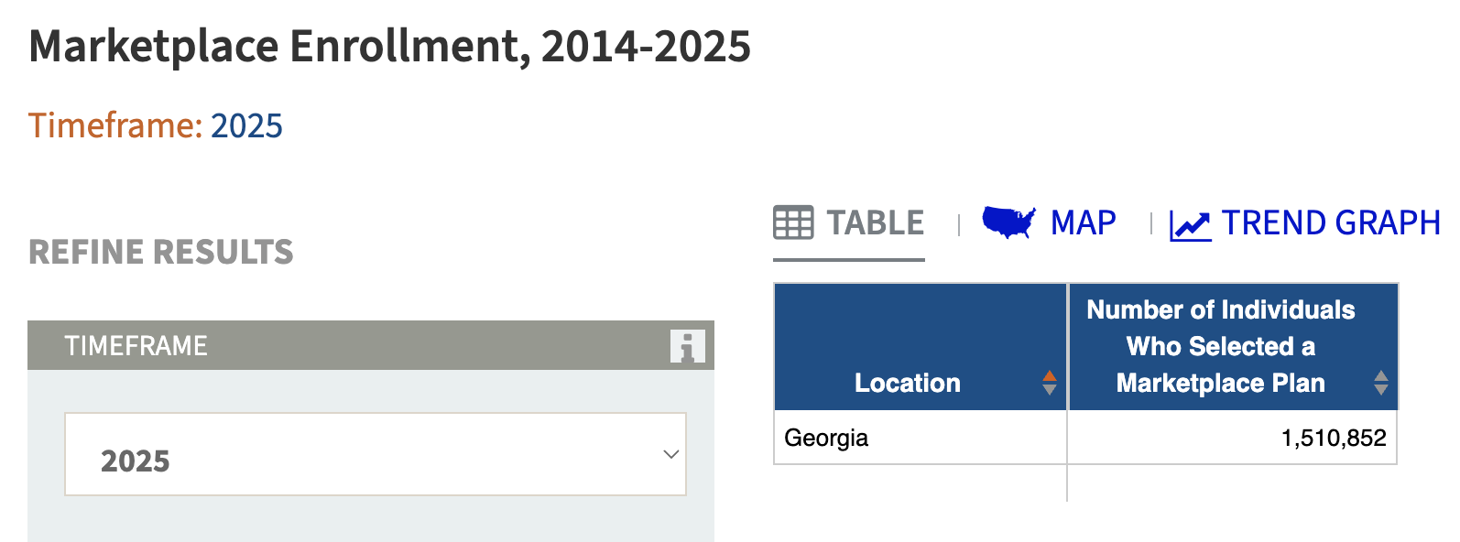
[KFF, Accessed 12/11/25]

Burt Jones Opposed Medicaid Expansion And Touted Medicaid Restrictions That Would Strip More Than 93,400 Georgians Of Their Medicaid

Burt Jones Opposed Medicaid Expansion And Supported Medicaid Work Requirements

Jones Touted That The Medicaid Work Requirements In Trump’s “Big Beautiful Bill” Were Similar To Georgia’s Pathways Program
July 2025: Jones Said He Did Not Support Medicaid Expansion And Touted That The Medicaid Work Requirements In Trump’s “One Big Beautiful Bill” Were Similar To Georgia’s Pathways Program. According to Jones on The Shelley Winter Show, “HOST: Before we went to break, we were talking about rural areas and Medicaid. Will you do Medicaid expansion here in Georgia as governor? JONES: No, no. And I think that Governor Kemp has been right spot on with his program that he’s put in place as far as the work procedure that these people need to have for Medicaid, in fact, and the Big Beautiful Bill that just passed at the federal level, we call it the Pathways program here in the state of Georgia. The federal program is going to mirror a lot of what we’re doing here in the state. And it also is going to give hospitals opportunity to get more funding because the way they’ve structured it and and the pathway programs that the Governor Kemp has championed is going to help rural communities and rural health care providers receive more money through the Medicaid program, which is a good thing for the state.” [Burt Jones Interview – Shelley Winter Show, 7/8/25] (AUDIO)
- Georgia Was The Only State With An Active Work Requirements System For Medicaid Eligibility Which Required Recipients To Report Their Working Hours Once A Month. According to NPR, “Now that Republicans’ big tax-and-spending bill has become law, there will be new bureaucratic hurdles for millions of Americans who rely on Medicaid. The new law contains a provision that in most states, for the first time, low-income adults will have to start meeting work requirements to keep their health coverage. Some states have already tried this, but Georgia is the only state that currently has an active system using work requirements to establish Medicaid eligibility — and recipients must report to the system once a month.” [NPR, 7/28/25]
- The U.S. Government Accountability Office Found Georgia’s Medicaid Work Requirements Cost An Additional $54.2 Million In Administrative Changes, $47.4 Million Of Which Came From Federal Funds. According to the U.S. Government Accountability Office, “In 2023, Georgia began requiring some Medicaid beneficiaries to work or engage in other activities like vocational training to keep their Medicaid coverage. The new requirements necessitated changes to the state’s eligibility and enrollment system, outreach efforts, and other administrative activities. To make these administrative changes, the state spent $54.2 million between October 2020 and March 2025. Most of these funds—$47.4 million—came from the federal government. We found weaknesses in federal oversight of this spending.” [U.S. Government Accountability Office, 9/3/25]

Under The “One Big Beautiful Bill,” 93,429 Medicaid Recipients In Georgia Were Expected To Lose Their Health Care By 2034
Under The “One Big Beautiful Bill,” 624,029 Georgians Were Expected To Lose Their Health Care By 2034, Including 530,600 ACA Enrollees And 93,429 Medicaid Recipients. [Joint Economic Committee Minority, 6/25]

The Affordable Care Act Allowed States To Expand Medicaid, Which Dramatically Lowered The Uninsured Rate Among Low-Income Workers
The Affordable Care Act Allowed States To Expand Medicaid, And States That Expanded Medicaid Dramatically Lowered The Number Of People Without Health Insurance. According to the Center on Budget and Policy Priorities, “The Affordable Care Act (ACA) permits states to expand Medicaid coverage to adults with incomes up to 138 percent of the poverty level (about $20,780 annually for an individual or $35,630 for a family of three). States that have adopted the expansion have dramatically lowered their uninsured rates. Extensive research finds that the people who gained coverage have grown healthier and more financially secure, while long-standing racial inequities in health outcomes, coverage, and access to care have shrunk.” [Center On Budget And Policy Priorities, 6/14/24]
- The Uninsured Rate Among Low-Income Workers Fell From 38 Percent In 2013 To 17 Percent In 2022, Which Coincided With Implementation Of Medicaid Expansion. According to the Center on Budget and Policy Priorities, “Millions of workers have gained coverage through Medicaid expansion, including people working in industries that provide critical goods and services such as health care, transportation, grocery stores, food manufacturers, and child care. Many have no access to health coverage through their jobs. In expansion states, the uninsured rate among low-income workers fell from 38 percent in 2013 to 17 percent in 2022; this sharp decline coincided with a large increase in the share of low-income workers enrolled in Medicaid.[16] In non-expansion states, the uninsured rate among low-income workers fell much less, from 46 percent to 31 percent. (See Figure 3.)” [Center On Budget And Policy Priorities, 6/14/24]

