Overview
In 2025, Burt Jones supported Trump’s “One Big Beautiful Bill,” which repealed clean energy tax credits and made them harder to access, threatening clean energy jobs in Georgia. Since the beginning of the Trump administration, $2.9 billion in clean energy projects that were projected to create 1,100 jobs in Georgia were canceled.

Burt Jones Opposed Protecting Georgia’s Clean Energy Jobs

Jones Supported The Republican Reconciliation Bill That Cut Clean Energy Tax Credits That Supported Georgia Jobs

Jones Supported The “One Big Beautiful Bill,” Which Cut Inflation Reduction Act Clean Energy Tax Credits And Made It Harder For Projects To Qualify For Clean Energy Tax Credits
2025: Jones Touted The “One Big Beautiful Bill” With Vance, And Claimed It Was The “LARGEST Tax Cut In History.” According to Jones’ campaign Twitter, “Excited to welcome back to Georgia my friend @VP as we tout the Big Beautiful Bill for delivering the LARGEST tax cut in history! The Trump administration will bring Georgia into the Golden Age of manufacturing and high paying jobs!”
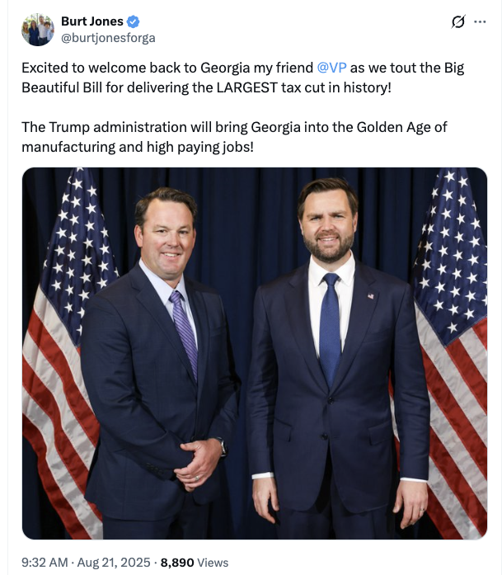
[Twitter, @burtjonesforga, 8/21/25]
The Republican Reconciliation Bill Restricted The Ability Of Projects To Qualify For Certain Clean Energy Tax Credits And Repealed Electric Vehicle Tax Credits. According to Utility Dive, "The bill restricts the ability of projects to qualify for the tech-neutral clean electricity 45Y production tax credit and 48E investment tax credit, shortens the timeline for those credits, and ends the 25D residential solar credit after this year. The 25E, 30D, 30C and 45W electric vehicle credits will terminate after Sept. 30. While clean energy advocates and congressional Democrats maintain that the final version of the bill goes too far in slashing IRA credits, some Republicans wanted to see more significant cuts." [Utility Dive, 7/3/25]
- The Final Republican Reconciliation Bill Allowed Projects To Avoid A Requirement That They Be In Service By 2027 To Qualify For Certain Credits If They Began Construction Within A Year Of The Bill Being Signed. According to Utility Dive, "Before the House Freedom Caucus reached an agreement with House leadership to vote in favor of the bill, the caucus circulated a memo that criticized the Senate’s version of the bill for offering an exemption from the House’s onerous requirement that clean energy projects be placed in service by 2027 to qualify for the 45Y and 48E credits. The Senate version allows projects to avoid this requirement if they begin construction within a year after the bill is signed into law." [Utility Dive, 7/3/25]

Trump’s Tax Bill Cut Federal Tax Credits For Wind, Solar, Storage, And Other Clean Energy Projects, Which Would Kill Tens Of Thousands Of Jobs
The House Republican Budget Bill Included Cuts To Federal Tax Credits For Wind, Solar, Storage, And Other Clean Energy Projects. According to Utility Dive, "House Republicans on Thursday morning narrowly passed a sweeping budget bill that guts federal support for wind, solar, storage and other clean energy industries. The bill terminates most technology-neutral clean energy tax credits for projects placed in service after 2028 and those that begin construction more than 60 days after the bill’s passage. It also tightens restrictions on foreign entities’ involvement in projects, creating a ‘truly untenable’ situation for developers, Jefferies analysts said Thursday. Nuclear projects have more time to qualify for the credit." [Utility Dive, 6/3/25]
One Trade Association CEO Said The Bill Would Weaken Power Systems, Send Shockwaves Through The U.S. Economy, And Kill Tens Of Thousands Of Jobs. According to Utility Dive, "The House bill ‘abruptly dismantles bipartisan, long-standing tax policy that has catalyzed billions in private investment for affordable, reliable energy while sparking a rebirth of manufacturing across America,’ AEU President and CEO Heather O’Neill said. ‘If enacted as written, this bill will weaken our power system and send shockwaves throughout the U.S. economy by raising electricity prices, killing tens of thousands of jobs and ceding energy dominance to China.’" [Utility Dive, 5/22/25]

Since The Start Of 2025, Clean Energy Projects In Georgia That Were Supposed To Have Created Hundreds Of Jobs Were Canceled
November 2025: More Than $2.9 Billion In Planned Clean Energy Projects In Georgia Were Canceled Since January, Which Were Expected To Generate Nearly 1,100 Jobs. According to The Telegraph, “Since January, companies have scrapped more than $2.9 billion in planned clean-energy factories and other projects in Georgia that were expected to generate nearly 1,100 jobs, according to separate E2 research.” [Telegraph, 11/19/25]
- 2024: Georgia Had More Than 85,500 Clean Energy Workers, And The Industry Grew “More Than Five Times Faster Than The Rest Of The State’s Economy.” According to The Telegraph, “Clean energy jobs in Georgia grew more than five times faster than the rest of the state’s economy in 2024, raising the total number of clean energy workers in the state to over 85,500, according to a new report released Wednesday by E2, a national, nonpartisan business group, and its partners at Georgia Solar Energy Association, Black Owners of Solar Services and Georgia Cleantech Innovation Hub.” [Telegraph, 11/19/25]

