Overview
Burt Jones was an out-of-touch anti-abortion extremist.
Jones supported Georgia’s 2019 “heartbeat” abortion ban, which banned abortion before many people know they are pregnant, and celebrated the Supreme Court Dobbs decision that allowed the ban to go into effect.
Jones attended an anti-choice event with extreme anti-abortion organization Frontline Policy Action. Frontline Policy Action’s mission was to educate others on “the reality of the unborn and the evil of abortion.” The organization also opposed increasing access to birth control, saying it would cause “uninhibited sexual self-expression” and claiming the birth control pill had “lifelong effects on fertility.”

Burt Jones Supported Georgia’s Extreme Abortion Ban And Supported Frontline Policy Action, An Organization That Deemed Abortion As “Evil”

Burt Jones Supported Georgia’s 2019 “Heartbeat” Abortion Ban

Jones Supported Georgia’s 2019 Abortion Ban, Saying It “Speaks For Itself”
January 2023: Jones Supported Georgia’s 2019 Abortion Ban, Saying It “Speaks For Itself” And Was “In The Hands Of The State Supreme Court.” According to Axios, “Jones said he has no intention of pushing for further abortion restrictions. The state’s 2019 ban ‘speaks for itself,’ he said, is now in the hands of the state supreme court.” [Axios, 1/11/23]
- Georgia’s 2019 Abortion Law Banned Abortion “When Cardiac Activity Is Detected, […] At Approximately Six Weeks Of Pregnancy And Before Many People Know They Are Pregnant.” According to Axios, “The law took effect in July, shortly after the Supreme Court overturned Roe v. Wade. It had been blocked since 2019.The law bans abortion when cardiac activity is detected, which is at approximately six weeks of pregnancy and before many people know they are pregnant.” [Axios, 11/23/22]

Jones Praised The Supreme Court’s Dobbs Decision Which Allowed Georgia’s “Heartbeat” Ban To Go Into Effect
June 2024: Jones Praised The Dobbs Decision For Saving “Countless Lives,” And Claimed The “Radical Left” Wanted “Abortion On Demand, With No Limits, Up Until The Moment Of Birth.” According to Jones’ Facebook, “Two years ago, The Dobbs Supreme Court decision saved countless lives. The radical left pushes for abortion on demand, with no limits, up until the moment of birth—extreme and inhumane. The Supreme Court rightly returned power to the states to make decisions for their citizens. Despite Democrat lies, the I will always fight for every stage of life.”
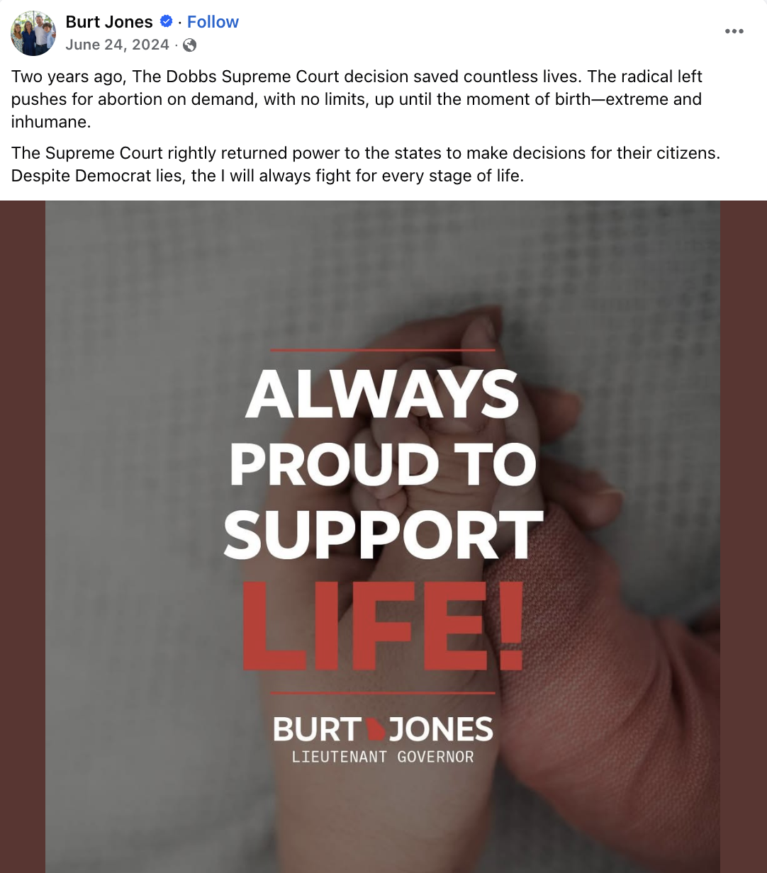
[Facebook, Burt Jones, 6/24/24]

Burt Jones Attended A Frontline Policy Action Event, An ORganization That Called Abortion “Evil” And opposed Contraception Access

In February 2024, Jones Attended Frontline Policy Action’s Pro-Life Pastor’s Prayer Breakfast
February 2024: Jones Attended Frontline Policy Action’s Pro-Life Pastor’s Prayer Breakfast. According to Jones’ Facebook, “Great to be with Frontline Policy Action this morning at their Pro-Life Pastor’s Prayer Breakfast. #gapol”
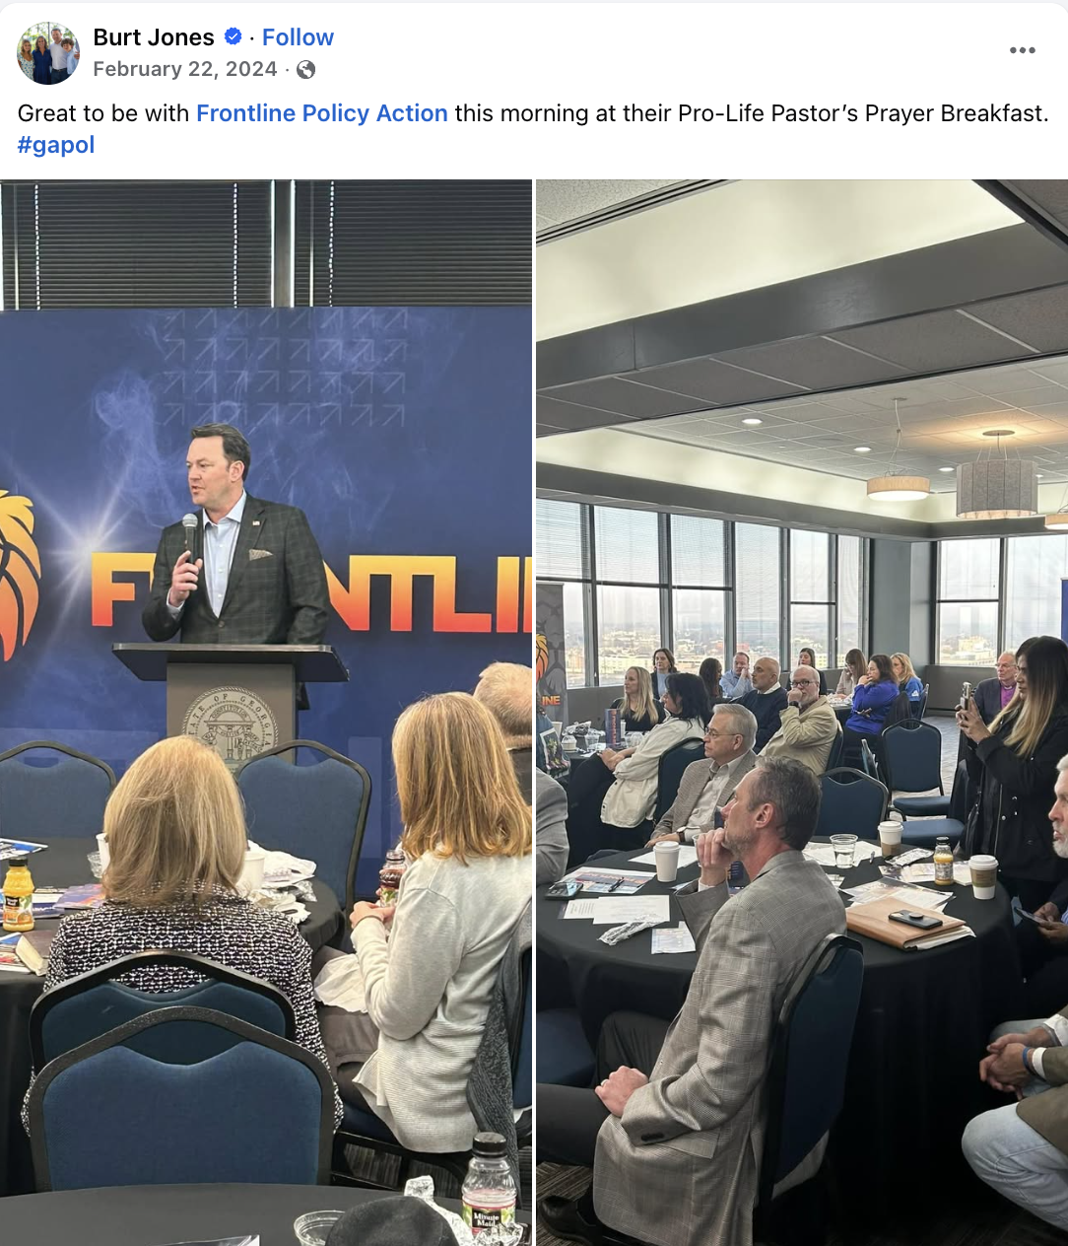
[Facebook, Burt Jones, 2/22/24]

Frontline Policy Action Pledged To Educate Others On “The Reality Of The Unborn And The Evil Of Abortion”
Frontline Policy Action Said Abortion “Brutally Robbed” The Life Of A Fetus And Pledged To Educate Others On “The Reality Of The Unborn And The Evil Of Abortion.” According to Frontline Policy Action’s Facebook, “The horror of abortion is that an innocent human being - fully human, fully valuable - is brutally robbed of life in the very place it should be most sheltered and secure. We must continue to engage our neighbors and our communities on the reality of the unborn and the evil of abortion, sharing truth with compassion, so that LIFE is cherished in our culture once more.”
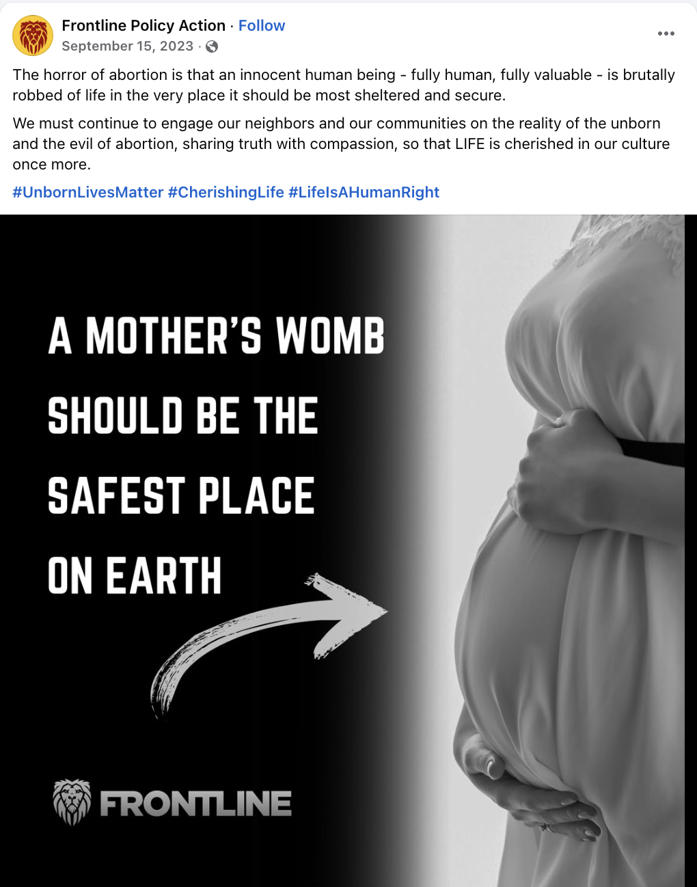
[Facebook, Frontline Policy Action, 9/15/23]

Frontline Policy Action Opposed Increasing Access To Birth Control
July 2023: Frontline Policy Action Opposed Over-The-Counter Birth Control, Saying It Would Cause “More Uninhibited Sexual Self-Expression,” And Claimed Birth Control Pills Had “A *Lifelong* Effect On Fertility.” According to Frontline Policy Action’s Facebook, “The radical, pro-abortion left is exultant today at the FDA's reckless permitting of over-the-counter birth control. Instead of celebrating the gift of life and encouraging committed relationships that protect both men and women, NARAL, Planned Parenthood, and other members of the Big Abortion Lobby merely want to see fewer children and more uninhibited sexual self-expression. The reality is that according to the most recent studies, birth control pills increase the risk of breast cancer by up to 30%, besides a host of other side effects up to and including a *lifelong* effect on fertility. Being on this medication in the absence of medical advice is dangerous, and could lead to other forms of abuse as well. This is not loving and caring for women, it is just another way for pharmaceutical companies to line their pockets while endangering women and girls. Yet another step down the path of the destruction of life by the Biden Administration.” [Facebook, Frontline Policy Action, 7/13/23]

