Overview
In 2025, Raffensperger supported Trump’s “One Big Beautiful Bill,” which made the largest cut to SNAP in history. Nearly 514,000 households in Georgia relied on SNAP to afford groceries.

Raffensperger Supported A Bill That Would Strip SNAP Benefits From Millions Of Americans And Make Food More Expensive, Which Could Impact Nearly 514,000 Georgian Households

Raffensperger Supported The Republican Reconciliation Bill That Cut Snap Benefits For Millions

Raffensperger Supported Trump’s “One Big Beautiful Bill,” Which Contained The Largest SNAP Cut In History
September 2025: Raffensperger Said Trump’s “One Big Beautiful Bill” Was “Needed” To Extend Middle Class Tax Cuts, And Said The Bill Helped “Every Small Business Owner” And “Every Person That Had Personal Income Tax.” According to Raffensperger in an interview with Politically Georgia, “HOST: Where do you stand on the big, beautiful bill or whatever the president is calling it these days? Because we're already seeing Democrats running for governor, running for other higher offices campaigning against that, particularly the the Medicaid cuts that they fear are already compounding problems that rural hospitals and not just rural hospitals, just hospitals in general are already facing. RAFFENSPERGER: Well, I think we need to understand that the key part of that bill was extending middle class tax cuts, The middle-class tax cuts were going to expire. And so that needed to extend it out because otherwise it actually was a tax increase. They were rolled back in 2017. This was just a continuation of those tax cuts that I think helps every small business owner because they report their income on their personal taxes. And every person that had personal income tax, that was huge.” [Brad Raffensperger Interview – Politically Georgia, 9/29/25] (AUDIO)
- HEADLINE: "Trump’s ‘Big Beautiful Bill’ Cuts Food Stamps For Millions — The Average Family May Lose $146 Per Month, Report Finds" [CNBC, 7/10/25]
- The GOP Reconciliation Bill Would Cut SNAP Funding By $186 Billion, Which CBPP Said Constituted The “Largest Cut To SNAP In History.” According to the Center on Budget and Policy Priorities, “The Senate Republican leadership’s reconciliation bill would dramatically raise costs and reduce food assistance for millions of people by cutting federal funding for the Supplemental Nutrition Assistance Program (SNAP) by $186 billion through 2034, according to the Congressional Budget Office (CBO), about 20 percent — the largest cut to SNAP in history. These cuts would increase poverty, food insecurity, and hunger, including among children. The so-called ‘Big Beautiful Bill’ is anything but beautiful; it would cause widespread harm by making massive cuts to Medicaid and SNAP, which would raise costs on families and make it much harder for them to afford the high cost of health care and groceries.” [Center On Budget And Policy Priorities, 6/30/25]
- 22.3 Million Families Would Lose Some Or All Of Their SNAP Benefits, With 5.3 Million Families Losing More Than $25 In Benefits Per Month, And Of Those Families, The Average Loss In Benefits Would Be $146. According to the Urban Institute, “Our preliminary estimates of the SNAP policies in the Senate bill show the following: 22.3 million US families would be affected, losing some or all of their SNAP benefits. Of the total affected families, 5.3 million would lose at least $25 in SNAP benefits per month. Among these families, 3.3 million are families with children, 3.5 million are working families, and 1.7 million are families with a full-time full-year worker. Families losing at least $25 per month would lose $146 per month on average ($1,752 for a full-year recipient). At the state level, average monthly benefit losses for families losing at least $25 per month would range from $72 in Kansas ($864 annually) to $231 in the District of Columbia ($2,772 annually).” [Urban Institute, 7/2/25]
- States That Could Not Afford To Pay The New Mandated SNAP Cost Shares May Cut The Program Entirely. According to CNBC, “Additionally, the legislation requires states to pay for a portion of benefit costs, ranging from 5% to 15%, if their payment error rate is at or over 6%. The error rates measure the accuracy of states’ eligibility and benefit payments. In fiscal year 2024, states had a 10.9% average payment error rate, with many states over 6%, according to the Department of Agriculture. States that can’t pay those shares may have to cut SNAP benefits or opt out of the program entirely, according to the Center on Budget and Policy Priorities.” [CNBC, 7/10/25]

513,900 Households In Georgia Relied On SNAP
2023: Across Georgia, 513,900 Households Relied On SNAP.
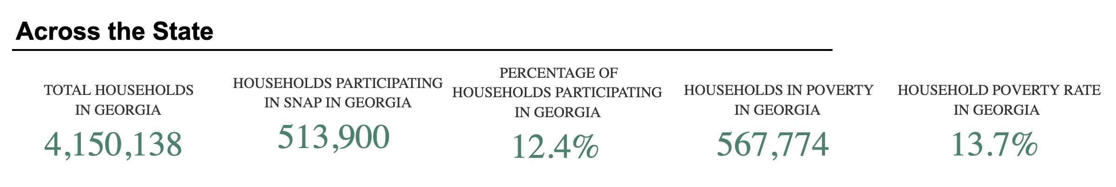
[U.S. Department of Agriculture, SNAP Community Characteristics, Accessed 12/11/25]

