Overview
In 2025, Raffensperger supported Trump’s “One Big Beautiful Bill,” which is estimated to kick 17 million Americans off their health insurance, including nearly 12 million Americans who rely on Medicaid. More than 624,000 Georgians could lose their health insurance as a result of the bill. More than 1.5 million Georgians were enrolled in Affordable Care Act Marketplace health insurance plans.
Raffensperger supported Medicaid work requirements, suggesting that Medicaid recipients who did not work did not have “pride in themselves,” and presented “private free market solutions” as an alternative to Medicaid expansion. By 2034, more than 93,400 Medicaid recipients in Georgia were expected to lose coverage due to Trump’s tax bill.

Raffensperger Supported Taking Health Insurance Away From Millions Of Americans Who Relied On Medicaid

Raffensperger Praised Trump’s “One Big Beautiful Bill,” Which Included Devastating Health Care Cuts To Fund Tax Cuts For The Wealthy

Raffensperger Praised Trump’s “One Big Beautiful Bill,” Which Would Cause 17 Million Americans To Lose Their Health Care
September 2025: Raffensperger Said Trump’s “One Big Beautiful Bill” Was “Needed” To Extend Middle Class Tax Cuts, And Said The Bill Helped “Every Small Business Owner” And “Every Person That Had Personal Income Tax.” According to Raffensperger in an interview with Politically Georgia, “HOST: Where do you stand on the big, beautiful bill or whatever the president is calling it these days? Because we're already seeing Democrats running for governor, running for other higher offices campaigning against that, particularly the the Medicaid cuts that they fear are already compounding problems that rural hospitals and not just rural hospitals, just hospitals in general are already facing. RAFFENSPERGER: Well, I think we need to understand that the key part of that bill was extending middle class tax cuts, The middle-class tax cuts were going to expire. And so that needed to extend it out because otherwise it actually was a tax increase. They were rolled back in 2017. This was just a continuation of those tax cuts that I think helps every small business owner because they report their income on their personal taxes. And every person that had personal income tax, that was huge.” [Brad Raffensperger Interview – Politically Georgia, 9/29/25] (AUDIO)
- HEADLINE: "At Least 17 Million Americans Would Lose Insurance Under Trump Plan" [Washington Post, 7/1/25]
- HEADLINE: “By The Numbers: Harmful Republican Megabill Favors The Wealthy And Leaves Millions Of Working Families Behind” [Center On Budget And Policy Priorities, 8/1/25]
- The Congressional Budget Office Estimated That 11.8 Million People Would Become Uninsured As A Result Of The Medicaid Cuts In Republicans’ Reconciliation Bill. According to the Washington Post, "The bill, which narrowly passed the Senate on Tuesday and now heads back to the House, would effectively accomplish what Republicans have long failed to do: unwind many of the key components of the ACA, President Barack Obama’s signature domestic achievement, which dramatically increased the number of Americans with access to health insurance. To start, the Congressional Budget Office estimated that the Senate version of the bill would result in 11.8 million more uninsured in 2034, mostly because of Medicaid cuts, compared with 10.9 million if the House version became law." [Washington Post, 7/1/25]
- The Bill’s $50 Billion In Rural Hospital Relief Funding Would Not Come Close To The Gap Created By Medicaid Cuts, With 300 Rural Hospitals At “Immediate Risk” Of Closure. According to the Center For American Progress, “The OBBBA includes $50 billion in relief funding for rural hospitals over a five-year period to help reduce the disastrous impacts of the bill’s roughly $1 trillion in Medicaid cuts. As of May 2025, there were approximately 2,086 rural hospitals receiving $12.2 billion a year in net revenue from Medicaid. At the median, rural hospitals’ revenue from Medicaid is $3.9 million a year.Rural hospitals have some of the lowest operating margins in the nation, especially compared with urban hospitals, meaning that any reductions in revenue could lead to closures. The average operating margin for rural hospitals was 3.1 percent in 2023, with 44 percent of rural hospitals operating with negative margins. As a result, more than 300 rural hospitals are currently at ‘immediate risk’ of closure, especially now that the OBBBA is projected to cut Medicaid spending by $1.02 trillion. The relief fund designed to blunt the negative impacts caused by the bill would not come close to filling that gap. If every rural hospital in the country received an even share of the $50 billion in relief support, it would amount to only $4.5 million every year for five years. At the close of those five years, that funding would disappear altogether.” [Center For American Progress, 7/3/25]

More Than 624,000 Georgians Were Expected To Lose Health Care Coverage Under Trump’s “One Big Beautiful Bill”
Under The “One Big Beautiful Bill,” 624,029 Georgians Were Expected To Lose Their Health Care By 2034, Including 530,600 ACA Enrollees And 93,429 Medicaid Recipients. According to the Joint Economic Committee Minority,
District | State | Est. # Losing ACA Coverage | Est. # Losing Medicaid Coverage | Est. Total # Losing Insurance
GA-01 | Georgia | 33,000 | 7,364 | 40,364
GA-02 | Georgia | 38,300 | 9,245 | 47,545
GA-03 | Georgia | 31,400 | 5,947 | 37,347
GA-04 | Georgia | 44,500 | 6,726 | 51,226
GA-05 | Georgia | 41,200 | 5,928 | 47,128
GA-06 | Georgia | 31,000 | 2,617 | 33,617
GA-07 | Georgia | 62,000 | 6,807 | 68,807
GA-08 | Georgia | 33,400 | 8,318 | 41,718
GA-09 | Georgia | 40,800 | 6,639 | 47,439
GA-10 | Georgia | 31,400 | 6,337 | 37,737
GA-11 | Georgia | 33,900 | 4,462 | 38,362
GA-12 | Georgia | 32,600 | 8,326 | 40,926
GA-13 | Georgia | 45,300 | 7,370 | 52,670
GA-14 | Georgia | 31,800 | 7,343 | 39,143
All | Totals | 530,600 | 93,429 | 624,029

[Joint Economic Committee Minority, 6/25]
- The House GOP Budget Bill Was Estimated To Increase The Uninsured Population By 8.6 Million By 2034. According to CNN, “The Medicaid and Affordable Care Act provisions in the package could result in 8.6 million more people being uninsured in 2034, according to an early CBO estimate released by Democratic lawmakers. That number is expected to grow with the latest changes.” [CNN, 5/28/25]
- The House GOP Budget Bill Codified A Trump Administration Proposal That Restricted Access To The Affordable Care Act. According to CNN, “The bill also calls for codifying a Trump administration proposal that would make changes to the Affordable Care Act enrollment process, including shortening the open enrollment period and eliminating the ability of low-income Americans to sign up year-round.” [CNN, 5/28/25]
- The House GOP Budget Bill Made The 2017 Income Tax Breaks Permanent And Added An Estimated $3.8 Trillion To The National Debt Over 10 Years. According to CNN, “The package includes several controversial measures that would deeply cut into two of the nation’s key safety net programs – Medicaid and food stamps – while making permanent essentially all of the trillions of dollars of individual income tax breaks contained in the GOP’s 2017 Tax Cuts and Jobs Act. What’s more, it would fulfill Trump’s campaign promises to cut taxes on tips and overtime, albeit temporarily. The magnitude of the measures is evident in the estimates of the cost they would incur or the savings they would produce. […] The tax changes in the package would add $3.8 trillion to the nation’s debt over a decade, according to a Congressional Budget Office analysis released before last-minute changes were made to the bill.” [CNN, 5/28/25]
- HEADLINE: "House Republican Budget Takes Away Health Care, Food Aid To Pay For Expanded Tax Cuts For Wealthy" [Center on Budget and Policy Priorities, 2/21/25]
- New York Times Reported The $880 Billion In Cuts Required By The Republican Budget Proposal Would Have To Come From Medicaid, Medicare, Or CHIP. According to the New York Times, "The budget resolution itself is silent on whether Congress cuts Medicaid, which provides health coverage to 72 million poor and disabled Americans. But it instructs the House Energy and Commerce Committee, which has jurisdiction over the program, to cut spending by $880 billion over the next decade. If the committee can’t save at least that much, the entire effort could be imperiled because of the special process Congress is using to avoid a Senate filibuster. Ten other committees have their own instructions to follow, though none have been assigned with cutting nearly as much. It’s not so simple as finding the cuts elsewhere. The special process, known as budget reconciliation, means Republicans will have to find all $880 billion from within the Energy and Commerce Committee’s jurisdiction. That leaves them with fewer options than one might think. […] If Republicans want to avoid major cuts to Medicaid, the largest pot of available money is in the other big government health insurance program: Medicare. […] Even if the committee cuts everything that’s not health care to $0, it will still be more than $600 billion short. The committee could also save around $200 billion by eliminating the Children’s Health Insurance Program, but that option has not been raised by the budget committee or anyone in House leadership. […] Even if all of these cuts, revenues and rule cancellations from outside health care can pass muster, the committee will still be left with hundreds of billions of dollars to cut to hit its goal. Mathematically, the budget committee’s instructions mean the committee would need to make major cuts to either Medicare, Medicaid or both." [New York Times, 2/25/25]

December 2025: There Were 1,510,852 Georgians Enrolled In An Affordable Care Act Marketplace Plan
As Of December 2025, There Were 1,510,852 Individuals Enrolled In An Affordable Care Act Marketplace Plan In Georgia. According to KFF, in 2025, there were 1,510,852 individuals enrolled in affordable care act marketplace plan in Georgia.
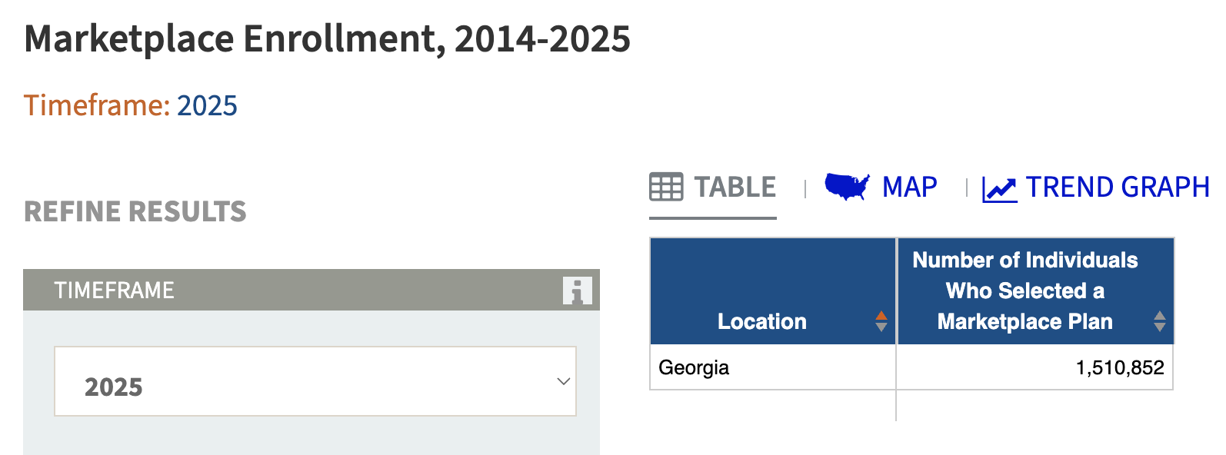
[KFF, Accessed 12/11/25]

The “One Big Beautiful Bill” And The Expiring Affordable Care Act Tax Credits Would Result In 499,000 Uninsured Georgians By 2034
The “One Big Beautiful Bill” And The Expiring Affordable Care Act Tax Credits Would Result In An Additional 499,000 Uninsured Georgians By 2034. According to the Center For American Progress, “The One Big Beautiful Bill Act will increase the number of Americans without health coverage in every state Estimated increase in the uninsured population due to the OBBBA and the expiration of the ACA’s enhanced premium tax credits, 2034”
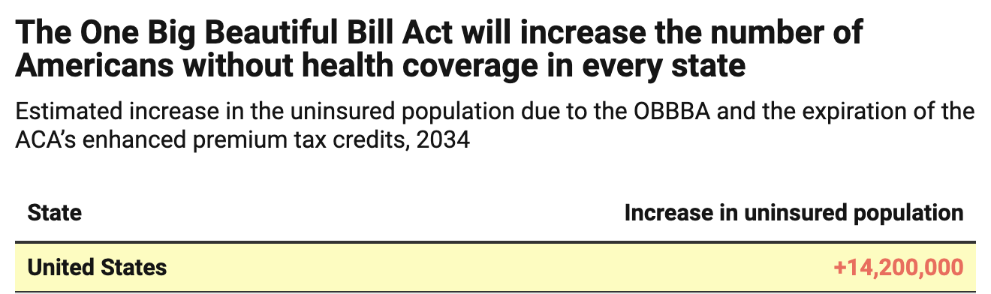
[Center For American Progress, 9/5/25]

Raffensperger Preferred “Private Free Market Solutions” To Medicaid Expansion, And Supported Medicaid Restrictions That Would Strip Medicaid From More Than 93,400 Georgians

Raffensperger Supported Medicaid Work Requirements And Preferred “Private Free Market Solutions” To Medicaid Expansion
September 2025: Raffensperger Supported Medicaid Work Requirements Because “Under The Biden Administration, You Had Able Bodied People That Were Sitting At Home Collecting A Government Benefit,” While Georgians Who “Had Pride In Themselves” Worked. According to Raffensperger in an interview with Politically Georgia, “I think that if you're able bodied, you should be working. And you look at a lot of what happened under the Biden administration, you had able bodied people that were sitting at home collecting a government benefit. Meanwhile, some hardworking Georgian is out there, pulling down not just one job two jobs to make ends meet. Because why? Because they had pride in themselves.” [Brad Raffensperger Interview – Politically Georgia, 9/29/25] (AUDIO)
September 2025: Raffensperger Dodged A Question On Whether He Supported Medicaid Expansion To Help Georgia Hospitals, Instead Saying That People Working On “Private Free Market Solutions” Should “Have A Seat At The Table.” According to Raffensperger in an interview with Politically Georgia, “HOST: Growing number of rank-and-file Republicans are supportive of Medicaid expansion to help solve some of those problems that smaller and urban medical facilities are facing. How do you see that issue? RAFFENSPERGER: There's a lot of people have been working on a private free market solutions, and I think that we need to let them have a seat at the table and we'll come up with a great plan, with some great ideas.” [Brad Raffensperger Interview – Politically Georgia, 9/29/25] (AUDIO)

Under The “One Big Beautiful Bill,” 93,429 Medicaid Recipients In Georgia Were Expected To Lose Their Health Care By 2034
Under The “One Big Beautiful Bill,” 624,029 Georgians Were Expected To Lose Their Health Care By 2034, Including 530,600 ACA Enrollees And 93,429 Medicaid Recipients. [Joint Economic Committee Minority, 6/25]

The Affordable Care Act Allowed States To Expand Medicaid, Which Dramatically Lowered The Uninsured Rate Among Low-Income Workers
The Affordable Care Act Allowed States To Expand Medicaid, And States That Expanded Medicaid Dramatically Lowered The Number Of People Without Health Insurance. According to the Center on Budget and Policy Priorities, "The Affordable Care Act (ACA) permits states to expand Medicaid coverage to adults with incomes up to 138 percent of the poverty level (about $20,780 annually for an individual or $35,630 for a family of three). States that have adopted the expansion have dramatically lowered their uninsured rates. Extensive research finds that the people who gained coverage have grown healthier and more financially secure, while long-standing racial inequities in health outcomes, coverage, and access to care have shrunk." [Center On Budget And Policy Priorities, 6/14/24]
- The Uninsured Rate Among Low-Income Workers Fell From 38 Percent In 2013 To 17 Percent In 2022, Which Coincided With Implementation Of Medicaid Expansion. According to the Center on Budget and Policy Priorities, "Millions of workers have gained coverage through Medicaid expansion, including people working in industries that provide critical goods and services such as health care, transportation, grocery stores, food manufacturers, and child care. Many have no access to health coverage through their jobs. In expansion states, the uninsured rate among low-income workers fell from 38 percent in 2013 to 17 percent in 2022; this sharp decline coincided with a large increase in the share of low-income workers enrolled in Medicaid.[16] In non-expansion states, the uninsured rate among low-income workers fell much less, from 46 percent to 31 percent. (See Figure 3.)" [Center On Budget And Policy Priorities, 6/14/24]

