Overview
Taylor Robson waited twice for Trump to speak out about the Epstein files before offering her own opinion, and in both cases, she merely agreed with what Trump supported releasing at the time.
Taylor Robson first spoke on the matter in August 2025 after Trump called to release the Epstein grand jury records, which Robson supported. However, she followed up her support insisting that the Democrats’ interest in the Epstein files was “a distraction from President Trump’s historic first seven months.”
In November 2025, Taylor Robson once again supported Trump decision to finally release the Epstein files, saying she stood with Trump’s “call for transparency.”

Taylor Robson Only Called For The Release Of The Epstein Files After Trump Signaled To House Republicans That He Approved

Taylor Robson Was Silent On The Epstein Files Until Trump Called For Their Release, And Said The Investigation Was A “Distraction” From Trump’s Successes

In August 2025, Taylor Robson “Broke Her Silence” On The Epstein Files And Agreed With Trump’s Call To Release The Grand Jury Records
August 2025: Taylor Robson “Broke Her Silence” On The Epstein Files And Agreed With Trump’s Call To Release The Grand Jury Records, But Claimed The Investigation Into The Epstein Files Was “A Distraction From President Trump’s Historic First Seven Months.” According to AZ Central, “Taylor Robson broke her silence on the issue Aug. 4. The president has called for release of grand jury records after the administration in July said it wouldn’t share the Department of Justice’s files, cuing criticism from some in the president’s own party. ‘I stand with what President Trump has said on Truth Social: We need to see the grand jury files and full transparency on Epstein,’ Taylor Robson said in a statement to The Arizona Republic, before turning focus on former President Joe Biden, a Democrat, and Biden’s attorney general. ‘But let’s be clear: Biden and Merrick Garland, who used law fare against President Trump, would’ve released these files if there was anything that could’ve saved Biden’s disastrous presidency. This is a distraction from President Trump’s historic first 7 months as President where he has shut down the border, cut fraud, waste and abuse from our government, and passed a tax cut for working class American families.’” [AZ Central, 8/5/25]

In November 2025, Taylor Robson Stood With Trump After He Said House Republicans Should Vote To Release The Epstein Files
November 18, 2025: Taylor Robson Said She “Stands With President Trump’s Call For Transparency” After Trump Told House Republicans To Release The Epstein Files. According to AZ Central, “Jeff Glassburner, senior adviser to Taylor Robson’s 2026 campaign, said she ‘stands with President Trump’s call for transparency as he posted this weekend.’ Taylor Robson had previously supported releasing grand jury files, a position Trump also held in August as he faced GOP backlash to disclose more documents. ‘I stand with what President Trump has said on Truth Social: We need to see the grand jury files and full transparency on Epstein,’ Taylor Robson said in an August statement. Both Taylor Robson and Biggs have received Trump’s endorsement in their gubernatorial campaigns.” [AZ Central, 11/18/25]
HEADLINE: “In A Shift, Trump Says House Republicans Should Vote To Release Epstein Files” [NPR, 11/16/25]
November 16, 2025: Trump Said House Republicans Should Vote To Release The Epstein Files And That The House Oversight Committee Could Have Whatever It Was Legally Entitled To. According to Trump’s Truth Social post, “As I said on Friday night aboard Air Force One to the Fake News Media, House Republicans should vote to release the Epstein files, because we have nothing to hide, and it’s time to move on from this Democrat Hoax perpetrated by Radical Left Lunatics in order to deflect from the Great Success of the Republican Party, including our recent Victory on the Democrat ‘Shutdown.’ The Department of Justice has already turned over tens of thousands of pages to the Public on ‘Epstein,’ are looking at various Democrat operatives (Bill Clinton, Reid Hoffman, Larry Summers, etc.) and their relationship to Epstein, and the House Oversight Committee can have whatever they are legally entitled to, I DON’T CARE! All I do care about is that Republicans get BACK ON POINT, which is the Economy, ‘Affordability’ (where we are winning BIG!), our Victory on reducing Inflation from the highest level in History to practically nothing, bringing down prices for the American People, delivering Historic Tax Cuts, gaining Trillions of Dollars of Investment into America (A RECORD!), the rebuilding of our Military, securing our Border, deporting Criminal Illegal Aliens, ending Men in Women’s Sports, stopping Transgender for Everyone, and so much more! Nobody cared about Jeffrey Epstein when he was alive and, if the Democrats had anything, they would have released it before our Landslide Election Victory. Some ‘members’ of the Republican Party are being ‘used,’ and we can’t let that happen. Let’s start talking about the Republican Party’s Record Setting Achievements, and not fall into the Epstein ‘TRAP,’ which is actually a curse on the Democrats, not us. MAKE AMERICA GREAT AGAIN!”
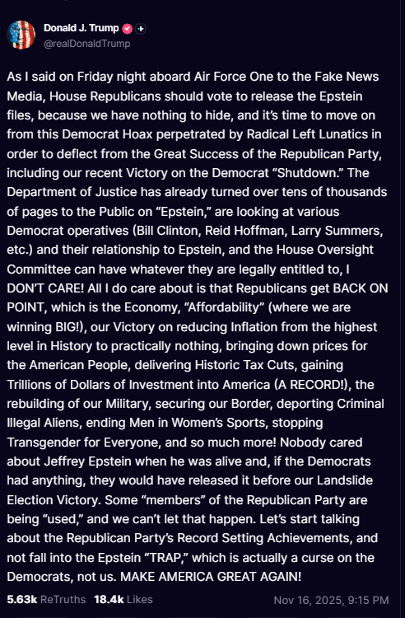
[Truth Social, @realDonaldTrump, 11/16/25]

