Overview
During her 2022 gubernatorial campaign, Taylor Robson used a payroll service to hide the identities of her campaign staff who were critical of Trump.
In since deleted tweets, Taylor Robson’s former Director of Communications and chief spokesman, Matthew Benson, called for conservatives to prevent Trump from winning the Republican nomination in 2015, and said he hoped to see Trump “wetting his pants on-stage.”
In since deleted tweets, Taylor Robson’s former Political Director, Brandon Hiller, said Trump “ruined” the Republican Party and was “the real RINO.”

Taylor Robson Used A Payroll Service To Hide Her Campaign Staff, Including Two Senior Staffers Who Were Critical Of Donald Trump

Taylor Robson Reported Paying Her Staff Through A Company Called Gusto Instead Of Disclosing Individual Salary Or Payroll Payments, Shielding Their Identities From Disclosure

Taylor Robson Paid Nearly $300,000 To Gusto For Campaign Staff Payroll But Did Not Disclose Payroll Or Salary Expenses
Taylor Robson Did Not Disclose Any Individual Payroll Or Salary Expenses On Her Campaign Finance Report. [Karrin For Arizona, Campaign Finance Report, filed 7/15/22]
Q2 2022 Cycle To Date: TaylorRobson Paid Nearly $300,000 To Gusto For Campaign Staff Payroll.
[Karrin For Arizona, Q2 2022 Campaign Finance Report, filed 7/15/22]

Gusto Was A Payroll Processing Company
Gusto Was A Payroll Processing Company. [Gusto.com, Accessed 12/9/25]

Taylor Robson’s Communications Director, Matthew Benson, Had A History Of Highly Critical Anti-Trump Posts, Which He Later Deleted, Including A Wish for Trump to Wet His Pants
2022 Campaign: Matthew Benson Was Taylor Robson’s Spokesman And Communications Director. According to Robson’s website, “The Karrin for Arizona campaign today announced senior communications roles for messaging and media relations veterans Matthew Benson and Annie Vogt, of Veridus LLC. Benson will serve in a Director of Communications and chief spokesman capacity.” [Karrin Taylor Robson Governor, Archived 2/11/22]
2015: Benson Tweeted, And Later Deleted, “Conservatives’ Highest Priority Now Must Be To Prevent Trump From Winning The Republican Nomination.” According to Benson’s Twitter, “‘Conservatives’ highest priority now must be to prevent Trump from winning the Republican nomination’”
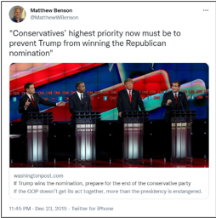
[Twitter, @MatthewWBenson, 12/23/15]
July 18, 2015: On The Day That Trump Infamously Said That John McCain Was Not A War Hero, Benson Deemed, In A Later Deleted Tweet, That The Trump Campaign Was Dead And Said He Hoped Trump Would Have Wet His Pants On Stage. According to Benson’s Twitter, “I was hoping for a more public face-flop to end the Trump campaign (wetting his pants on-stage or something) but this will have to suffice.”
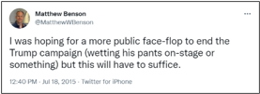
[Twitter, @MatthewWBenson, 7/18/15]
- July 18, 2015: Trump Said John McCain Was “Not A War Hero” And “I Like People Who Weren’t Captured.” According to Politico, “Donald Trump might finally have crossed the line. Appearing on Saturday at the Family Leadership Summit in Ames, Iowa, the real estate mogul took his running feud with Arizona Sen. John McCain to a new level. ‘He’s not a war hero,’ said Trump.’ He was a war hero because he was captured. I like people who weren’t captured.’” [Politico, 7/18/15]

Taylor Robson’s Political Director, Brandon Hiller, Previously Tweeted, And Later Deleted, That Trump “Ruined The Party” And Was “The Real RINO”
2022 Campaign: Brandon Hiller Was Taylor Robson’s Political Director. According to Robson’s website, “Today, the Karrin for Arizona campaign announced three new senior staff members. The campaign has hired Brandon Hiller to serve as the statewide Political Director; Cale Ottens as Press Secretary; and Ben Mills as Operations Manager.” [Karrin Taylor Robson Governor, Archived 2/11/22]
2016: Hiller Tweeted, And Later Deleted, “Trump Has Ruined The Party.” According to Hiller’s Twitter, “These senators aren’t going to get reelected because Trump has ruined the party.”
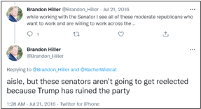
[Twitter, @Brandon_Hiller, 7/21/16]
2017: Hiller Tweeted, And Later Deleted, “Trump Is The Real RINO.” According to Hiller’s Twitter, “It’s actually funny because Trump is the real RINO.”
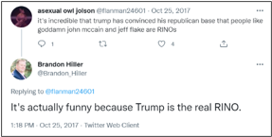
[Twitter, @Brandon_Hiller, 10/25/17]

