Overview
In 2025, Schweikert voted for Trump’s “One Big Beautiful Bill,” which was estimated to kick 17 million Americans off their health insurance, including nearly 12 million Americans who relied on Medicaid. More than 342,000 Arizonans could lose their health insurance as a result of Schweikert’s vote. Schweikert’s vote also jeopardized the future of some rural hospitals in Arizona, with at least five at risk of closing.
Before voting for the final bill, Schweikert's own plan proposed $900 billion in cuts to Medicaid through per-capita caps, which could shift costs to Arizona and force cuts that could cause people to those their health benefits. On air, he dismissed constituents worried about Medicaid and health-care cuts as “whining” and “bedwetting.” By 2034, 193,981 Medicaid recipients in Arizona were expected to lose their coverage due to Schweikert’s support for Trump’s tax bill.
In January 2026, Schweikert voted against extending the Affordable Care Act subsidies for three years, despite Arizonans already experiencing a nearly 30% increase in premiums during the ACA’s 2026 open enrollment period after Republicans allowed the subsidies to expire. In December 2025, Schweikert voted for Republicans’ health care bill which would weaken protections for people with pre-existing conditions and allowed ACA tax credits to expire. Schweikert did not sign multiple discharge positions aimed at extending premium ACA tax credits. Schweikert’s and Republicans’ inaction over ACA subsidies created a “subsidy cliff” whereby households could lose all eligibility for assistance if they earn even $1 more than a specified income threshold.

Schweikert Voted To Take Health Insurance Away From Millions Of Americans Who Relied On Medicaid

Schweikert Voted For The “One Big Beautiful Bill,” Which Included Devastating Health Care Cuts To Fund Tax Cuts For The Wealthy

July 2025: Schweikert Voted For The Final Version Of The “One Big Beautiful Bill,” Which Would Cause 17 Million Americans To Lose Their Health Care
July 2025: Schweikert Voted For The Senate FY 2025 Budget Reconciliation Bill, The “One Big Beautiful Bill,” Which Extended $4 Trillion In Expiring Tax Cuts, Added New Tax Breaks, Appropriated $448 Billion In Defense, Border, And Immigration Enforcement Funding, Increased The SALT Deduction To $40,000, And Cut Medicaid And Other Social Programs To Offset The Costs. In July 2025, Schweikert voted for, according to Congressional Quarterly, the “motion to concur in the Senate amendment to the bill that would permanently extend nearly $4 trillion in expiring individual and business tax cuts, create several new tax breaks and fund border and immigration enforcement and air traffic control upgrades. It would cut Medicaid and other safety net programs to partly offset the cost. Among other provisions, it would raise the statutory debt ceiling by $5 trillion and appropriate more than $448 billion in mandatory funding for Trump administration priorities and other needs, including $153 billion for defense, $89 billion for immigration enforcement, and $89.5 billion for border control and security. It also would increase the state and local tax deduction cap to $40,000 annually for five years for households making up to $500,000 a year until 2030, when it would permanently revert to $10,000.” The House passed the bill by a vote of 218 to 214. The bill was ultimately signed into law. [House Vote 190, 7/3/25; Congressional Quarterly, 7/3/25; Congressional Actions, H.R. 1]
- HEADLINE: “At Least 17 Million Americans Would Lose Insurance Under Trump Plan” [Washington Post, 7/1/25]
- HEADLINE: “By The Numbers: Harmful Republican Megabill Favors The Wealthy And Leaves Millions Of Working Families Behind” [Center On Budget And Policy Priorities, 8/1/25]
- The Congressional Budget Office Estimated That 11.8 Million People Would Become Uninsured As A Result Of The Medicaid Cuts In Republicans’ Reconciliation Bill. According to the Washington Post, “The bill, which narrowly passed the Senate on Tuesday and now heads back to the House, would effectively accomplish what Republicans have long failed to do: unwind many of the key components of the ACA, President Barack Obama’s signature domestic achievement, which dramatically increased the number of Americans with access to health insurance. To start, the Congressional Budget Office estimated that the Senate version of the bill would result in 11.8 million more uninsured in 2034, mostly because of Medicaid cuts, compared with 10.9 million if the House version became law.” [Washington Post, 7/1/25]
- The Bill’s $50 Billion In Rural Hospital Relief Funding Would Not Come Close To The Gap Created By Medicaid Cuts, With 300 Rural Hospitals At “Immediate Risk” Of Closure. According to the Center For American Progress, “The OBBBA includes $50 billion in relief funding for rural hospitals over a five-year period to help reduce the disastrous impacts of the bill’s roughly $1 trillion in Medicaid cuts. As of May 2025, there were approximately 2,086 rural hospitals receiving $12.2 billion a year in net revenue from Medicaid. At the median, rural hospitals’ revenue from Medicaid is $3.9 million a year.Rural hospitals have some of the lowest operating margins in the nation, especially compared with urban hospitals, meaning that any reductions in revenue could lead to closures. The average operating margin for rural hospitals was 3.1 percent in 2023, with 44 percent of rural hospitals operating with negative margins. As a result, more than 300 rural hospitals are currently at ‘immediate risk’ of closure, especially now that the OBBBA is projected to cut Medicaid spending by $1.02 trillion. The relief fund designed to blunt the negative impacts caused by the bill would not come close to filling that gap. If every rural hospital in the country received an even share of the $50 billion in relief support, it would amount to only $4.5 million every year for five years. At the close of those five years, that funding would disappear altogether.” [Center For American Progress, 7/3/25]

More Than 342,000 Arizonans Were Expected To Lose Health Care Coverage Under Trump’s “One Big Beautiful Bill” And At Least Five Arizona Rural Hospitals Were At Risk Of Closing
Under The “One Big Beautiful Bill,” 342,481 Arizonans Were Expected To Lose Their Health Care By 2034, Including 148,500 ACA Enrollees And 193,981 Medicaid Recipients. According to the Joint Economic Committee Minority,
District | State | Est. # Losing ACA Coverage | Est. # Losing Medicaid Coverage | Est. Total # Losing Insurance
AZ-01 | Arizona | 18,800 | 12,601 | 31,401
AZ-02 | Arizona | 15,800 | 26,014 | 41,814
AZ-03 | Arizona | 18,000 | 35,083 | 53,083
AZ-04 | Arizona | 15,800 | 18,538 | 34,338
AZ-05 | Arizona | 16,300 | 13,263 | 29,563
AZ-06 | Arizona | 15,000 | 16,925 | 31,925
AZ-07 | Arizona | 15,400 | 32,035 | 47,435
AZ-08 | Arizona | 16,300 | 16,701 | 33,001
AZ-09 | Arizona | 17,100 | 22,821 | 39,921
All | Totals | 148,500 | 193,981 | 342,481

[Joint Economic Committee Minority, 6/25]
Under The “One Big Beautiful Bill,” Five Rural Arizona Hospitals That Served 50,000 Arizonans Across Five Cities And 400,000 Arizonans Across Five Counties Were At Risk Of Closing. According to The Copper Courier, “People in rural areas of Arizona will likely face greater health and injury risks, now that President Donald Trump’s ‘One Big Beautiful Bill Act’ has been signed into law. That’s because the following rural hospitals are now at risk of closing, according to a University of North Carolina study: Page Hospital (Page) Little Colorado Medical Center (Winslow) Copper Queen Community Hospital (Bisbee) Carondelet Holy Cross Hospital (Nogales) Cobre Valley Regional Medical Center (Globe) Those five cities account for nearly 50,000 Arizonans. Roughly 400,000 Arizonans live across the five impacted counties, in similar smaller towns that may or may not have dedicated hospitals.” [Copper Courier, 7/8/25]
Under The “One Big Beautiful Bill,” Rural Arizona Hospitals Stood To Lose $1.2 Billion Over 10 Years Due To Lost Revenue From Medicaid Patients, Who Made Up One Third Of The Hospitals’ Payer Base. According to Cronkite News, “The impact wouldn’t be confined to those forced off the state-federal program, because lost revenue from those patients would make it harder for some facilities to stay open. ‘What it’s going to do to rural health care in Arizona is destroying it,’ said Neal Jenson, CEO of Cobre Valley Regional Medical Center in Globe, 70 miles east of Phoenix and the seat of rural Gila County. About a third of Cobre Valley’s patients are on Medicaid, he said, and ‘anytime you jeopardize a third of your payer base, you will have a significant impact.’ […] In Arizona alone, rural hospitals stand to lose $1.2 billion over 10 years under the Senate version, according to estimates from the National Rural Health Association. Even those rural hospitals that stay open could be forced to cut back. People with private insurance would also face delayed emergency care or long drives for maternity care and other services. ‘It’s not just for Medicaid patients,’ said Ann-Marie Alameddin, president and CEO of the Arizona Hospital and Healthcare Association. ‘It’s for all patients.’” [Cronkite News, 7/1/25]

May 2025: Schweikert Fell Asleep During The Vote On House Republicans’ Reconciliation Bill, Which Cut Medicaid

Schweikert Missed The Vote On The FY 2025 Budget Reconciliation Bill And Admitted To Falling Asleep During The Vote
May 2025: Schweikert Missed The Vote On The FY 2025 Budget Reconciliation Bill That Included $3.8 Trillion In Tax Cuts Offset By $1.5 Trillion In Spending Reductions To Programs Like Medicaid And The Supplemental Nutrition Assistance Program. In May 2025, Schweikert was absent on the vote for, according to Congressional Quarterly, “the bill that would provide for approximately $3.8 trillion in net tax cuts and $321 billion in military, border enforcement and judiciary spending, offset by $1.5 trillion in spending reductions, as instructed in the fiscal 2025 budget resolution. It would raise the statutory debt limit by $4 trillion and provide for increased spending on defense and border security, spending cuts on social safety net programs, such as Medicaid and the Supplemental Nutrition Assistance Program. It also includes a mix of tax breaks for businesses and individuals; tax increases on universities and foundations; and a phase-down of clean energy tax credits. […] It would reduce federal spending on the Supplemental Nutrition Assistance Program by requiring states to shoulder more of the cost, expand work requirements for SNAP, extend programs authorized under the 2018 farm bill, and prohibit the U.S. Department of Agriculture from increasing the cost of the Thrifty Food Program. As amended, it would cap state and local tax deductions at $40,000 for households with incomes below $500,000.” The House passed the bill by a vote of 215 to 214. [House Vote 145, 5/22/25; Congressional Quarterly, 5/22/25; Congressional Actions, H.R. 1]
- The House GOP Budget Bill Was Estimated To Increase The Uninsured Population By 8.6 Million By 2034. According to CNN, “The Medicaid and Affordable Care Act provisions in the package could result in 8.6 million more people being uninsured in 2034, according to an early CBO estimate released by Democratic lawmakers. That number is expected to grow with the latest changes.” [CNN, 5/28/25]
- The House GOP Budget Bill Codified A Trump Administration Proposal That Restricted Access To The Affordable Care Act. According to CNN, “The bill also calls for codifying a Trump administration proposal that would make changes to the Affordable Care Act enrollment process, including shortening the open enrollment period and eliminating the ability of low-income Americans to sign up year-round.” [CNN, 5/28/25]
- The House GOP Budget Bill Made The 2017 Income Tax Breaks Permanent And Added An Estimated $3.8 Trillion To The National Debt Over 10 Years. According to CNN, “The package includes several controversial measures that would deeply cut into two of the nation’s key safety net programs – Medicaid and food stamps – while making permanent essentially all of the trillions of dollars of individual income tax breaks contained in the GOP’s 2017 Tax Cuts and Jobs Act. What’s more, it would fulfill Trump’s campaign promises to cut taxes on tips and overtime, albeit temporarily. The magnitude of the measures is evident in the estimates of the cost they would incur or the savings they would produce. […] The tax changes in the package would add $3.8 trillion to the nation’s debt over a decade, according to a Congressional Budget Office analysis released before last-minute changes were made to the bill.” [CNN, 5/28/25]
May 2025: Schweikert Admitted To Falling Asleep Before Congress Voted On The Republican Reconciliation Bill. According to KTAR News, “Arizona U.S. Rep. David Schweikert confirmed that he missed this week’s House vote on a massive bill central to President Donald Trump’s agenda because he fell asleep. ‘It’s embarrassing,’ the northeast Valley Republican told KTAR News 92.3 FM’s The Mike Broomhead Show on Friday. Schweikert, chair of the Joint Economic Committee, said he’d been negotiating the One Big Beautiful Bill Act for ‘36 straight hours’ before going down the hall to change his shirt early Thursday. ‘Next thing I know, I’m holding a cup of coffee and my phone is ringing saying the vote is on. I’d fallen asleep,’ he said. He raced back to the House floor, but it was too late.” [KTAR News, 5/23/25]
- HEADLINE: “'It's Embarrassing': Arizona Congressman Sleeps Through Key Spending Bill Vote” [12 News (NBC), 5/23/25]

Schweikert Said He Would Have Voted “Yes” On The Bill Had He Been Awake
Schweikert Said He Would Have Voted To Support The Republican Budget Bill, But He Fell Asleep. According to KJZZ, “Republican Rep. David Schweikert says it will likely be months before Congress passes President Donald Trump’s so-called Big Beautiful Bill. Last week, Republicans in the U.S. House of Representatives narrowly passed the bill, which would renew Trump’s 2017 tax cuts. […] Schweikert was the only member of Arizona’s Republican delegation not to vote for the bill, though he says he supported it. Schweikert said he missed the vote because he fell asleep in his office.” [KJZZ, 5/27/25]
- Speaker Mike Johnson Claimed Schweikert Intended On Voting In Favor Of The Budget Bill Despite Not Voting. According to Politico, “Johnson said Schweikert, who was one of only a handful of Republicans to submit floor amendments to the bill, also intended to vote in favor.” [Politico, 5/22/25]

March 2025: Schweikert Offered A Menu Of Options For Reducing Government Spending, Which Included Instituting Medicaid Per Capita Caps, Which He Estimated Would Cut $900 Billion
March 2025: Schweikert Proposed His Own Plan For Budget Cuts That Included $900 Billion Worth Of Cuts In The Form Of Medicaid Per Capita Caps. According to the Washington Post, “The Arizona Republican had shopped a binder of spending cuts and program modernizations around the Capitol for six weeks as the GOP assembled its budget, hoping to interest colleagues in them. He identified nearly $6.5 trillion in savings over 10 years, without the sharp cuts to social safety net programs that another House GOP document envisioned, according to an copy he provided The Post. But House leaders didn’t run with much of Schweikert’s proposal.’” [Washington Post, 3/6/25]
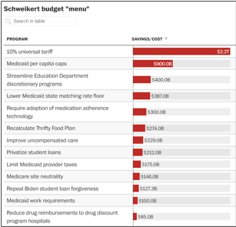
[Washington Post, 3/6/25]
- Medicaid Per Capita Cap Proposals Would Slash Federal Funding And Force States To Cut Eligibility And Benefits, Ultimately Threatening Millions Of People’s Health Care. According to the Center on Budget and Policy Priorities, “Recent proposals from Republican congressional leaders and a conservative think tank would impose a per capita cap on federal Medicaid funding or, similarly, turn Medicaid into a block grant.[1] These proposals would dramatically change Medicaid’s funding structure, deeply cut federal funding, and shift costs and financial risks to states. Faced with large and growing reductions in federal funding, states would cut eligibility and benefits, leaving millions of people without health coverage and access to needed care.” [Center On Budget And Policy Priorities, 1/7/25]

February 2025: Schweikert Voted For A Budget Resolution That Set Up Future Medicaid Cuts
February 2025: Schweikert Voted For The FY 2025 Budget Framework That Included $2 Trillion In Cuts, Raised The Statutory Debt Limit By $4 Trillion, And Required House Committees To Recommend Legislation That Would Implement Trump’s Agenda. In February 2025, Schweikert voted for, according to Congressional Quarterly, “the concurrent resolution that would recommend a budget for fiscal 2025 and budget levels through fiscal 2034. The resolution would assume minimum savings of $1.5 trillion over 10 years and 2.6 percent economic growth over the same period. It also would require the statutory debt limit to be raised by $4 trillion. It also would authorize the House Ways and Means Committee to increase deficits by $4.5 trillion over 10 years to extend the 2017 tax cuts and implement new tax cuts proposed by the White House. It also would provide instructions for the budget reconciliation process through which separate legislation could be considered and passed in the Senate via a simple majority vote. The measure would deliver instructions to 11 House committees to report legislation that would implement President Donald Trump’s agenda, such as expanding tax cuts and bolstering border security and immigration enforcement. The committees would be required to report their legislative recommendations to the House Budget Committee by March 27, 2025. It also would set a $2 trillion target for the spending cuts to be submitted to the House Budget Committee. The resolution also would stipulate that if the committees don't reach that target, the Ways and Means’ reconciliation instructions to increase the deficit by a maximum of $4.5 trillion would be decreased by the amount the other committees come in below the target. Similarly, it would stipulate that Ways and Means could increase the deficit above the $4.5 trillion level by the amount of savings the committees achieve above the $2 trillion target.” The vote was on passage. The House passed the resolution by a vote of 217 to 215. [House Vote 50, 2/25/25; Congressional Quarterly, 2/25/25; Congressional Actions, H. Con. Res. 14]
- HEADLINE: “House Republican Budget Takes Away Health Care, Food Aid To Pay For Expanded Tax Cuts For Wealthy” [Center On Budget And Policy Priorities, 2/21/25]
- New York Times Reported The $880 Billion In Cuts Required By The Republican Budget Proposal Would Have To Come From Medicaid, Medicare, Or CHIP. According to the New York Times, “The budget resolution itself is silent on whether Congress cuts Medicaid, which provides health coverage to 72 million poor and disabled Americans. But it instructs the House Energy and Commerce Committee, which has jurisdiction over the program, to cut spending by $880 billion over the next decade. If the committee can’t save at least that much, the entire effort could be imperiled because of the special process Congress is using to avoid a Senate filibuster. Ten other committees have their own instructions to follow, though none have been assigned with cutting nearly as much. It’s not so simple as finding the cuts elsewhere. The special process, known as budget reconciliation, means Republicans will have to find all $880 billion from within the Energy and Commerce Committee’s jurisdiction. That leaves them with fewer options than one might think. […] If Republicans want to avoid major cuts to Medicaid, the largest pot of available money is in the other big government health insurance program: Medicare. […] Even if the committee cuts everything that’s not health care to $0, it will still be more than $600 billion short. The committee could also save around $200 billion by eliminating the Children’s Health Insurance Program, but that option has not been raised by the budget committee or anyone in House leadership. […] Even if all of these cuts, revenues and rule cancellations from outside health care can pass muster, the committee will still be left with hundreds of billions of dollars to cut to hit its goal. Mathematically, the budget committee’s instructions mean the committee would need to make major cuts to either Medicare, Medicaid or both.” [New York Times, 2/25/25]

Schweikert To Arizonans: Stop “Whining” About My Support For Health Care Cuts

Schweikert Dismissed Concerns About The Cuts To Medicaid He Voted For As “Whining And Bedwetting”
HEADLINE: “Arizona Congressman Defends Medicaid Cuts After Dismissing Concerns As 'Bedwetting'“ [Arizona Republic, 8/28/25]
Schweikert: “Think Of The Whining And The Bedwetting Over The Medicaid Changes.” According to an interview Rep. David Schweikert gave on Wake Up Live, “SCHWEIKERT: You make a deal saying, okay, if I'm allowed to move forward, the pay fors, if I can get enough co-sponsors, we'll put that into the reconciliation package because most folks don't understand how much your taxes were going up next year. You know, so that debt that comes from the big beautiful bill, that's the extension of the tax policy. For like my district, it's $2,000 or $3,000 per family. Your taxes were going up. And think of the whining and the bedwetting over the Medicaid changes. Even though Medicaid continues to grow in spending, it just grows less fast. And this was actually a kick in the head for me because I thought a lot of these people I see on Fox and OANN and Newsmax who talk about we need to be tough, we need to cut spending. When they were given real spending fix bills. And they all run away from it because one has the word immigration, one actually has the word Medicare in it. But you've got to go there. That's where the spending is now.” [Wake Up Live, 8/14/25] (VIDEO)

The “One Big Beautiful Bill” And The Expiring Affordable Care Act Tax Credits Would Result In 422,000 Uninsured Arizonans By 2034
The “One Big Beautiful Bill” And The Expiring Affordable Care Act Tax Credits Would Result In 422,000 Uninsured Arizonans By 2034. According to the Center For American Progress, “The One Big Beautiful Bill Act will increase the number of Americans without health coverage in every state Estimated increase in the uninsured population due to the OBBBA and the expiration of the ACA’s enhanced premium tax credits, 2034”
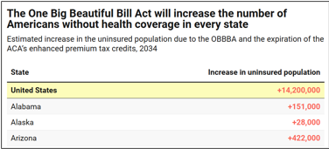
[Center For American Progress, 9/5/25]

November 2025: There Were 423,025 Arizonans Enrolled In An Affordable Care Act Marketplace Plan
As Of November 2025, There Were 423,025 Individuals Enrolled In An Affordable Care Act Marketplace Plan In Arizona. According to KFF, in 2025, there were 423,025 individuals enrolled in affordable care act marketplace plan in Arizona.
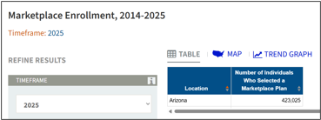
[KFF, Accessed 11/21/25]

Under The “One Big Beautiful Bill,” 193,981 Medicaid Recipients In Arizona Were Expected To Lose Their Health Care By 2034
Under The “One Big Beautiful Bill,” 342,481 Arizonans Were Expected To Lose Their Health Care By 2034, Including 148,500 ACA Enrollees And 193,981 Medicaid Recipients. [Joint Economic Committee Minority, 6/25]

The Affordable Care Act Allowed States To Expand Medicaid, Which Dramatically Lowered The Uninsured Rate Among Low-Income Workers
The Affordable Care Act Allowed States To Expand Medicaid, And States That Expanded Medicaid Dramatically Lowered The Number Of People Without Health Insurance. According to the Center on Budget and Policy Priorities, “The Affordable Care Act (ACA) permits states to expand Medicaid coverage to adults with incomes up to 138 percent of the poverty level (about $20,780 annually for an individual or $35,630 for a family of three). States that have adopted the expansion have dramatically lowered their uninsured rates. Extensive research finds that the people who gained coverage have grown healthier and more financially secure, while long-standing racial inequities in health outcomes, coverage, and access to care have shrunk.” [Center On Budget And Policy Priorities, 6/14/24]
- The Uninsured Rate Among Low-Income Workers Fell From 38 Percent In 2013 To 17 Percent In 2022, Which Coincided With Implementation Of Medicaid Expansion. According to the Center on Budget and Policy Priorities, “Millions of workers have gained coverage through Medicaid expansion, including people working in industries that provide critical goods and services such as health care, transportation, grocery stores, food manufacturers, and child care. Many have no access to health coverage through their jobs. In expansion states, the uninsured rate among low-income workers fell from 38 percent in 2013 to 17 percent in 2022; this sharp decline coincided with a large increase in the share of low-income workers enrolled in Medicaid.[16] In non-expansion states, the uninsured rate among low-income workers fell much less, from 46 percent to 31 percent. (See Figure 3.)” [Center On Budget And Policy Priorities, 6/14/24]

David Schweikert Allowed ACA Tax Credits To Expire, Jacking Up Premium Costs For Arizonans By Nearly 30 Percent

Schweikert Voted Against Extending The Affordable Care Act Tax Credits For Three Years, Even Though 22 Million Americans Relied On ACA Premium Tax Credits To Afford Health Insurance

January 2026: Schweikert Voted Against Extending The Affordable Care Act Tax Credits For Three Years
January 2026: Schweikert Voted Against Extending The Affordable Care Act Tax Credits For Three Years. In January 2026, Schweikert voted against, according to Congressional Quarterly, “the bill, as amended, that would extend for three years, through the end of calendar year 2028, the enhanced tax credits to subsidize premiums for health insurance purchased on the Affordable Health Care Act health insurance markets. It would allow taxpayers whose household income exceeds 400 percent of the federal poverty line to receive tax credits for three more years. The measure would retroactively take effect Jan. 1, 2026.” The vote was on passage. The House passed the bill by a vote of 230 to 196. [House Vote 11, 1/8/26; Congressional Quarterly, 1/8/26; Congressional Actions. H.R. 1834]
- The Bill Extended The Enhanced COVID-Era ACA Tax Credits That Republicans Let Expire At The End Of 2025, Resulting In Greater Health Costs For A Third Of All Those Insured Through The ACA Marketplace. According to Congressional Quarterly, “Congress temporarily expanded the tax credits created through the ACA (PL 111-148, PL 111-152) during the COVID-19 pandemic. The enhanced credits expired Dec. 31, meaning roughly one-third of individuals who get coverage through the ACA marketplace are facing significantly higher costs for 2026. The open enrollment period for these plans closes Jan. 15.” [Congressional Quarterly, 1/8/26]
- Seventeen Republicans Voted For Passage Of The “Clean” Extension Of ACA Subsidies, Following A Procedural Vote The Day Before That Had Support From Nine Republicans. According to Politico, “Seventeen Republicans joined Democrats in passing legislation Thursday that would revive enhanced Affordable Care Act subsidies for three years, rebuffing opposition from GOP leadership. The 230-196 vote follows a procedural vote Wednesday to advance the bill, where nine Republicans joined Democrats in favor of moving forward.” [Politico, 1/8/26]
- The Bill Would Fail In The Senate But Helped Lay The Groundwork For A Bipartisan Agreement. According to Politico, “While the measure is destined to die in the Senate, Democrats and some Republicans hope it will lay the groundwork for a bipartisan agreement to tame skyrocketing health insurance premiums — the result of Congress allowing the tax credits to lapse Dec. 31. ‘The Senate could put together a product that could ultimately get sent back over to the House that we can then conference on and hopefully move across the finish line,’ said Rep. Rob Bresnahan (R-Pa.), who supported the Democratic-led bill.” [Politico, 1/8/26]
- The Vote Increased The Likelihood That The Senate Would Consider The Extension And Pass A Bill With Some Reforms. According to Politico, “Earlier Thursday, members of the bipartisan House Problem Solvers Caucus met with senators to discuss a potential solution. Rep. Jeff Hurd (R-Colo.) said that the meeting — and senators’ plea to show a strong force on this vote in the House — influenced his decision to vote for the measure after initially being inclined to vote against it. ‘There was a sentiment conveyed that if we could get a bill out of the House that had a meaningful amount of bipartisan support, that that would increase the likelihood that the Senate would take this up, pass a bill that has some reforms in it, and send it back,’ Hurd said in an interview about the message communicated during the bicameral meeting.” [Politico, 1/8/26]

Approximately 22 Million Americans Relied On ACA Premium Tax Credits To Afford Health Insurance
Approximately 22 Million Americans Relied On ACA Premium Tax Credits To Afford Health Insurance. According to CNBC, "About 22 million Americans received premium subsidies, also known as premium tax credits, in 2025. Households can opt to receive the tax credit in one of two ways: As a lump sum during tax season or as an advanced payment. Under the latter option, by far the most popular, the federal government issues the tax credit directly to a consumer’s insurer, which then lowers the consumer’s out-of-pocket premium. Consumers receive those advanced ACA subsidies based on an estimated annual income they provide when signing up for insurance. They must reconcile those subsidies during tax season and repay any excess tax credits to the IRS." [CNBC, 1/6/26]

ValuePenguin By LendingTree Analysis: Arizona Health Insurance Premiums For The Most Popular Health Plans In The State Increased Nearly 30% In 2026
2026 ACA Open Enrollment: Approximately 70,000 Fewer Arizonans Signed Up For Affordable Care Act Plans After Republicans Allowed ACA Tax Credits To Expire And Insurance Premiums Increased Nearly 30% In Arizona’s Marketplace. According to Arizona Mirror, “About 70,000 fewer Arizonans have signed up for health insurance through the Affordable Care Act after Republicans in Congress refused to extend tax credits and premiums soared. One analysis found that insurance premiums on the ACA marketplace for Arizona jumped nearly 30% on average. Data released this week by the Centers for Medicare & Medicaid Services show that 353,000 Arizonans have signed up for 2026 ACA insurance plans, nearly 17% fewer than purchased plans for 2025.” [Arizona Mirror, 1/14/26]
ValuePenguin By LendingTree Analysis: Arizona Health Insurance Premiums For The Most Popular Health Plans In The State Were Rising By 29% In 2026. According to AZ Big Media, “ValuePenguin by LendingTree’s comprehensive review of all health insurance plans on the marketplace in 2026 reveals a troubling trend for Arizona: Arizona health insurance premiums for the most popular health plans in the state are rising 29% in 2026, the 12th largest rate increase in the U.S.” [AZ Big Media, 1/15/26]

Schweikert voted For A Bill Which would weaken protections for people with pre-existing conditions and failed to address premium spikes

December 2025: Schweikert Voted For Republican Legislation That Would Allow ACA Tax Credits To Expire
December 2025: Schweikert Voted For Republican Legislation That Prohibited Abortion-Related Care Under ACA Plans And Allowed The ACA Tax Credits To Expire. In December 2025, Schweikert voted for, according to Congressional Quarterly, “the bill that would expand the ability of small businesses to establish association health plans and bars states from preventing small businesses from obtaining stop-loss insurance for self-funded health insurance plans. It would codify and expand rules governing employer-funded health reimbursement arrangements and would allow employees in such arrangements to pay Affordable Care Act health insurance premiums through salary reductions. It would provide funding for ACA policy cost sharing reduction payments that reduce deductibles and copayments. It would prohibit plans from providing abortion-related care. It also would require pharmacy benefit managers to provide transparency regarding prescription drug costs and the drug rebates they receive.” The vote was on passage. The House passed the bill by a vote of 216 to 211. [House Vote 349, 12/17/25; Congressional Quarterly, 12/17/25; Congressional Actions, H.R. 6703]
- HEADLINE: “House Passes GOP Health Bill Without ACA Credit Extension” [Congressional Quarterly, 12/17/25]
- The Bill Would Result In 100,000 People Losing Coverage Under The ACA As Gains In Enrollments From Association Plans Would Be Offset By The Loss Created By Cost Sharing Payments. According to Congressional Quarterly, “Overall, the CBO said, the new House bill headed to the floor Wednesday would result in about 100,000 people losing coverage, as ending silver loading offsets the gain in coverage from expanded association health plans.” [Congressional Quarterly, 12/17/25]
- The Bill Would Exempt Certain Insurance Policies Offered By Small Employers From Expansive ACA Coverage Requirements. According to Congressional Quarterly, “Provisions in the bill (HR 6703) offered by Rep. Mariannette Miller-Meeks, R-Iowa — one of her party's most vulnerable incumbents — include legislation that would expand access to association health plans and exempt certain insurance policies offered by smaller employees from expansive ACA coverage requirements.” [Congressional Quarterly, 12/17/25]
- The Bill Included Cost-Sharing Reduction Payments For Insurers. According to Congressional Quarterly, “Another key feature of Miller-Meeks' bill would fund payments to insurers to offset the ACA's required reductions in cost-sharing expenses, like deductibles and co-pays, for lower-income beneficiaries. While support for this funding has crossed party lines in the past — it was initially an Obama administration policy, opposed by Republicans and eliminated in President Donald Trump's first term — traditional partisan roles have reversed. Democrats now oppose ‘cost-sharing reduction’ payments or CSRs, making this funding a long shot for passage in the closely divided Senate.” [Congressional Quarterly, 12/17/25]
- The Bill Would Allow Association Health Care Plans To Evade Consumer Protections Under The ACA, Including “Essential Coverage” Requirements, With Critics Arguing The Bill Would Result In “Adverse Selection,” Hurting Older And Sicker Individuals. According to Congressional Quarterly, “Critics say the bill could allow association health plans to evade consumer protections enshrined in the ACA, including requirements to provide a minimum level of ‘essential’ health care benefits. The legislation would allow such plans to be self-funded or be treated as large employer plans, each of which are exempt from the essential coverage requirements. By allowing these plans to operate under different rules in order to offer lower-cost policies, it could lead to ‘adverse selection’ in health insurance markets that makes it harder for older, sicker individuals to find affordable coverage, according to the American Academy of Actuaries.” [Congressional Quarterly, 12/17/25]
- Association Health Plans Would Be Able To Set Higher Premiums Based On Factors Such As Age, Gender, And Occupation. According to Congressional Quarterly, “While the bill prohibits discrimination due to pre-existing conditions or any health-related status, association health plans could still set premiums based on other factors, including age, gender, occupation and geographic location. ‘As a result, this bill would all but invite AHPs to charge workers with more expensive health needs far higher premiums — if those workers could even afford to participate in the associations at all,’ House Education and Workforce Democrats wrote in a committee report accompanying the version of the bill that panel approved in the 118th Congress.” [Congressional Quarterly, 12/17/25]
- Democrats Opposed Stop-Loss Provisions As They Would Put Enrollees At Risk Of Losing Insurance If Medical Costs For The Group Rise. According to Congressional Quarterly, “The AFL-CIO, which opposed both bills, wrote that the stop-loss measure would leave many enrollees at risk because their insurers ‘often retain the right to drop the insurance if medical costs for the group begin to climb.’” [Congressional Quarterly, 12/17/25]
- Cost Sharing Payments Would End Silver Loading Offsets, Resulting In 300,000 People Losing Coverage. According to Congressional Quarterly, “The CBO estimated the provisions would cut spending by $31 billion over nine years — since updated to $37 billion in the latest GOP bill. It would result in some 300,000 enrollees dropping their coverage because the reduced subsidies would outweigh the lower premiums resulting from the end of silver loading, the CBO said.” [Congressional Quarterly, 12/17/25]

Center On Budget And Policy Priorities: The December 2025 Republican Health Care Bill Failed To Prevent Imminent Premium Spikes And Undermined Protections For Pre-Existing Conditions
Center On Budget And Policy Priorities: The December 2025 Republican Health Care Bill Failed To Prevent Imminent Premium Spikes For More Than 20 Million People Who Relied On ACA Marketplace Plans. According to the Center on Budget and Policy Priorities, "The health bill House Republicans are preparing to bring to the floor this week not only fails to prevent imminent premium spikes for more than 20 million people in marketplace plans, but would raise costs even higher for many marketplace enrollees and weaken pre-existing condition protections for individuals and small businesses." [Center On Budget And Policy Priorities, 12/16/25]
Center On Budget And Policy Priorities: The December 2025 Republican Health Care Bill Would Expand Association Health Plans, Which Would Result In Higher Underlying Premiums For Individuals And Small Businesses That Remained In ACA-Regulated Markets. According to the Center on Budget and Policy Priorities, "It would expand association health plans (AHPs), a type of health plan that trade associations, professional groups, and other organizations may offer their members, to cover self-employed individuals and small businesses as if they were large employers. By allowing more people to enroll in coverage not subject to ACA standards and consumer protections, this would segment insurance risk pools: individuals who are younger and healthier, or small businesses with younger or healthier employees, could get plans with lower premiums because they would be priced separately from ACA-compliant coverage and wouldn’t have to meet ACA standards such as having to cover a set of essential health benefits. As a result, individuals and small businesses remaining in ACA-regulated markets would see higher underlying premiums." [Center On Budget And Policy Priorities, 12/16/25]
Center On Budget And Policy Priorities: The December 2025 Republican Health Care Bill Would Likely Lead To Higher Premiums For Older And Sicker Small Groups And Self-Employed People, Thereby Undermining Protections For People With Pre-Existing Conditions. According to the Center on Budget and Policy Priorities, "In addition, the bill would undermine protections for people with pre-existing conditions. While it would bar AHPs from rejecting individuals or charging them more based on certain health factors, it would give them greater ability to base a small group’s or self-employed person’s costs on their health risk compared to individual or small-group coverage. This would likely lead to higher premiums for older and sicker small groups and self-employed individuals, making such arrangements more attractive to healthier individuals and groups." [Center On Budget And Policy Priorities, 12/16/25]

Congressional Budget Office Estimated The December 2025 Republican Health Care Bill Would Result In 100,000 Americans Losing Their Health Insurance
Congressional Budget Office Estimated The December 2025 Republican Health Care Bill Would Take Health Coverage From 100,000 Americans. According to Axios, "By the numbers: The GOP bill would increase the uninsured population by 100,000 and save the government $35.6 billion over 10 years, according to the Congressional Budget Office." [Axios, 12/17/25]

Schweikert Did Not Sign Discharge Petitions Aimed At Extending Premium ACA Tax Credits
Schweikert Was Not One Of The Republican Signers On A Discharge Petition For H.R. 1834 Led By House Minority Leader Hakeem Jeffries.
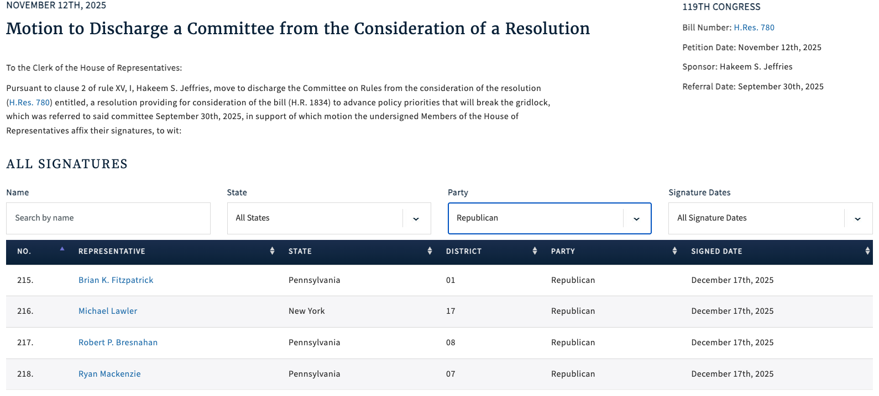
[Clerk of the U.S. House of Representatives, Discharge Petition No. 10, 11/12/25]
- House Minority Leader Jeffries’ Discharge Petition Sought To Extend ACA Premium Tax Credits For Three Years. According to Politico Pulse, "House Democrats could move as soon as tomorrow to force a vote on extending the expired Obamacare subsidies for three years, Meredith Lee Hill reports. This measure follows last month’s major setback for Speaker Mike Johnson, when four House Republicans broke from the party to support a discharge petition backed by Minority Leader Hakeem Jeffries to hold a vote." [Politico Pulse, 1/6/26]

Schweikert Was Not One Of The Republican Signers On A Discharge Petition For H.R. 3001 Led By Rep. Brian Fitzpatrick.
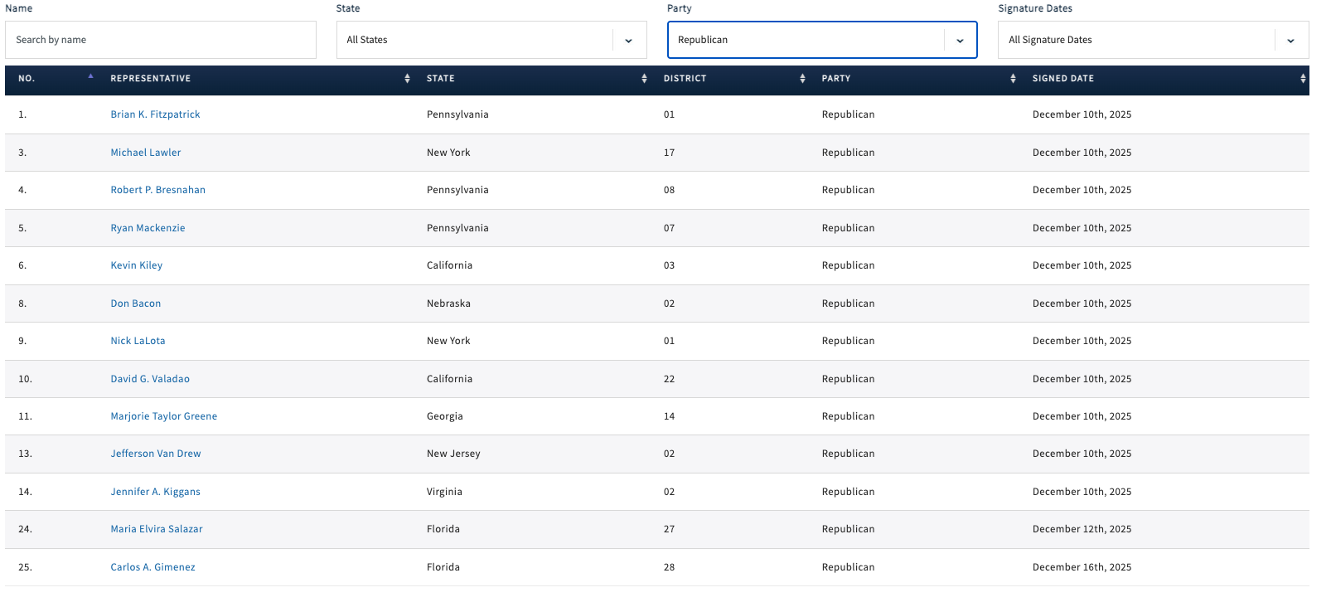
[Clerk of the U.S. House of Representatives, Discharge Petition No. 12, 12/10/25]
- December 2025: Fitzpatrick Filed A Discharge Petition Aimed At Extending ACA Premium Tax Credits For Two Years. According to a press release from Rep. Brian Fitzpatrick, "Today, Congressman Brian Fitzpatrick (PA-1) released the following statement after filing a discharge petition to bring his Bipartisan Health Insurance Affordability Act directly to the House floor for a vote, ensuring Congress takes action to prevent devastating health insurance premium increases when current protections expire at the end of the year: ‘Congress cannot sit idle while American families face a preventable crisis. Our job is to protect the people we serve, and that responsibility demands immediate action. […] Key Provisions of the Bipartisan Health Insurance Affordability Act The legislation advances five reforms designed to protect affordability, strengthen accountability, and ensure taxpayer value: Prevents premium spikes: Extends enhanced premium tax credits through 2027, to protect families from abrupt monthly cost increases. Restores Consumer Control: Stops unauthorized plan and subsidy changes by requiring consent and prompt notification before any modifications take effect. Shines Light on Middlemen: Ends hidden spread pricing, severs PBM profits from drug prices, and requires full rebate pass-through to ensure savings reach patients. Gives Families New Tools to Manage Costs: Expands access to Health Savings Accounts and simplifies premium payments to reduce disruptions in coverage. Smart Stewardship of Taxpayer Dollars: Modernizes eligibility and introduces a reasonable minimum contribution to protect long-term affordability and responsible stewardship of federal dollars." [Press Release – Rep. Brian Fitzpatrick, 12/10/25]
Schweikert Was Not One Of The Republican Signers On A Discharge Petition For H.R. 185 Led By Rep. Josh Gottheimer.
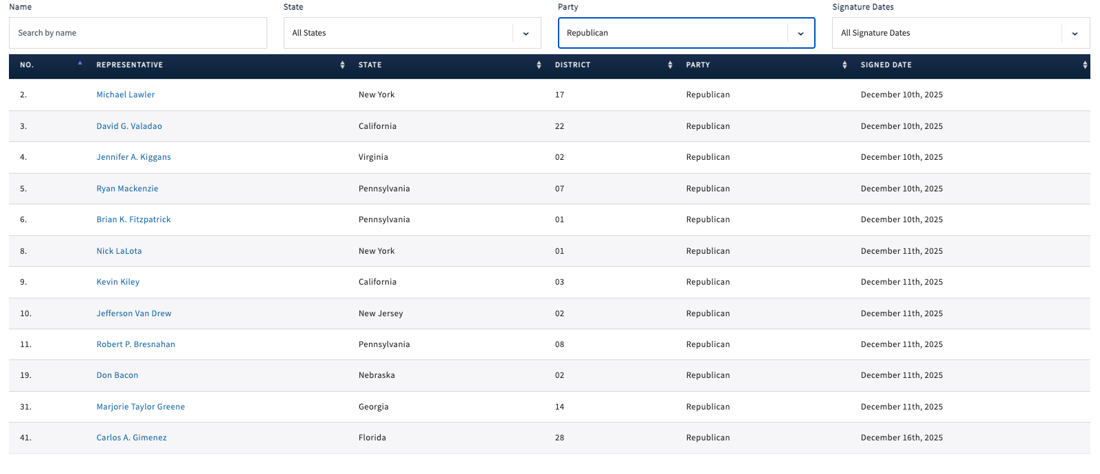
[Clerk of the U.S. House of Representatives, Discharge Petition No. 13, 12/10/25]
- December 2025: Gottheimer Filed A Discharge Petition Aimed At Extending ACA Premium Tax Credits For Two Years. According to a press release from Rep. Josh Gottheimer, "Today, December 11, 2025, U.S. Congressman Josh Gottheimer (NJ-5) released the following statement: ‘In less than three weeks, unless Congress acts now, Affordable Care Act tax credits will expire, and health insurance premiums will shoot up 175% — or $20,000 a year — for families in Jersey. This week, Congresswoman Jen Kiggans and I, with 36 of our Democratic and Republican colleagues, introduced new bipartisan legislation that includes a two-year extension of health insurance premium tax cuts for American families. It’s a commonsense proposal that will keep costs down and prevent families’ premiums from skyrocketing in January. But, the Speaker of the House is refusing to bring our legislation to the floor for a vote. So, our bipartisan group just launched a discharge petition to force an immediate vote in the House. We must get this done now. We must find common ground and lower health insurance premiums. Time is running out for families.’" [Press Release – Rep. Josh Gottheimer, 12/11/25]

Schweikert’s Inaction Created A Dramatic “Subsidy Cliff,” Whereby Households Could Lose All Eligibility For Assistance
The Expiration Of Enhanced ACA Premium Tax Credits Created A “Subsidy Cliff” Whereby If Households Earned Even $1 More Than A Specific Income Threshold, They Could Lose All Eligibility For Assistance. According to CNBC, "For the first time in years, many Americans enrolled in a health insurance plan via the Affordable Care Act marketplace will need to keep a careful accounting of their annual income — or risk a hefty federal tax bill. Enhanced ACA subsidies lapsed at the end of 2025, leaving millions of households on the hook for higher insurance premiums. The lapse also reintroduced the so-called subsidy cliff, whereby households that earn even $1 more than a specific income threshold will lose all eligibility for subsidies, also known as premium tax credits. That income cutoff, which varies by family size, is $62,600 for a single person, $84,600 for a two-person household and $128,600 for a family of four in 2026, for example." [CNBC, 1/6/26]
- More Than Two Million Americans Had Incomes Near A “Subsidy Cliff.” According to CNBC, "More than 2 million people enrolled in an ACA marketplace plan have an income near the subsidy cliff. ACA enrollees also tend to have relatively volatile incomes, making it hard to predict their annual earnings, experts said." [CNBC, 1/6/26]
Households That Went Over The Income Limit Would Have To Pay Back Any Federal Assistance They Received For Premiums, Which Could Cost Thousands Of Dollars, When They Filed Their Taxes. According to CNBC, "Households over the limit would have to pay back any federal subsidies they received for premiums — potentially worth thousands of dollars — when they file taxes next year for 2026." [CNBC, 1/6/26]
Republicans’ “One Big Beautiful Bill” Exacerbated The Problem By Stripping Away Guardrails Capping The Amount Of Excess Subsidies Households Are Required To Repay. According to CNBC, "The potential financial impact is exacerbated by a multitrillion-dollar legislative package known as the ‘big beautiful bill’ that Republicans passed over the summer, which stripped away guardrails capping the amount of excess subsidies households must repay, experts said." [CNBC, 1/6/26]

