Overview
In 2025, Biggs voted for a bill that made the largest cut to SNAP in history. Biggs touted voting for the SNAP cuts and previously called SNAP a “highly abused welfare program.” In Arizona, more than 294,000 households relied on SNAP to afford groceries.

Biggs Voted To Strip SNAP Benefits From Arizonans And Make Food More Expensive

Biggs Voted For The House Republican Reconciliation Bill That Cut Snap Benefits For Millions

July 2025: Biggs Voted For The Final Version Of The “One Big Beautiful Bill,” Which Contained The Largest SNAP Cut In History
July 2025: Biggs Voted For The Senate FY 2025 Budget Reconciliation Bill, The “One Big Beautiful Bill,” Which Extended $4 Trillion In Expiring Tax Cuts, Added New Tax Breaks, Appropriated $448 Billion In Defense, Border, And Immigration Enforcement Funding, Increased The SALT Deduction To $40,000, And Cut Medicaid And Other Social Programs To Offset The Costs. In July 2025, Biggs voted for, according to Congressional Quarterly, the “motion to concur in the Senate amendment to the bill that would permanently extend nearly $4 trillion in expiring individual and business tax cuts, create several new tax breaks and fund border and immigration enforcement and air traffic control upgrades. It would cut Medicaid and other safety net programs to partly offset the cost. Among other provisions, it would raise the statutory debt ceiling by $5 trillion and appropriate more than $448 billion in mandatory funding for Trump administration priorities and other needs, including $153 billion for defense, $89 billion for immigration enforcement, and $89.5 billion for border control and security. It also would increase the state and local tax deduction cap to $40,000 annually for five years for households making up to $500,000 a year until 2030, when it would permanently revert to $10,000.” The House passed the bill by a vote of 218 to 214. The bill was ultimately signed into law. [House Vote 190, 7/3/25; Congressional Quarterly, 7/3/25; Congressional Actions, H.R. 1]
- HEADLINE: "Trump’s ‘Big Beautiful Bill’ Cuts Food Stamps For Millions — The Average Family May Lose $146 Per Month, Report Finds" [CNBC, 7/10/25]
- The GOP Reconciliation Bill Would Cut SNAP Funding By $186 Billion, Which CBPP Said Constituted The “Largest Cut To SNAP In History.” According to the Center on Budget and Policy Priorities, “The Senate Republican leadership’s reconciliation bill would dramatically raise costs and reduce food assistance for millions of people by cutting federal funding for the Supplemental Nutrition Assistance Program (SNAP) by $186 billion through 2034, according to the Congressional Budget Office (CBO), about 20 percent — the largest cut to SNAP in history. These cuts would increase poverty, food insecurity, and hunger, including among children. The so-called ‘Big Beautiful Bill’ is anything but beautiful; it would cause widespread harm by making massive cuts to Medicaid and SNAP, which would raise costs on families and make it much harder for them to afford the high cost of health care and groceries.” [Center On Budget And Policy Priorities, 6/30/25]
- 22.3 Million Families Would Lose Some Or All Of Their SNAP Benefits, With 5.3 Million Families Losing More Than $25 In Benefits Per Month, And Of Those Families, The Average Loss In Benefits Would Be $146. According to the Urban Institute, “Our preliminary estimates of the SNAP policies in the Senate bill show the following: 22.3 million US families would be affected, losing some or all of their SNAP benefits. Of the total affected families, 5.3 million would lose at least $25 in SNAP benefits per month. Among these families, 3.3 million are families with children, 3.5 million are working families, and 1.7 million are families with a full-time full-year worker. Families losing at least $25 per month would lose $146 per month on average ($1,752 for a full-year recipient). At the state level, average monthly benefit losses for families losing at least $25 per month would range from $72 in Kansas ($864 annually) to $231 in the District of Columbia ($2,772 annually).” [Urban Institute, 7/2/25]
- States That Could Not Afford To Pay The New Mandated SNAP Cost Shares May Cut The Program Entirely. According to CNBC, “Additionally, the legislation requires states to pay for a portion of benefit costs, ranging from 5% to 15%, if their payment error rate is at or over 6%. The error rates measure the accuracy of states’ eligibility and benefit payments. In fiscal year 2024, states had a 10.9% average payment error rate, with many states over 6%, according to the Department of Agriculture. States that can’t pay those shares may have to cut SNAP benefits or opt out of the program entirely, according to the Center on Budget and Policy Priorities.” [CNBC, 7/10/25]

May 2025: Biggs Voted For The House Version Of The Republican Reconciliation Bill, Which Included A $300 Billion Cut To SNAP
2025: Biggs Voted For The FY 2025 Budget Reconciliation Bill That Included $3.8 Trillion In Tax Cuts Offset By $1.5 Trillion In Spending Reductions To Programs Like Medicaid And The Supplemental Nutrition Assistance Program. In May 2025, Biggs voted for, according to Congressional Quarterly, “the bill that would provide for approximately $3.8 trillion in net tax cuts and $321 billion in military, border enforcement and judiciary spending, offset by $1.5 trillion in spending reductions, as instructed in the fiscal 2025 budget resolution (H Con Res 14). It would raise the statutory debt limit by $4 trillion and provide for increased spending on defense and border security, spending cuts on social safety net programs, such as Medicaid and the Supplemental Nutrition Assistance Program. It also includes a mix of tax breaks for businesses and individuals; tax increases on universities and foundations; and a phase-down of clean energy tax credits. […] It would reduce federal spending on the Supplemental Nutrition Assistance Program by requiring states to shoulder more of the cost, expand work requirements for SNAP, extend programs authorized under the 2018 farm bill, and prohibit the U.S. Department of Agriculture from increasing the cost of the Thrifty Food Program. As amended, it would cap state and local tax deductions at $40,000 for households with incomes below $500,000.” The House passed the bill by a vote of 215 to 214. [House Vote 145, 5/22/25; Congressional Quarterly, 5/22/25; Congressional Actions, H.R. 1]
- The House Republican Reconciliation Bill Included Nearly $300 Billion In Cuts To The Supplemental Nutrition Assistance Program. According to the Center on Budget and Policy Priorities, "The House-passed Republican reconciliation plan would cut nearly $300 billion from the Supplemental Nutrition Assistance Program (SNAP) through 2034, based on Congressional Budget Office (CBO) estimates — by far the largest cut to SNAP in history.[1] As a result of these cuts and other policies in the legislation — which are being used to pay partly for trillions in tax cuts skewed to the wealthy — millions of people would lose some or all of the food assistance they need to afford groceries, when many low-income households are struggling to afford the high cost of food and other basic needs." [Center on Budget and Policy Priorities, 5/28/25]

February 2025: Biggs Voted For House Republicans’ Budget Framework, Which Set Up Future Cuts To SNAP
2025: Biggs Voted For The FY 2025 Budget Framework That Included $2 Trillion In Cuts, Raised The Statutory Debt Limit By $4 Trillion, And Required House Committees To Recommend Legislation That Would Implement Trump’s Agenda. In February 2025, Biggs voted for, according to Congressional Quarterly, “the concurrent resolution that would recommend a budget for fiscal 2025 and budget levels through fiscal 2034. The resolution would assume minimum savings of $1.5 trillion over 10 years and 2.6 percent economic growth over the same period. It also would require the statutory debt limit to be raised by $4 trillion. It also would authorize the House Ways and Means Committee to increase deficits by $4.5 trillion over 10 years to extend the 2017 tax cuts and implement new tax cuts proposed by the White House. It also would provide instructions for the budget reconciliation process through which separate legislation could be considered and passed in the Senate via a simple majority vote. The measure would deliver instructions to 11 House committees to report legislation that would implement President Donald Trump’s agenda, such as expanding tax cuts and bolstering border security and immigration enforcement. The committees would be required to report their legislative recommendations to the House Budget Committee by March 27, 2025. It also would set a $2 trillion target for the spending cuts to be submitted to the House Budget Committee. The resolution also would stipulate that if the committees don't reach that target, the Ways and Means’ reconciliation instructions to increase the deficit by a maximum of $4.5 trillion would be decreased by the amount the other committees come in below the target. Similarly, it would stipulate that Ways and Means could increase the deficit above the $4.5 trillion level by the amount of savings the committees achieve above the $2 trillion target.” The vote was on passage. The House passed the resolution by a vote of 217 to 215. [House Vote 50, 2/25/25; Congressional Quarterly, 2/25/25; Congressional Actions, H. Con. Res. 14]
- HEADLINE: "House Republican Budget Takes Away Health Care, Food Aid To Pay For Expanded Tax Cuts For Wealthy" [Center on Budget and Policy Priorities, 2/21/25]
- CBPP Said The Republican Budget Resolution Outlined $230 Billion In Cuts, Primary From SNAP Benefits. According to the Center on Budget and Policy Priorities, "The House Republicans’ budget plan would give major tax cuts to high-income, wealthy households. Extending the expiring individual income and estate tax provisions for households with incomes in the top 5 percent of the income distribution (households with incomes over $321,000) costs around $1.8 trillion through 2034, accounting for 49 percent of the total $3.6 trillion cost of extension through 2034. That $1.8 trillion for wealthy and high-income households is close to the amount of the spending cuts House Republicans have outlined — including at least $880 billion primarily from Medicaid, $230 billion primarily from SNAP benefits, and $330 billion primarily from making student loans more expensive. Of the tax cuts for wealthy households, nearly $200 billion is for an estate tax giveaway that showers some $6 million per estate on the 1 in 1,000 wealthiest estates. In contrast, the average SNAP benefit is $6.20 per person per day, which helps struggling families put food on the table." [Center on Budget and Policy Priorities, 2/21/25]

Biggs Supported Cutting SNAP And Medicaid Benefits In Arizona And Wanted More Cuts

Biggs Said Arizona Had “Some Cleanup To Do” In SNAP And Medicaid Benefits, And Alleged Annual Fraud
October 2025: Biggs Said Arizona Had “Some Cleanup To Do” In SNAP And Medicaid Benefits, And Suggested The State “Might Have As Much As $6 Billion Of Fraud And Waste And Abuse On An Annual Basis.” According to Biggs on The Afternoon Addiction with Garret Lewis, “HOST: That'll be great. I mean, look at right? There's about 7 million people in Arizona and they're saying there's about 950,000 people that are on these food stamps, SNAP benefits. We have way too much dependency. ﻿BIGGS: Yeah. I mean, it's reportedly 12% of our entire state population is on SNAP benefits, which is puts us in a pretty, pretty, you know, a high, high rate compared to other states. And we know that I'm going to leave our snap here, but we do know, like in Medicaid, there's been studies indicating that we might have as much as $6 billion of fraud and waste and abuse on an annual basis out of a $22 billion net. So, yeah, we've got some cleanup to do here.” [Andy Biggs – Afternoon Addiction With Garret Lewis, 10/28/25] (AUDIO)

Biggs Touted Voting For The SNAP And Medicaid Cuts
July 2025: Biggs Touted Voting For The “One Big Beautiful Bill,” Including Voting For “Significant Spending Reductions And Reforms To Medicaid And SNAP Benefits.” According to a press release from Congressman Andy Biggs, “‘Today, I voted to advance President Trump’s One Big, Beautiful Bill through the House of Representatives and to the President’s desk. I have worked directly with President Trump to advance his policy priorities, and I will continue to advance the America First mandate he was elected to deliver. […] ‘My colleagues in the House Freedom Caucus and I worked diligently with President Trump and House and Senate Leadership to push for significant spending reductions and reforms to Medicaid and SNAP benefits. While there is always room to improve, the historic tax cuts and reforms in this bill move us in the right direction and will power our economy.’” [Press Release – Congressman Andy Biggs, 7/3/25]
2025: Biggs Claimed The SNAP Recipients Were “Choosing Not To Work” And Praised The Inclusion Of Stricter Work Requirements For Medicaid And SNAP In The “One Big Beautiful Bill.” According to Andy Biggs’ livestream video, “You have SNAP, which is food stamps. Those are big programs, but you have a lot of able bodied people who are not working, choosing to not work. They're staying home and they're getting those benefits that you as a taxpayer are paying for. So we get the work requirements in for both Medicaid and SNAP. That was the Freedom Caucus working with our friends in the Senate and again, with President Trump and his team in the White House. So that was really good.” [Andy Biggs Livestream, 7/3/25] (VIDEO)

Despite Touting His Votes For The Bill’s Spending Cuts, Biggs Agreed The “One Big Beautiful Bill” Was A “Disgusting Abomination” Because He Wanted More Cuts
June 2025: Biggs Agreed With Elon Musk That The “One Big Beautiful Bill” Was A “Disgusting Abomination,” Arguing It Needed Even More Spending Cuts, But Defended His Vote For The Package To Advance Trump’s Agenda. According to U.S. Representative Biggs’ Twitter, “He’s not wrong. This sentiment would have been much more impactful before the vote, when my @freedomcaucus colleagues and I were catching flack for fighting tooth and nail for more spending reductions. As it was, we voted to advance President Trump’s agenda.”
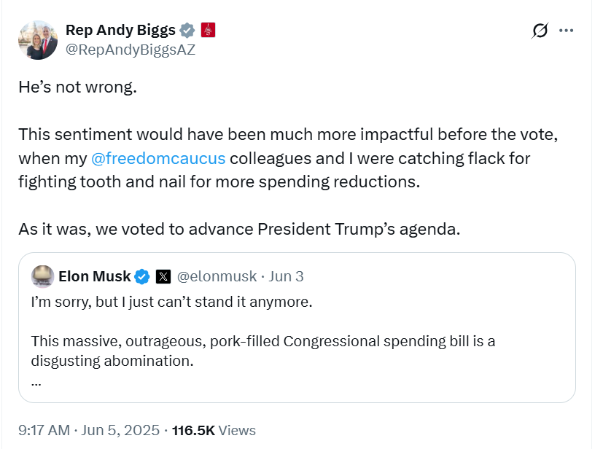
[Twitter, @RepAndyBiggsAZ, 6/5/25]

Biggs Called SNAP A “Highly Abused Welfare Program”
2024: Biggs Called SNAP A “Highly Abused Welfare Program” And Called For Separating SNAP Funding From Agriculture Funding. According to U.S. Representative Biggs’ Twitter, “More than 80% of funding in the Farm Bill goes to SNAP, a highly abused welfare program. Funding for agriculture ought to be separate from funding for food stamps. Hardworking American farmers deserve better.”
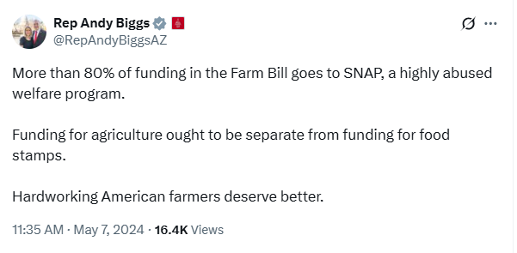
[Twitter, @RepAndyBiggsAZ, 5/7/24]

294,151 Households In Arizona Relied On SNAP
2023: Across Arizona, 294,151 Households Relied On SNAP.
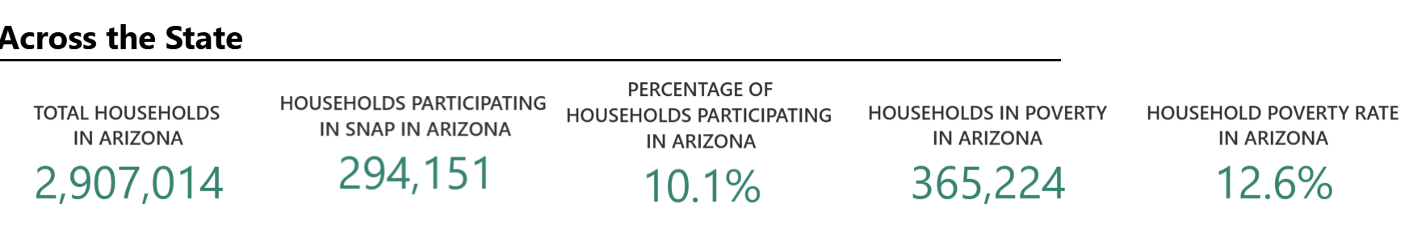
[U.S. Department of Agriculture, SNAP Community Characteristics, Accessed 11/24/25]

