Overview
In 2025, Biggs voted for Trump’s “One Big Beautiful Bill,” which was estimated to kick 17 million Americans off their health insurance, including nearly 12 million Americans who rely on Medicaid. More than 342,000 Arizonans could lose their health insurance as a result of Biggs’ vote.
Biggs called for the repeal of the Affordable Care Act. In 2025, more than 423,000 Arizonans were enrolled in Affordable Care Act Marketplace health insurance plans. Biggs called Medicaid expansion “our biggest growing financial danger,” even though Medicaid expansion enabled coverage for more Arizonans. By 2034, 193,981 Medicaid recipients in Arizona were expected to lose their coverage due to Biggs’ support for Trump's tax bill.
In January 2026, Biggs voted against extending the Affordable Care Act subsidies for three years, despite Arizonans already experiencing a nearly 30% increase in premiums during the ACA’s 2026 open enrollment period after Republicans allowed the subsidies to expire. In December 2025, Biggs voted for Republicans’ health care bill which would weaken protections for people with pre-existing conditions and allowed ACA tax credits to expire. Biggs did not sign multiple discharge positions aimed at extending premium ACA tax credits. Biggs’ and Republicans’ inaction over ACA subsidies created a “subsidy cliff” whereby households could lose all eligibility for assistance if they earn even $1 more than a specified income threshold. Biggs called for the elimination of ACA subsidies and falsely claimed families earning up to $600,000 a year were not paying any premiums at all, under the Affordable Care Act tax credits.

Biggs Voted To Take Health Insurance Away From Millions Of Americans Who Relied On Medicaid

Biggs Voted For The “One Big Beautiful Bill,” Which Included Devastating Health Care Cuts To Fund Tax Cuts For The Wealthy

July 2025: Biggs Voted For The Final Version Of The “One Big Beautiful Bill,” Which Would Cause 17 Million Americans To Lose Their Health Care
July 2025: Biggs Voted For The Senate FY 2025 Budget Reconciliation Bill, The “One Big Beautiful Bill,” Which Extended $4 Trillion In Expiring Tax Cuts, Added New Tax Breaks, Appropriated $448 Billion In Defense, Border, And Immigration Enforcement Funding, Increased The SALT Deduction To $40,000, And Cut Medicaid And Other Social Programs To Offset The Costs. In July 2025, Biggs voted for, according to Congressional Quarterly, the “motion to concur in the Senate amendment to the bill that would permanently extend nearly $4 trillion in expiring individual and business tax cuts, create several new tax breaks and fund border and immigration enforcement and air traffic control upgrades. It would cut Medicaid and other safety net programs to partly offset the cost. Among other provisions, it would raise the statutory debt ceiling by $5 trillion and appropriate more than $448 billion in mandatory funding for Trump administration priorities and other needs, including $153 billion for defense, $89 billion for immigration enforcement, and $89.5 billion for border control and security. It also would increase the state and local tax deduction cap to $40,000 annually for five years for households making up to $500,000 a year until 2030, when it would permanently revert to $10,000.” The House passed the bill by a vote of 218 to 214. The bill was ultimately signed into law. [House Vote 190, 7/3/25; Congressional Quarterly, 7/3/25; Congressional Actions, H.R. 1]
- HEADLINE: "At Least 17 Million Americans Would Lose Insurance Under Trump Plan" [Washington Post, 7/1/25]
- HEADLINE: “By The Numbers: Harmful Republican Megabill Favors The Wealthy And Leaves Millions Of Working Families Behind” [Center On Budget And Policy Priorities, 8/1/25]
- The Congressional Budget Office Estimated That 11.8 Million People Would Become Uninsured As A Result Of The Medicaid Cuts In Republicans’ Reconciliation Bill. According to the Washington Post, "The bill, which narrowly passed the Senate on Tuesday and now heads back to the House, would effectively accomplish what Republicans have long failed to do: unwind many of the key components of the ACA, President Barack Obama’s signature domestic achievement, which dramatically increased the number of Americans with access to health insurance. To start, the Congressional Budget Office estimated that the Senate version of the bill would result in 11.8 million more uninsured in 2034, mostly because of Medicaid cuts, compared with 10.9 million if the House version became law." [Washington Post, 7/1/25]
- The Bill’s $50 Billion In Rural Hospital Relief Funding Would Not Come Close To The Gap Created By Medicaid Cuts, With 300 Rural Hospitals At “Immediate Risk” Of Closure. According to the Center For American Progress, “The OBBBA includes $50 billion in relief funding for rural hospitals over a five-year period to help reduce the disastrous impacts of the bill’s roughly $1 trillion in Medicaid cuts. As of May 2025, there were approximately 2,086 rural hospitals receiving $12.2 billion a year in net revenue from Medicaid. At the median, rural hospitals’ revenue from Medicaid is $3.9 million a year. Rural hospitals have some of the lowest operating margins in the nation, especially compared with urban hospitals, meaning that any reductions in revenue could lead to closures. The average operating margin for rural hospitals was 3.1 percent in 2023, with 44 percent of rural hospitals operating with negative margins. As a result, more than 300 rural hospitals are currently at ‘immediate risk’ of closure, especially now that the OBBBA is projected to cut Medicaid spending by $1.02 trillion. The relief fund designed to blunt the negative impacts caused by the bill would not come close to filling that gap. If every rural hospital in the country received an even share of the $50 billion in relief support, it would amount to only $4.5 million every year for five years. At the close of those five years, that funding would disappear altogether.” [Center For American Progress, 7/3/25]

More Than 342,000 Arizonans Were Expected To Lose Health Care Coverage Under Trump’s “One Big Beautiful Bill,” Including 29,563 Arizonans In Biggs’ Congressional District (AZ-5)
Under The “One Big Beautiful Bill,” 342,481 Arizonans Were Expected To Lose Their Health Care By 2034, Including 148,500 ACA Enrollees And 193,981 Medicaid Recipients. According to the Joint Economic Committee Minority,
District | State | Est. # Losing ACA Coverage | Est. # Losing Medicaid Coverage | Est. Total # Losing Insurance
AZ-01 | Arizona | 18,800 | 12,601 | 31,401
AZ-02 | Arizona | 15,800 | 26,014 | 41,814
AZ-03 | Arizona | 18,000 | 35,083 | 53,083
AZ-04 | Arizona | 15,800 | 18,538 | 34,338
AZ-05 | Arizona | 16,300 | 13,263 | 29,563
AZ-06 | Arizona | 15,000 | 16,925 | 31,925
AZ-07 | Arizona | 15,400 | 32,035 | 47,435
AZ-08 | Arizona | 16,300 | 16,701 | 33,001
AZ-09 | Arizona | 17,100 | 22,821 | 39,921
All | Totals | 148,500 | 193,981 | 342,481

[Joint Economic Committee Minority, 6/25]
- Under The “One Big Beautiful Bill,” 29,563 Arizonans Were Expected To Lose Their Health Care In Biggs’ Congressional District (AZ-5) By 2034, Including 16,300 ACA Enrollees And 13,263 Medicaid Recipients. [Joint Economic Committee Minority, 6/25]
- 300,000 Arizonans Were Expected To Lose Health Care Coverage Under Trump’s “One Big Beautiful Bill.” According to the Arizona Monitor, “The alarming picture painted by a panel of health care leaders is a direct result of Trump’s ‘Big, Beautiful Bill Act,’ which was backed by all of Arizona’s Republican congressmen. Medicaid provides insurance to 80 million Americans and around two million Arizonans — more than 25% of the state’s residents — with low incomes or disabilities. The new spending law means an estimated 300,000 Arizonans are expected to lose coverage through the Arizona Health Care Cost Containment System, or AHCCCS, the state’s Medicaid program.” [Arizona Monitor, 8/14/25]

May 2025: Biggs Voted For The House FY 2025 Budget Reconciliation Bill, Which Was Estimated To Increase The Uninsured Population By 8.6 Million By 2034
May 2025: Biggs Voted For The House FY 2025 Budget Reconciliation Bill, Which Included $3.8 Trillion In Tax Cuts Offset By $1.5 Trillion In Spending Reductions To Programs Like Medicaid And The Supplemental Nutrition Assistance Program. In May 2025, Biggs voted for, according to Congressional Quarterly, “the bill that would provide for approximately $3.8 trillion in net tax cuts and $321 billion in military, border enforcement, and judiciary spending, offset by $1.5 trillion in spending reductions, as instructed in the fiscal 2025 budget resolution. It would raise the statutory debt limit by $4 trillion and provide for increased spending on defense and border security, spending cuts on social safety net programs, such as Medicaid and the Supplemental Nutrition Assistance Program. It also includes a mix of tax breaks for businesses and individuals; tax increases on universities and foundations; and a phase-down of clean energy tax credits. […] It would reduce federal spending on the Supplemental Nutrition Assistance Program by requiring states to shoulder more of the cost, expand work requirements for SNAP, extend programs authorized under the 2018 farm bill, and prohibit the U.S. Department of Agriculture from increasing the cost of the Thrifty Food Program. As amended, it would cap state and local tax deductions at $40,000 for households with incomes below $500,000.” The House passed the bill by a vote of 215 to 214. [House Vote 145, 5/22/25; Congressional Quarterly, 5/22/25; Congressional Actions, H.R. 1]
- The House GOP Budget Bill Was Estimated To Increase The Uninsured Population By 8.6 Million By 2034. According to CNN, “The Medicaid and Affordable Care Act provisions in the package could result in 8.6 million more people being uninsured in 2034, according to an early CBO estimate released by Democratic lawmakers. That number is expected to grow with the latest changes.” [CNN, 5/28/25]
- The House GOP Budget Bill Codified A Trump Administration Proposal That Restricted Access To The Affordable Care Act. According to CNN, “The bill also calls for codifying a Trump administration proposal that would make changes to the Affordable Care Act enrollment process, including shortening the open enrollment period and eliminating the ability of low-income Americans to sign up year-round.” [CNN, 5/28/25]
- The House GOP Budget Bill Made The 2017 Income Tax Breaks Permanent And Added An Estimated $3.8 Trillion To The National Debt Over 10 Years. According to CNN, “The package includes several controversial measures that would deeply cut into two of the nation’s key safety net programs – Medicaid and food stamps – while making permanent essentially all of the trillions of dollars of individual income tax breaks contained in the GOP’s 2017 Tax Cuts and Jobs Act. What’s more, it would fulfill Trump’s campaign promises to cut taxes on tips and overtime, albeit temporarily. The magnitude of the measures is evident in the estimates of the cost they would incur or the savings they would produce. […] The tax changes in the package would add $3.8 trillion to the nation’s debt over a decade, according to a Congressional Budget Office analysis released before last-minute changes were made to the bill.” [CNN, 5/28/25]

February 2025: Biggs voted for a budget resolution that set up future medicaid cuts
February 2025: Biggs Voted For The FY 2025 Budget Framework That Included $2 Trillion In Cuts, Raised The Statutory Debt Limit By $4 Trillion, And Required House Committees To Recommend Legislation That Would Implement Trump’s Agenda. In February 2025, Biggs voted for, according to Congressional Quarterly, “the concurrent resolution that would recommend a budget for fiscal 2025 and budget levels through fiscal 2034. The resolution would assume minimum savings of $1.5 trillion over 10 years and 2.6 percent economic growth over the same period. It would also require the statutory debt limit to be raised by $4 trillion. It would also authorize the House Ways and Means Committee to increase deficits by $4.5 trillion over 10 years to extend the 2017 tax cuts and implement new tax cuts proposed by the White House. It would also provide instructions for the budget reconciliation process through which separate legislation could be considered and passed in the Senate via a simple majority vote. The measure would deliver instructions to 11 House committees to report legislation that would implement President Donald Trump’s agenda, such as expanding tax cuts and bolstering border security and immigration enforcement. The committees would be required to report their legislative recommendations to the House Budget Committee by March 27, 2025. It would also set a $2 trillion target for the spending cuts to be submitted to the House Budget Committee. The resolution also would stipulate that if the committees don't reach that target, the Ways and Means’ reconciliation instructions to increase the deficit by a maximum of $4.5 trillion would be decreased by the amount the other committees come in below the target. Similarly, it would stipulate that Ways and Means could increase the deficit above the $4.5 trillion level by the amount of savings the committees achieve above the $2 trillion target.” The vote was on passage. The House passed the resolution by a vote of 217 to 215. [House Vote 50, 2/25/25; Congressional Quarterly, 2/25/25; Congressional Actions, H. Con. Res. 14]
- HEADLINE: "House Republican Budget Takes Away Health Care, Food Aid To Pay For Expanded Tax Cuts For Wealthy" [Center on Budget and Policy Priorities, 2/21/25]
- New York Times Reported The $880 Billion In Cuts Required By The Republican Budget Proposal Would Have To Come From Medicaid, Medicare, Or CHIP. According to the New York Times, "The budget resolution itself is silent on whether Congress cuts Medicaid, which provides health coverage to 72 million poor and disabled Americans. But it instructs the House Energy and Commerce Committee, which has jurisdiction over the program, to cut spending by $880 billion over the next decade. If the committee can’t save at least that much, the entire effort could be imperiled because of the special process Congress is using to avoid a Senate filibuster. Ten other committees have their own instructions to follow, though none have been assigned with cutting nearly as much. It’s not so simple as finding the cuts elsewhere. The special process, known as budget reconciliation, means Republicans will have to find all $880 billion from within the Energy and Commerce Committee’s jurisdiction. That leaves them with fewer options than one might think. […] If Republicans want to avoid major cuts to Medicaid, the largest pot of available money is in the other big government health insurance program: Medicare. […] Even if the committee cuts everything that’s not health care to $0, it will still be more than $600 billion short. The committee could also save around $200 billion by eliminating the Children’s Health Insurance Program, but that option has not been raised by the budget committee or anyone in House leadership. […] Even if all of these cuts, revenues, and rule cancellations from outside health care can pass muster, the committee will still be left with hundreds of billions of dollars to cut to hit its goal. Mathematically, the budget committee’s instructions mean the committee would need to make major cuts to either Medicare, Medicaid or both." [New York Times, 2/25/25]

Biggs Opposed The Affordable Care Act And Called Medicaid Expansion “Our Biggest Growing Financial Danger”

Biggs Called For The Repeal Of The Affordable Care Act

Biggs Called For The Repeal Of The Affordable Care Act, Calling The Law A “Failure”
2025: Biggs Called The Affordable Care Act A “Failure” And Introduced Legislation To Repeal The Law. According to U.S. Representative Biggs’ Twitter, “The reality is that Obamacare is only affordable when it is heavily subsidized. The complete failure of the ‘Affordable’ Care Act is why health insurance premiums have skyrocketed. That’s why I introduced a bill to completely—and responsibly—repeal Obamacare.”
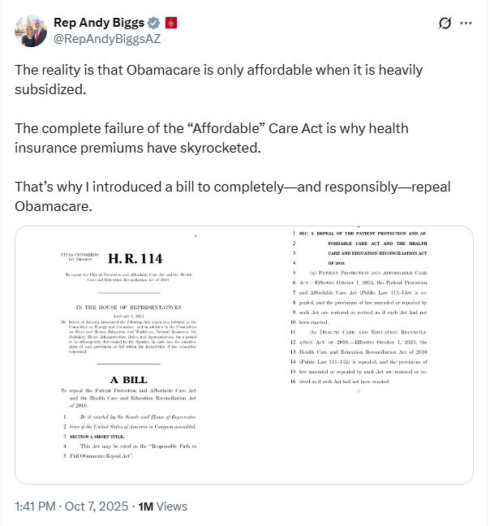
[Twitter, @RepAndyBiggsAZ, 10/7/25]
2025: Biggs Alleged There Were $30 Billion In Fraudulent Payments Annually Under The Affordable Care Act. According to Newsmax, “Fraud and mismanagement also remain pressing concerns, Biggs said. ‘Don't forget, you've got $30 billion a year going out in fraudulent payments under Obamacare,’ he said, referring to data showing millions of individuals automatically re-enrolled without realizing it. ‘A lot of reform has to take place there.’” [Newsmax, 11/21/25]

The “One Big Beautiful Bill” And The Expiring Affordable Care Act Tax Credits Would Result In 422,000 Uninsured Arizonans By 2034
The “One Big Beautiful Bill” And The Expiring Affordable Care Act Tax Credits Would Result In 422,000 Uninsured Arizonans By 2034. According to the Center For American Progress, “The One Big Beautiful Bill Act will increase the number of Americans without health coverage in every state Estimated increase in the uninsured population due to the OBBBA and the expiration of the ACA’s enhanced premium tax credits, 2034”
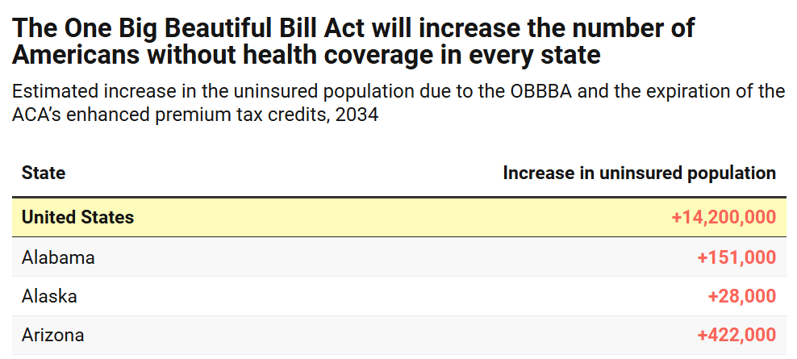
[Center For American Progress, 9/5/25]

2025: There Were 423,025 Arizonans Enrolled In An Affordable Care Act Marketplace Plan
2025: There Were 423,025 Individuals Enrolled In An Affordable Care Act Marketplace Plan In Arizona. According to KFF, in 2025, there were 423,025 individuals enrolled in affordable care act marketplace plan in Arizona.
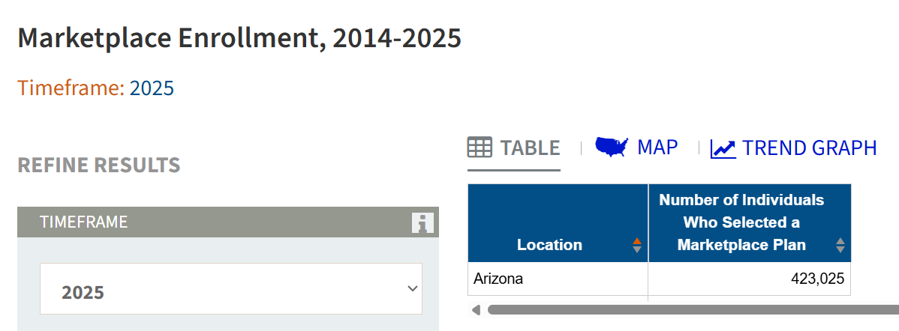
[KFF, Accessed 11/21/25]

Biggs Claimed “Obamacare Destroyed Medicaid,” Called It “Our Biggest Growing Financial Danger,” And Said Arizona Had “Some Cleanup To Do” In SNAP And Medicaid Benefits

Biggs: “Obamacare Destroyed Medicaid” And Was “Our Biggest Growing Financial Danger”
2025: Biggs: “Obamacare Destroyed Medicaid. Medicaid Shouldn’t Be America’s Fastest Growing Program—But Able-Bodied Americans Are Taking Advantage.” According to U.S. Representative Biggs’ Twitter, “Obamacare destroyed Medicaid. Medicaid shouldn’t be America’s fastest growing program—but able-bodied Americans are taking advantage.”
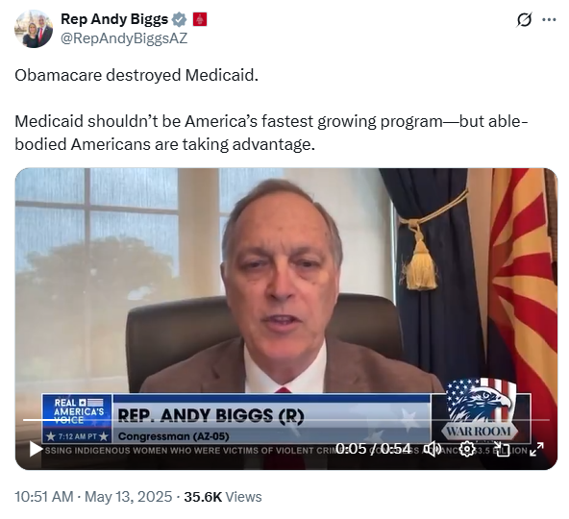
[Twitter, @RepAndyBiggsAZ, 5/13/25]
- 2025: Biggs Called Medicaid Expansion Under The Affordable Care Act “Our Biggest Growing Financial Danger” Because Of The Growing Number Of “Able-Bodied” Medicaid Recipients. According to Biggs on Real America’s Voice, “Medicaid’s really important because you have two basic fundamental groups. You have the original Medicaid, which is to care of the disabled, the elderly, pregnant women, and children, right. Then you have the Obamacare side of it, which is the expansion population, which is the able-bodied adults. And then you have the matching rates that are very different, you don’t have work requirements. This bill has very modest work requirements – 20 hours a week. C’mon Steve, I mean that’s just crazy to get all of your medical care if you’re an able-bodied adult. There are some states that are reimbursing at Medicaid rates that are multiple times the Medicare reimbursement rates. Why are those different? Well, the number one growing area is the Medicaid, and that is our biggest growing program and our biggest growing financial danger that we have.” [Andy Biggs Interview – Real America’s Voice, 5/13/25] (VIDEO)

Biggs Said Arizona Had “Some Cleanup To Do” In SNAP And Medicaid Benefits
October 2025: Biggs Said Arizona Had “Some Cleanup To Do” In SNAP And Medicaid Benefits, And Suggested The State “Might Have As Much As $6 Billion Of Fraud And Waste And Abuse On An Annual Basis.” According to Biggs on The Afternoon Addiction with Garret Lewis, “HOST: That'll be great. I mean, look at right? There's about 7 million people in Arizona and they're saying there's about 950,000 people that are on these food stamps, SNAP benefits. We have way too much dependency. ﻿BIGGS: Yeah. I mean, it's reportedly 12% of our entire state population is on SNAP benefits, which is puts us in a pretty, pretty, you know, a high, high rate compared to other states. And we know that I'm going to leave our snap here, but we do know, like in Medicaid, there's been studies indicating that we might have as much as $6 billion of fraud and waste and abuse on an annual basis out of a $22 billion net. So, yeah, we've got some cleanup to do here.” [Andy Biggs – Afternoon Addiction With Garret Lewis, 10/28/25] (AUDIO)

Under The “One Big Beautiful Bill,” 193,981 Medicaid Recipients In Arizona Were Expected To Lose Their Health Care By 2034
Under The “One Big Beautiful Bill,” 342,481 Arizonans Were Expected To Lose Their Health Care By 2034, Including 148,500 ACA Enrollees And 193,981 Medicaid Recipients. [Joint Economic Committee Minority, 6/25]

The Affordable Care Act Allowed States To Expand Medicaid, Which Dramatically Lowered The Uninsured Rate Among Low-Income Workers
The Affordable Care Act Allowed States To Expand Medicaid, And States That Expanded Medicaid Dramatically Lowered The Number Of People Without Health Insurance. According to the Center on Budget and Policy Priorities, "The Affordable Care Act (ACA) permits states to expand Medicaid coverage to adults with incomes up to 138 percent of the poverty level (about $20,780 annually for an individual or $35,630 for a family of three). States that have adopted the expansion have dramatically lowered their uninsured rates. Extensive research finds that the people who gained coverage have grown healthier and more financially secure, while long-standing racial inequities in health outcomes, coverage, and access to care have shrunk." [Center On Budget And Policy Priorities, 6/14/24]
- The Uninsured Rate Among Low-Income Workers Fell From 38 Percent In 2013 To 17 Percent In 2022, Which Coincided With Implementation Of Medicaid Expansion. According to the Center on Budget and Policy Priorities, "Millions of workers have gained coverage through Medicaid expansion, including people working in industries that provide critical goods and services such as health care, transportation, grocery stores, food manufacturers, and child care. Many have no access to health coverage through their jobs. In expansion states, the uninsured rate among low-income workers fell from 38 percent in 2013 to 17 percent in 2022; this sharp decline coincided with a large increase in the share of low-income workers enrolled in Medicaid.[16] In non-expansion states, the uninsured rate among low-income workers fell much less, from 46 percent to 31 percent. (See Figure 3.)" [Center On Budget And Policy Priorities, 6/14/24]

Andy Biggs Allowed ACA Tax Credits To Expire, Jacking Up Premium Costs For Arizonans By Nearly 30 Percent

Biggs Voted Against Extending The Affordable Care Act Tax Credits For Three Years, Even Though 22 Million Americans Relied On Aca Premium Tax Credits To Afford Health Insurance

January 2026: Biggs Voted Against Extending The Affordable Care Act Tax Credits For Three Years
January 2026: Biggs Voted Against Extending The Affordable Care Act Tax Credits For Three Years. In January 2026, Biggs voted against, according to Congressional Quarterly, “the bill, as amended, that would extend for three years, through the end of calendar year 2028, the enhanced tax credits to subsidize premiums for health insurance purchased on the Affordable Health Care Act health insurance markets. It would allow taxpayers whose household income exceeds 400 percent of the federal poverty line to receive tax credits for three more years. The measure would retroactively take effect Jan. 1, 2026.” The vote was on passage. The House passed the bill by a vote of 230 to 196. [House Vote 11, 1/8/26; Congressional Quarterly, 1/8/26; Congressional Actions. H.R. 1834]
- The Bill Extended The Enhanced COVID-Era ACA Tax Credits That Republicans Let Expire At The End Of 2025, Resulting In Greater Health Costs For A Third Of All Those Insured Through The ACA Marketplace. According to Congressional Quarterly, “Congress temporarily expanded the tax credits created through the ACA (PL 111-148, PL 111-152) during the COVID-19 pandemic. The enhanced credits expired Dec. 31, meaning roughly one-third of individuals who get coverage through the ACA marketplace are facing significantly higher costs for 2026. The open enrollment period for these plans closes Jan. 15.” [Congressional Quarterly, 1/8/26]
- Seventeen Republicans Voted For Passage Of The “Clean” Extension Of ACA Subsidies, Following A Procedural Vote The Day Before That Had Support From Nine Republicans. According to Politico, “Seventeen Republicans joined Democrats in passing legislation Thursday that would revive enhanced Affordable Care Act subsidies for three years, rebuffing opposition from GOP leadership. The 230-196 vote follows a procedural vote Wednesday to advance the bill, where nine Republicans joined Democrats in favor of moving forward.” [Politico, 1/8/26]
- The Bill Would Fail In The Senate But Helped Lay The Groundwork For A Bipartisan Agreement. According to Politico, “While the measure is destined to die in the Senate, Democrats and some Republicans hope it will lay the groundwork for a bipartisan agreement to tame skyrocketing health insurance premiums — the result of Congress allowing the tax credits to lapse Dec. 31. ‘The Senate could put together a product that could ultimately get sent back over to the House that we can then conference on and hopefully move across the finish line,’ said Rep. Rob Bresnahan (R-Pa.), who supported the Democratic-led bill.” [Politico, 1/8/26]
- The Vote Increased The Likelihood That The Senate Would Consider The Extension And Pass A Bill With Some Reforms. According to Politico, “Earlier Thursday, members of the bipartisan House Problem Solvers Caucus met with senators to discuss a potential solution. Rep. Jeff Hurd (R-Colo.) said that the meeting — and senators’ plea to show a strong force on this vote in the House — influenced his decision to vote for the measure after initially being inclined to vote against it. ‘There was a sentiment conveyed that if we could get a bill out of the House that had a meaningful amount of bipartisan support, that that would increase the likelihood that the Senate would take this up, pass a bill that has some reforms in it, and send it back,’ Hurd said in an interview about the message communicated during the bicameral meeting.” [Politico, 1/8/26]

Approximately 22 Million Americans Relied On ACA Premium Tax Credits To Afford Health Insurance
Approximately 22 Million Americans Relied On ACA Premium Tax Credits To Afford Health Insurance. According to CNBC, "About 22 million Americans received premium subsidies, also known as premium tax credits, in 2025. Households can opt to receive the tax credit in one of two ways: As a lump sum during tax season or as an advanced payment. Under the latter option, by far the most popular, the federal government issues the tax credit directly to a consumer’s insurer, which then lowers the consumer’s out-of-pocket premium. Consumers receive those advanced ACA subsidies based on an estimated annual income they provide when signing up for insurance. They must reconcile those subsidies during tax season and repay any excess tax credits to the IRS." [CNBC, 1/6/26]

ValuePenguin By LendingTree Analysis: Arizona Health Insurance Premiums For The Most Popular Health Plans In The State Increased Nearly 30% In 2026
2026: Approximately 70,000 Fewer Arizonans Signed Up For Affordable Care Act Plans After Republicans Allowed ACA Tax Credits To Expire And Insurance Premiums Increased Nearly 30% In Arizona’s Marketplace. According to Arizona Mirror, “About 70,000 fewer Arizonans have signed up for health insurance through the Affordable Care Act after Republicans in Congress refused to extend tax credits and premiums soared. One analysis found that insurance premiums on the ACA marketplace for Arizona jumped nearly 30% on average. Data released this week by the Centers for Medicare & Medicaid Services show that 353,000 Arizonans have signed up for 2026 ACA insurance plans, nearly 17% fewer than purchased plans for 2025.” [Arizona Mirror, 1/14/26]
ValuePenguin By LendingTree Analysis: Arizona Health Insurance Premiums For The Most Popular Health Plans In The State Were Rising By 29% In 2026. According to AZ Big Media, “ValuePenguin by LendingTree’s comprehensive review of all health insurance plans on the marketplace in 2026 reveals a troubling trend for Arizona: Arizona health insurance premiums for the most popular health plans in the state are rising 29% in 2026, the 12th largest rate increase in the U.S.” [AZ Big Media, 1/15/26]

Biggs Voted For A Bill Which would weaken protections for people with pre-existing conditions and failed to address premium spikes

December 2025: Biggs Voted For Republican Legislation That Would Allow ACA Tax Credits To Expire
December 2025: Biggs Voted For Republican Legislation That Prohibited Abortion-Related Care Under ACA Plans And Allowed The ACA Tax Credits To Expire. In December 2025, Biggs voted for, according to Congressional Quarterly, “the bill that would expand the ability of small businesses to establish association health plans and bars states from preventing small businesses from obtaining stop-loss insurance for self-funded health insurance plans. It would codify and expand rules governing employer-funded health reimbursement arrangements and would allow employees in such arrangements to pay Affordable Care Act health insurance premiums through salary reductions. It would provide funding for ACA policy cost sharing reduction payments that reduce deductibles and copayments. It would prohibit plans from providing abortion-related care. It also would require pharmacy benefit managers to provide transparency regarding prescription drug costs and the drug rebates they receive.” The vote was on passage. The House passed the bill by a vote of 216 to 211. [House Vote 349, 12/17/25; Congressional Quarterly, 12/17/25; Congressional Actions, H.R. 6703]
- HEADLINE: “House Passes GOP Health Bill Without ACA Credit Extension” [Congressional Quarterly, 12/17/25]
- The Bill Would Result In 100,000 People Losing Coverage Under The ACA As Gains In Enrollments From Association Plans Would Be Offset By The Loss Created By Cost Sharing Payments. According to Congressional Quarterly, “Overall, the CBO said, the new House bill headed to the floor Wednesday would result in about 100,000 people losing coverage, as ending silver loading offsets the gain in coverage from expanded association health plans.” [Congressional Quarterly, 12/17/25]
- The Bill Would Exempt Certain Insurance Policies Offered By Small Employers From Expansive ACA Coverage Requirements. According to Congressional Quarterly, “Provisions in the bill (HR 6703) offered by Rep. Mariannette Miller-Meeks, R-Iowa — one of her party's most vulnerable incumbents — include legislation that would expand access to association health plans and exempt certain insurance policies offered by smaller employees from expansive ACA coverage requirements.” [Congressional Quarterly, 12/17/25]
- The Bill Included Cost-Sharing Reduction Payments For Insurers. According to Congressional Quarterly, “Another key feature of Miller-Meeks' bill would fund payments to insurers to offset the ACA's required reductions in cost-sharing expenses, like deductibles and co-pays, for lower-income beneficiaries. While support for this funding has crossed party lines in the past — it was initially an Obama administration policy, opposed by Republicans and eliminated in President Donald Trump's first term — traditional partisan roles have reversed. Democrats now oppose ‘cost-sharing reduction’ payments or CSRs, making this funding a long shot for passage in the closely divided Senate.” [Congressional Quarterly, 12/17/25]
- The Bill Would Allow Association Health Care Plans To Evade Consumer Protections Under The ACA, Including “Essential Coverage” Requirements, With Critics Arguing The Bill Would Result In “Adverse Selection,” Hurting Older And Sicker Individuals. According to Congressional Quarterly, “Critics say the bill could allow association health plans to evade consumer protections enshrined in the ACA, including requirements to provide a minimum level of ‘essential’ health care benefits. The legislation would allow such plans to be self-funded or be treated as large employer plans, each of which are exempt from the essential coverage requirements. By allowing these plans to operate under different rules in order to offer lower-cost policies, it could lead to ‘adverse selection’ in health insurance markets that makes it harder for older, sicker individuals to find affordable coverage, according to the American Academy of Actuaries.” [Congressional Quarterly, 12/17/25]
- Association Health Plans Would Be Able To Set Higher Premiums Based On Factors Such As Age, Gender, And Occupation. According to Congressional Quarterly, “While the bill prohibits discrimination due to pre-existing conditions or any health-related status, association health plans could still set premiums based on other factors, including age, gender, occupation and geographic location. ‘As a result, this bill would all but invite AHPs to charge workers with more expensive health needs far higher premiums — if those workers could even afford to participate in the associations at all,’ House Education and Workforce Democrats wrote in a committee report accompanying the version of the bill that panel approved in the 118th Congress.” [Congressional Quarterly, 12/17/25]
- Democrats Opposed Stop-Loss Provisions As They Would Put Enrollees At Risk Of Losing Insurance If Medical Costs For The Group Rise. According to Congressional Quarterly, “The AFL-CIO, which opposed both bills, wrote that the stop-loss measure would leave many enrollees at risk because their insurers ‘often retain the right to drop the insurance if medical costs for the group begin to climb.’” [Congressional Quarterly, 12/17/25]
- Cost Sharing Payments Would End Silver Loading Offsets, Resulting In 300,000 People Losing Coverage. According to Congressional Quarterly, “The CBO estimated the provisions would cut spending by $31 billion over nine years — since updated to $37 billion in the latest GOP bill. It would result in some 300,000 enrollees dropping their coverage because the reduced subsidies would outweigh the lower premiums resulting from the end of silver loading, the CBO said.” [Congressional Quarterly, 12/17/25]

Center On Budget And Policy Priorities: The December 2025 Republican Health Care Bill Failed To Prevent Imminent Premium Spikes And Undermined Protections For Pre-Existing Conditions
Center On Budget And Policy Priorities: The December 2025 Republican Health Care Bill Failed To Prevent Imminent Premium Spikes For More Than 20 Million People Who Relied On ACA Marketplace Plans. According to the Center on Budget and Policy Priorities, "The health bill House Republicans are preparing to bring to the floor this week not only fails to prevent imminent premium spikes for more than 20 million people in marketplace plans, but would raise costs even higher for many marketplace enrollees and weaken pre-existing condition protections for individuals and small businesses." [Center On Budget And Policy Priorities, 12/16/25]
Center On Budget And Policy Priorities: The December 2025 Republican Health Care Bill Would Expand Association Health Plans, Which Would Result In Higher Underlying Premiums For Individuals And Small Businesses That Remained In ACA-Regulated Markets. According to the Center on Budget and Policy Priorities, "It would expand association health plans (AHPs), a type of health plan that trade associations, professional groups, and other organizations may offer their members, to cover self-employed individuals and small businesses as if they were large employers. By allowing more people to enroll in coverage not subject to ACA standards and consumer protections, this would segment insurance risk pools: individuals who are younger and healthier, or small businesses with younger or healthier employees, could get plans with lower premiums because they would be priced separately from ACA-compliant coverage and wouldn’t have to meet ACA standards such as having to cover a set of essential health benefits. As a result, individuals and small businesses remaining in ACA-regulated markets would see higher underlying premiums." [Center On Budget And Policy Priorities, 12/16/25]
Center On Budget And Policy Priorities: The December 2025 Republican Health Care Bill Would Likely Lead To Higher Premiums For Older And Sicker Small Groups And Self-Employed People, Thereby Undermining Protections For People With Pre-Existing Conditions. According to the Center on Budget and Policy Priorities, "In addition, the bill would undermine protections for people with pre-existing conditions. While it would bar AHPs from rejecting individuals or charging them more based on certain health factors, it would give them greater ability to base a small group’s or self-employed person’s costs on their health risk compared to individual or small-group coverage. This would likely lead to higher premiums for older and sicker small groups and self-employed individuals, making such arrangements more attractive to healthier individuals and groups." [Center On Budget And Policy Priorities, 12/16/25]

Congressional Budget Office Estimated The December 2025 Republican Health Care Bill Would Result In 100,000 Americans Losing Their Health Insurance
Congressional Budget Office Estimated The December 2025 Republican Health Care Bill Would Take Health Coverage From 100,000 Americans. According to Axios, "By the numbers: The GOP bill would increase the uninsured population by 100,000 and save the government $35.6 billion over 10 years, according to the Congressional Budget Office." [Axios, 12/17/25]

Biggs Did Not Sign Discharge Petitions Aimed At Extending Premium ACA Tax Credits
Biggs Was Not One Of The Republican Signers On A Discharge Petition H.R. 1834 Led By House Minority Leader Hakeem Jeffries.
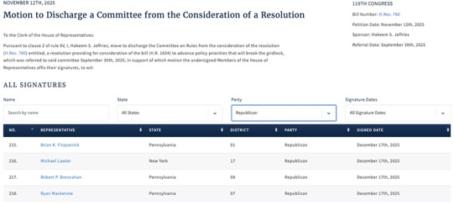
[Clerk of the U.S. House of Representatives, Discharge Petition No. 10, 11/12/25]
- House Minority Leader Jeffries’ Discharge Petition Sought To Extend ACA Premium Tax Credits For Three Years. According to Politico Pulse, "House Democrats could move as soon as tomorrow to force a vote on extending the expired Obamacare subsidies for three years, Meredith Lee Hill reports. This measure follows last month’s major setback for Speaker Mike Johnson, when four House Republicans broke from the party to support a discharge petition backed by Minority Leader Hakeem Jeffries to hold a vote." [Politico Pulse, 1/6/26]
Biggs Was Not One Of The Republican Signers On A Discharge Petition For H.R. 3001 Led By Rep. Brian Fitzpatrick.
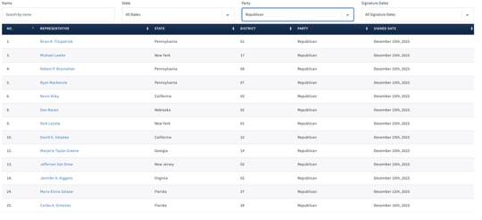
[Clerk of the U.S. House of Representatives, Discharge Petition No. 12, 12/10/25]
- December 2025: Fitzpatrick Filed A Discharge Petition Aimed At Extending ACA Premium Tax Credits For Two Years. According to a press release from Rep. Brian Fitzpatrick, "Today, Congressman Brian Fitzpatrick (PA-1) released the following statement after filing a discharge petition to bring his Bipartisan Health Insurance Affordability Act directly to the House floor for a vote, ensuring Congress takes action to prevent devastating health insurance premium increases when current protections expire at the end of the year: ‘Congress cannot sit idle while American families face a preventable crisis. Our job is to protect the people we serve, and that responsibility demands immediate action. […] Key Provisions of the Bipartisan Health Insurance Affordability Act The legislation advances five reforms designed to protect affordability, strengthen accountability, and ensure taxpayer value: Prevents premium spikes: Extends enhanced premium tax credits through 2027, to protect families from abrupt monthly cost increases. Restores Consumer Control: Stops unauthorized plan and subsidy changes by requiring consent and prompt notification before any modifications take effect. Shines Light on Middlemen: Ends hidden spread pricing, severs PBM profits from drug prices, and requires full rebate pass-through to ensure savings reach patients. Gives Families New Tools to Manage Costs: Expands access to Health Savings Accounts and simplifies premium payments to reduce disruptions in coverage. Smart Stewardship of Taxpayer Dollars: Modernizes eligibility and introduces a reasonable minimum contribution to protect long-term affordability and responsible stewardship of federal dollars." [Press Release – Rep. Brian Fitzpatrick, 12/10/25]
Biggs Was Not One Of The Republican Signers On A Discharge Petition For H.R. 185 Led By Rep. Josh Gottheimer.
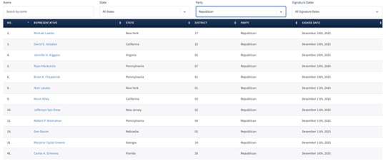
[Clerk of the U.S. House of Representatives, Discharge Petition No. 13, 12/10/25]
- December 2025: Gottheimer Filed A Discharge Petition Aimed At Extending ACA Premium Tax Credits For Two Years. According to a press release from Rep. Josh Gottheimer, "Today, December 11, 2025, U.S. Congressman Josh Gottheimer (NJ-5) released the following statement: ‘In less than three weeks, unless Congress acts now, Affordable Care Act tax credits will expire, and health insurance premiums will shoot up 175% — or $20,000 a year — for families in Jersey. This week, Congresswoman Jen Kiggans and I, with 36 of our Democratic and Republican colleagues, introduced new bipartisan legislation that includes a two-year extension of health insurance premium tax cuts for American families. It’s a commonsense proposal that will keep costs down and prevent families’ premiums from skyrocketing in January. But, the Speaker of the House is refusing to bring our legislation to the floor for a vote. So, our bipartisan group just launched a discharge petition to force an immediate vote in the House. We must get this done now. We must find common ground and lower health insurance premiums. Time is running out for families.’" [Press Release – Rep. Josh Gottheimer, 12/11/25]

Biggs’ inaction created a dramatic “subsidy cliff,” Whereby Households Could Lose All Eligibility For Assistance
The Expiration Of Enhanced ACA Premium Tax Credits Created A “Subsidy Cliff” Whereby If Households Earned Even $1 More Than A Specific Income Threshold, They Could Lose All Eligibility For Assistance. According to CNBC, "For the first time in years, many Americans enrolled in a health insurance plan via the Affordable Care Act marketplace will need to keep a careful accounting of their annual income — or risk a hefty federal tax bill. Enhanced ACA subsidies lapsed at the end of 2025, leaving millions of households on the hook for higher insurance premiums. The lapse also reintroduced the so-called subsidy cliff, whereby households that earn even $1 more than a specific income threshold will lose all eligibility for subsidies, also known as premium tax credits. That income cutoff, which varies by family size, is $62,600 for a single person, $84,600 for a two-person household and $128,600 for a family of four in 2026, for example." [CNBC, 1/6/26]
- More Than Two Million Americans Had Incomes Near A “Subsidy Cliff.” According to CNBC, "More than 2 million people enrolled in an ACA marketplace plan have an income near the subsidy cliff. ACA enrollees also tend to have relatively volatile incomes, making it hard to predict their annual earnings, experts said." [CNBC, 1/6/26]
Households That Went Over The Income Limit Would Have To Pay Back Any Federal Assistance They Received For Premiums, Which Could Cost Thousands Of Dollars, When They Filed Their Taxes. According to CNBC, "Households over the limit would have to pay back any federal subsidies they received for premiums — potentially worth thousands of dollars — when they file taxes next year for 2026." [CNBC, 1/6/26]
Republicans’ Big Beautiful Bill Exacerbated The Problem By Stripping Away Guardrails Capping The Amount Of Excess Subsidies Households Are Required To Repay. According to CNBC, "The potential financial impact is exacerbated by a multitrillion-dollar legislative package known as the ‘big beautiful bill’ that Republicans passed over the summer, which stripped away guardrails capping the amount of excess subsidies households must repay, experts said." [CNBC, 1/6/26]

Biggs Called For Eliminating ACA Subsidies For People Above The Poverty Level After Falsely Claiming Wealthy Families Were Not Paying Premiums
2025: Biggs Said The Affordable Care Act Was Not Affordable Anymore, And Called For “Reforms,” Including Eliminating Subsidies For People Above The Poverty Level. According to Newsmax, “‘The Affordable Care Act isn't affordable anymore,’ he said, pointing to the ‘multi-tiered approach’ that Senate Republicans are proposing to reform the law. ‘What it's based on is the fact that insurance profits have gone way up,’ he said, noting that millions of Americans have seen premiums double since 2013. One proposed reform would target subsidies distributed to higher-income households. ‘Think of it this way: You're going to probably get rid of subsidies for the people who make more than 400% of poverty level,’ Biggs said, emphasizing that tightening eligibility would redirect resources more efficiently.” [Newsmax, 11/21/25]
October 2025: Biggs Falsely Claimed That People Earning Up To $600,000 A Year Were “Not Paying Any Premiums At All” Under The Affordable Care Act Subsidies. According to AZ Family, “Rep. Andy Biggs’ claim that people making up to $600,000 a year receive free health care through the Affordable Care Act sparked a flood of viewer responses after his appearance on ‘Good Morning Arizona’ Friday morning. The Arizona congressman’s statement about Obamacare subsidies had viewers asking the newsroom to investigate. What the facts reveal tells a different story from what Biggs described. ‘So you have people who are not paying any premiums at all who might be making up to $600,000 who don’t have to pay any premium at all for their health care if they’re on the exchange,’ Biggs said during his studio appearance. While there is no income cap on who can apply for Affordable Care Act subsidies, the nonpartisan Joint Committee on Taxation checked the numbers last month and found that no one making more than half a million dollars a year receives those benefits.” [AZ Family, 10/9/25]
- The Arizona Public Health Association Found The Monthly Premium Of A 60-Year-Old Couple Earning $80,000 A Year Would Increase From $567 To $2,026 Without Affordable Care Act Subsidies. According to AZ Family, “The Arizona Public Health Association ran its own numbers. A 60-year-old couple making $80,000 a year currently pays about $567 a month for health insurance under Obamacare. If the subsidies disappear, that cost would jump to $2,026 a month — more than $17,000 a year just to stay insured.” [AZ Family, 10/9/25]

