Overview
Andy Biggs was an out-of-touch anti-abortion extremist, who said he could not support anyone who backed abortion rights.
In Congress, Biggs repeatedly voted to strip Americans of their reproductive rights. Biggs voted against codifying abortion protections in federal law, claiming it would expand a procedure that “killed an estimated 62 million babies since Roe v. Wade.” He voted against protecting out-of-state abortion services and protecting interstate movement of FDA-approved abortion drugs. Biggs also voted against codifying the right to access contraception in federal law.
Biggs introduced anti-abortion legislation to impose ultrasound mandates and deny abortion as health care, and worked to strip international law language protecting reproductive rights. He also supported defunding Planned Parenthood.
Biggs referred to abortion as “murder,” “slaughter,” and “killing” the unborn, and falsely claimed that a fetus “may feel pain as early as 12 weeks.”

Biggs Voted Against Reproductive Rights And Supported Anti-Abortion Legislation

Biggs Voted Against Codifying Abortion Protections And The Right To Access Contraceptives

Biggs Voted Against Codifying Roe V. Wade And Claimed Codifying Abortion Rights Would “Would Make Every State In The Country A Late Term Abortion State”
2022: Biggs Voted Against Codifying The Right To Receive Abortion Services And The Right For Medical Providers To Provide Abortion Services And Against Prohibiting Abortion Restrictions. In July 2022, according to Congressional Quarterly, Biggs voted against the Women’s Health Protection Act of 2022, which would “statutorily establish that health care providers have a right to provide and patients have a right to receive abortion services, and it would prohibit certain restrictions related to abortion services. The bill would specify that rights established by the bill may not be restricted by certain requirements or limitations related to abortion services, including prohibitions on abortion prior to fetal viability, or after fetal viability if a provider determines that continuation of a pregnancy would pose a risk to a patient's life or health; requirements that patients disclose reasons for seeking an abortion or make medically unnecessary in-person appointments; requirements that providers provide medically inaccurate information or perform specific medical tests or procedures in connection with the provision of abortion services; limitations on providers' ability to prescribe drugs based on good-faith medical judgment, provide services via telemedicine or provide immediate services when a delay would pose a risk to a patient's health; and requirements for facilities and personnel that would not apply to facilities providing medically comparable procedures. It would also prohibit requirements or limitations that are similar to those established by the bill or that impede access to abortion services and expressly or implicitly single out abortion services, providers or facilities.” The vote was on passage. The House passed the bill by a vote 219-210, thus the bill was sent to the Senate. The Senate did not take substantive action on the bill. [House Vote 360, 7/15/22; Congressional Quarterly, 7/15/22; Congressional Actions, H.R. 8296]
- October 2021: Biggs Criticized Legislation To Codify Roe V. Wade, Claiming It Would Expand A Procedure That “Killed An Estimated 62 Million Babies Since Roe V. Wade” And “Would Make Every State In The Country A Late Term Abortion State.” According to Biggs at an abortion hearing, “We're discussing the Democrats assertion that we must expand access to a procedure that has killed an estimated 62 million babies since Roe v. Wade was decided just last week. The House passed legislation that, if enacted, would codify Roe v. Wade and would make every state in the country a late term abortion state. And last week, the Democrats voted not to preserve the life of a baby born alive after an abortion.” [Andy Biggs – Abortion Hearing, 10/1/21] (VIDEO)

Biggs Voted Against Protecting Out-Of-State Abortion Services And Against Protecting Interstate Movement Of FDA-Approved Abortion Drugs
2022: Biggs Voted Against Protecting An Individual’s Access To Out-Of-State Abortion Services And Against Prohibiting The Restriction Of Interstate Movement Against Any FDA-Approved Abortion Drug. In July 2022, according to Congressional Quarterly, Biggs voted against the Ensuring Women’s Right to Reproductive Freedom Act, which would “prohibit individuals from interfering with patients' ability to access to abortion services in another state where the services are legal. Specifically, it would prohibit any person acting under color of state law from preventing, restricting or retaliating against health care providers' ability to provide abortion services that are legal in the provider's state to patients who do not reside in that state; a person's ability to assist in providing such services; or a person's ability to travel or assist another person traveling across state lines to obtain an abortion. It would also prohibit individuals from preventing, restricting or retaliating against the interstate movement of any drug approved by the Food and Drug Administration for the termination of a pregnancy.” The vote was on passage. The House passed the bill by a vote 223-205, thus the bill was sent to the Senate. The Senate did not take substantive action on the bill. [House Vote 362, 7/15/22; Congressional Quarterly, 7/15/22; Congressional Actions, H.R. 8297]

Biggs Voted Against Codifying The Right To Access Contraceptives
2022: Biggs Voted Against Codifying The Right To Access Contraceptives And The Right For Health Care Providers To Provide Contraceptives To Their Patients. In July 2022, according to Congressional Quarterly, Biggs voted against the Right to Contraception Act, which would “protect a person's ability to access contraceptives and to engage in contraception, and to protect a health care provider's ability to provide contraceptives, contraception, and information related to contraception.” The vote was on passage. The House passed the bill by a vote 228-195, thus the bill was sent to Senate. The Senate did not take substantive action on the bill. [House Vote 385, 7/21/22; Congressional Quarterly, 7/21/22; Congressional Actions, H.R. 8373]

Biggs Supported Anti-Abortion Legislation And Opposed International Law Language Protecting Reproductive Rights

Biggs Introduced Anti-Abortion Legislation To Impose Ultrasound Requirements And Deny Abortion As Health Care
January 2024: Biggs Introduced Legislation To Require Abortion Providers Show Ultrasound Images To Women Seeking Abortions, And Provide “A Complete Medical Description Of The Ultrasound Images.” According to The Hill, “Rep. Andy Biggs (R-Ariz.) introduced legislation Thursday to ‘ensure’ pregnant people receive an ultrasound and are offered a chance to see its images before consenting to an abortion. The legislation says abortion providers ‘shall’ perform an ultrasound, ‘provide a complete medical description of the ultrasound images’ — including size of the embryo and whether there is cardiac activity — and show the images to the mother.” [The Hill, 1/18/24]
May 2019: Biggs Introduced The “Abortion Is Not Health Care Act” To “Uphold The Call For Human Dignity At All Stages Of Life, Including While Still In Womb.” According to U.S. Representative Biggs’ Twitter, “Earlier today, I introduced the 'Abortion Is Not Health Care Act.' I urge all of my colleagues to uphold the call for human dignity at all stages of life, including while still in womb, and to support this legislation.”
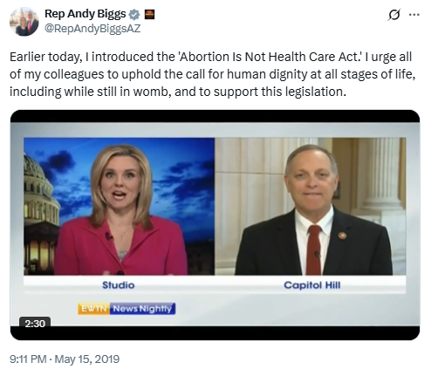
[Twitter, @RepAndyBiggsAZ, 5/15/19]

As An International Lawyer, Biggs Worked To Strip International Law Language Protecting Reproductive Rights
August 2025: Biggs Said That, As An International Lawyer, He Worked To Remove Language From International Law That Included “Enforced Pregnancy,” Which Biggs Called A “Euphemism” For “Anti-Abortion.” According to Biggs at a Dewey Meet & Greet, “Number one, when I, uh, was a younger guy and I was practicing law a little bit, I, I did some pro bono work on behalf of organizations and I would go to the, I would go to the, uh, United Nations and other multilateral institutions, and I was, I was there working for pro-family, pro-life issues. And we would, we would go in and we would fight and, um, we, and, and I won't get to international law. We were trying to take out some language or get language into any one of these documents because that's the prior credit for international law. And we would do it. We'd get a win. Maybe the language would come up on something called Enforced Pregnancy, which is a euphemism for. For, uh, anti-abortion. Okay. Yeah. So we would, we'd take care of that language and we'd get it out, and this wasn't the first time or two that we did this. Then we'd all go out to dinner to celebrate our big victory. But you know what the other side was doing? They were having meetings and they were trying to find new ways, scrubbing the rules to figure out how they could actually get that language back in. I'm telling you, evil never rests.” [Andy Biggs – Dewey Meet & Greet, 8/12/25] (AUDIO)

Biggs Opposed Federal Funding For Planned Parenthood
October 2025: Biggs Claimed The Budget Democrats Wanted To Pass Included “Abortion That Keeps Getting Paid For With State Federal Funding.” According to Biggs on The Jason Rantz Show, “I mean, the other thing about this that the people aren't realizing is there's some stuff in that the Democrats want with with like there's transgender surgeries keep getting paid for, abortion that keeps getting paid for with state federal funding. Those are the things those things keep happening. And that's that's what the Democrats want to have happen. And that's why they've put forward their their three and a half dollar program.” [Andy Biggs – Jason Rantz Show, 10/4/25] (AUDIO)
July 2025: Biggs Criticized The Big Beautiful Bill For Allowing Funding For Planned Parenthood Abortion Services For An Additional Year. According to Biggs in an OANN interview, “Think about the Planned Parenthood thing. The bill actually had ten years, no funding for abortion services through Planned Parenthood. Then this parliamentarian said, well, we're going to let you do that for nine years. But the first year Planned Parenthood gets to keep that money. I mean, I want you to think about how illogical that is and how partisan that is.” [Andy Biggs – OANN Interview, 7/4/25] (VIDEO)

Biggs Used Extreme Anti-Abortion Rhetoric, Such As “Murder,” “Slaughter,” And “Killing” The “Unborn,” And Spread Anti-Abortion Misinformation

Biggs Called Abortion “Murder” And “Slaughter” Of The “Unborn”
October 2024: Biggs Denied Abortion Was Health Care And Said “No One Has The ‘Right’ To Murder An Innocent Unborn Baby.” According to U.S. Representative Biggs’ Twitter, “No one has the ‘right’ to murder an innocent unborn baby. Abortion isn’t healthcare.”
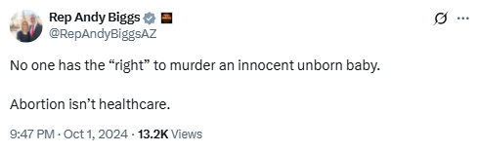
[Twitter, @RepAndyBiggsAZ, 10/1/24]
Biggs Touted His “A+ Rating” From Susan B. Anthony Pro-Life America, And Called Abortion “Slaughter” Of The “Unborn.” According to Biggs’ Twitter, “I’m honored to have earned an A+ rating on @sbaprolife ’s scorecard for consistently working to protect the right to life. Life begins in the womb. Congress must protect the unborn and fight to ensure that Americans’ taxpayer dollars are never used to fund their slaughter.”
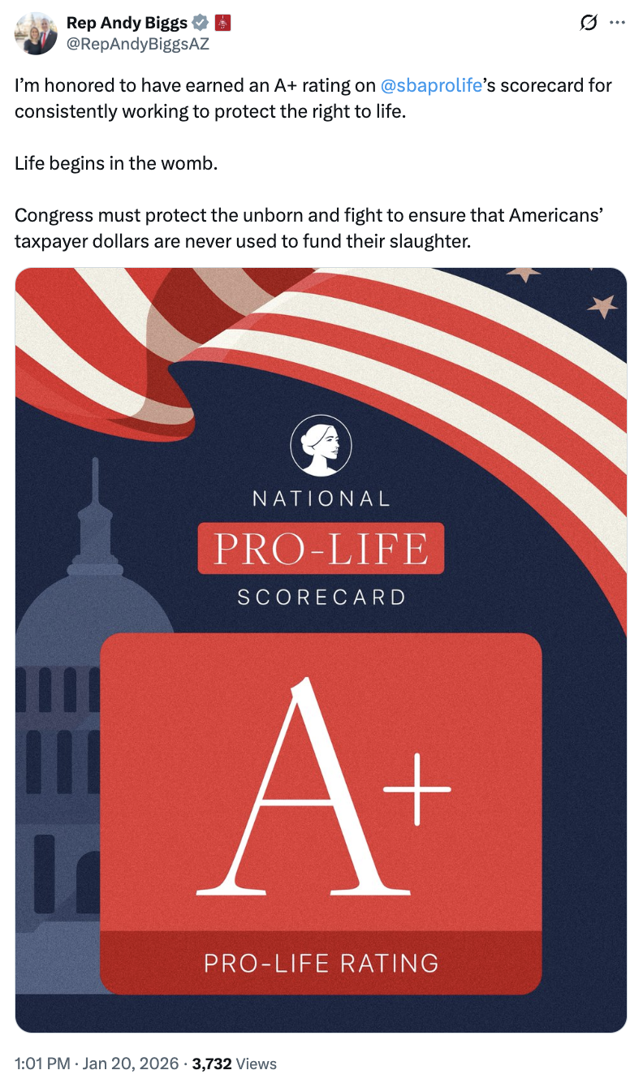
[Twitter, @RepAndyBiggsAZ, 1/20/26]

Biggs Said Democrats Had A “Craven Desire To Kill The Unborn”
September 2021: Biggs Said Democrats Had A “Craven Desire To Kill The Unborn” And Voted To “Make Sure Babies That Are Born Alive During An Abortion Should Also Be Murdered.” According to Biggs during a tele-town hall, “We've been hard at work battling the Democrats’ heinous pro-abortion agenda. Last week, the House Democrats used their majority to pass pernicious legislation that attacks and kills the unborn. And we're given the chance. They voted to make sure babies that are born alive during an abortion should also be murdered. This sickness permeates their drive to solve all human rights, but especially that craven desire to kill the unborn and the newly born.” [Andy Biggs – Tele-Town Hall, 9/30/21] (AUDIO)

Biggs Falsely Claimed That A Fetus “May Feel Pain As Early As 12 Weeks”
October 2021: Biggs Cited Evidence From A Journal Claiming That A Fetus “May Feel Pain As Early As 12 Weeks,” And Questioned A Doctor Who Claimed That A Fetus Undergoing Surgery Receives Anesthesia Because “The Cognitive Dissonance That Applies To Abortion Does Not Apply To Him.” According to Biggs at an abortion hearing, “BIGGS: This is from a journal called Journal of Medical Ethics by Dr. Stuart Darbyshire and John Bachmann, who wrote Current neuroscientific evidence supports the possibility of fetal pain before the consensus cutoff of 24 weeks. In fact, they go on to conclude that they may have a baby in utero, may feel pain as early as 12 weeks. Your comments, please. Dr. SKOP: You know, that article is very interesting because Dr. Darbyshire is well known as an expert in the field and in fact, ACOG, the American College of Obstetricians and Gynecologists in their statement saying that fetal pain does not occur until the third trimester, quoted Dr. Darbyshire. The other paper that they quoted was Susan Lee. And that was a very biased paper written by abortion provider. Nonetheless, Dr. Darbyshire is a pro-choice man, but he also is willing to follow the science where it goes. And he has become convinced with his research that there is compelling evidence that pain exist as early as 12 weeks. This is he went in his previous statements. He went and said, you know what, I was wrong. So it takes a I wish we could all do that, that we could all re-examine our biases and look at the current evidence and decide that perhaps in some ways we have been wrong. BIGGS: Thank you. And from another piece, I'm going to quote from it today, during a fetal surgery, a specialist in fetal anesthesia is invariably present to administer a general anesthetic to the baby, as well as a paralytic agent and an opioid. Is that accurate? Dr. SKOP: That is accurate. That is the standard of care for fetal surgery. BIGGS: And why would you provide fetal anesthesia and a paralytic agent and maybe even an opioid to a fetus receiving surgery? Dr. SKOP Because in that case, the fetus is the patient he is desired. The cognitive dissonance that applies to abortion does not apply to him. And so he is treated with care and respect.” [Andy Biggs – Abortion Hearing, 10/1/21] (VIDEO)
- The American College Of Obstetricians And Gynecologists Stated That “A Human Fetus Does Not Have The Capacity To Experience Pain Until After At Least 24-25 Weeks.” According to the Virginia Independent, “According to the American College of Obstetricians and Gynecologists, ‘The science conclusively establishes that a human fetus does not have the capacity to experience pain until after at least 24–25 weeks.’” [Virginia Independent, 8/19/25]

Biggs Said He Could Not “Support Anybody Who Isn’t Pro-Life”
September 2021: Biggs Said He Could Not “Support Anybody Who Isn’t Pro-Life” And Said The Country Needed To “Recalibrate” After The 40 Million Abortions Performed Since Roe V. Wade. According to Biggs on The Todd Starnes Show, “But, you know, Todd, my position has always been I'm a I'm an adamant pro-life or I can't support anybody who isn’t pro-life. I don't care if you're going to go to be the dogcatcher, whatever. In my mind, the first liberty is the liberty of life and people standing up and saying, well, this is going to harm us. We have we have had somewhere north of 40 million abortions since Roe v. Wade, and it's time to really recalibrate as a country.” [Andy Biggs – Todd Starnes Show, 9/3/21] (AUDIO)

